TEST SCENARIOS

|  |  |  |
| --- | --- | --- |
| 1 | PO | Req creation 🡪 Req Approval (Done-SP1->TC11) |
| 2 | PO | Blanket Release creation from PR 🡪 Blanket Release Approval-Pending Hassen |
| 3 | PO | Standard PO creation from PR 🡪 PO Approval(Done->SP7->TC00104) |
| 4 | PO | PO Receipt creation(Done->SP7->TC00116) |
| 5 | PO | Invoice creation(Done->SP7-> PO_iSupplier_InvoiceCreation_00120) |
| 6 | PO | Assign a Buyer to an Approved Requisition where the Buyer is unavailable(Done-SP1🡪TC16) |
| 7 | PO | Change the Buyer on an Approved Requisition (Done-SP1🡪TC17) |
| 8 | PO | Return to Supplier(Done-SP7🡪TC0014) |
| 9 | PO | Global Blanket Agreement Creation 🡪 Approval(Done->SP7->00117) |
| 10 | PO | Blanket Release creation without a Purchase Requisition and Approval(Done->SP7->TC00120) |
| 11 | PO | Standard PO creation without a PR 🡪 Approval(Done->SP7->TC00105) |
| 12 | PO | Update a PO while In Process status |
| 13 | PO | PO Receiving and Deliver to Sub Inventory |
| 14 | PO | Requisition creation in iProcurement(Done->SP7-> 00123, SP8-> 00124) |
| 15 | PO | Receive in iProcurement(SP8-> PO_iProcurement_PR_Receive_From_Receiving_00126) |
| 16 | PO | PO Corrections |
| 17 | PO | Creation of Two Stage RFQ- Approval |
| 18 | PO | Publish RFQ |
| 19 | PO | Quotation by Suppliers |
| 20 | PO | Close RFQ |
| 21 | PO | Unlock Technical |
| 22 | PO | Enter Technical Score |
| 23 | PO | Unseal Stage: Technical |
| 24 | PO | Lock Scoring and Complete Technical Evaluation |
| 25 | PO | Unlock Stage: Commercial |
| 26 | PO | Enter Commercial Score |
| 27 | PO | Unseal Stage: Commercial and Lock Scoring |
| 28 | PO | Award by Quote |
| 29 | PO | Express Receive – iProcurement |
| 30 | PO | Reject a Purchase Order, Update and Submit for Approval |
| 31 | PO | Internal Requisition(Done-> SP7->PO_Internal_Requisition_00128) |

1. Requisition creation 🡪 Req Approval

User- BRAHMEG

Responsibility – MWSPC Purchasing Power Generation

Purchasing Preparer 🡪 Requisitions

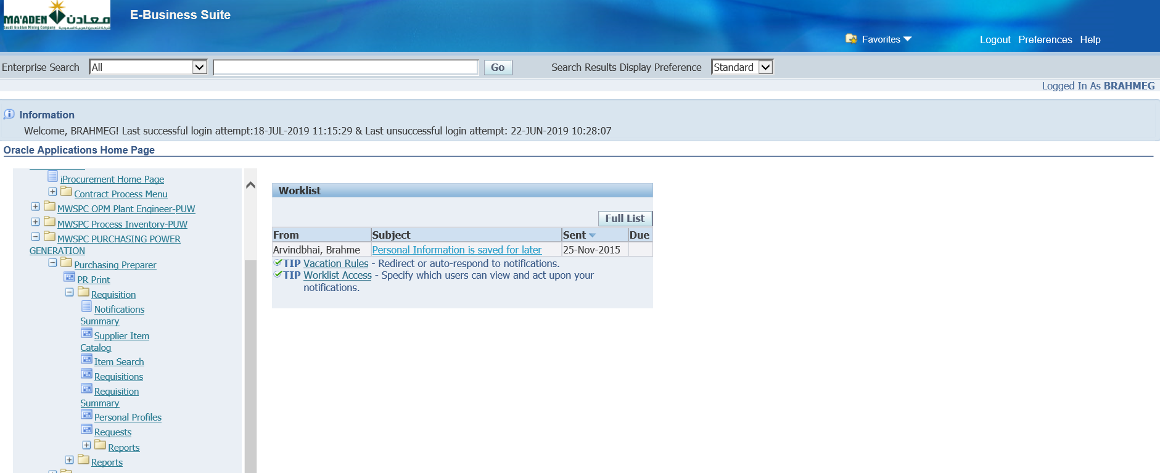

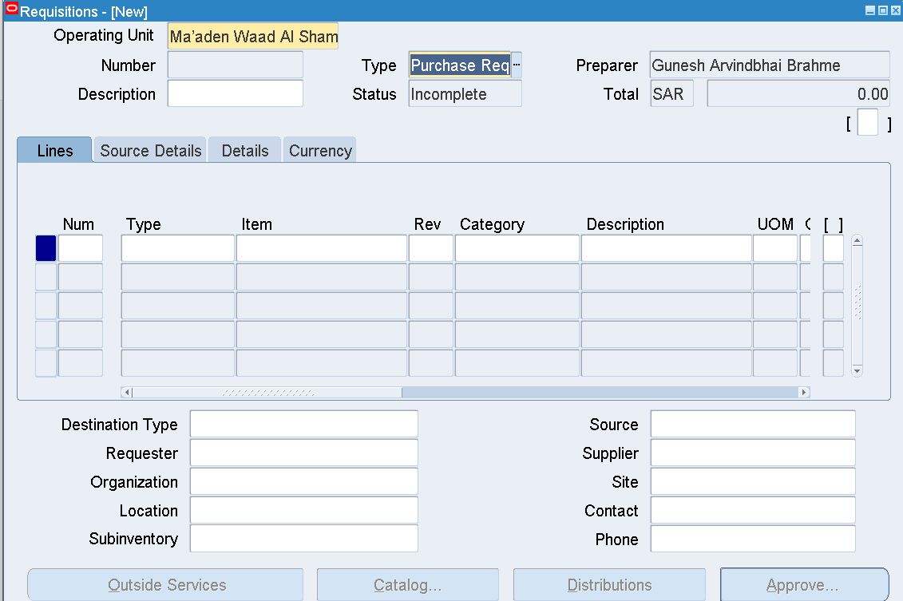

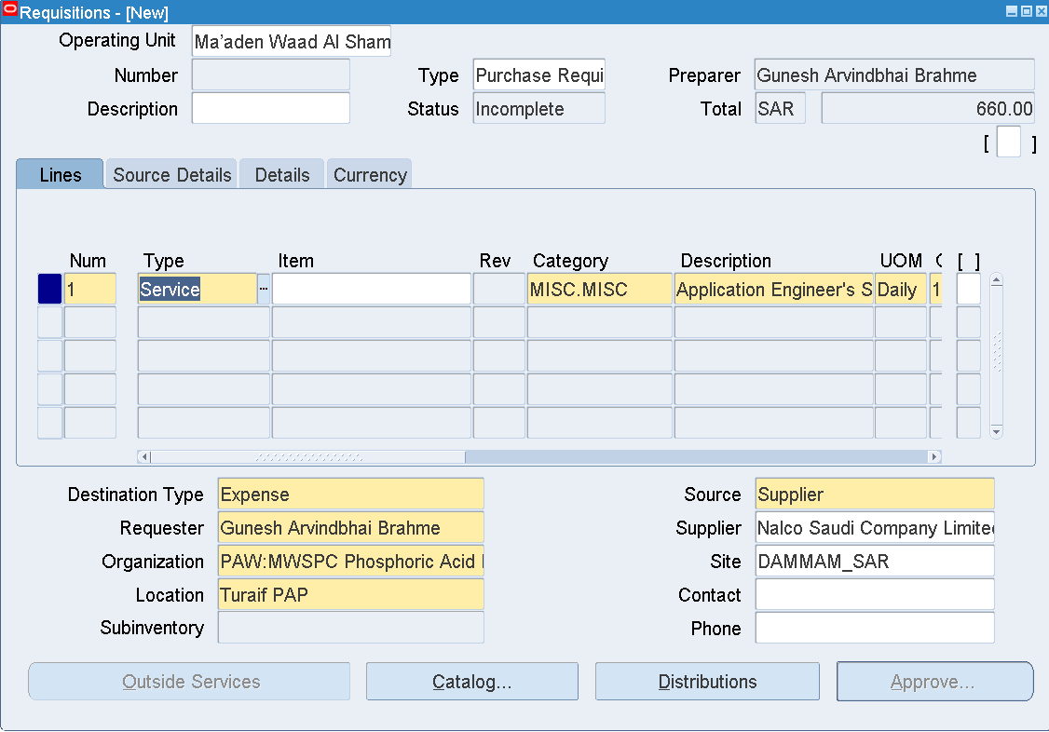

|  |  |
| --- | --- |
| Type | Service |
| Category | MISC.MISC |
| Description | Application Engineer's Service Charge |
| UOM | Daily |
| Quantity | 1 |
| Price | 660 |
| Need by Date | Any future date |
| Organization | PAW:MWSPC Phosphoric Acid Plant Warehouse |
| Location | Turaif PAP |
| Supplier | Nalco Saudi Company Limited |
| Site | DAMMAM_SAR |
| Source Details |  |
| Document Type | Blanket Purchase Agreement |
| Document | 741700202 |
| Line | 13 |

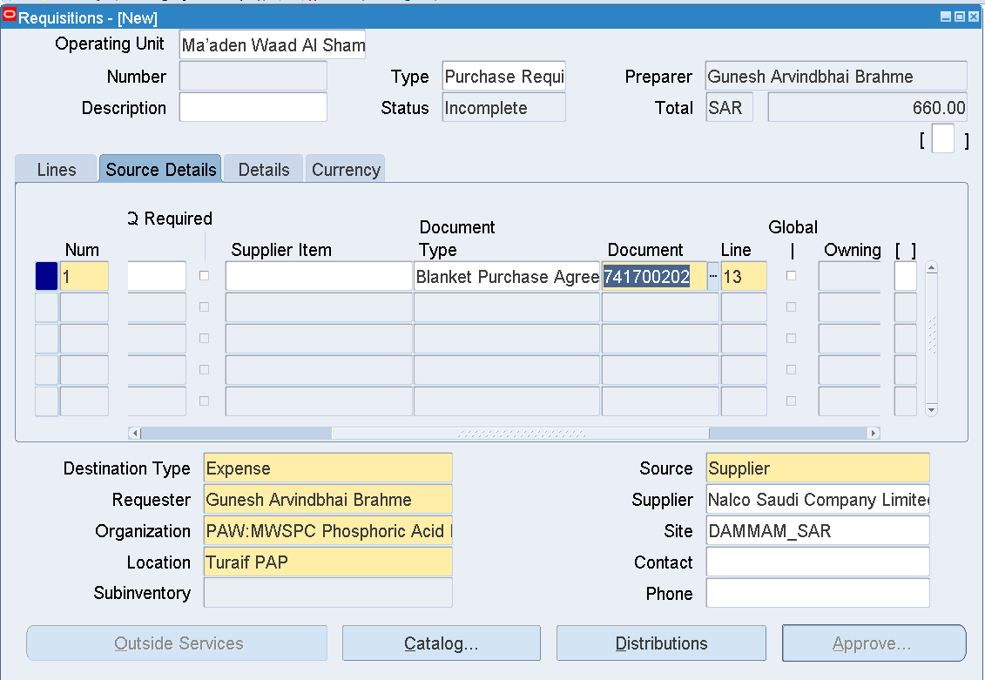

Save

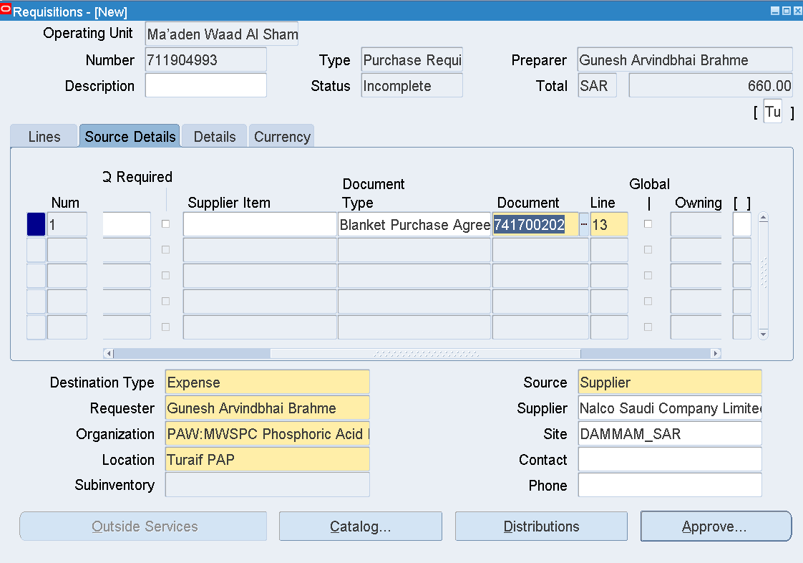

Requisition number 711904993 is generated

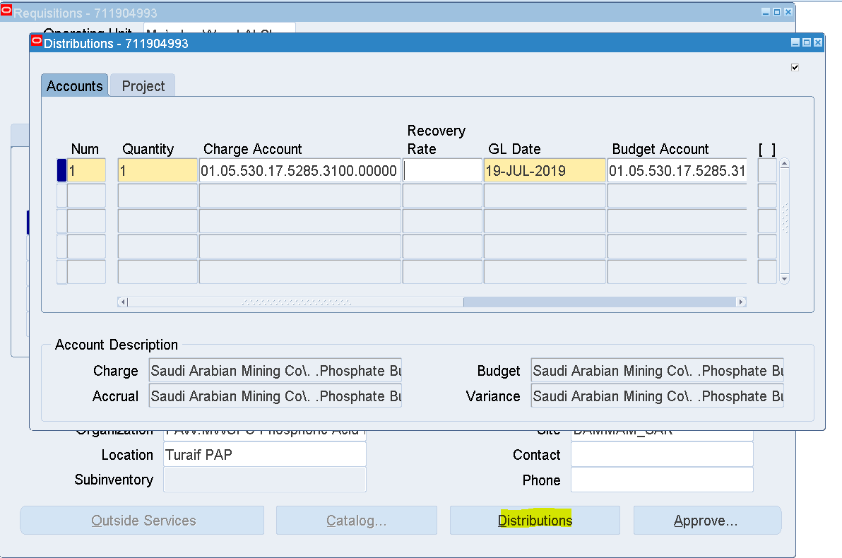

Distributions

Enter Charge Account - 01.05.530.17.5285.3100.00000 (01.05.530.30.0000.1260.00000)

Save

Approve

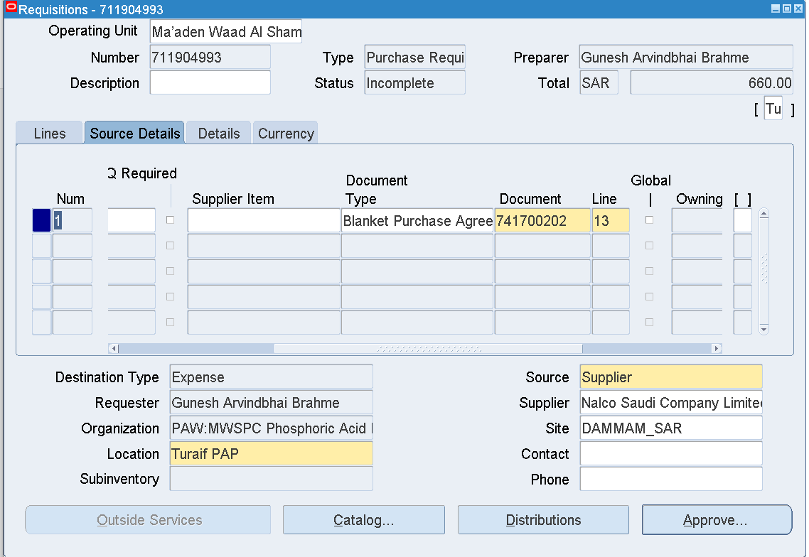

Approve

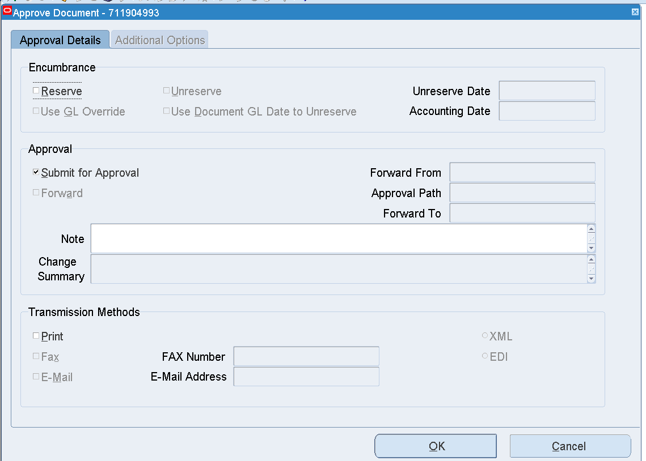

OK

Requisition – 711904993

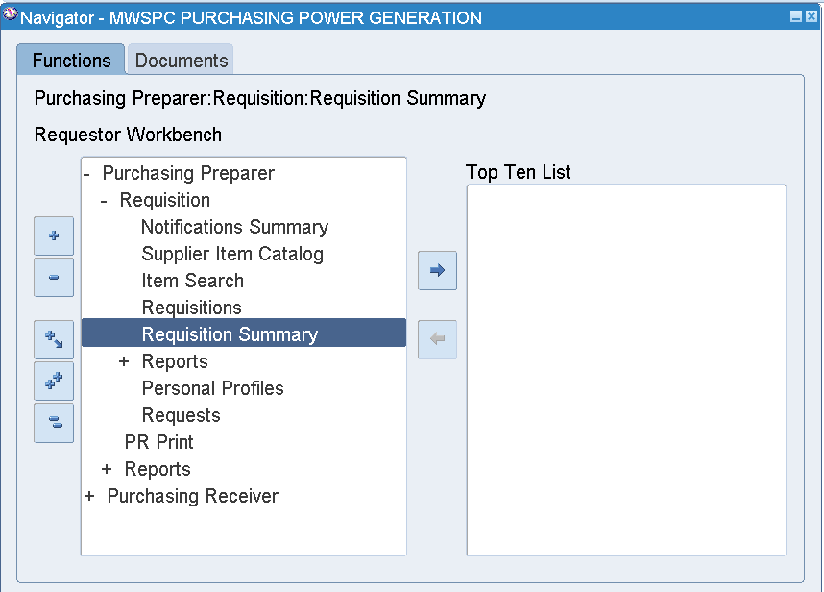

Requisition Summary

Enter Requisition Number 711904993

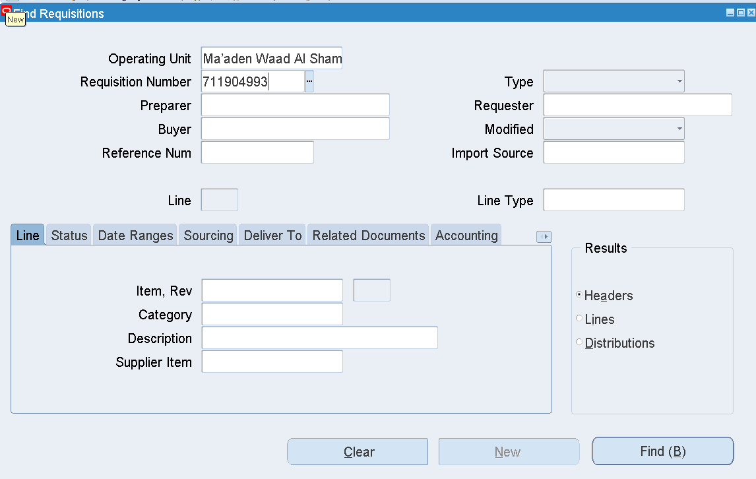

Find

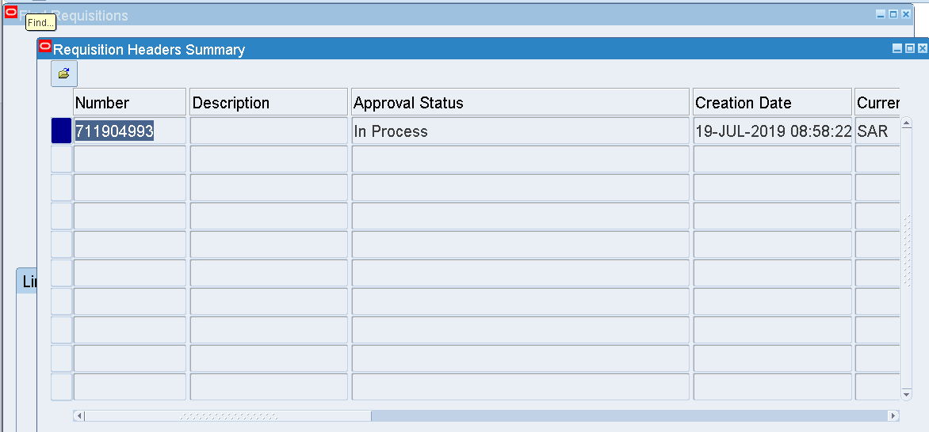

Approval Status 🡪 In Process

Tools 🡪 View Action History

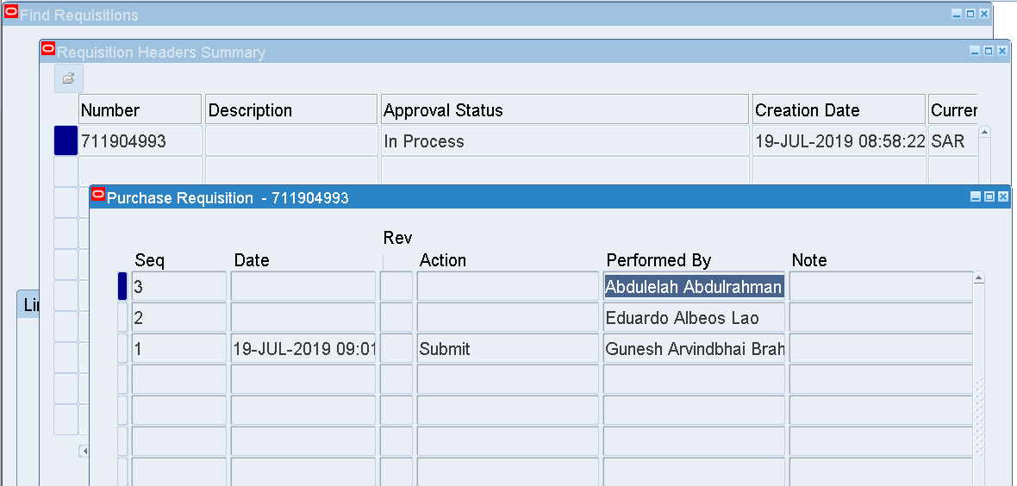

Approver - Abdulelah Abdulrahman Mohammed Alameri

Abdulelah Abdulrahman Mohammed Alameri’s User name – ALAMERIA

Login as ALAMERIA

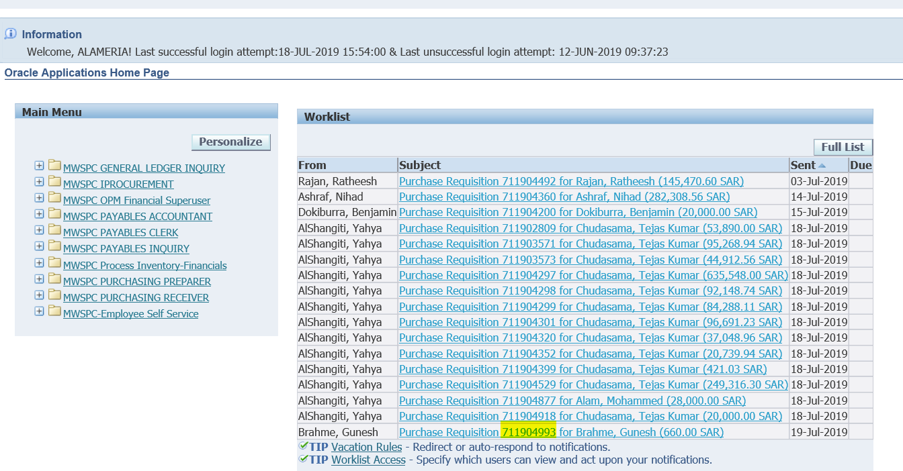

The Requisition is available in the Worklist

And awaiting Approval

Select that Link

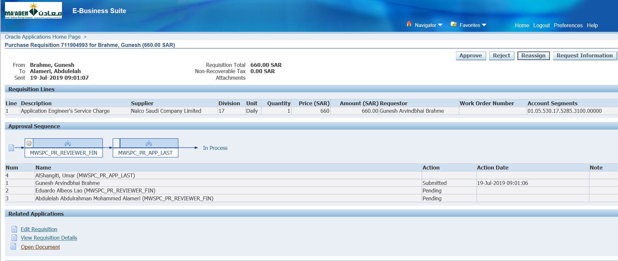

Click Approve

Then Login as Umar Khatri AlShangiti

User - SHANGITIU

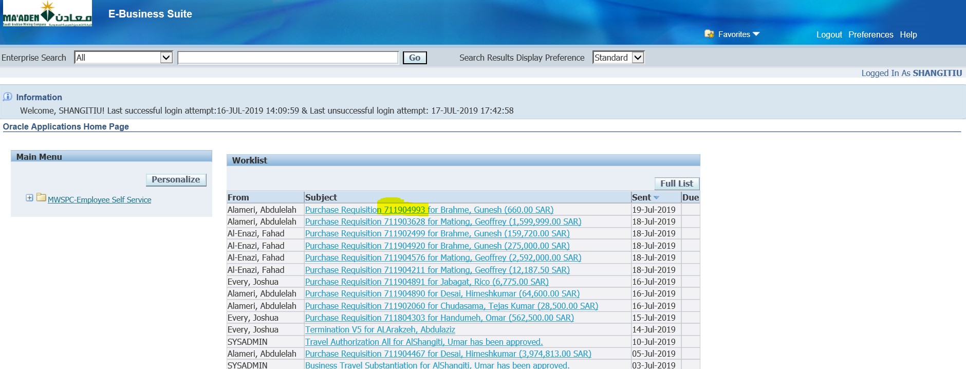

Open that Requisition from the worklist

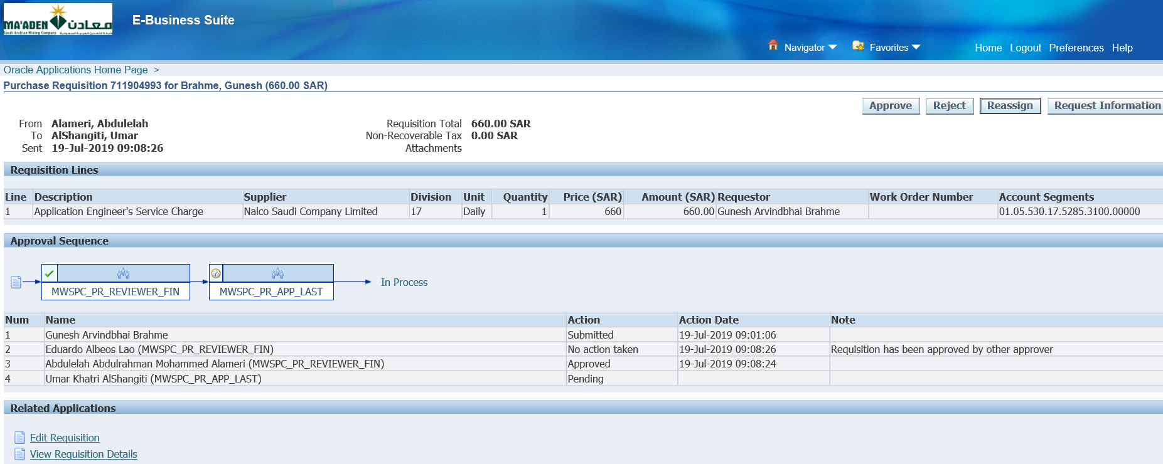

Click Approve

Once this is Approved

1. Blanket Release creation from PR 🡪 Blanket Release Approval

Login as Buyer – Shaji Peethambaran

User – PEETHAMBARANS

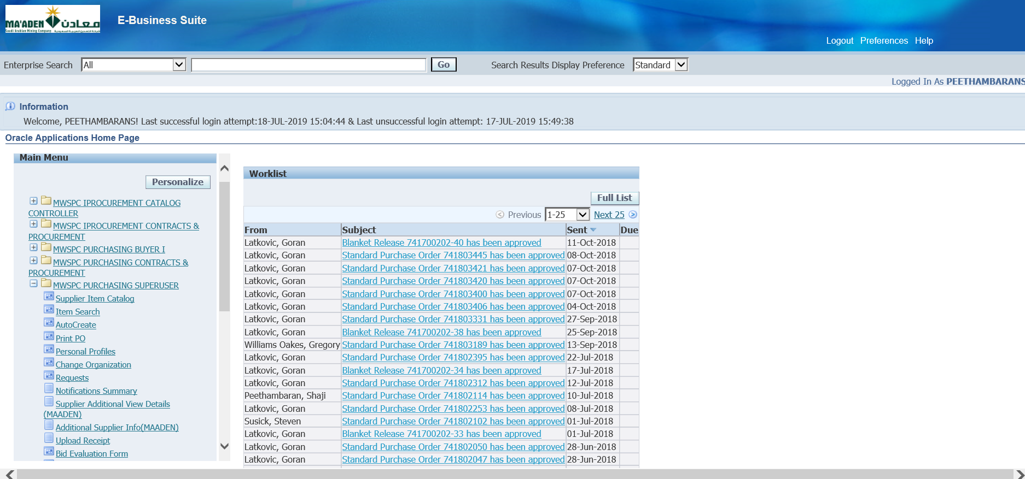

Responsibility – MWSPC Purchasing Superuser

Autocreate

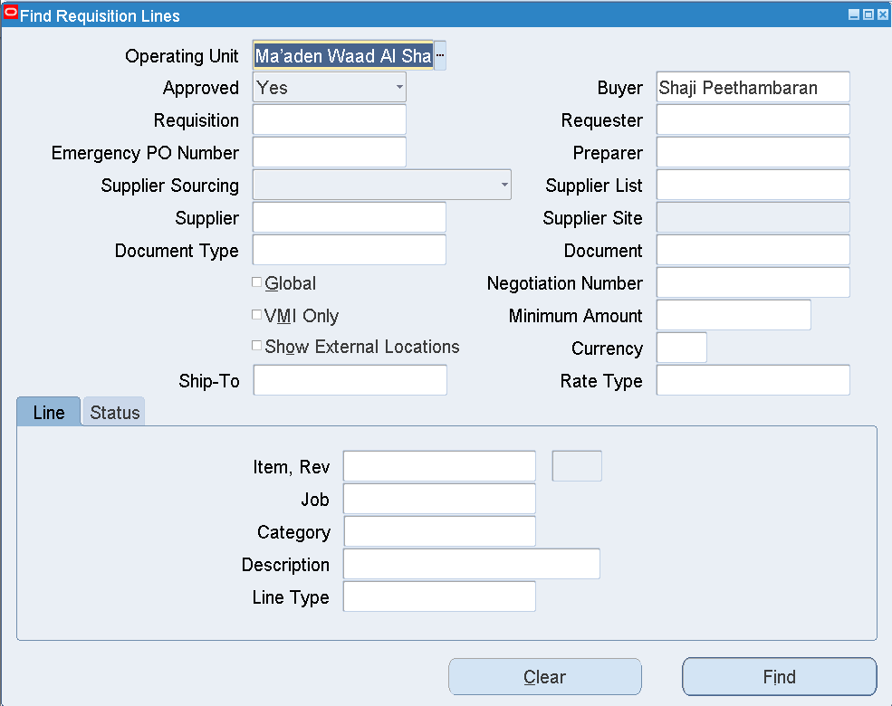

Clear Buyer

Enter Requisition number – (Approved PR re required) 711904993- 711804259

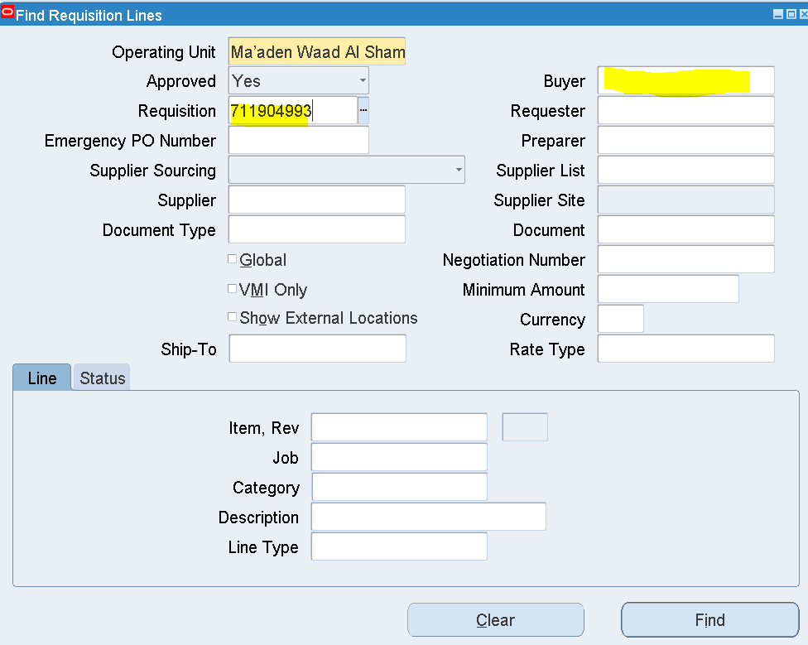

Find

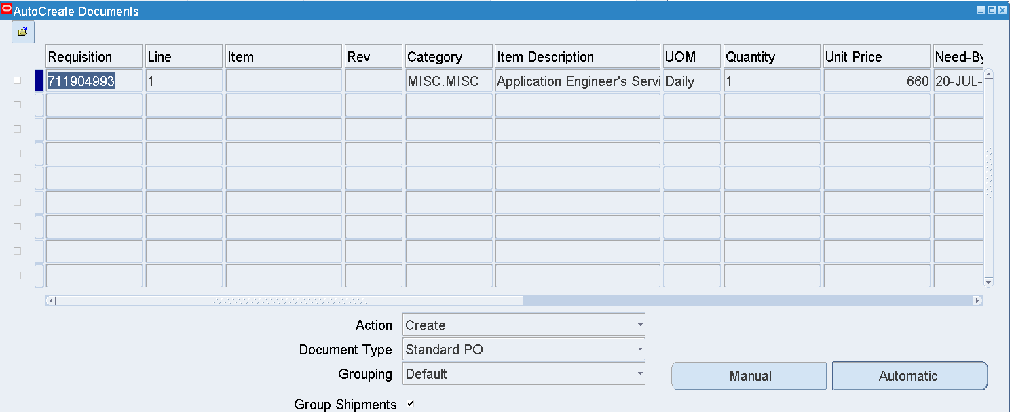

Select the Line as below

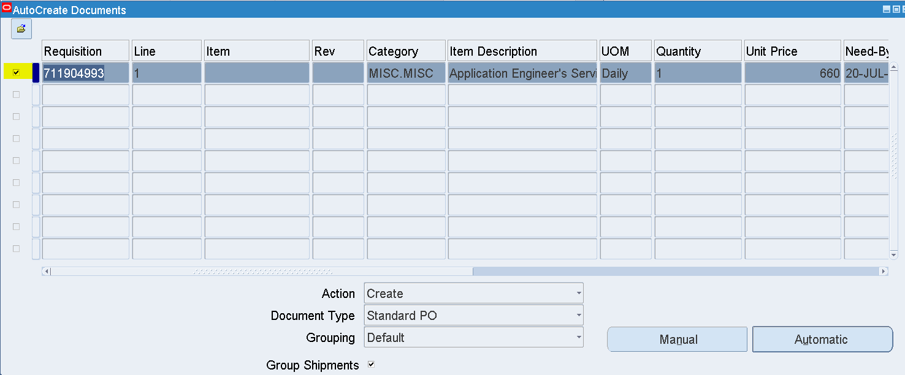

Change Document Type from Standard PO – Blanket Release

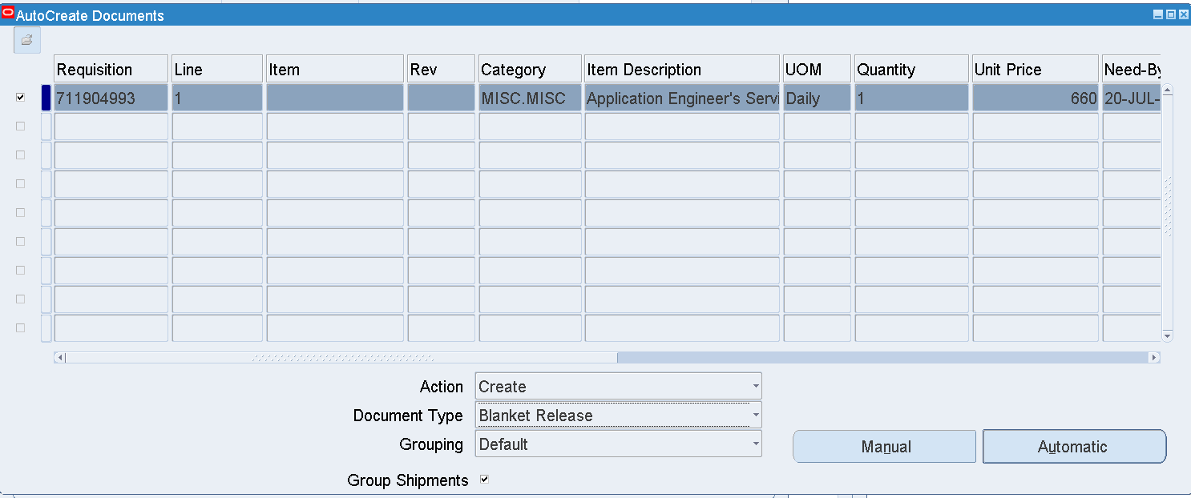

Click Manual

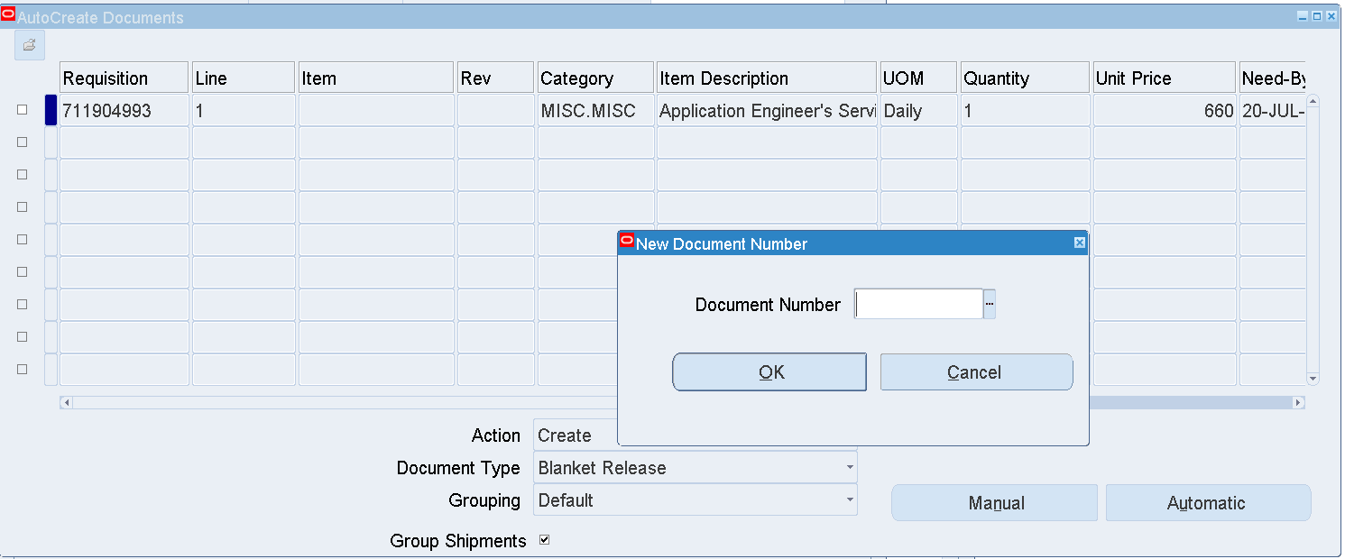

Enter BPA – 741700202 / 741600012

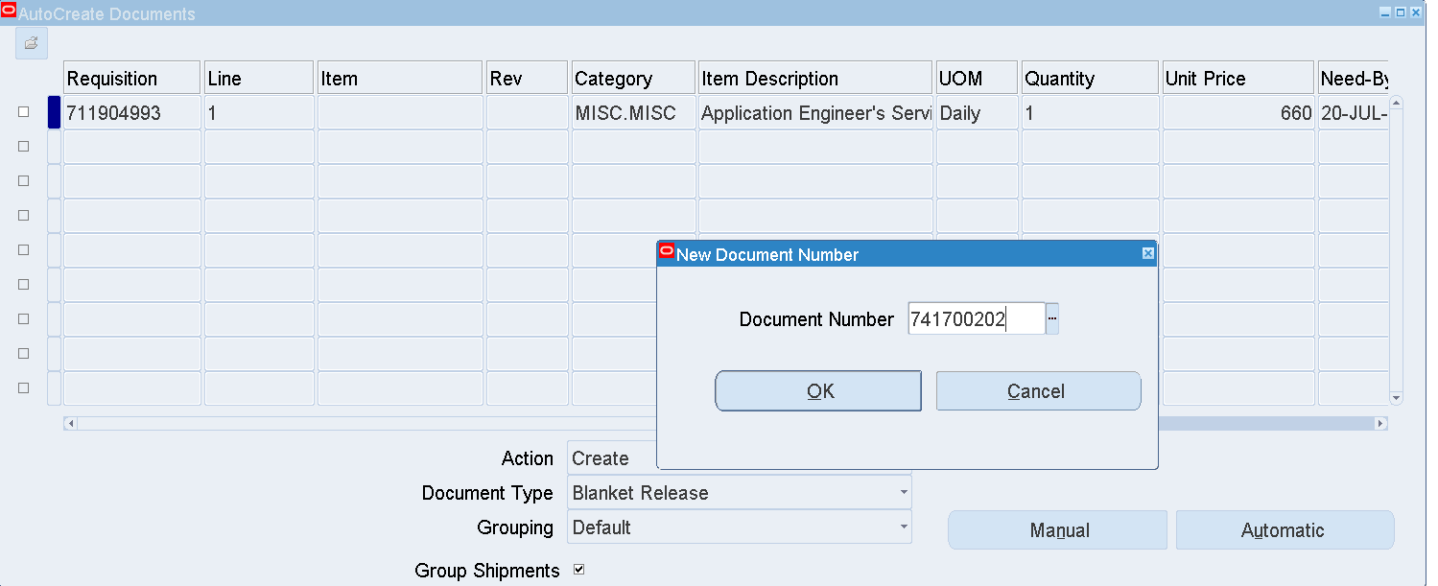

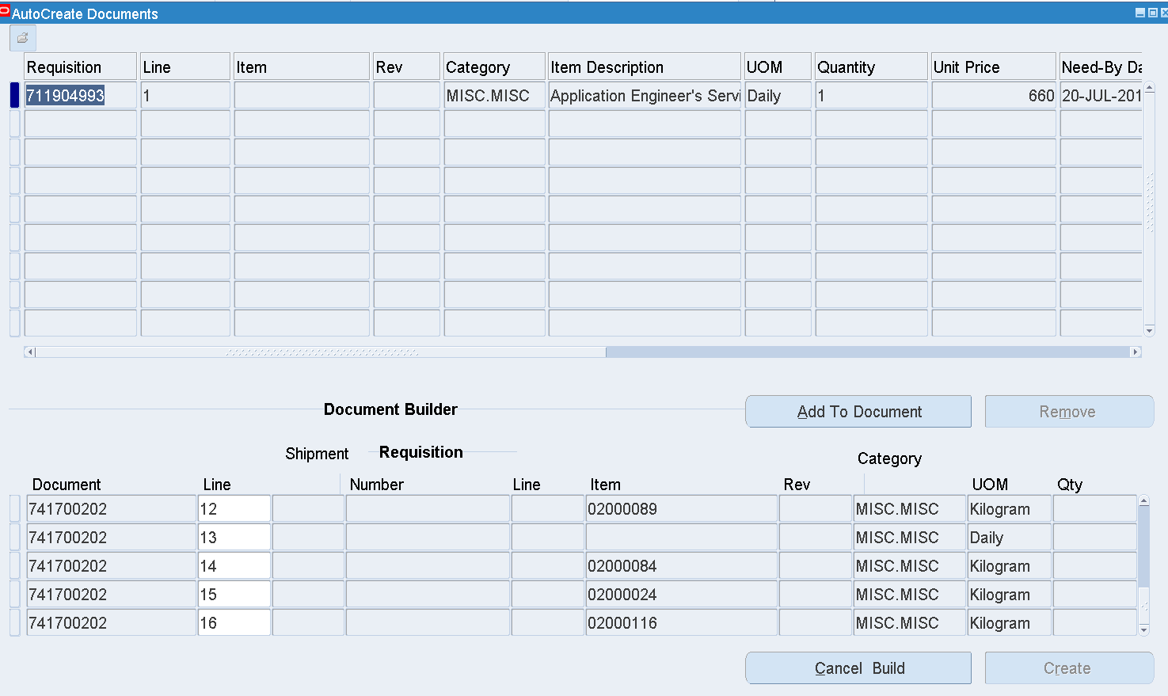

Select Line 13

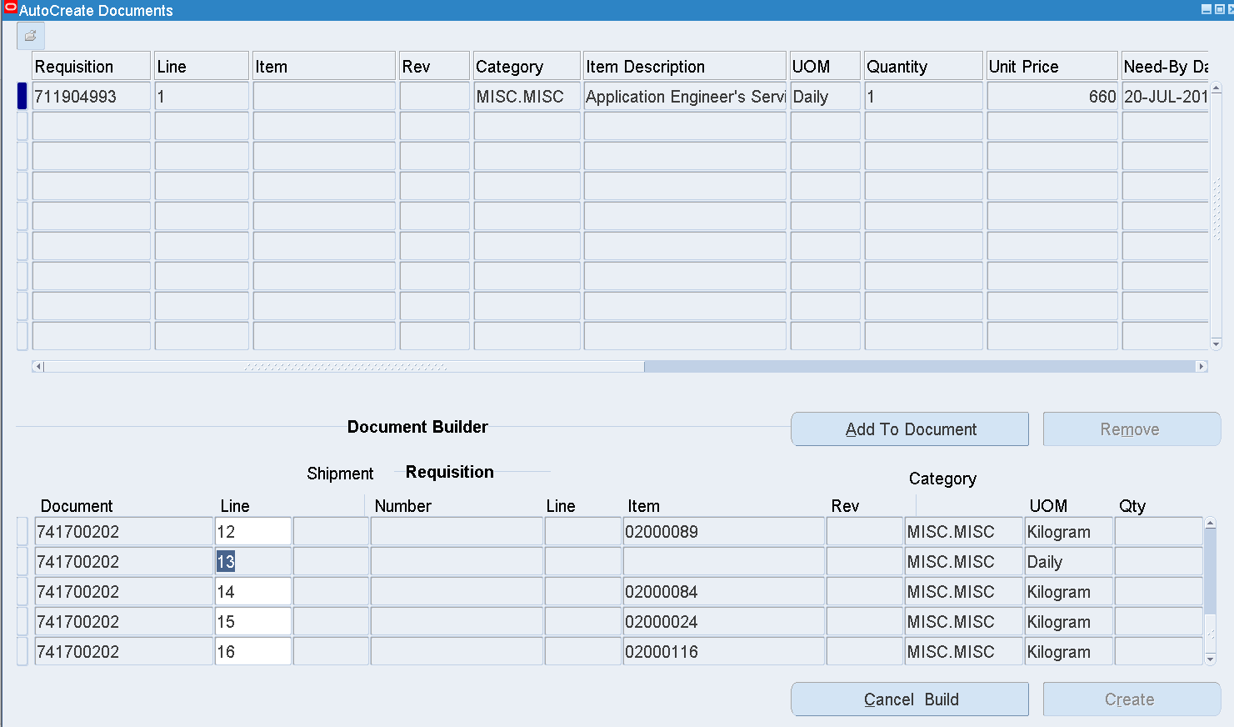

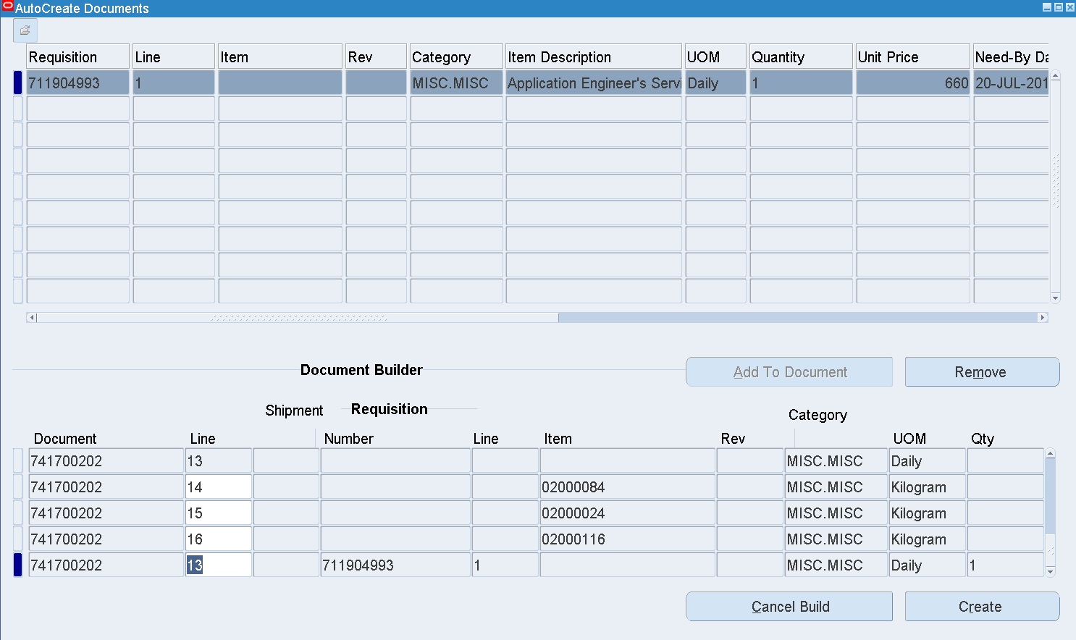

Click Create

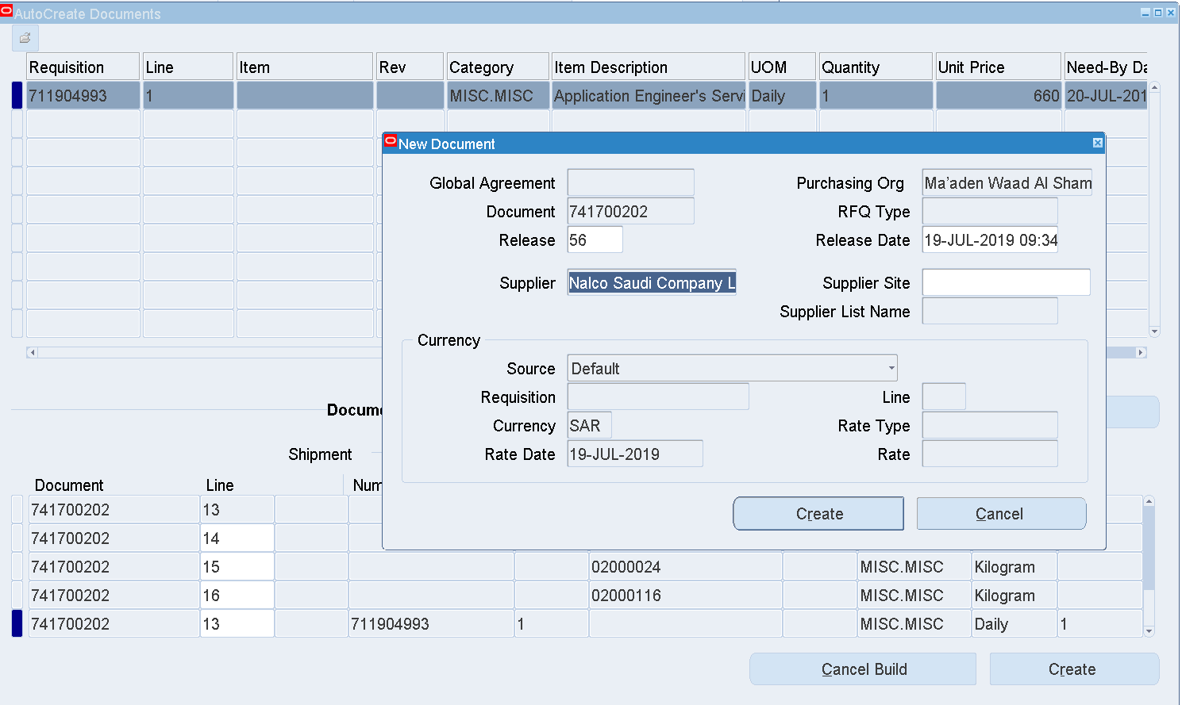

Create

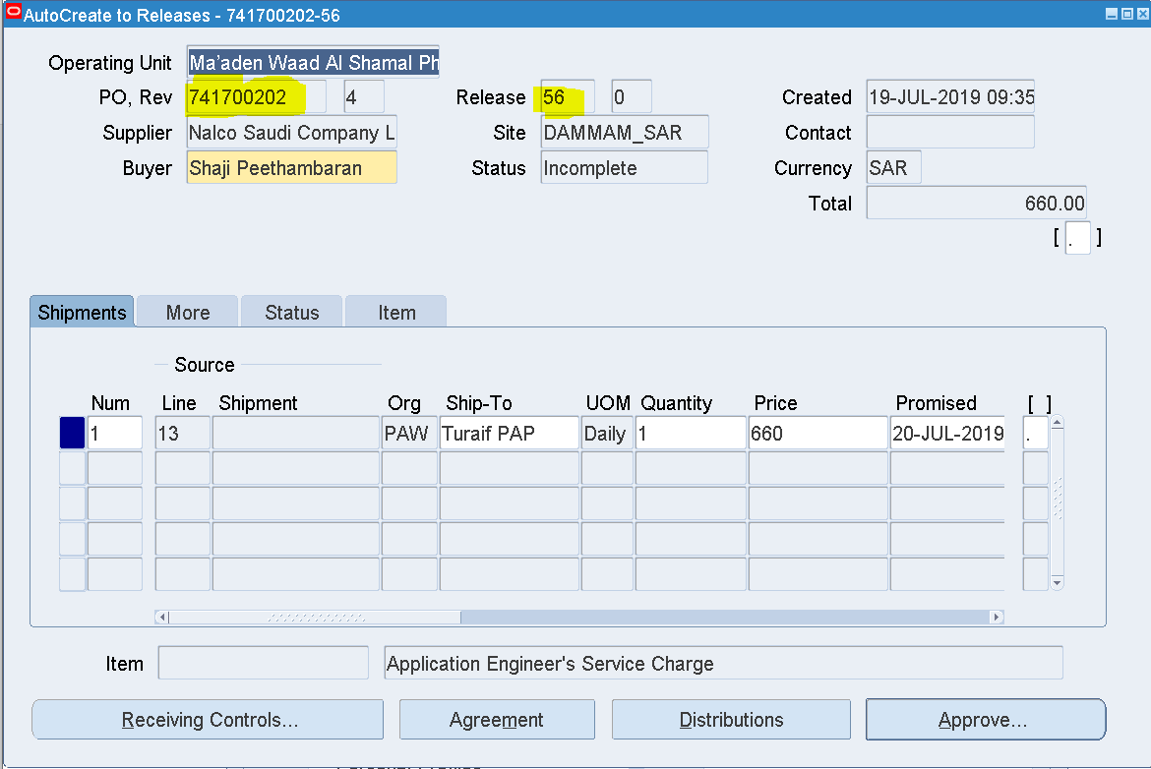

Blanket Release has been created

741700202 - 56

Click Approve

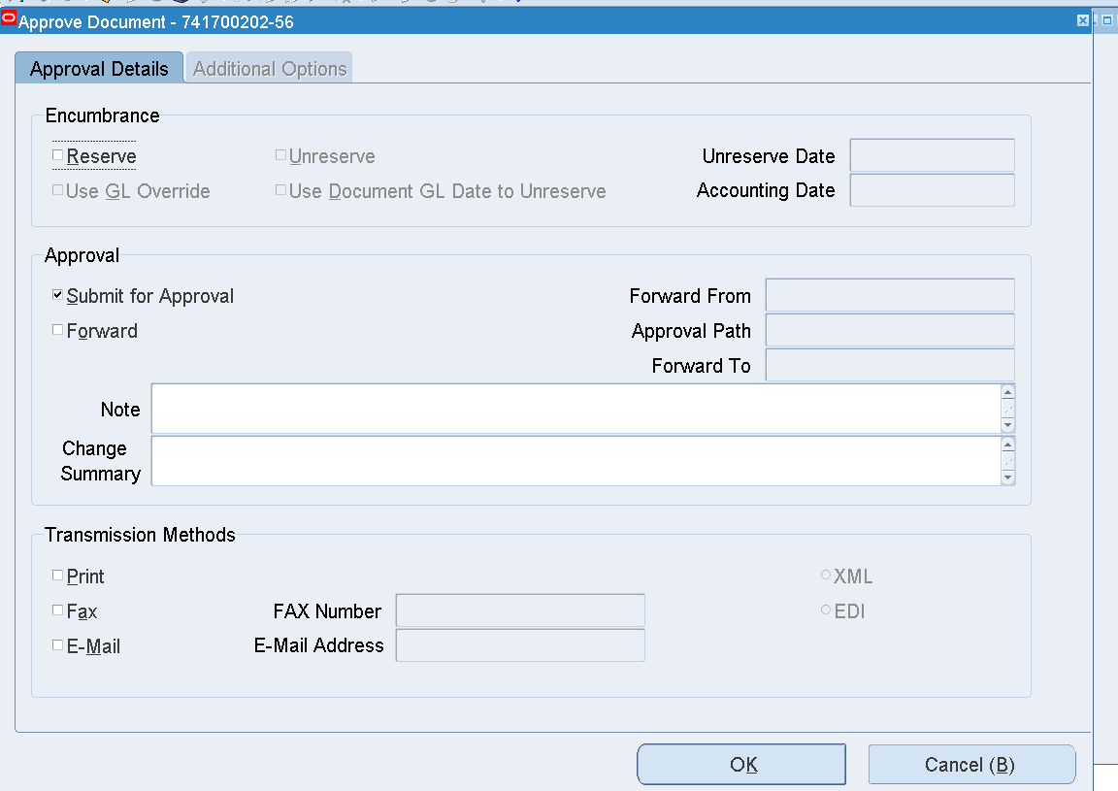

OK

Search the Purchase order Number

Purchase order 🡪 Purchase order Summary

Enter Purchase order number and Release number as below

Find

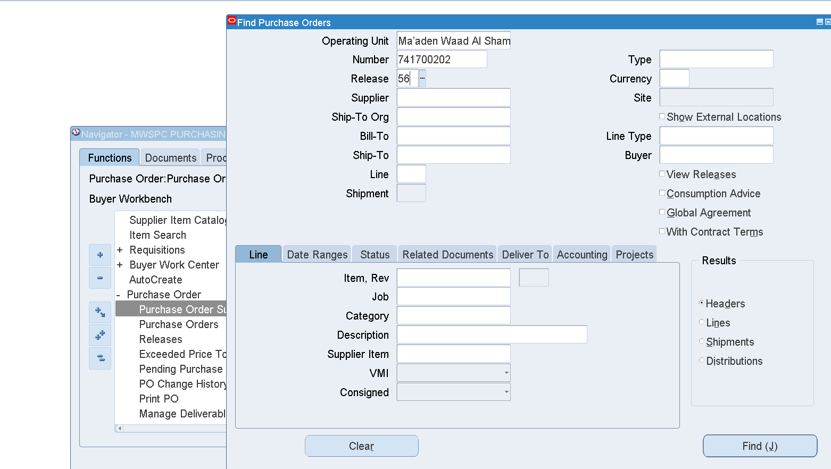

Inquire 🡪 Action History

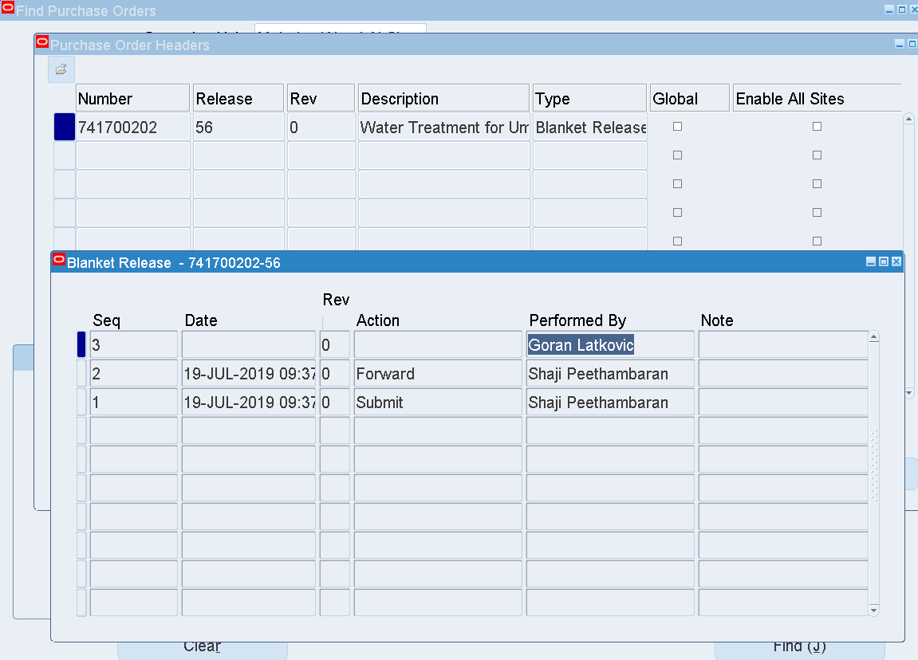

Login as Goran Latkovic to approve the Blanket Release

User – LATKOVICG

Select the Blanket Release worklist notification

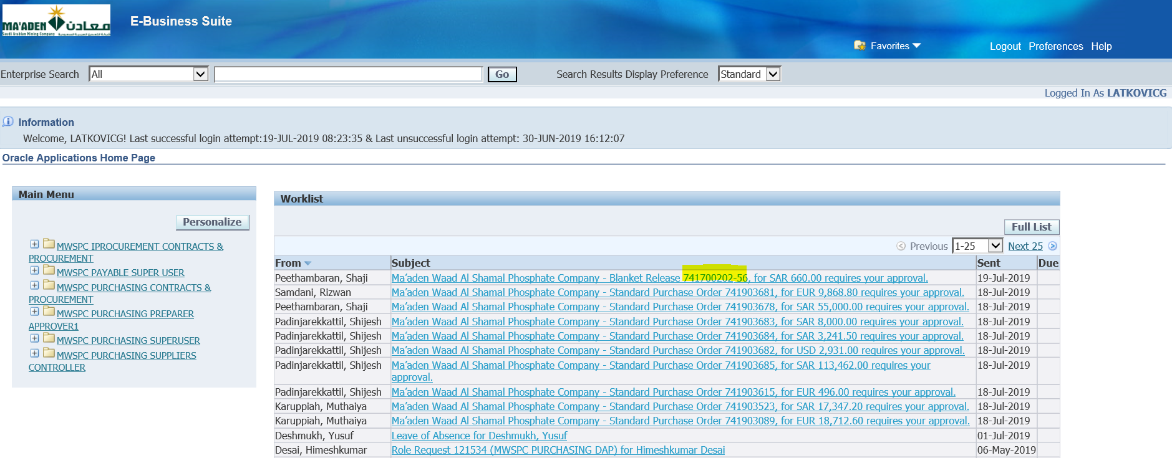

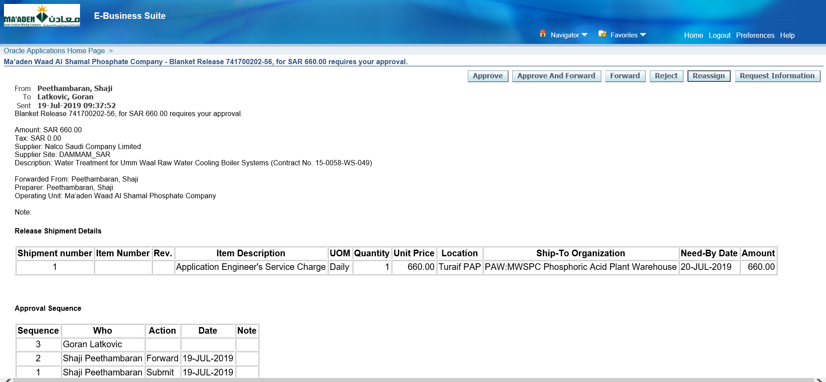

Approve

Check the Blanket Release Status

MWSPC Purchasing Super User 🡪 Purchase Order 🡪 Purchase order Summary

Enter the Blanket Release number as below

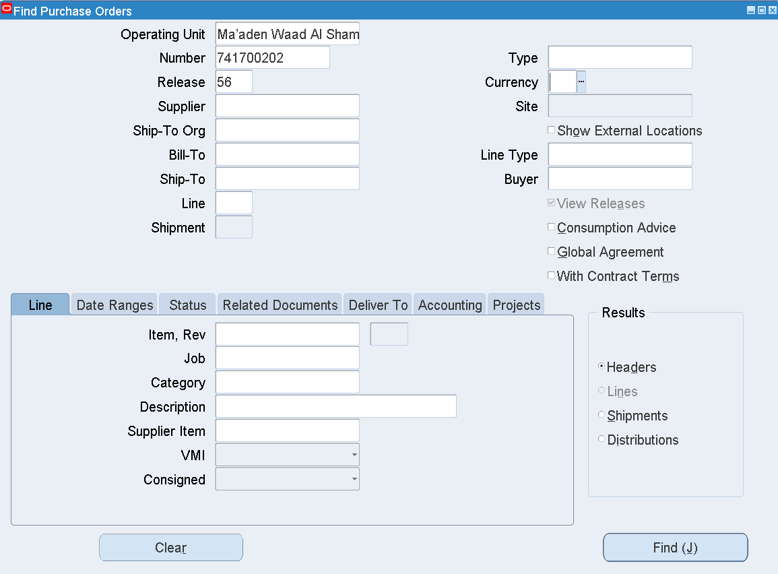

Find

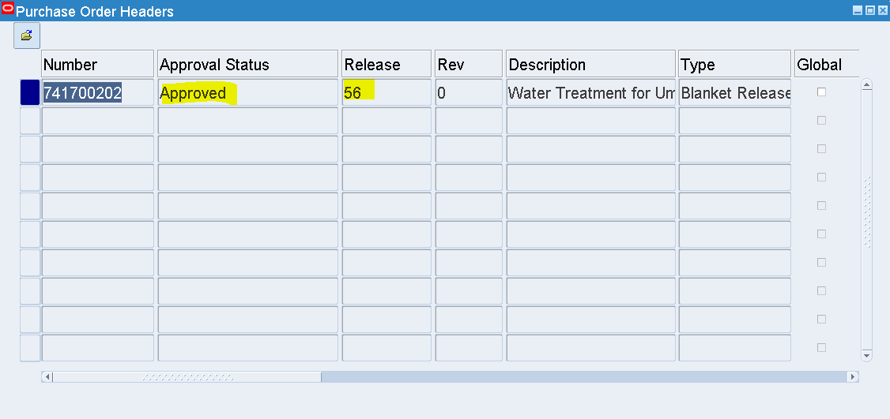

The Blanket Release has been Approved

1. Standard PO creation from PR 🡪 PO Approval

Login as FAREEDM

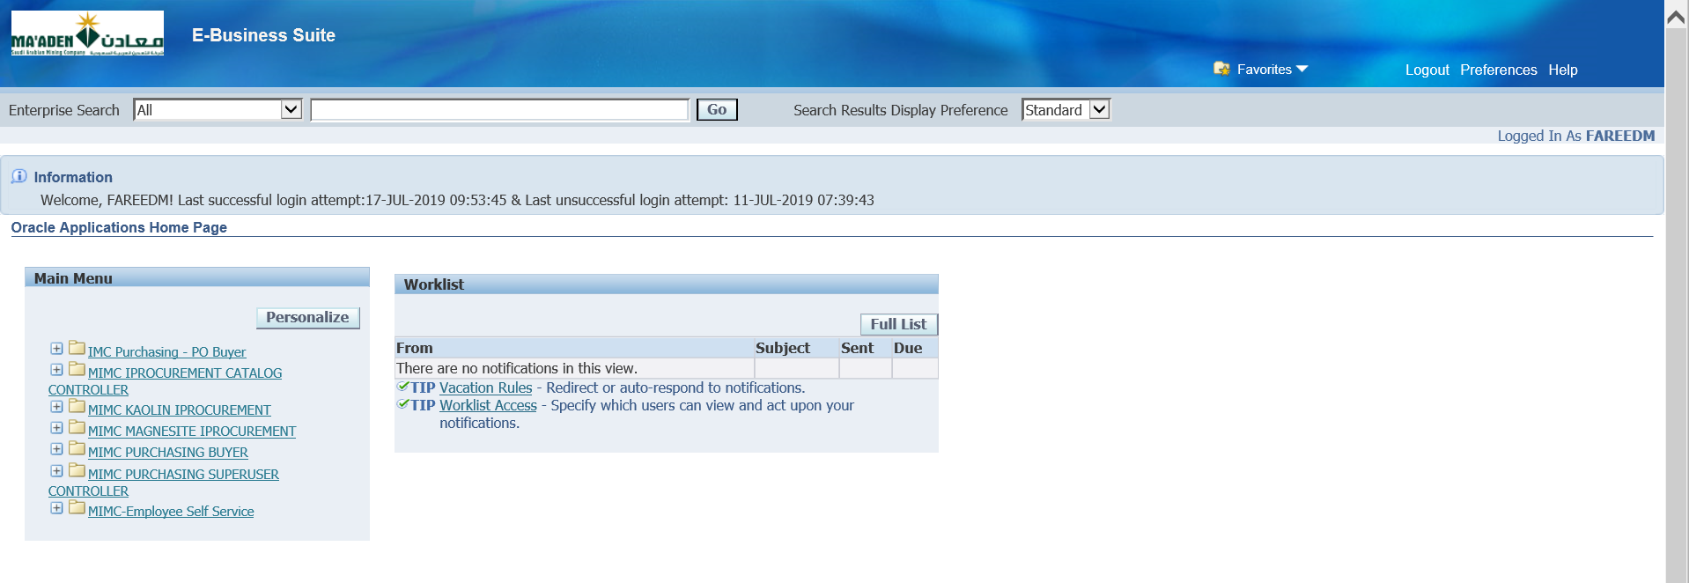

Responsibility 🡪 MIMC Purchasing Buyer🡪 Autocreate

Search for any available Requisitions / Select the Requisition which was created earlier

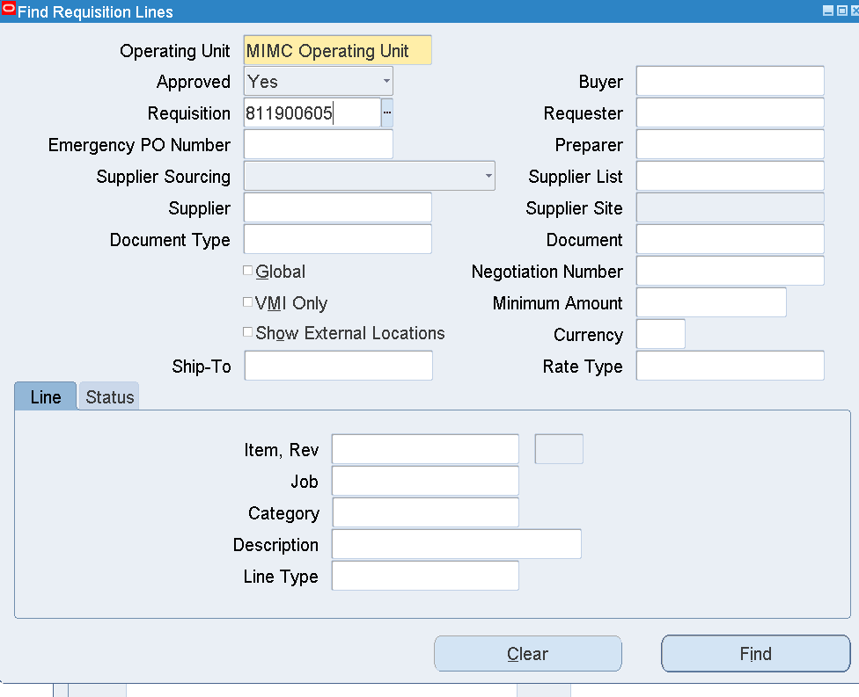

Clear Buyer Name

Enter Requisition number

Find

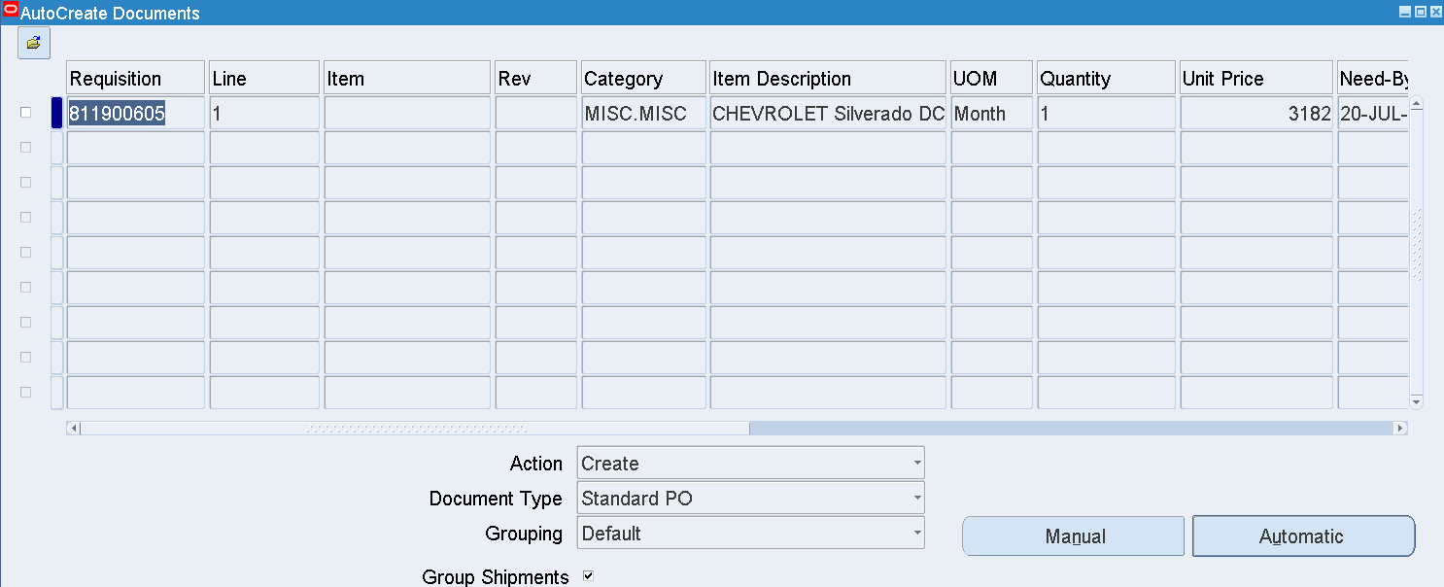

Select the Requisition Line 🡪 Automatic

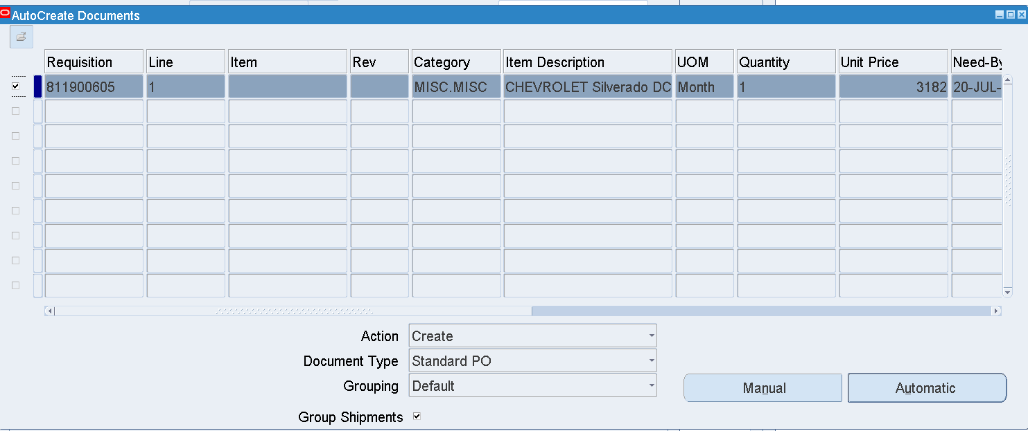

Automatic

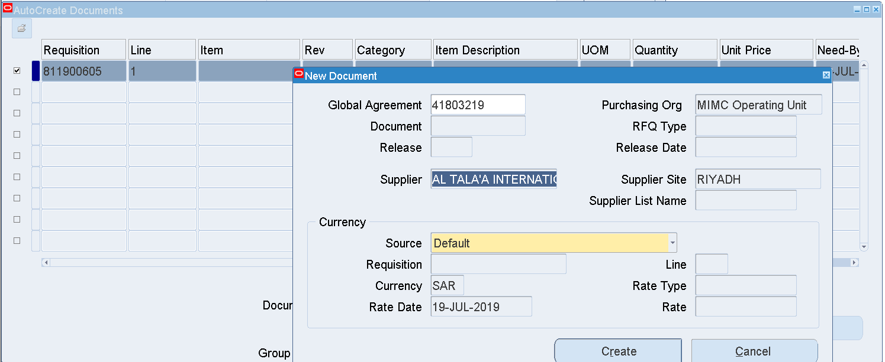

Supplier name- AL TALA'A INTERNATIONAL TRANSPORTATION CO LTD. Hanco

Site-ALKHOBAR

711905497-> 741904484

Create

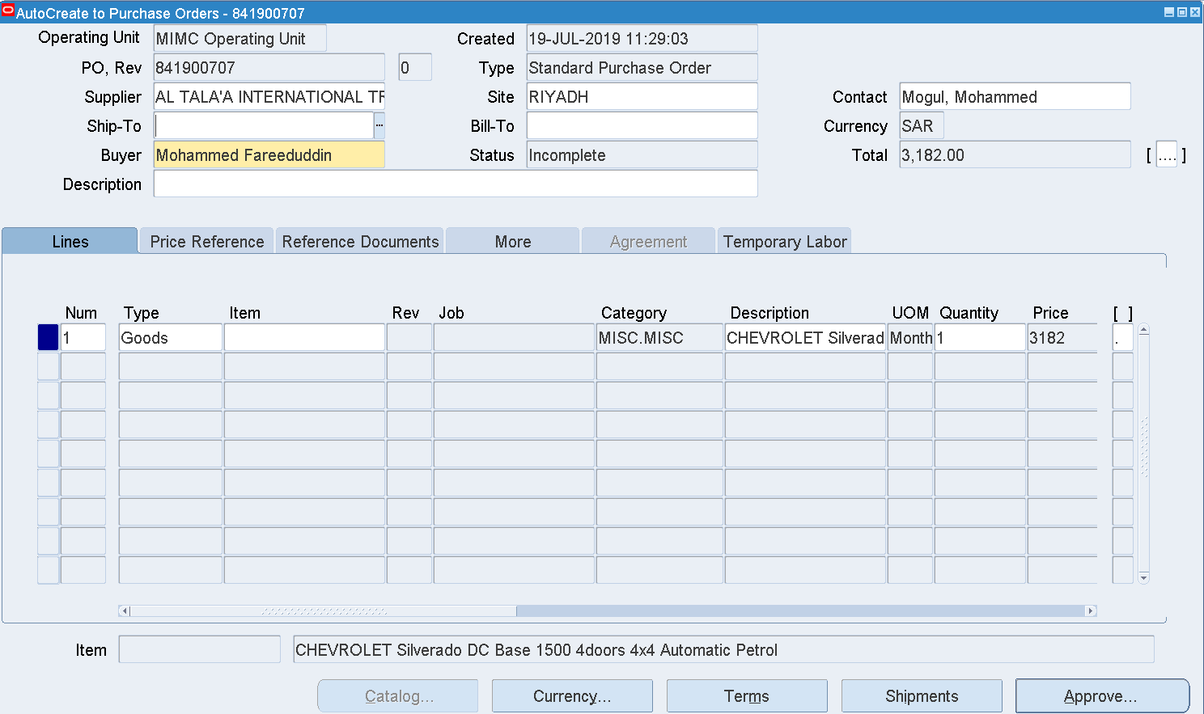

PO-841900707

Terms

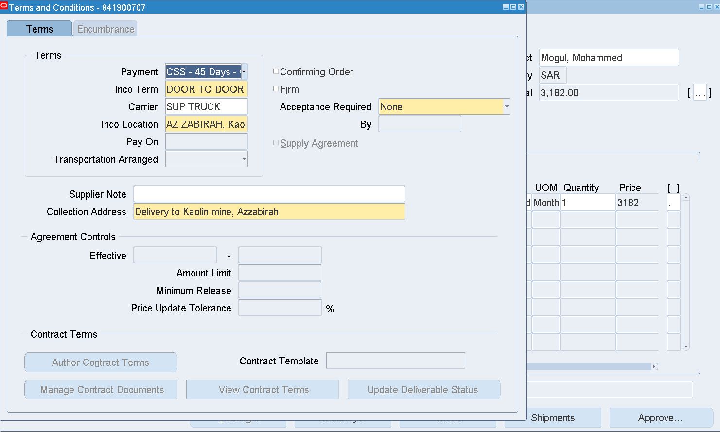

|  |  |
| --- | --- |
| Inco Term | DOOR TO DOOR |
| Carrier | SUP TRUCK |
| Inco Location | AZ ZABIRAH, Kaolin Project |
| Collection Address | Delivery to Kaolin mine, Azzabirah |

Enter Ship to and Bill to as below

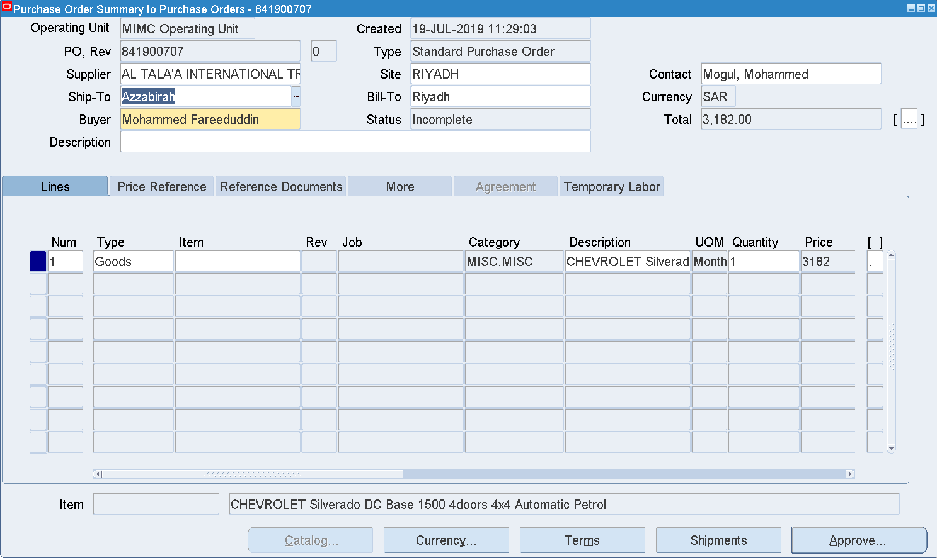

Header DFF

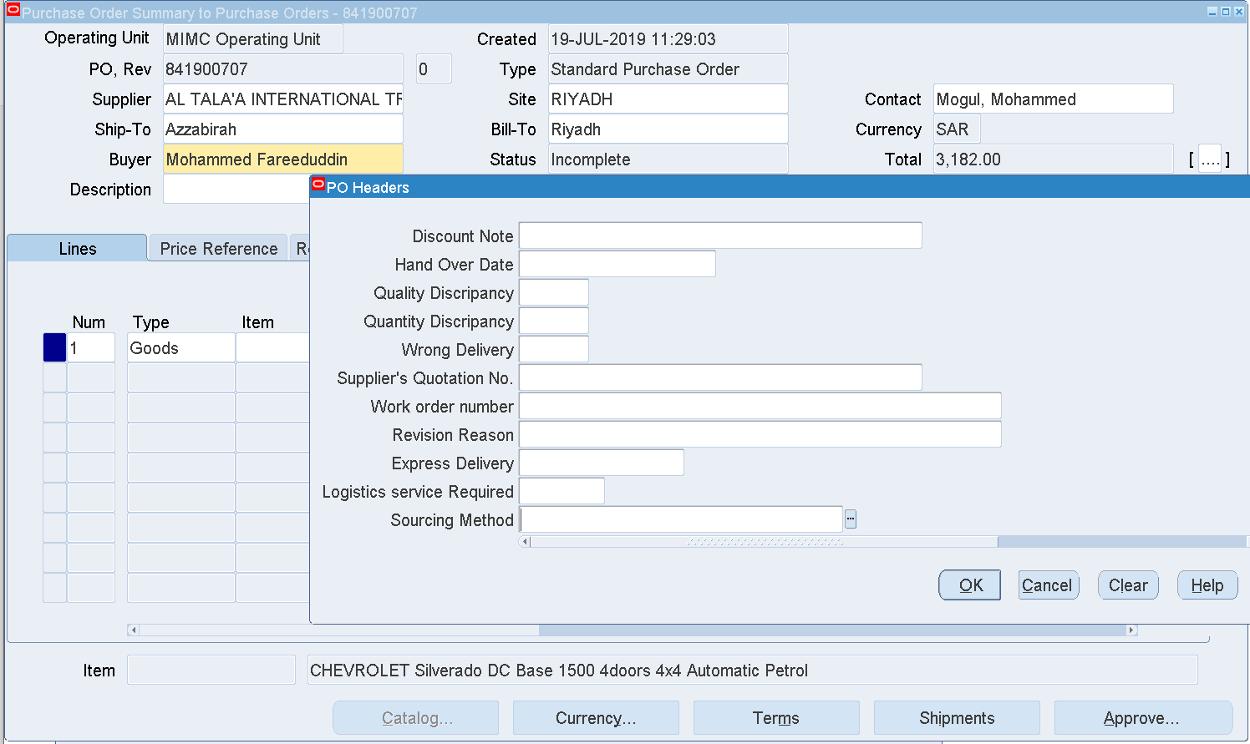

Sourcing Method

Enter – Single Source

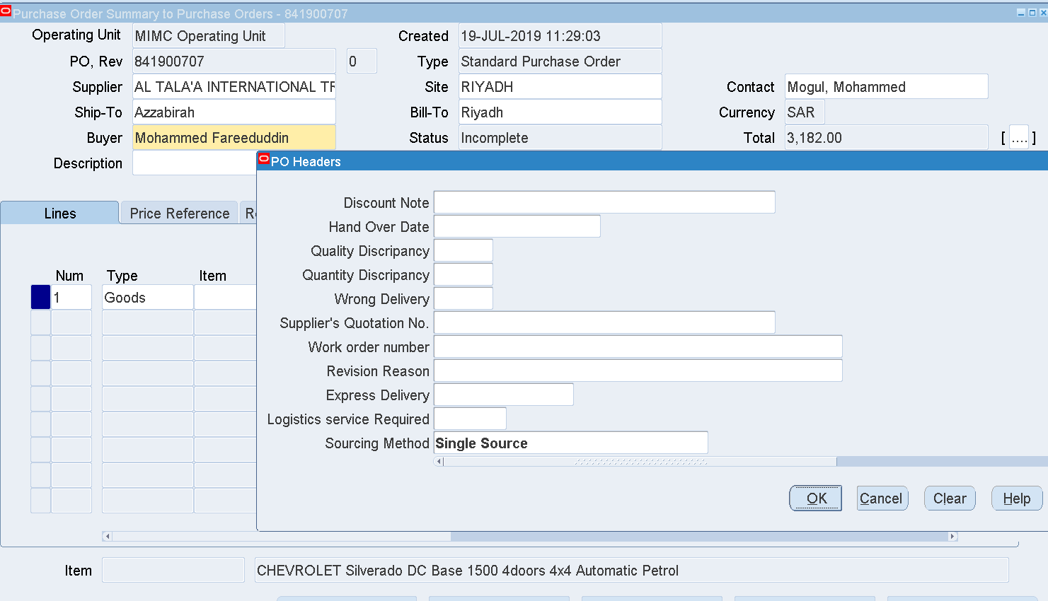

OK

Approve

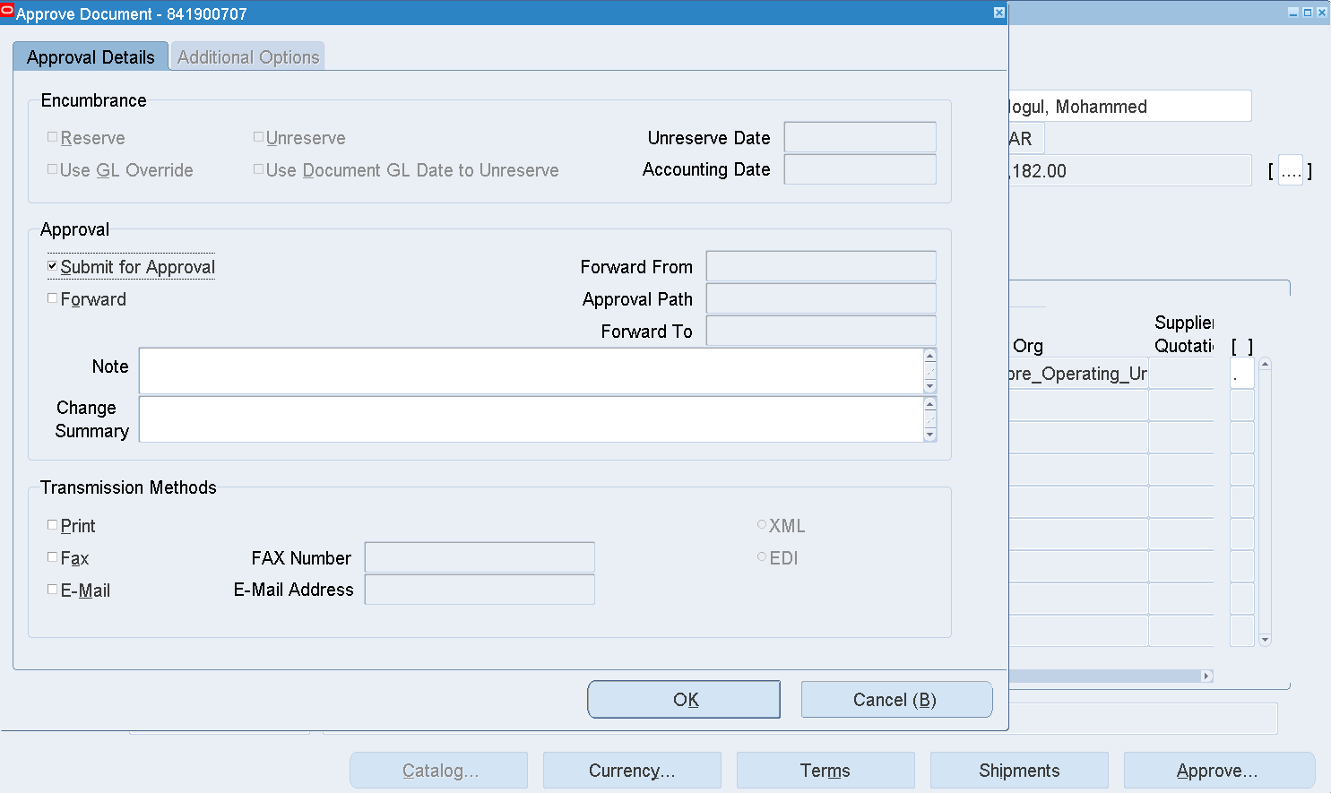

OK

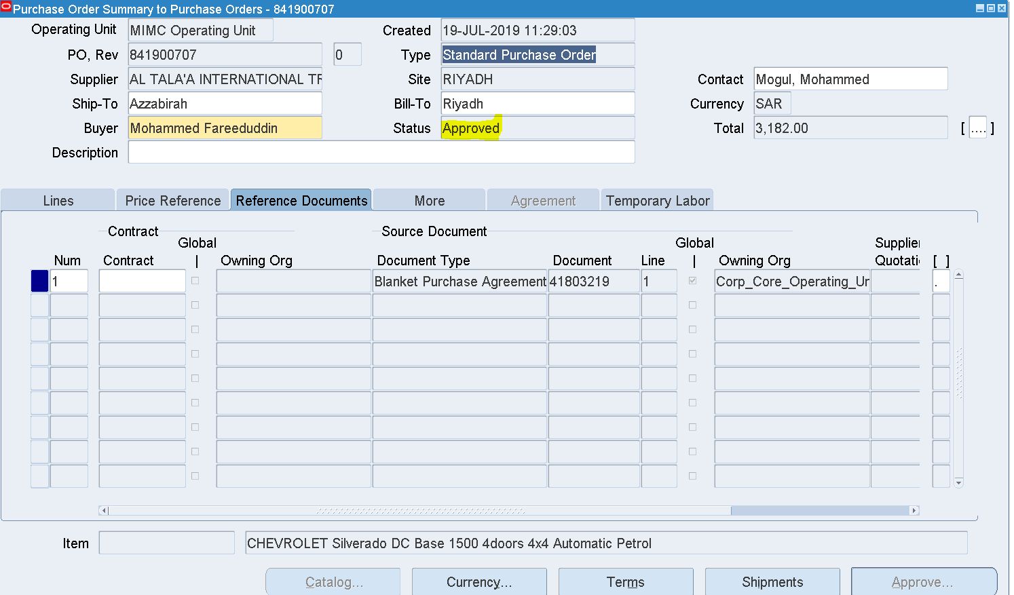

The PO 841900707 has been Approved

1. Receipt creation

Receipts 🡪Receipts

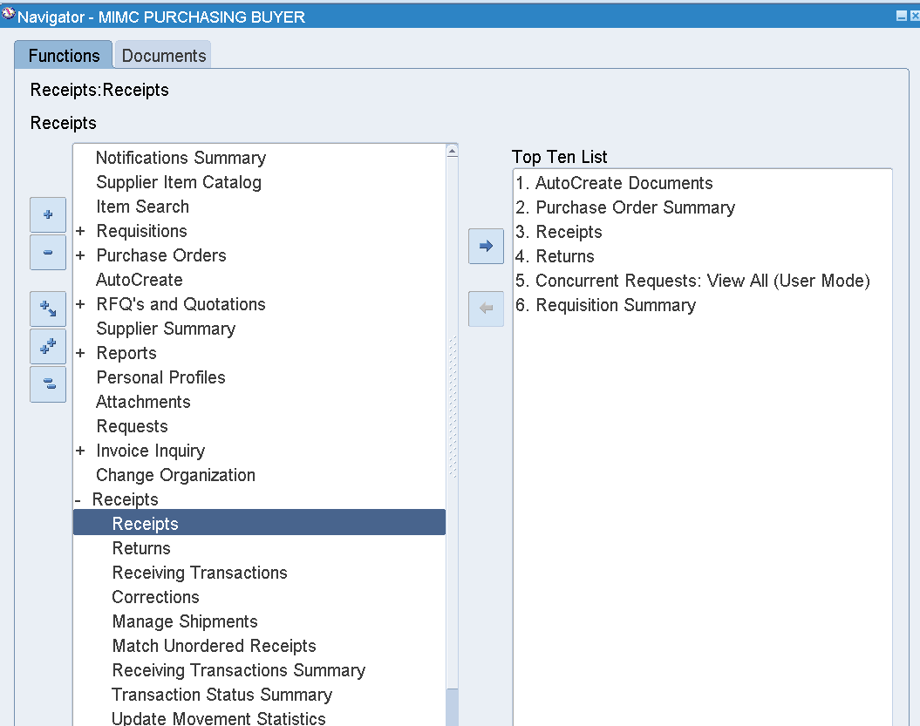

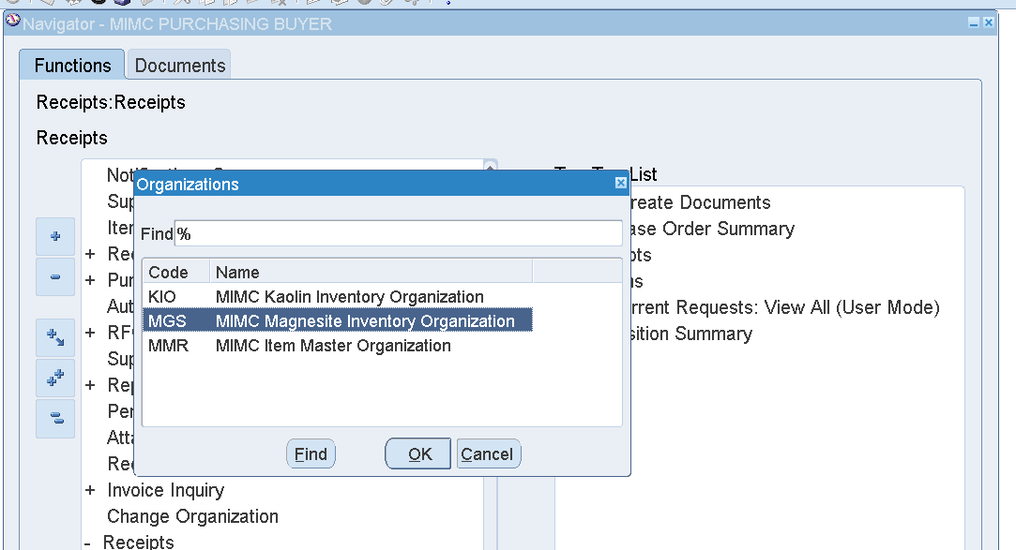

Select the Org – MGS

OK

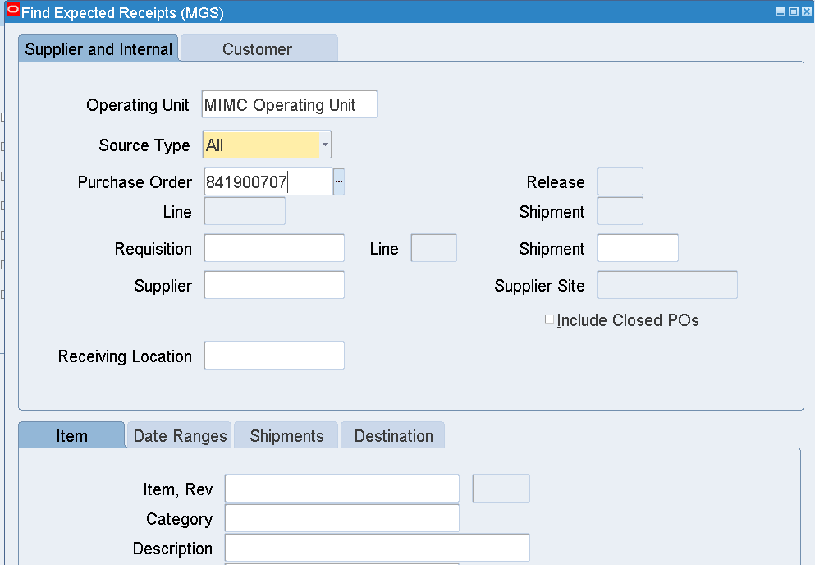

Enter Purchase Order Number

Find

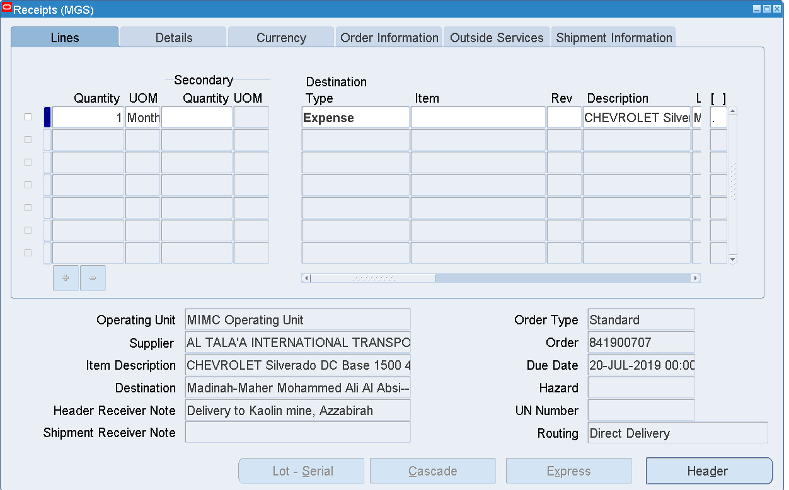

Select the Line

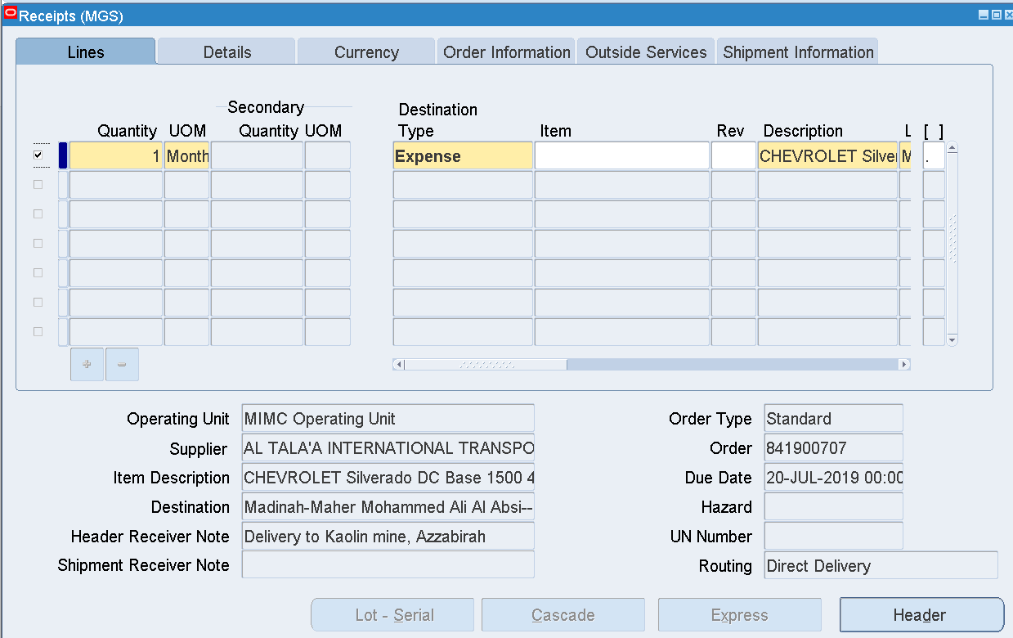

Save

Click the Header

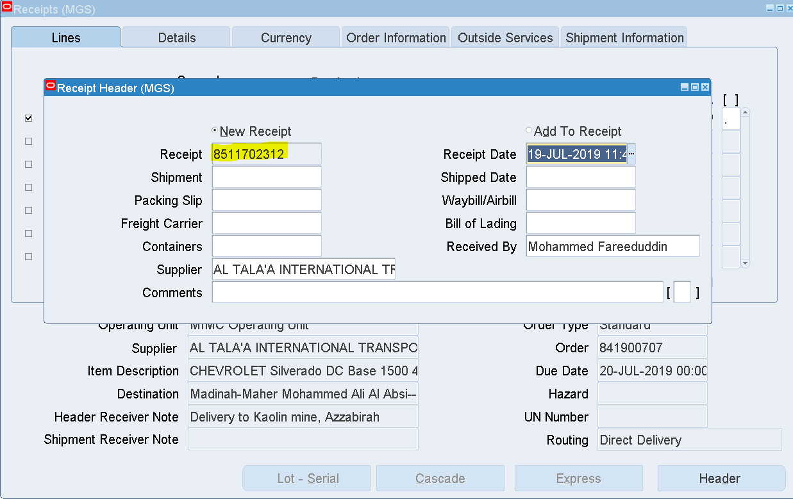

Receipt 8511702312 has been generated

1. Invoice creation

Search for the PO which was created earlier or select any available POs

Create an Invoice

Login as [Helen.RHODES@3ds.com](mailto:Helen.RHODES@3ds.com)

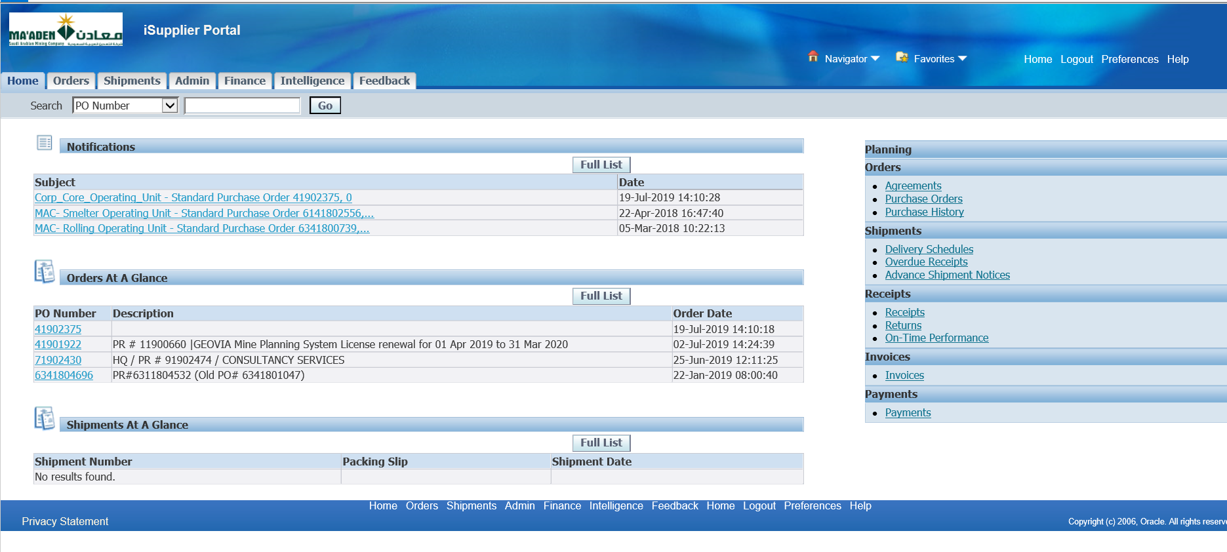

Finance tab

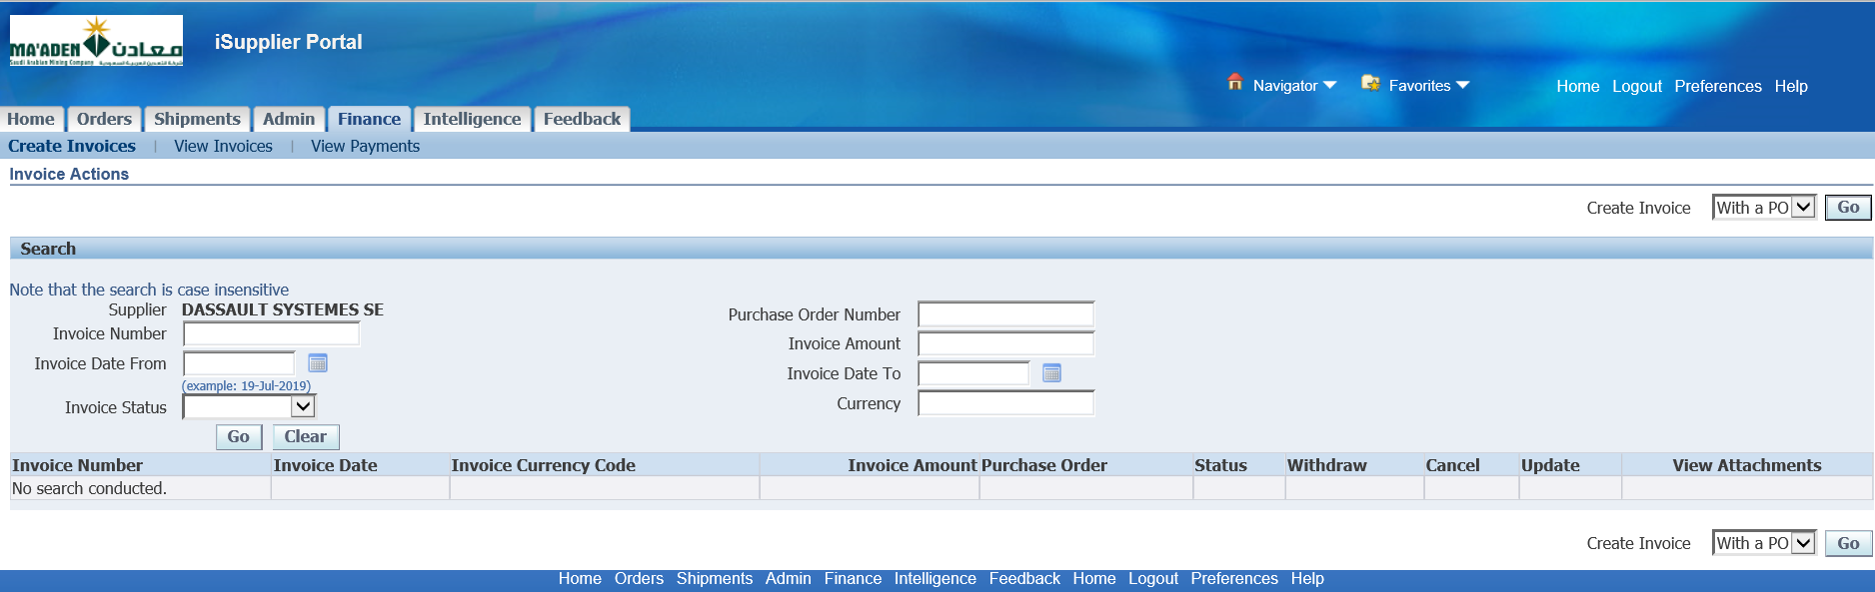

Create Invoice with a PO

Go

PO – 41902375

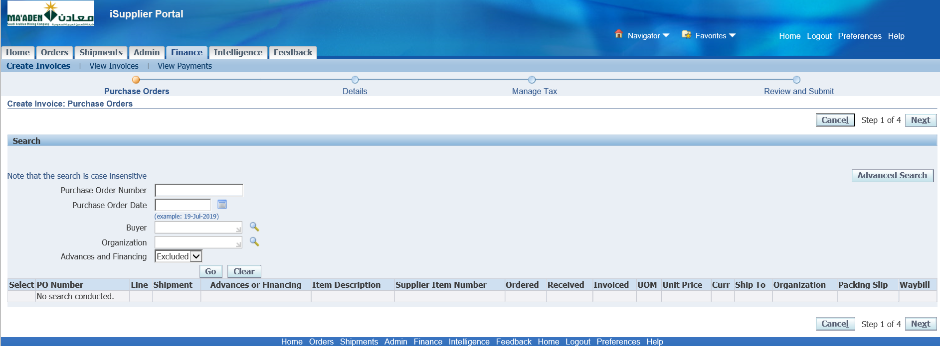

Enter PO number and Click Go

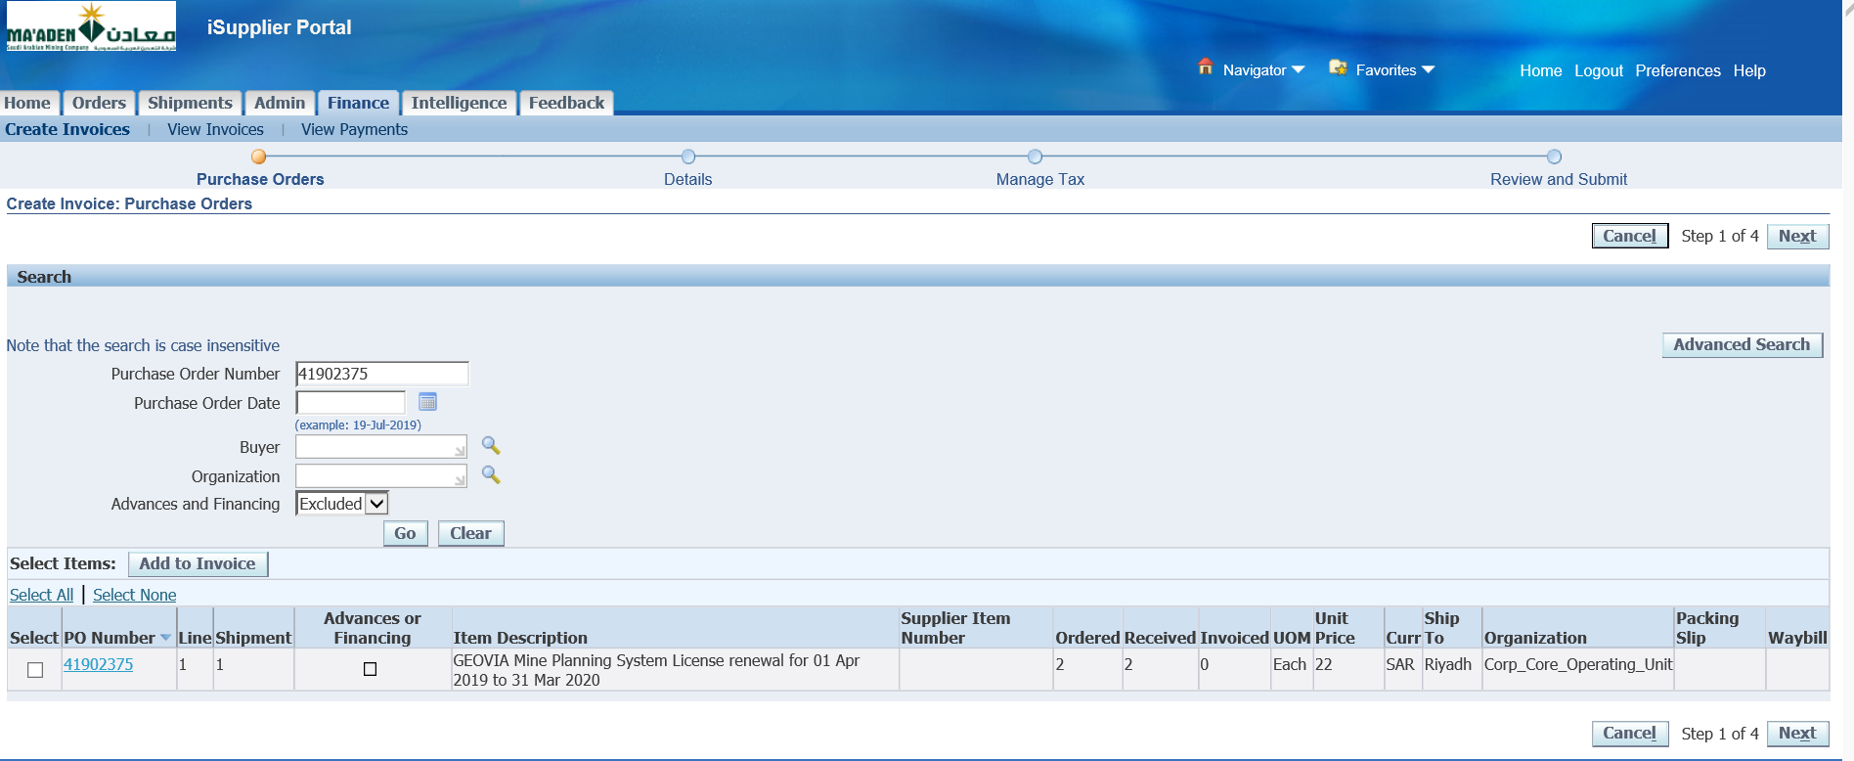

Select the Line 🡪 Add to Invoice

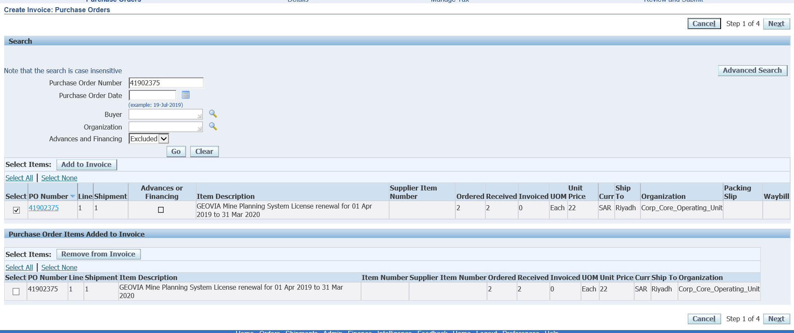

Click Next

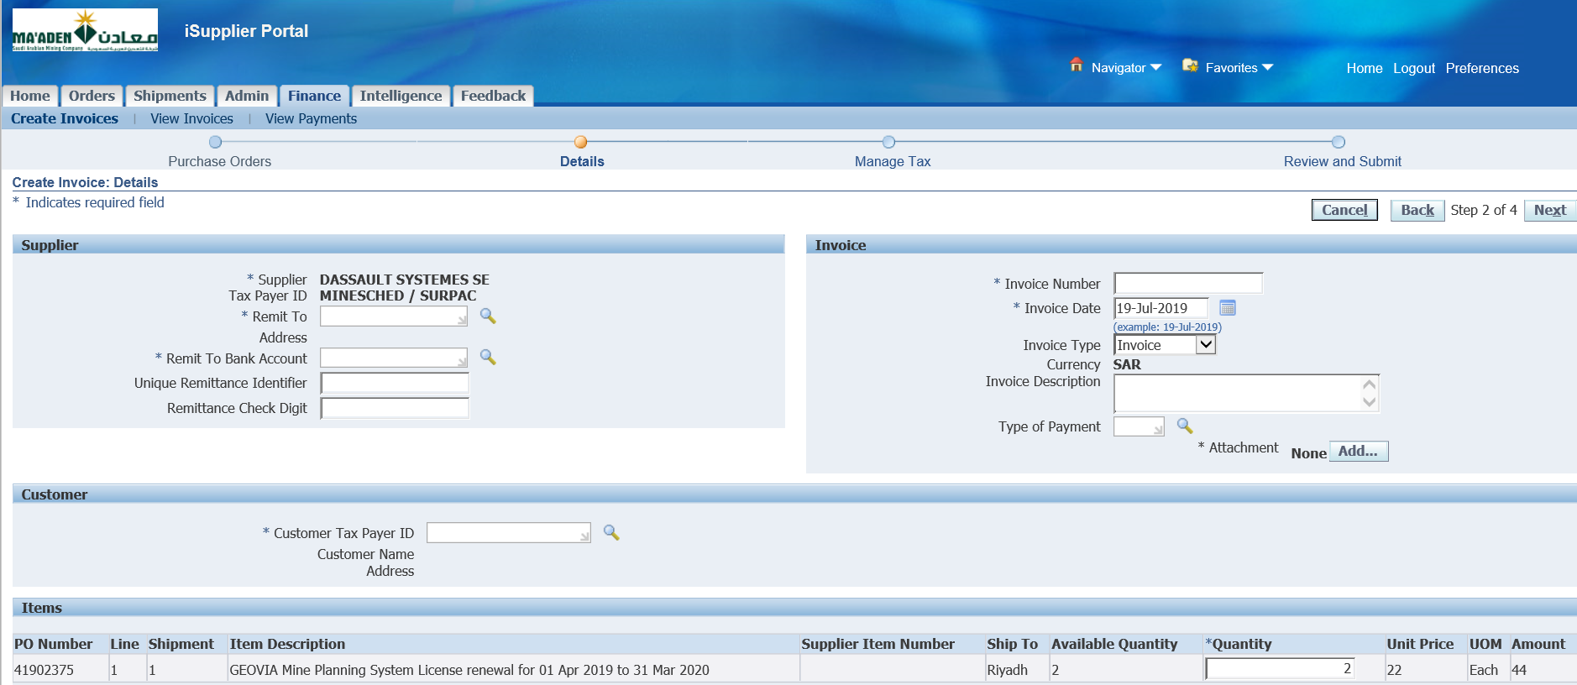

Search for Remit to

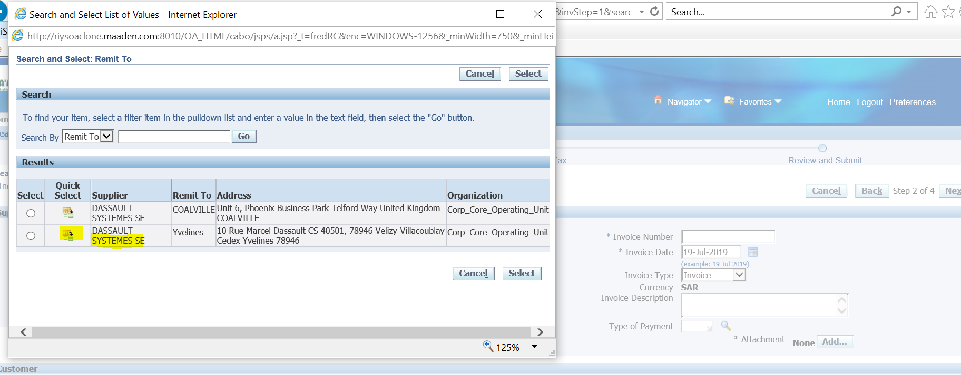

Select the Remit to Supplier

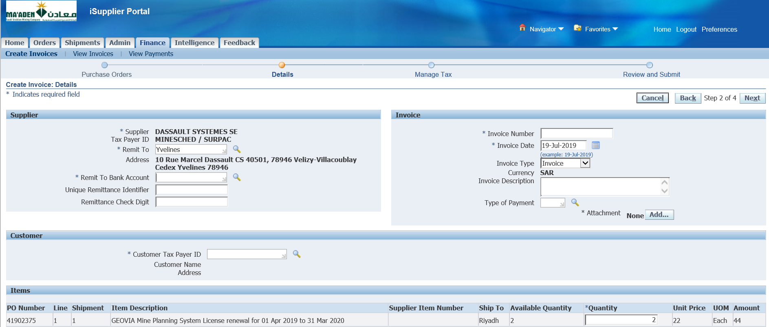

Select Remit to Bank Account

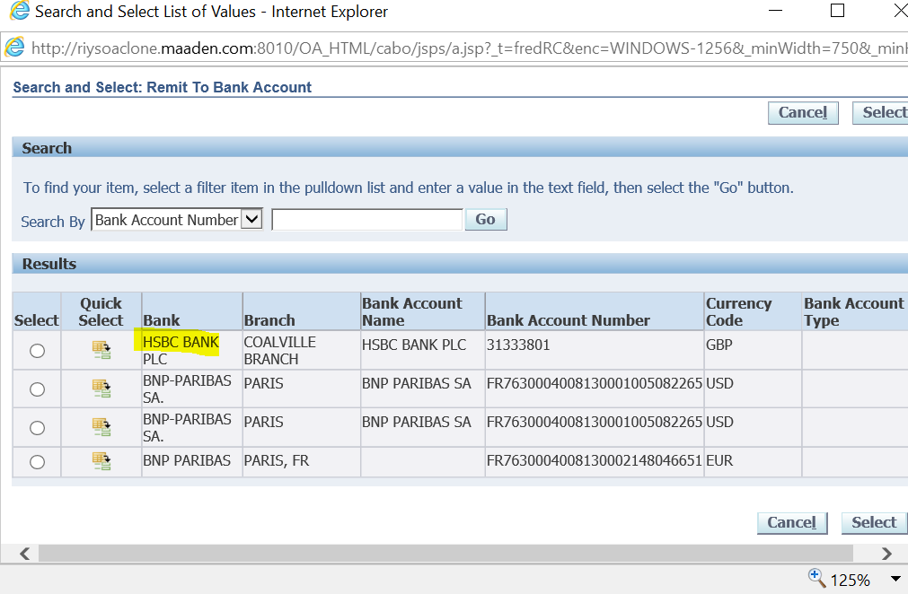

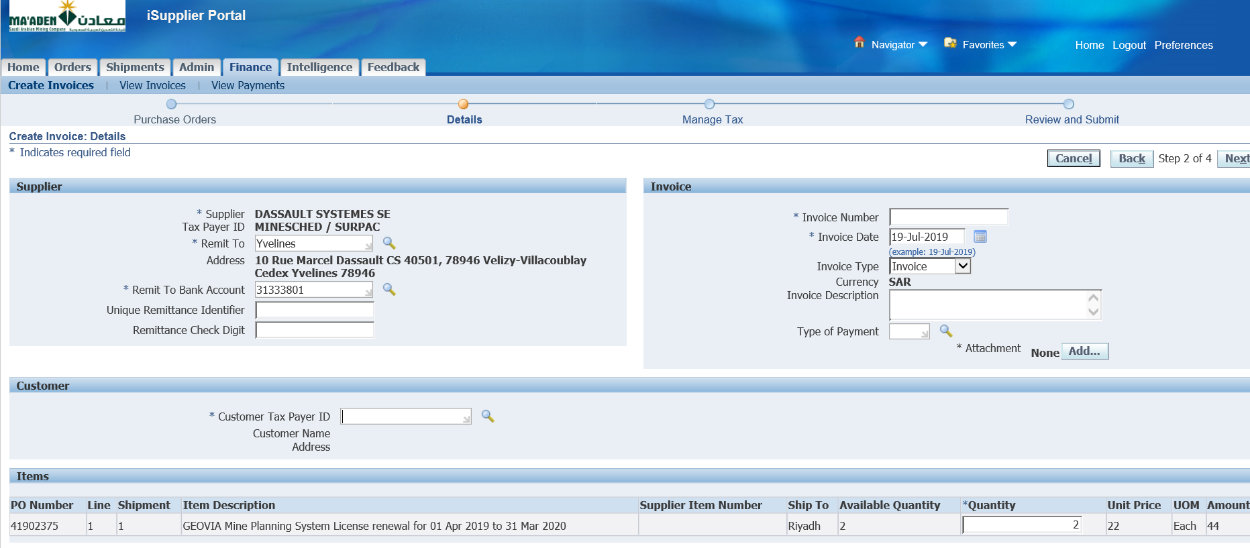

Select Customer Tax Payer ID

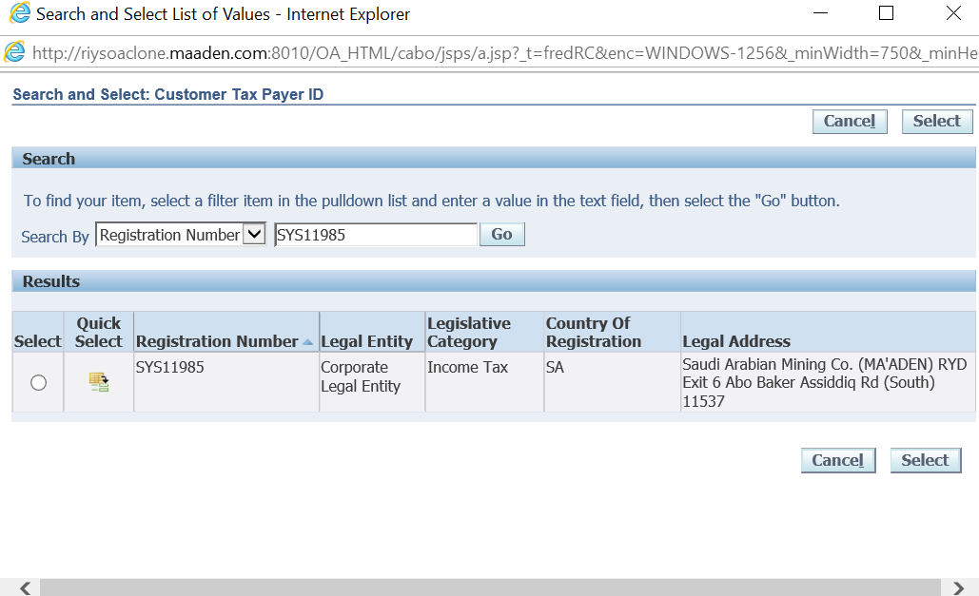

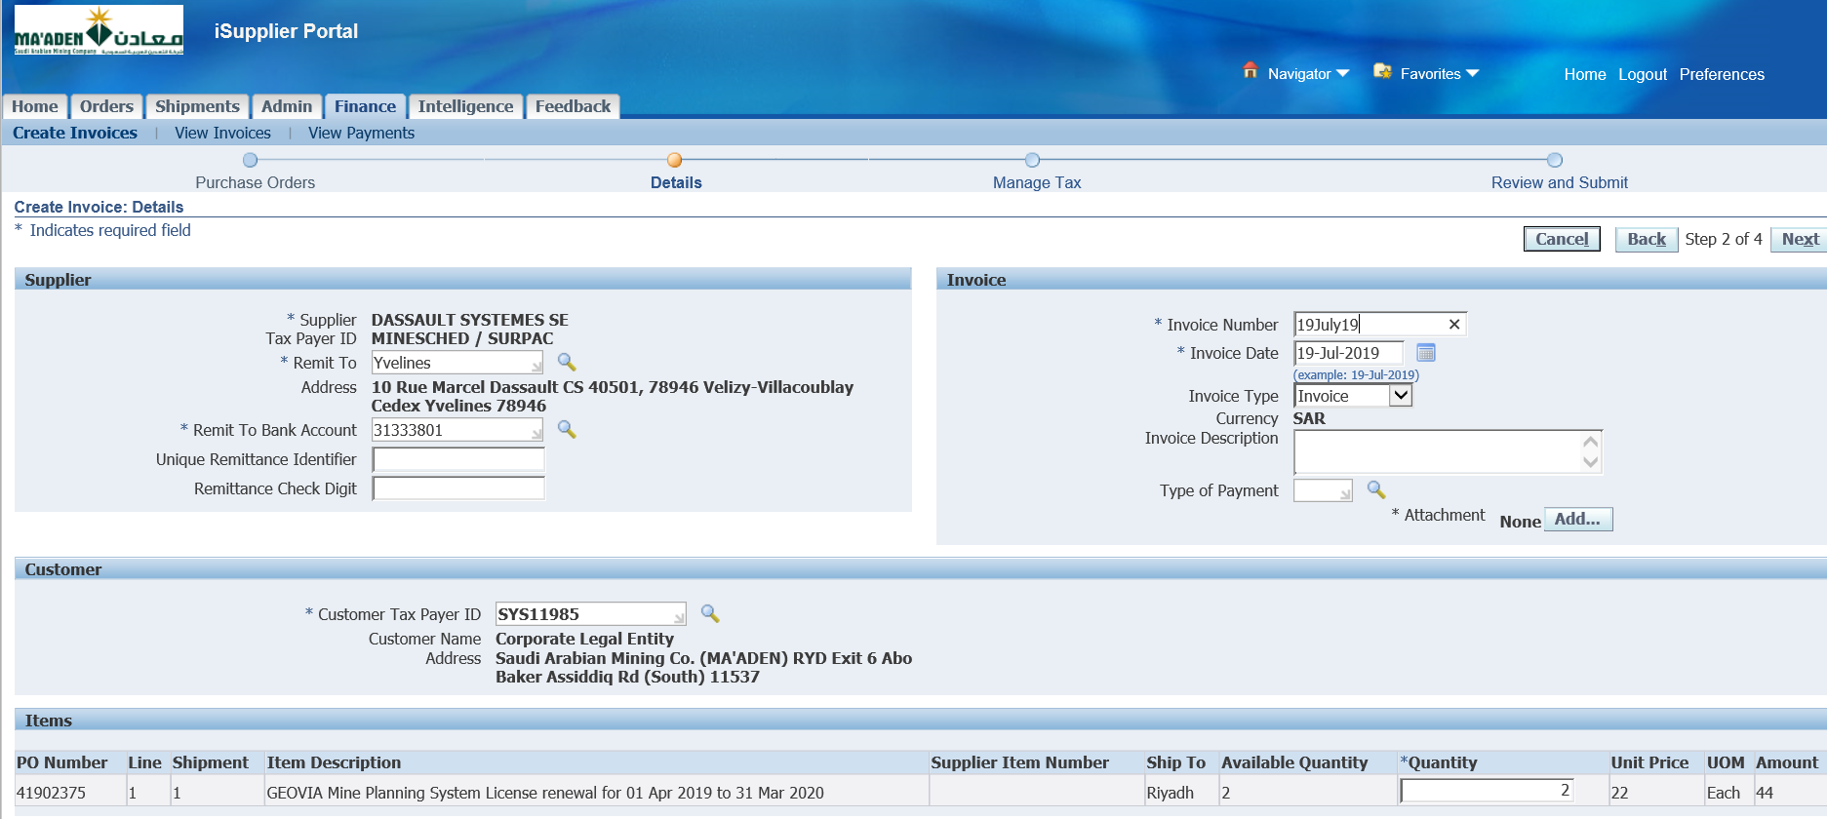

Manually Enter Invoice Num as above or even PO num

Add Attachment

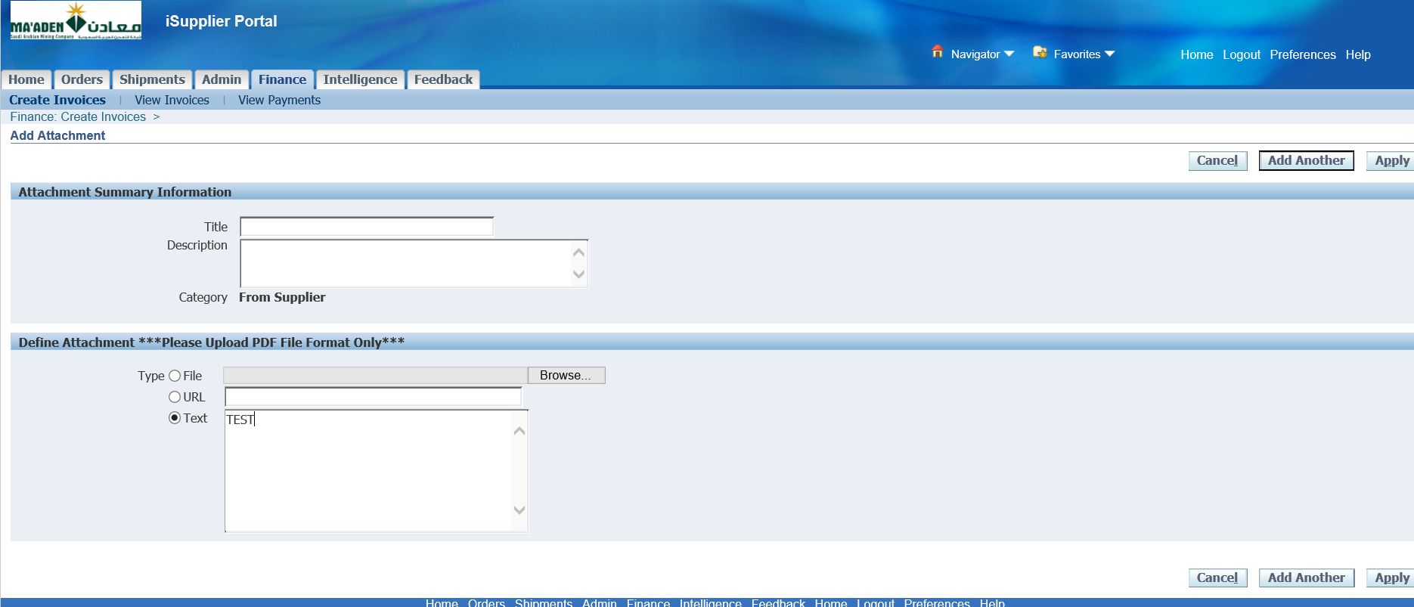

Select Text 🡪 Enter Some Text

Apply

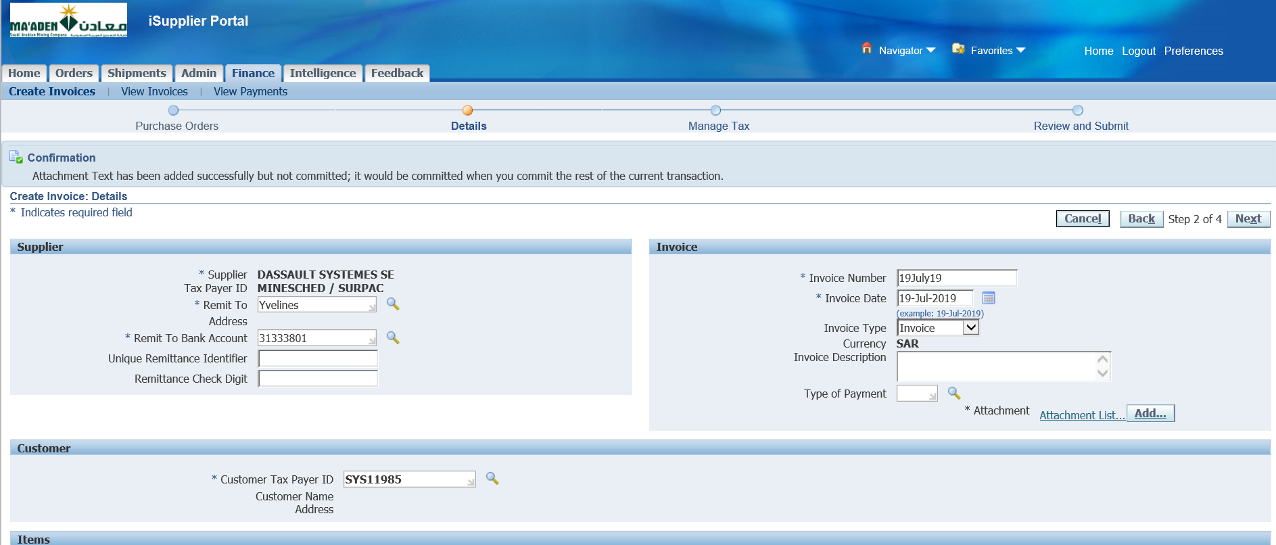

Next

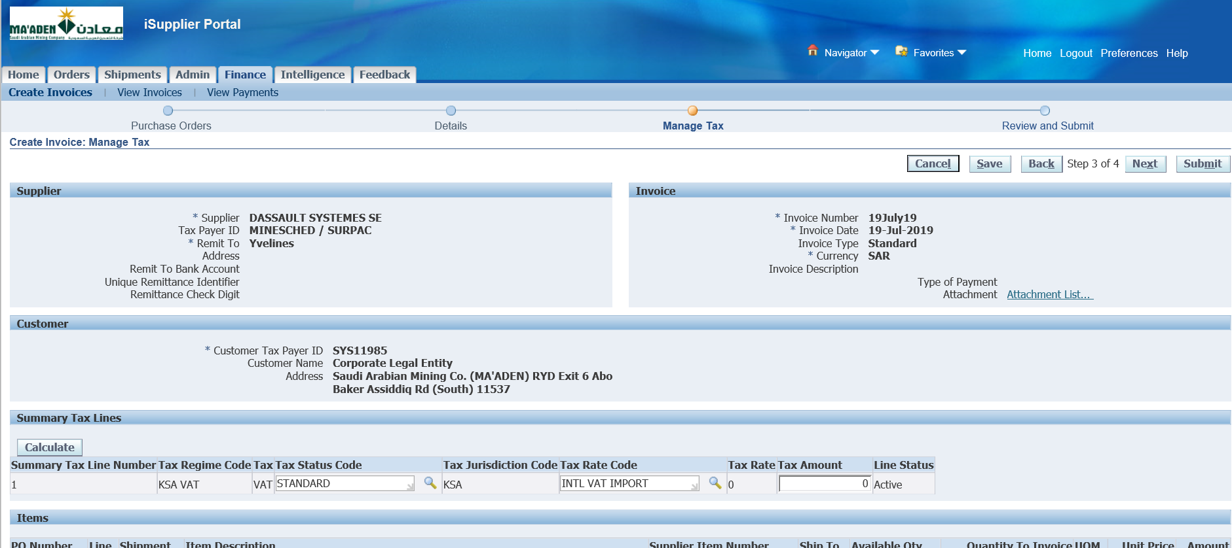

Submit

Invoice – 19July19

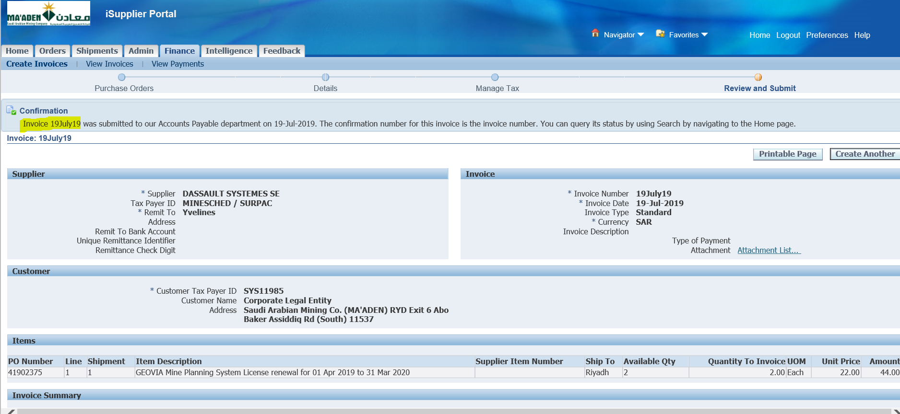

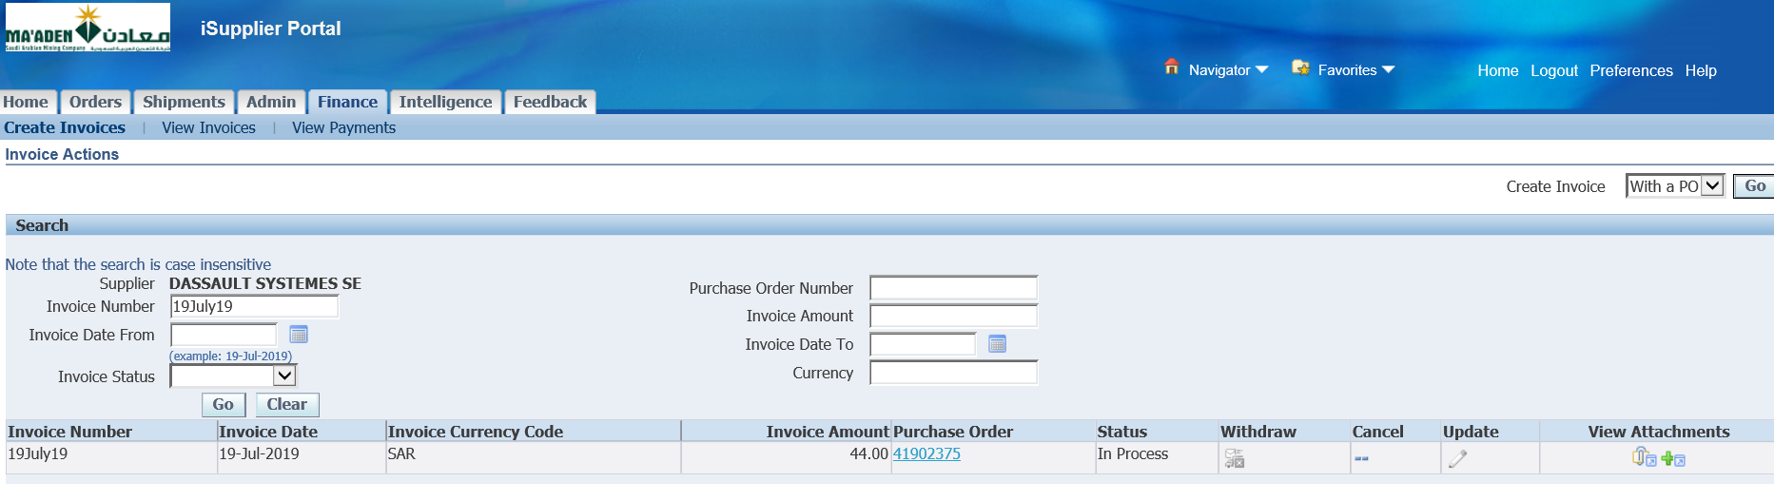

1. Change the Buyer on an Approved Requisition

Responsibility 🡪 Corp Purchasing Superuser

Select a Requisition which is Approved and has a Buyer on the Lines

Requisition –11901677

Lines 🡪 Select Folder 🡪 Show Field 🡪 Buyer - Hamad Rashid Al Hino

Hamad Rashid Al Hino is the Buyer available in the Requisition lines

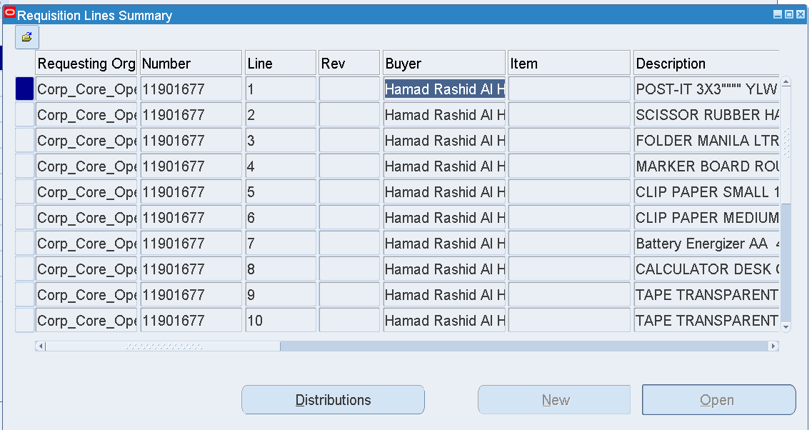

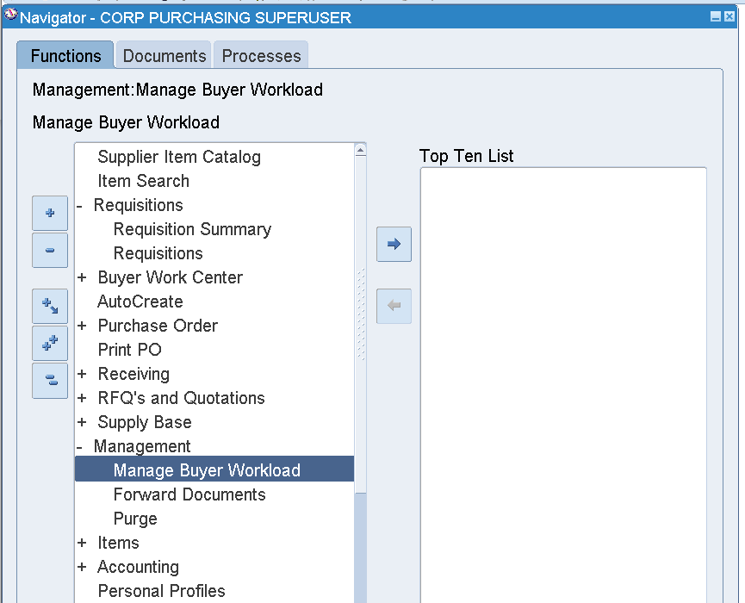

Change the Buyer on the Lines to Abdul Noorul Huda

Management 🡪 Manage Buyer Workload

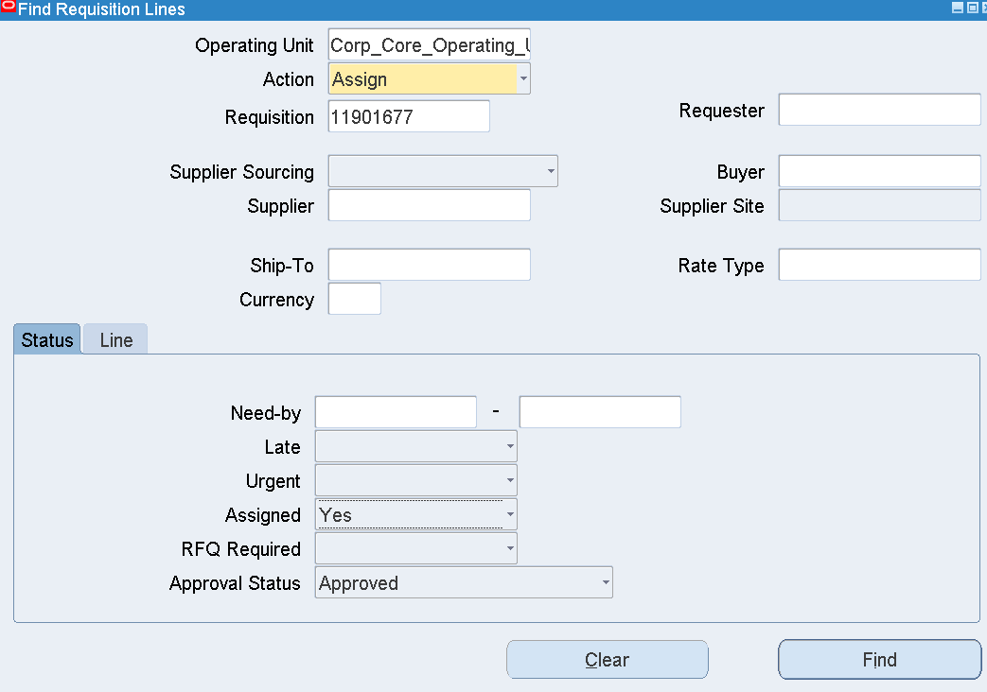

Enter Requisition number

Assigned – Yes

Approval Status – Approved

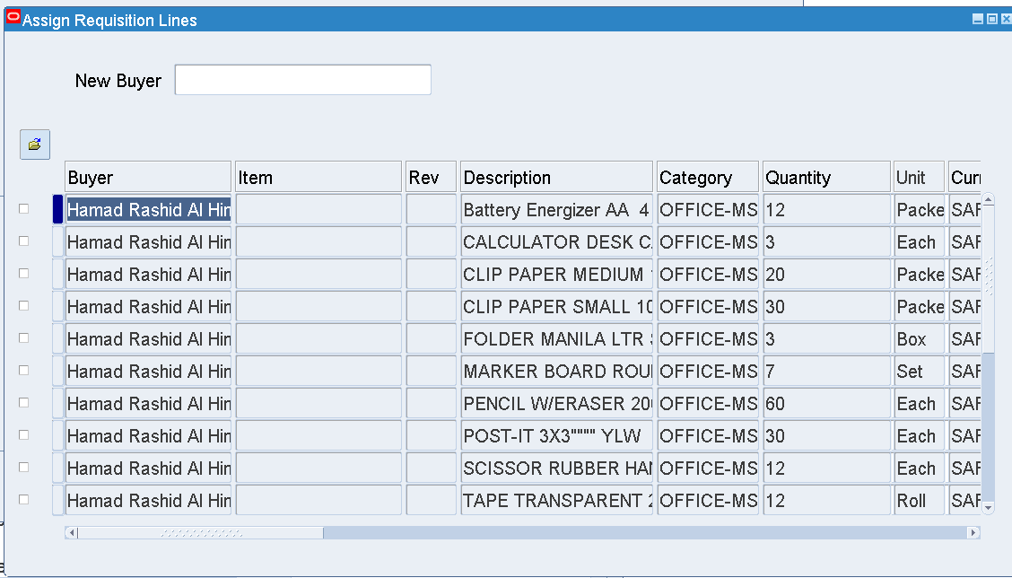

Enter New Buyer – Abdul Noorul Huda

Save

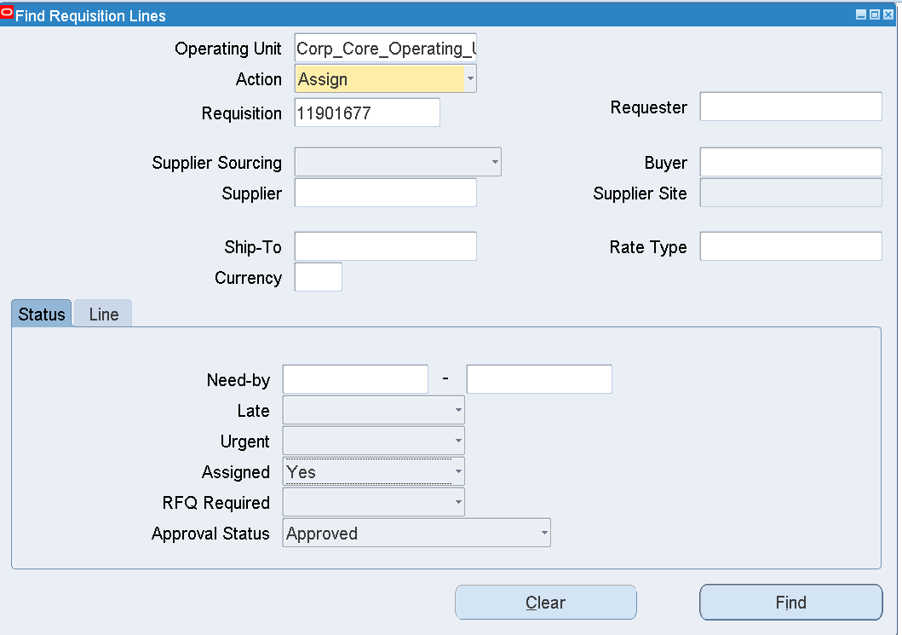

Find

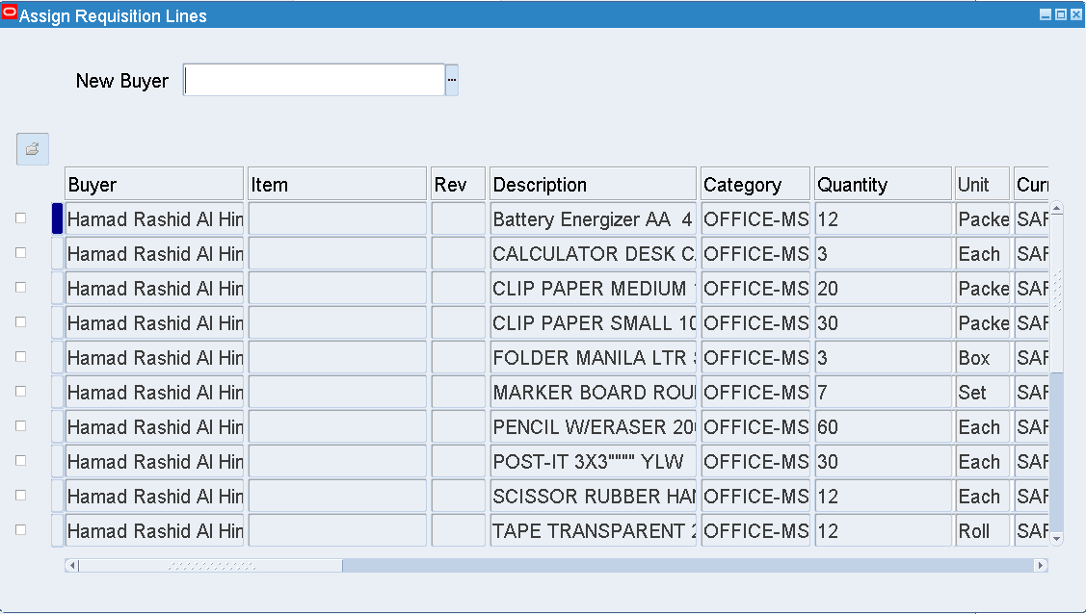

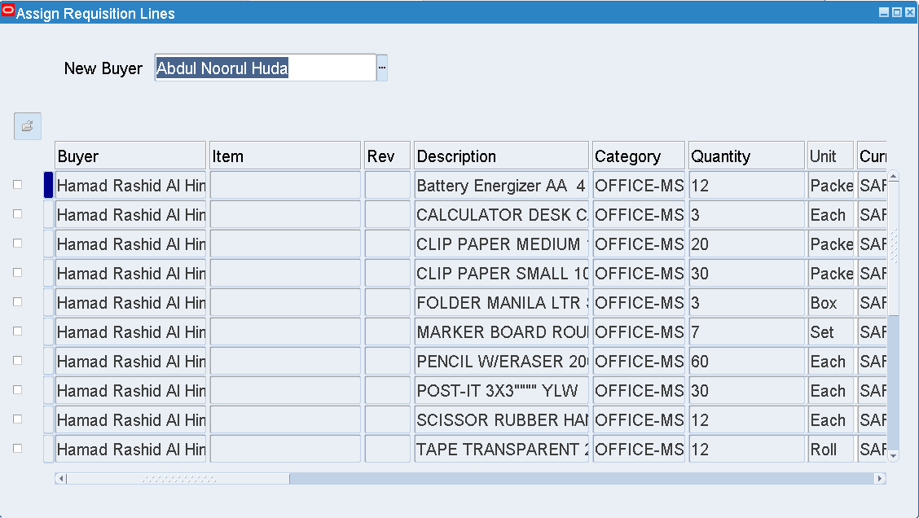

Enter the New Buyer name

Select a Line or All Lines

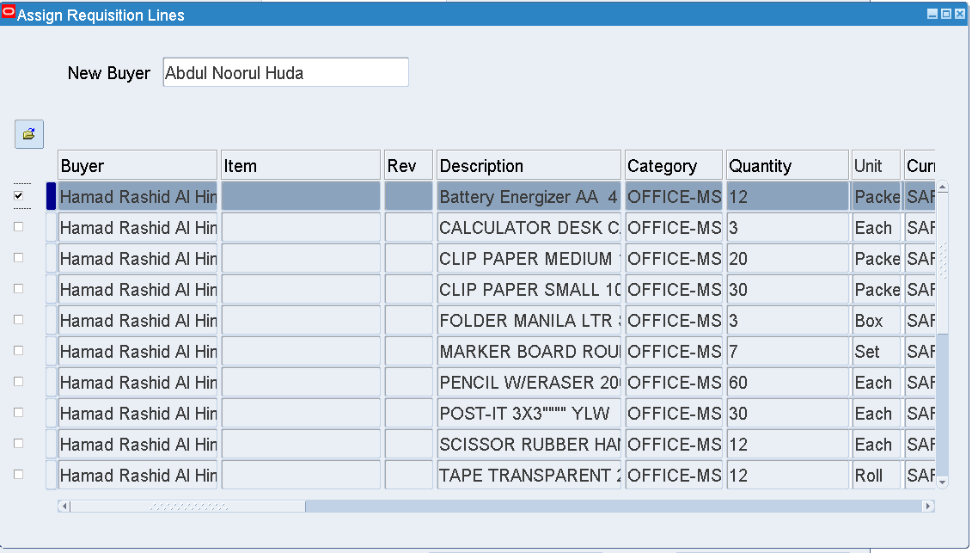

Save

Line 1 on the Req – Buyer is changed to Abdul Noorul Huda

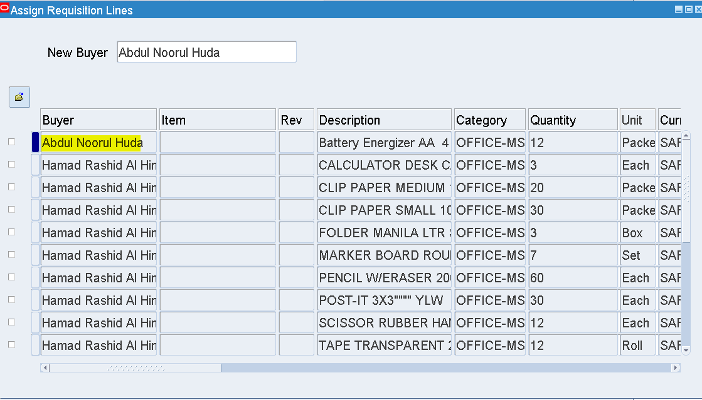

1. Assign a Buyer to an Approved Requisition where there is no Buyer on the Lines

Requisition – 11901679

Purchase Requisition Preparer- PARAGASJ

Approved by GHANNAMMG / NASSARR

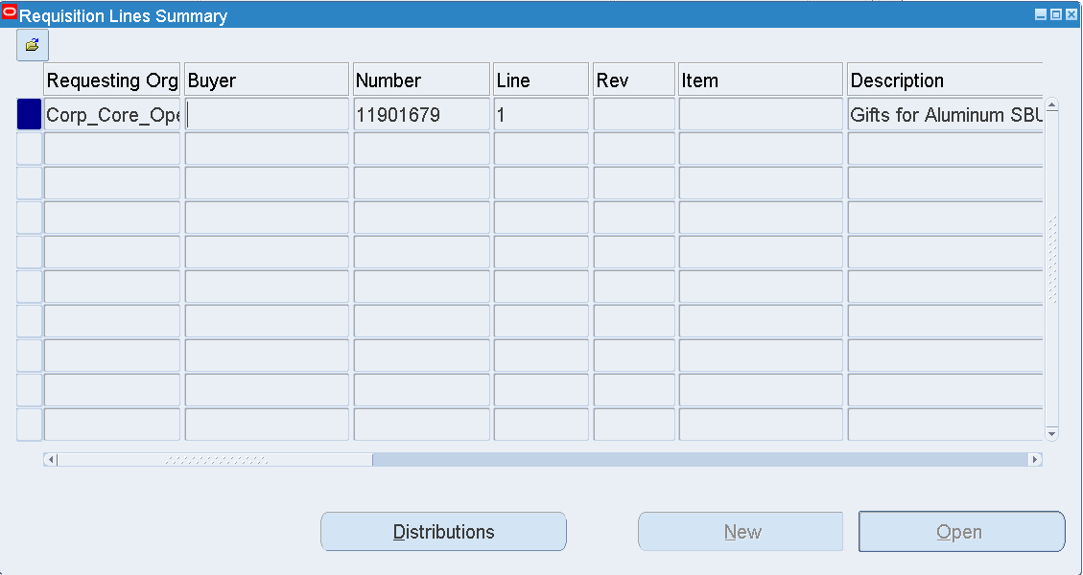

The Buyer on the Requisition Line is Blank

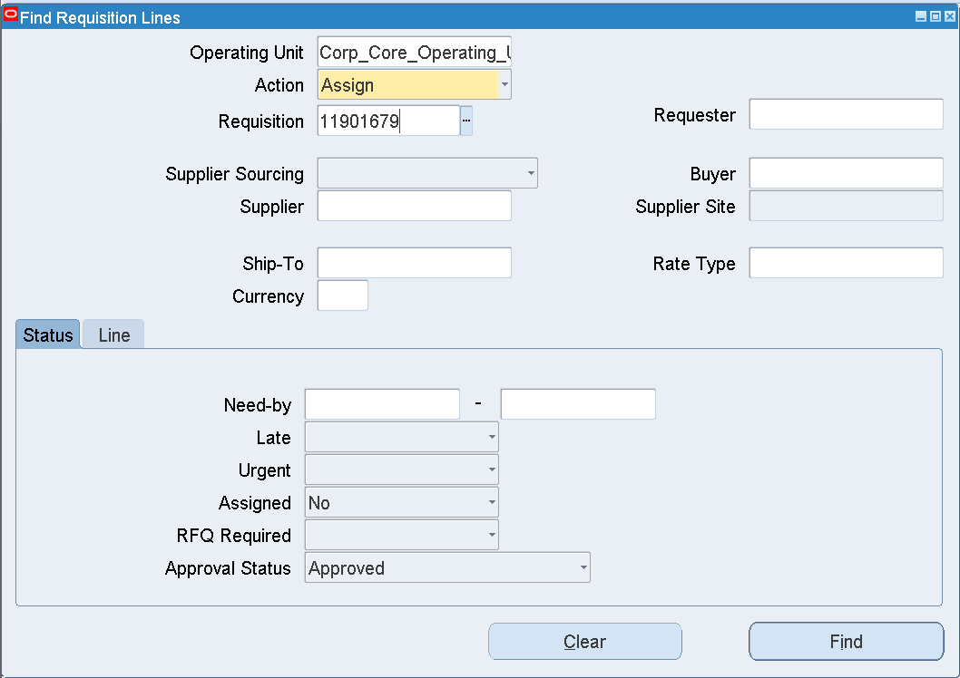

Enter Requisition number

Assigned – No

Approval Status – Approved

Find

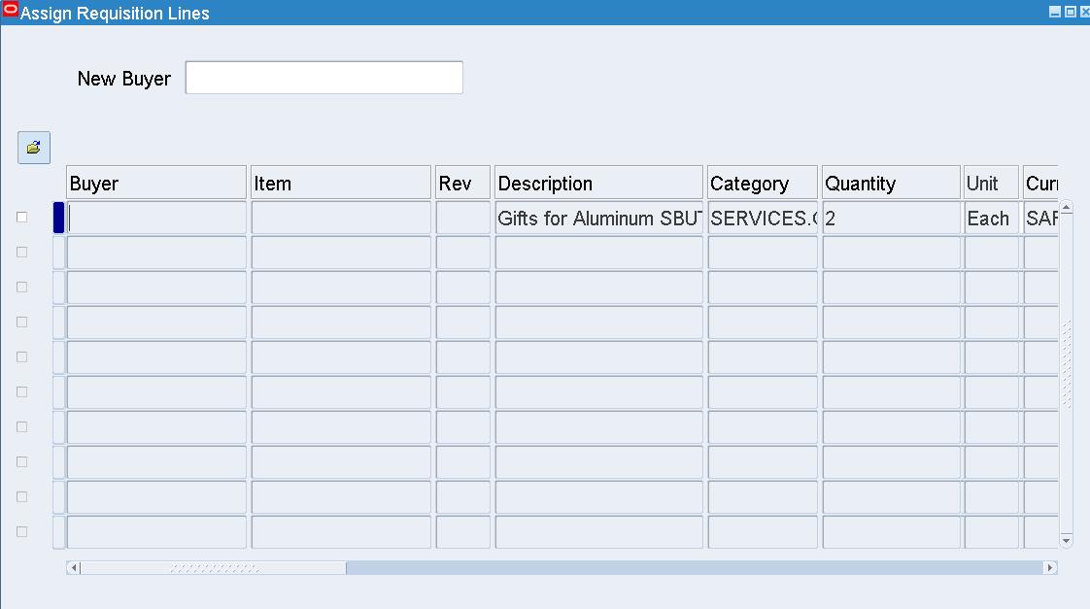

Buyer field is Blank

Enter Buyer

Save

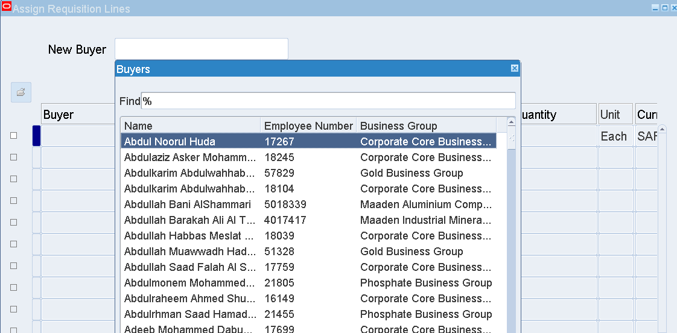

Select a Buyer from the LOV

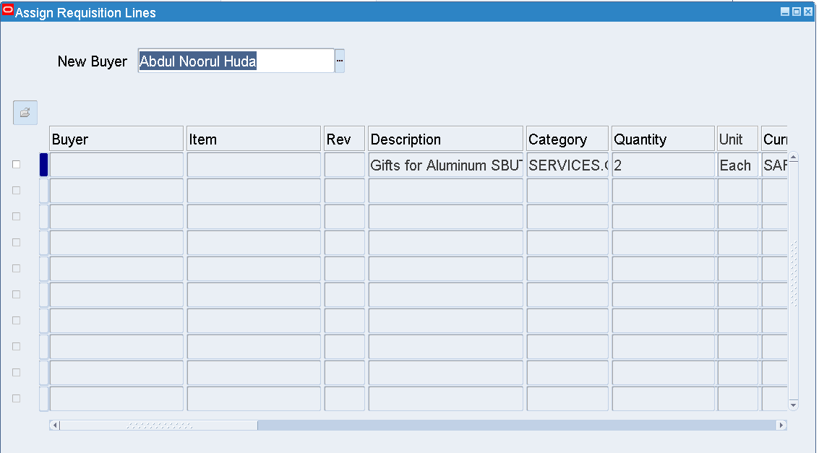

Select the Line

Save

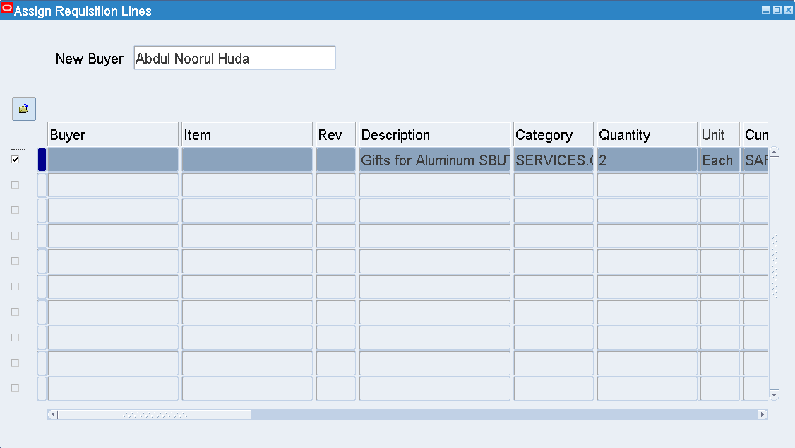

Save

Query the Requisition from Requisitions Summary

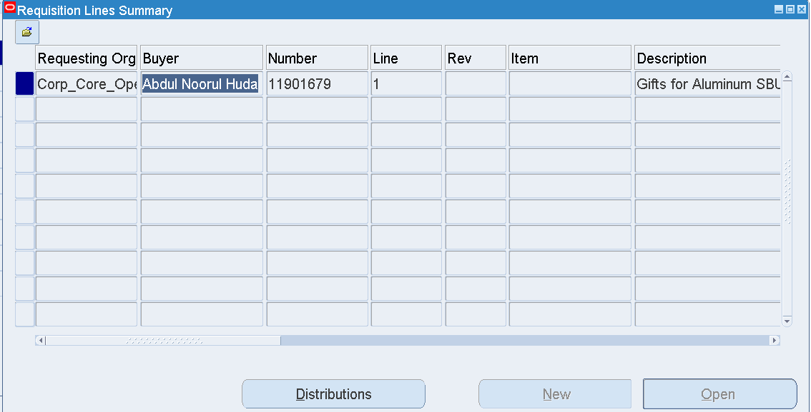

Lines 🡪 Folder 🡪 Show Field 🡪 Buyer

Buyer – Abdul Noorul Huda is assigned

1. Return to Supplier

Step-1:

Check a PO which has been received.

PO(741903172)->lines->Shipment

PO_Summary-> PO->Lines->Shipment-> below screen will appear

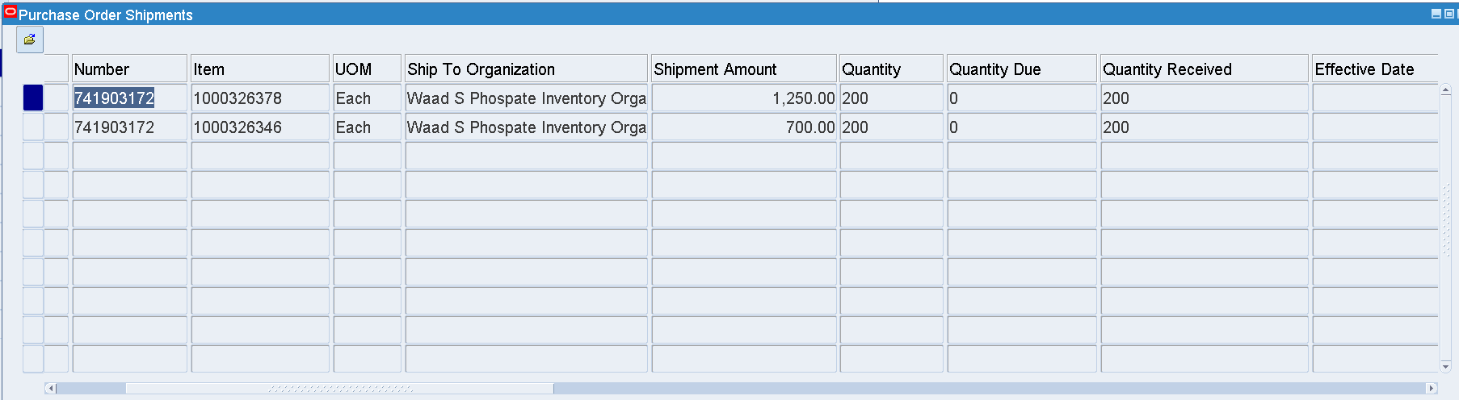

Line 1,2

Qty Received = 200 and Qty Due = 0

The Line is eligible for Return to Supplier

Step-2: MWSPC Purchasing Superuser 🡪 Receiving 🡪 Returns

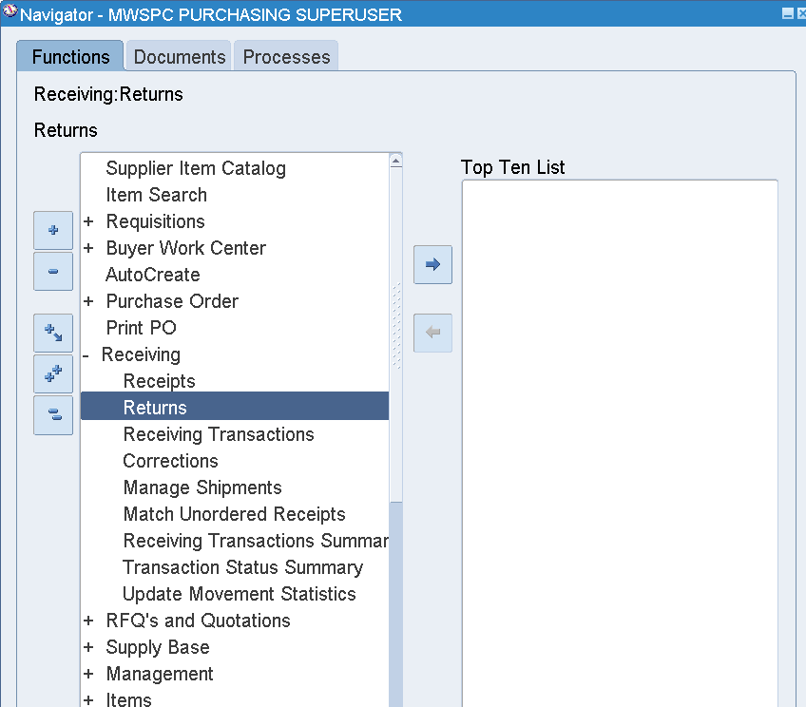

Select an Organization

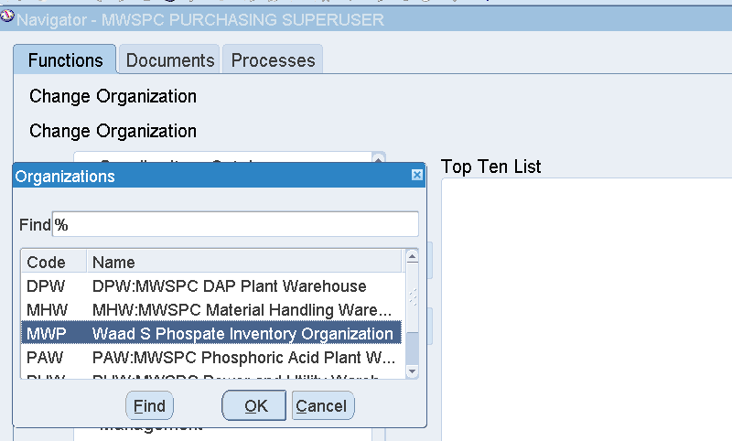

Enter Purchase Order number

Line -1

Find

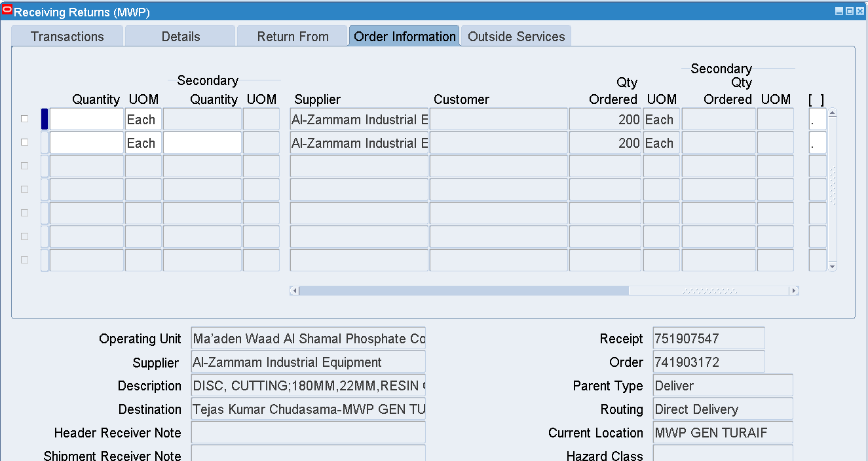

Check the Ordered Quantity in the Order Information tab

Enter the Quantity that has to be Returned to the Supplier

Return to Supplier

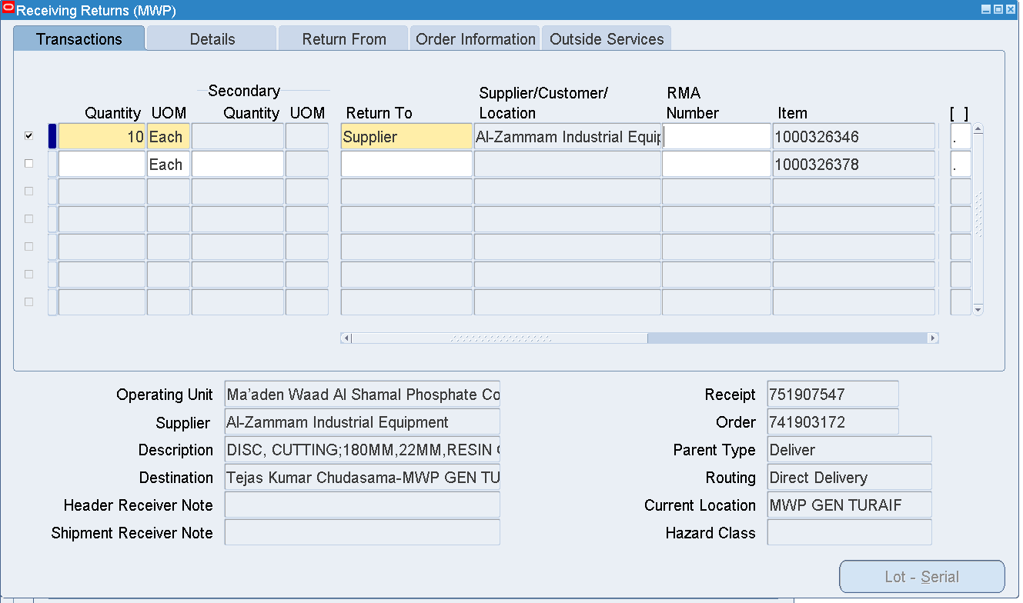

Save

Returned Qty = 10 on Line 1

Check the PO Quantity Due now

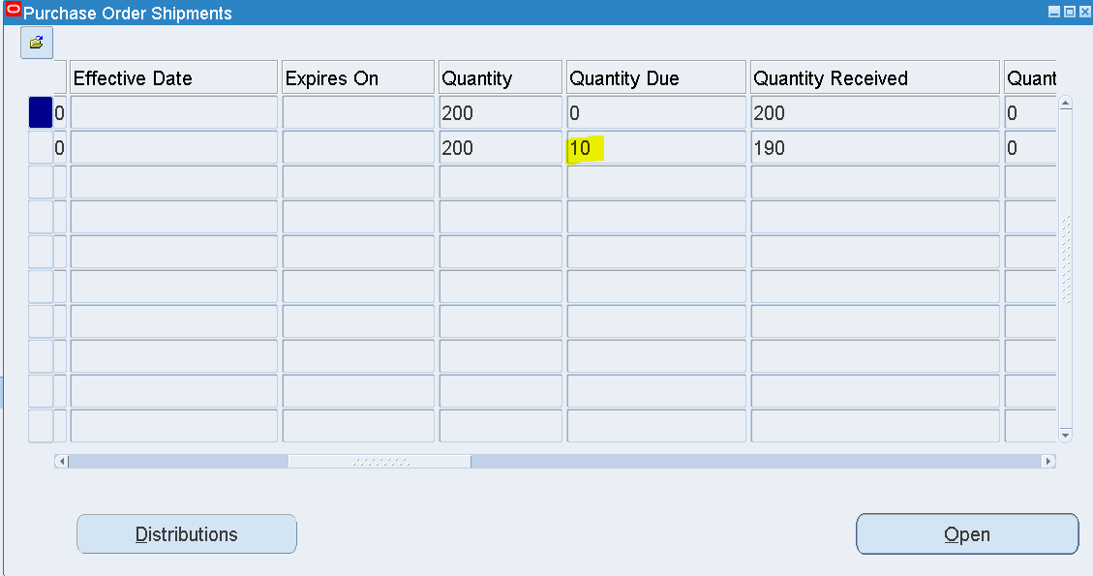

Qty due = 10

1. Global Blanket Agreement Creation 🡪 Approval

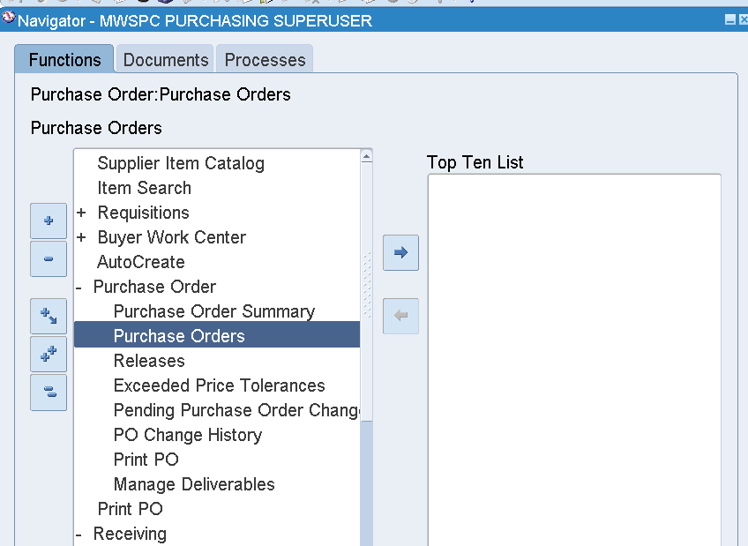

MWSPC Purchasing Superuser 🡪 Purchase Order 🡪 Purchase Orders

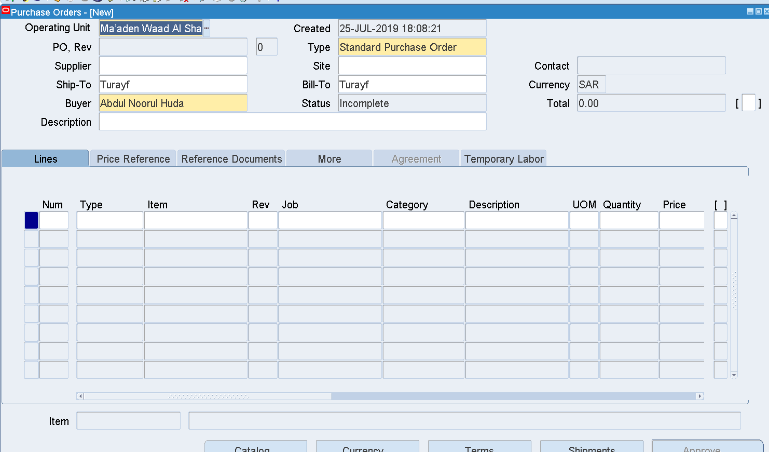

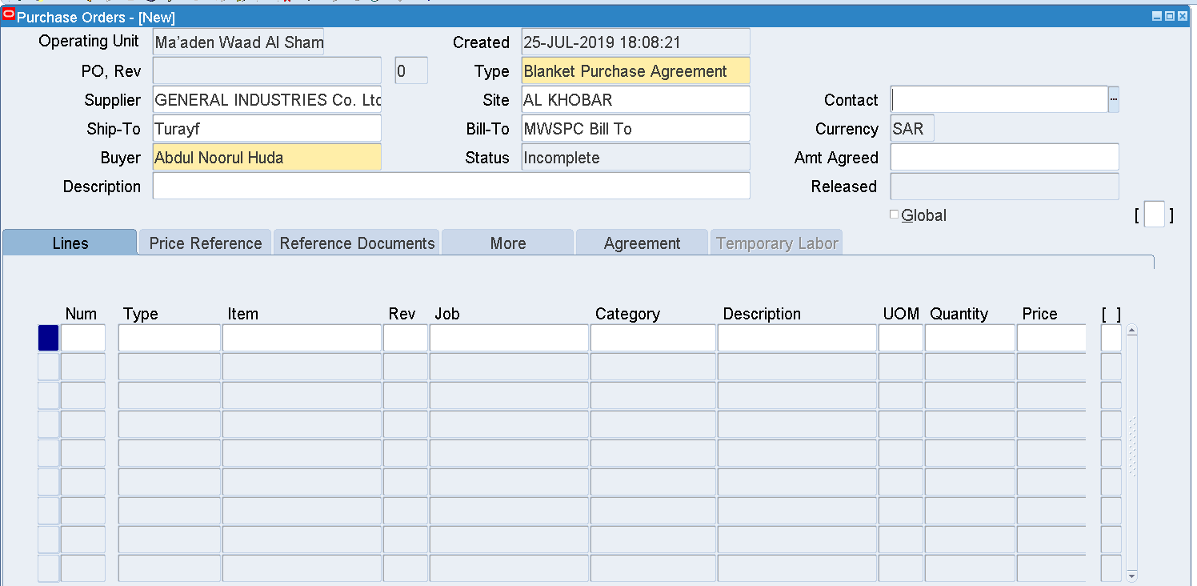

Change the Type to Blanket Purchase Agreement

Enter Supplier -- GENERAL INDUSTRIES Co. Ltd.

Site -- AL KHOBAR

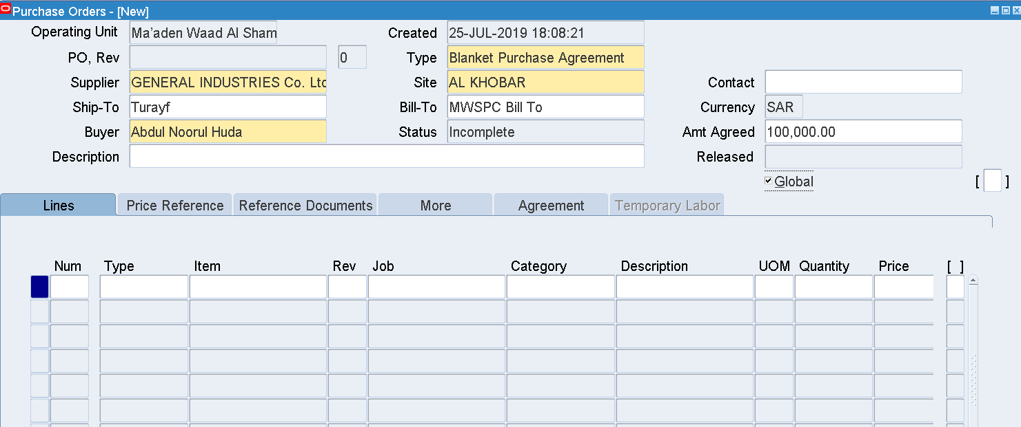

Enter Amount Agreed

Check the Global checkbox

This is a Global Blanket Purchase Agreement

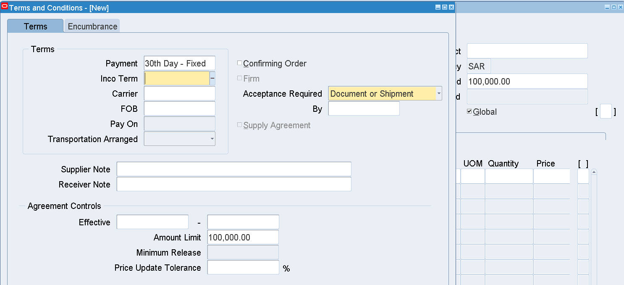

Enter Inco Term 🡪 Freight Term

DDP

Agreement Controls 🡪 Effective Dates

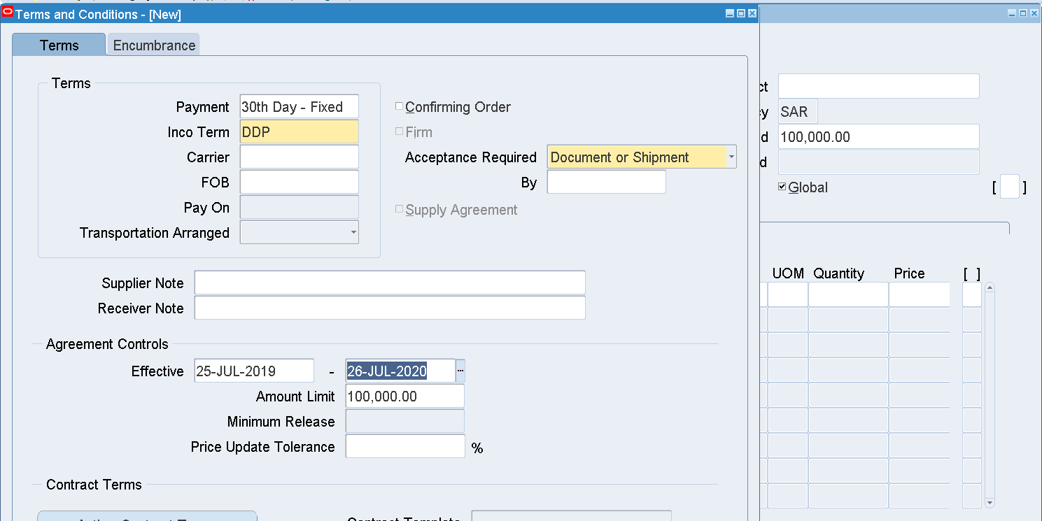

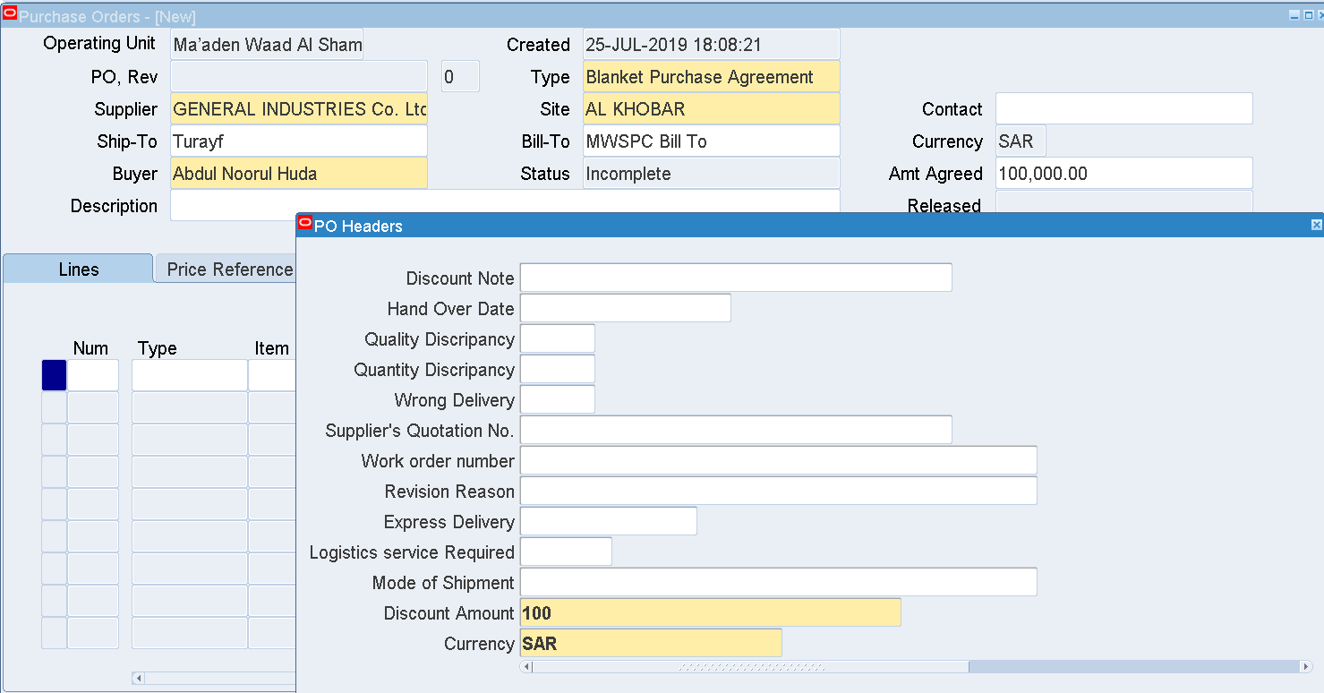

Enter the Header DFF

Discount Amount – some value

Currency – SAR

Save

After saving, Blanket number will be generated as below

Blanket PO - 741903870

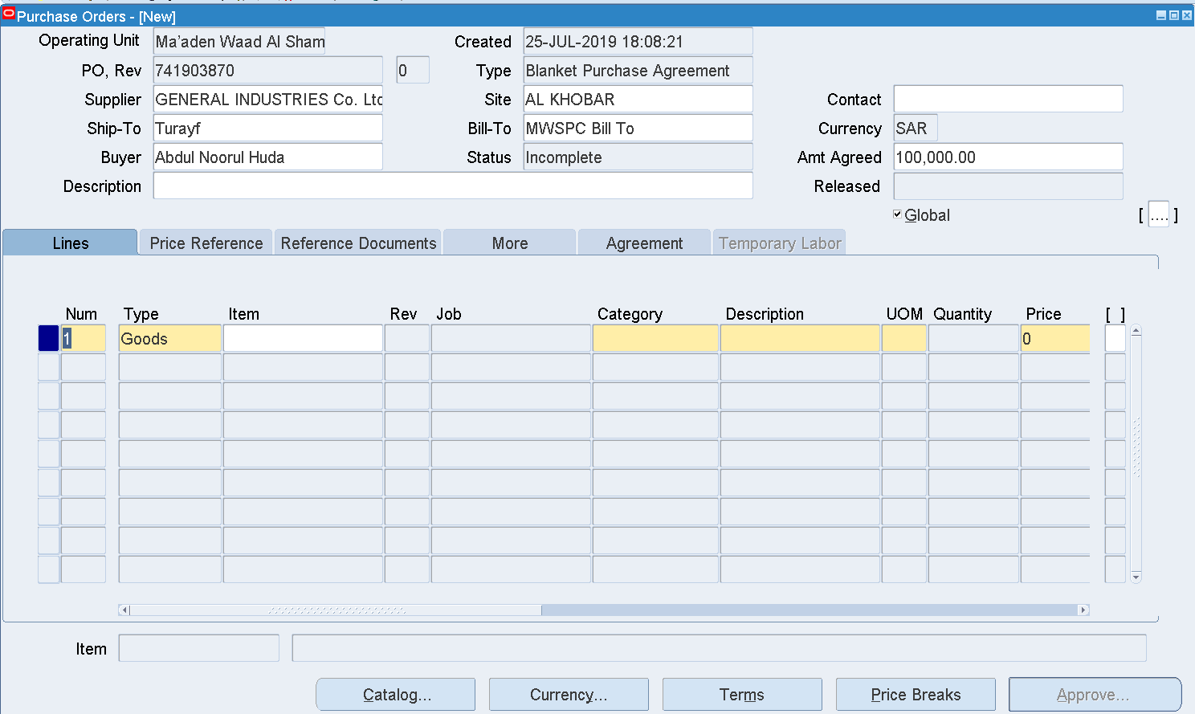

Enter an Item

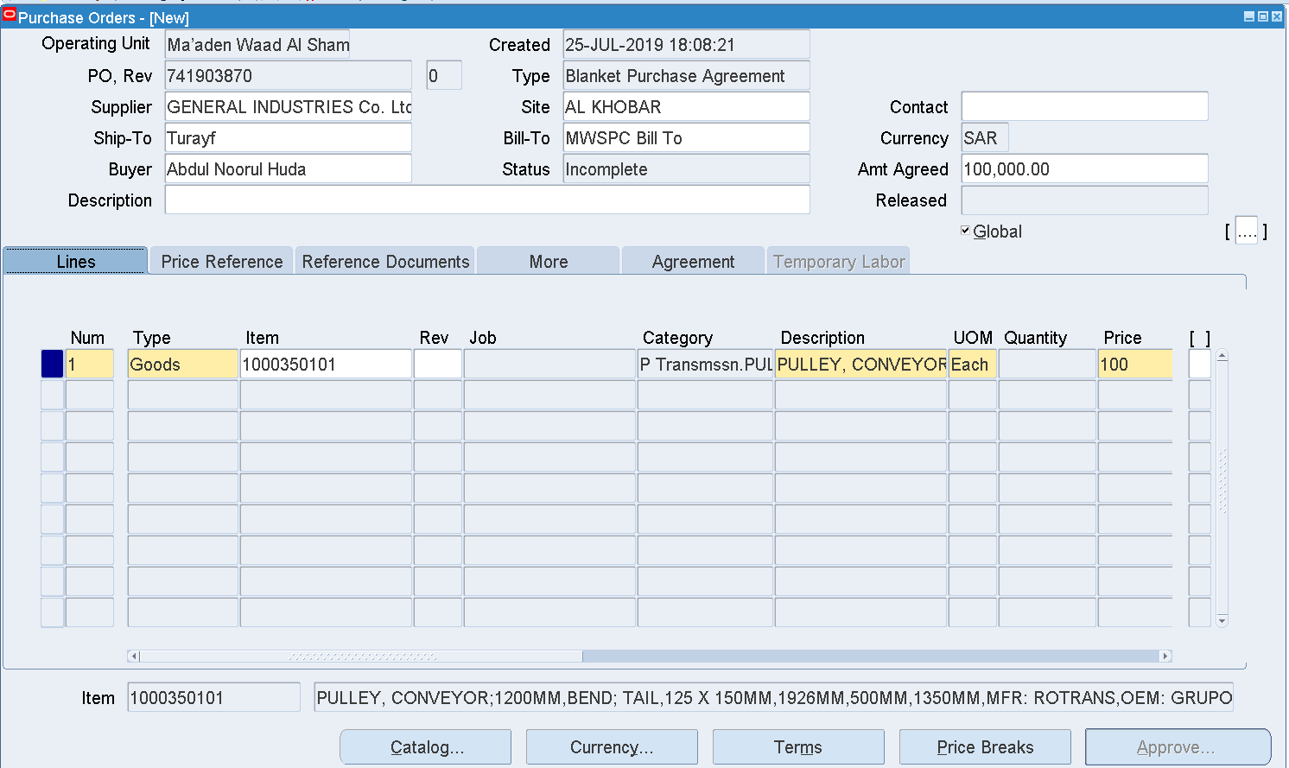

Price – 100

Save

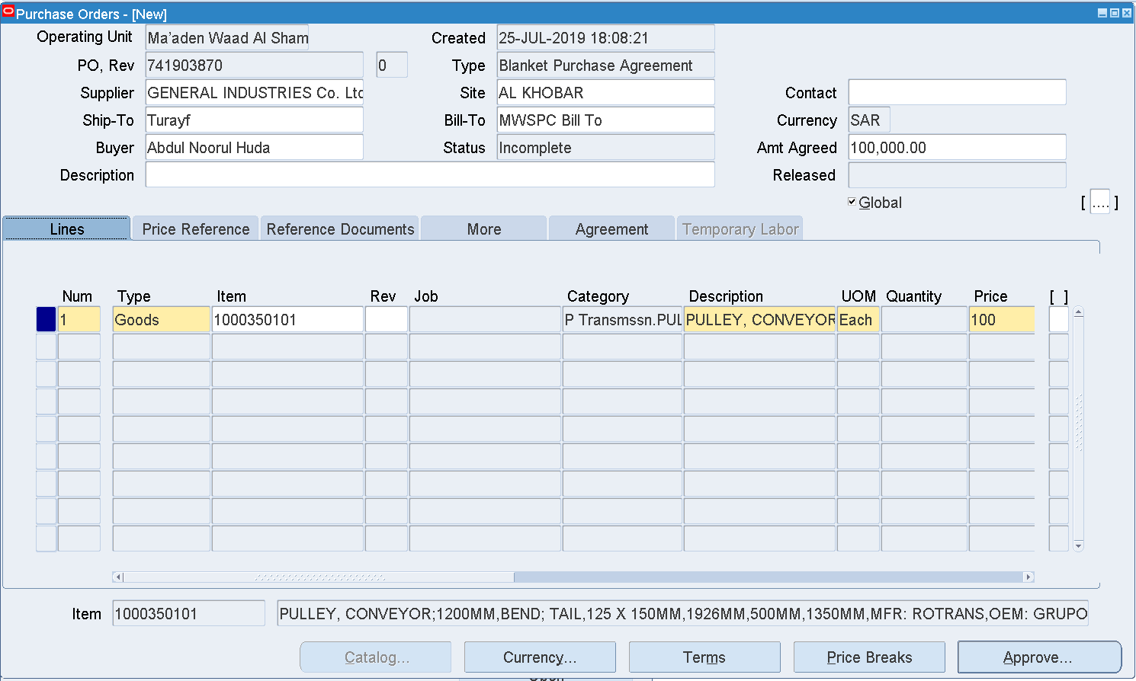

Approve

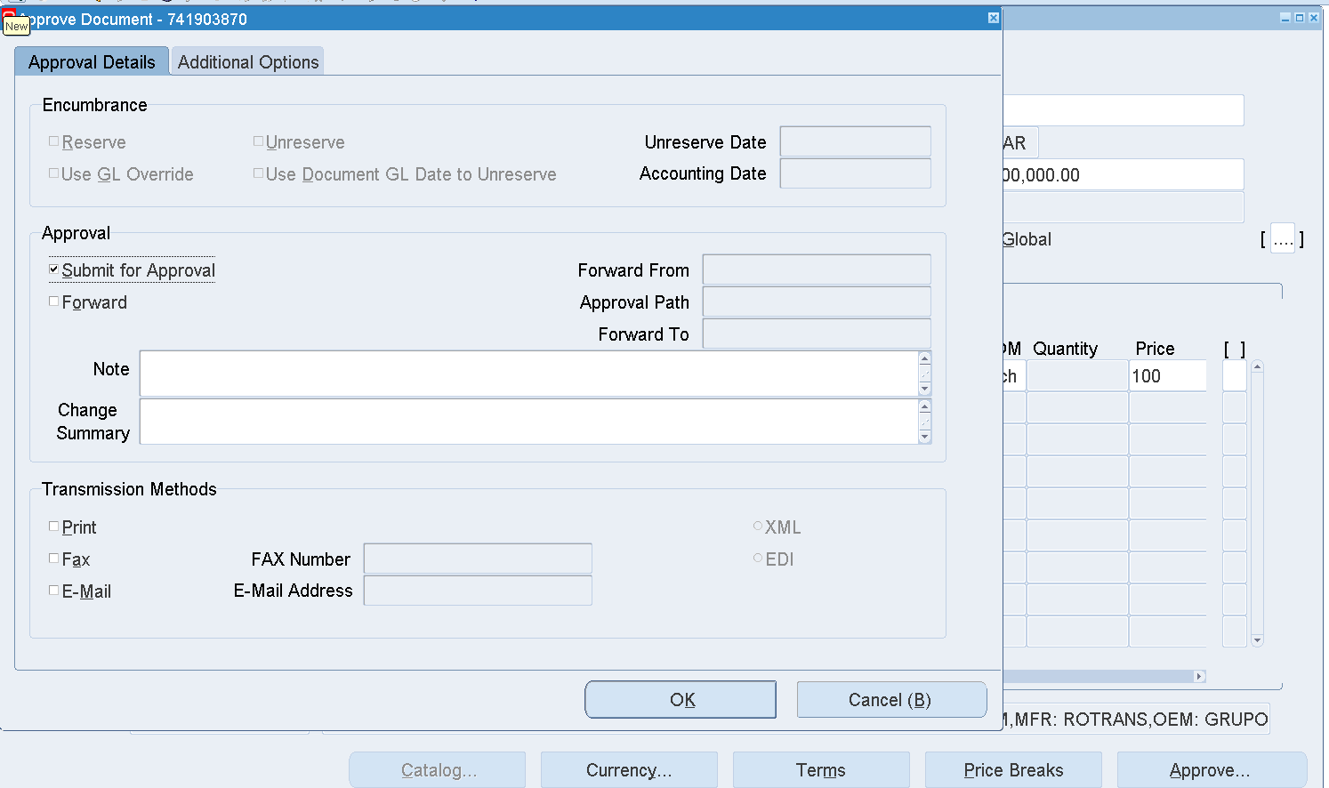

OK

Once it’s submitted for Approval, then the Blanket Agreement will be forwarded to the Approver based on the PO Hierarchy

Find the BPA

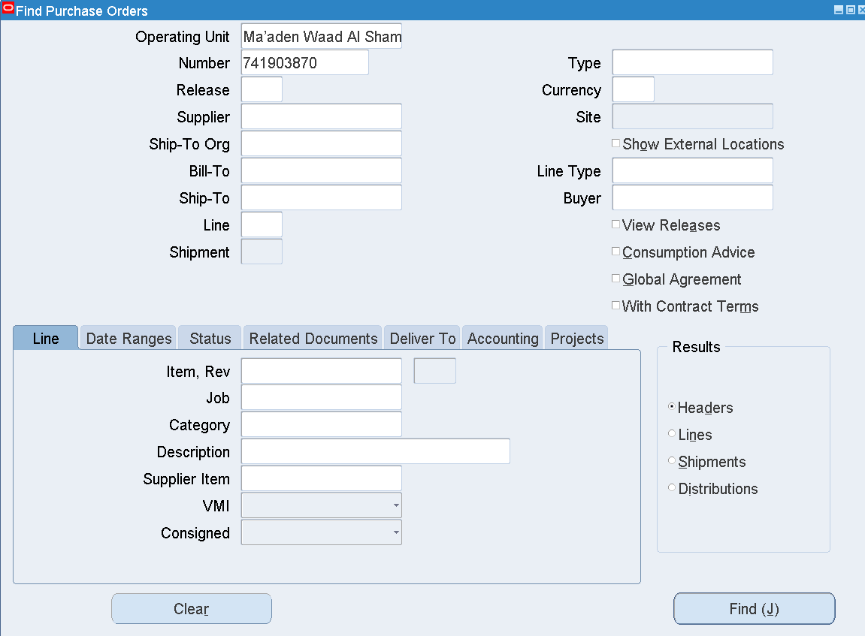

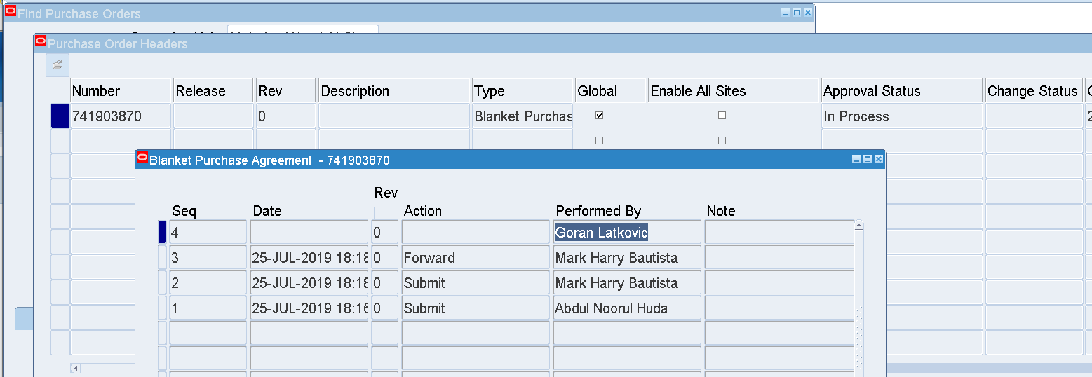

The BPA is In Process status

This is sent to Goran Latkovic

Login as LATKOVICG

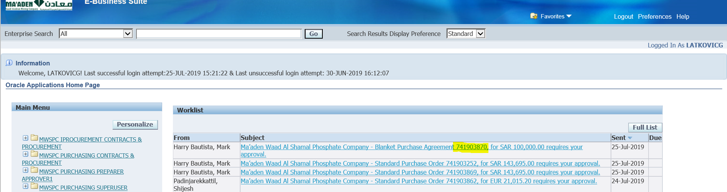

Open the Approval Notification

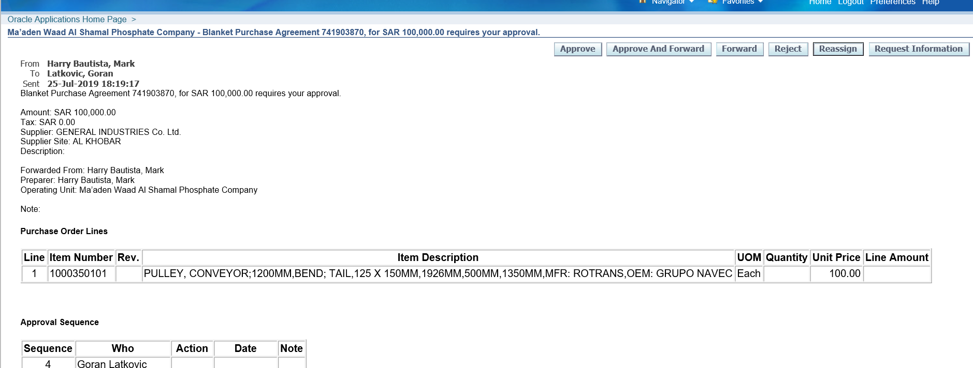

Click Approve

Check the PO whether it’s Approved

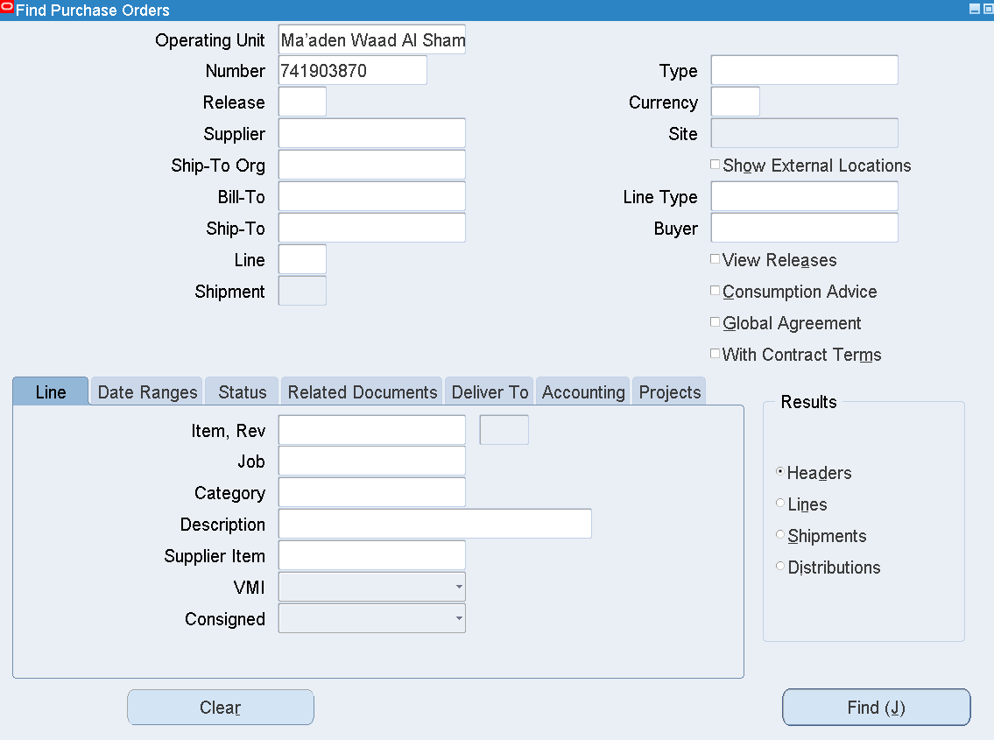

Purchase order 🡪 Purchase Order Summary

Enter the PO NUM

Find

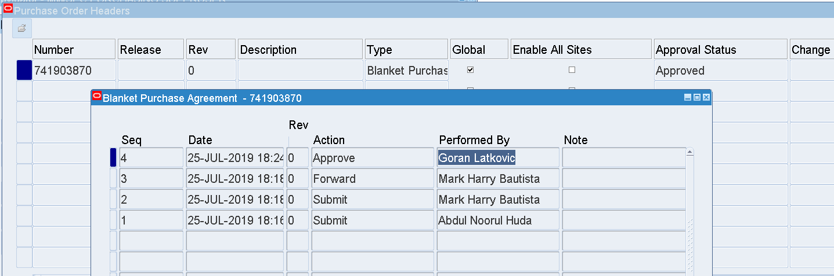

The Global Blanket Purchase Agreement has been Approved by Goran Latkovic

This is used for creating Purchase Requisitions and Standard Purchase Orders

1. Blanket Release creation without a Purchase Requisition

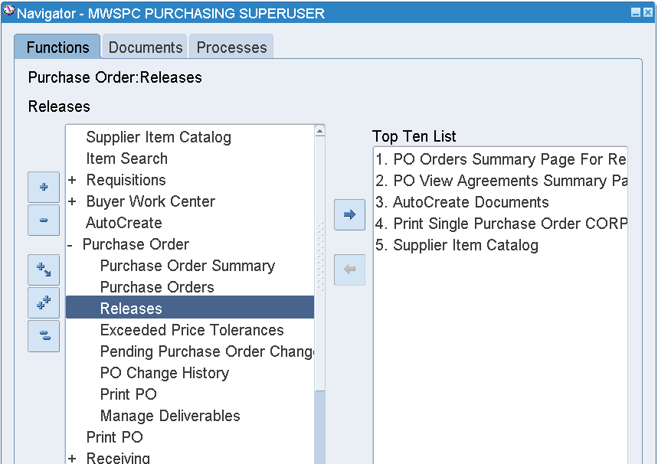

MWSPC Purchasing Superuser

Purchase Order 🡪 Releases

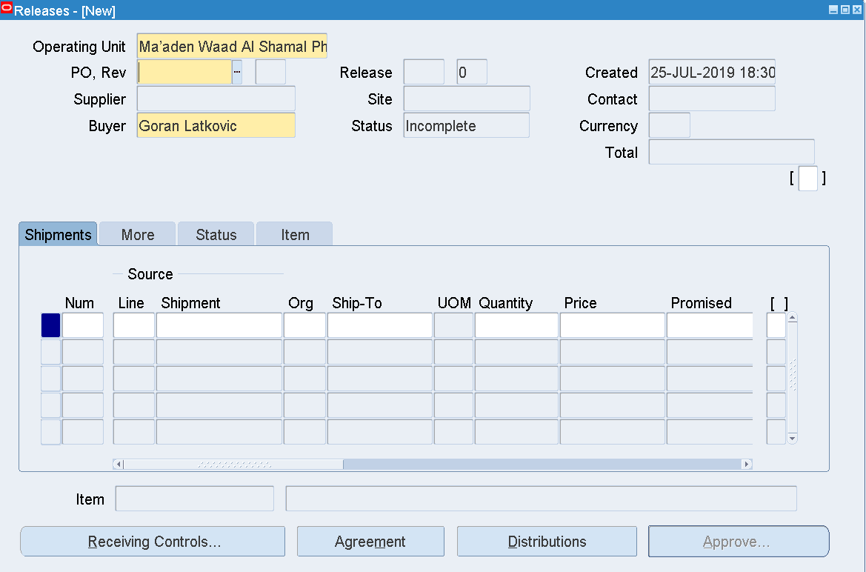

Select a BPA from the LOV

The Global Blanket Purchase Agreement isn’t eligible for creating a Release

Only Local Blanket Purchase Agreement is eligible for creating a Release

Local BPA – Global check box isn’t checked in the BPA creation form

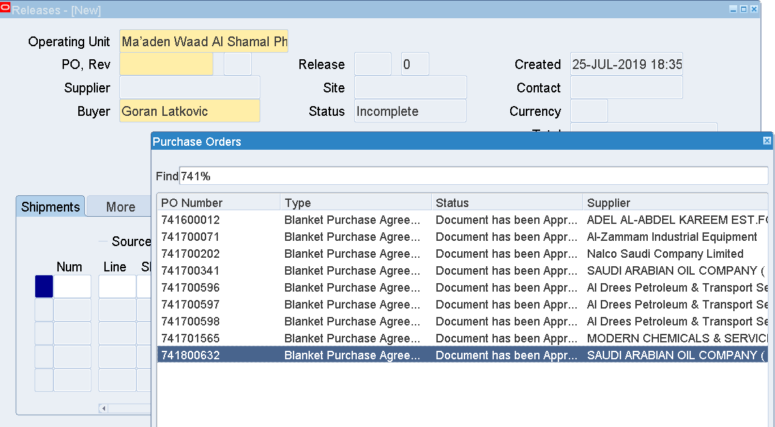

Select the available BPA

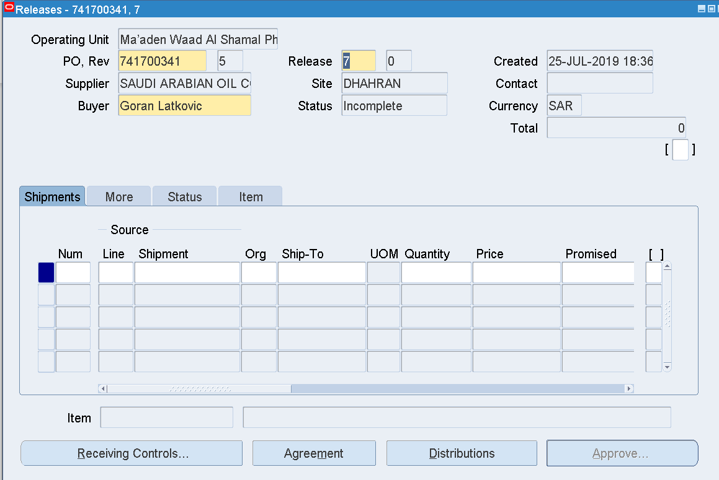

Enter Num and Line Num of the BPA

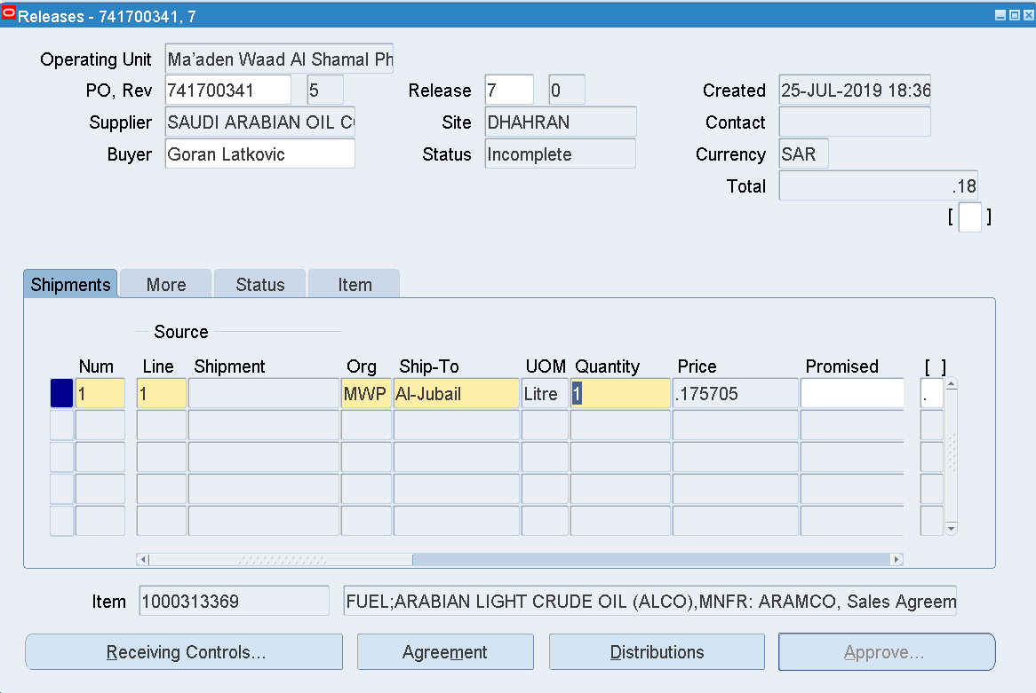

Enter Org

Ship – to

Quantity – 1

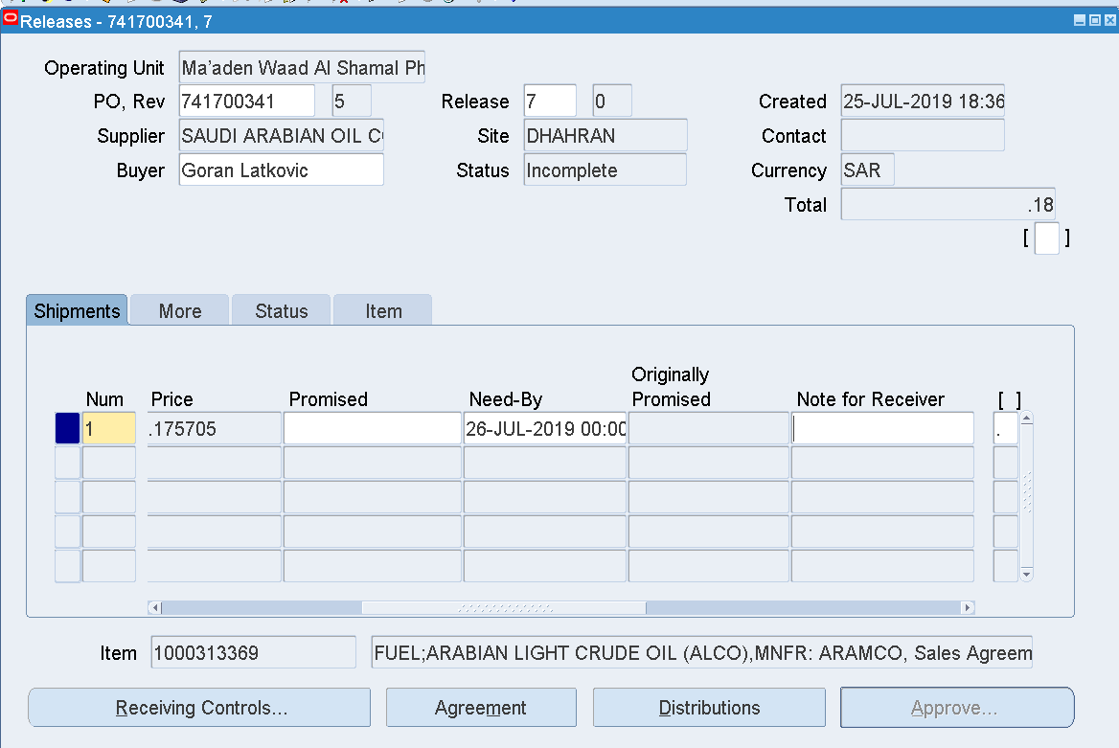

Enter Need by Date-27-AUG-2021 00:00:00

Save

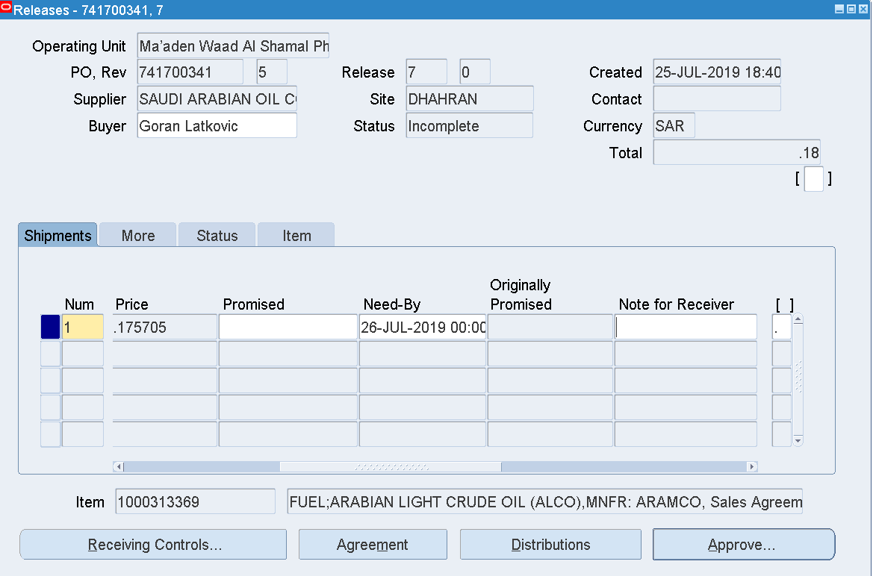

Click Approve

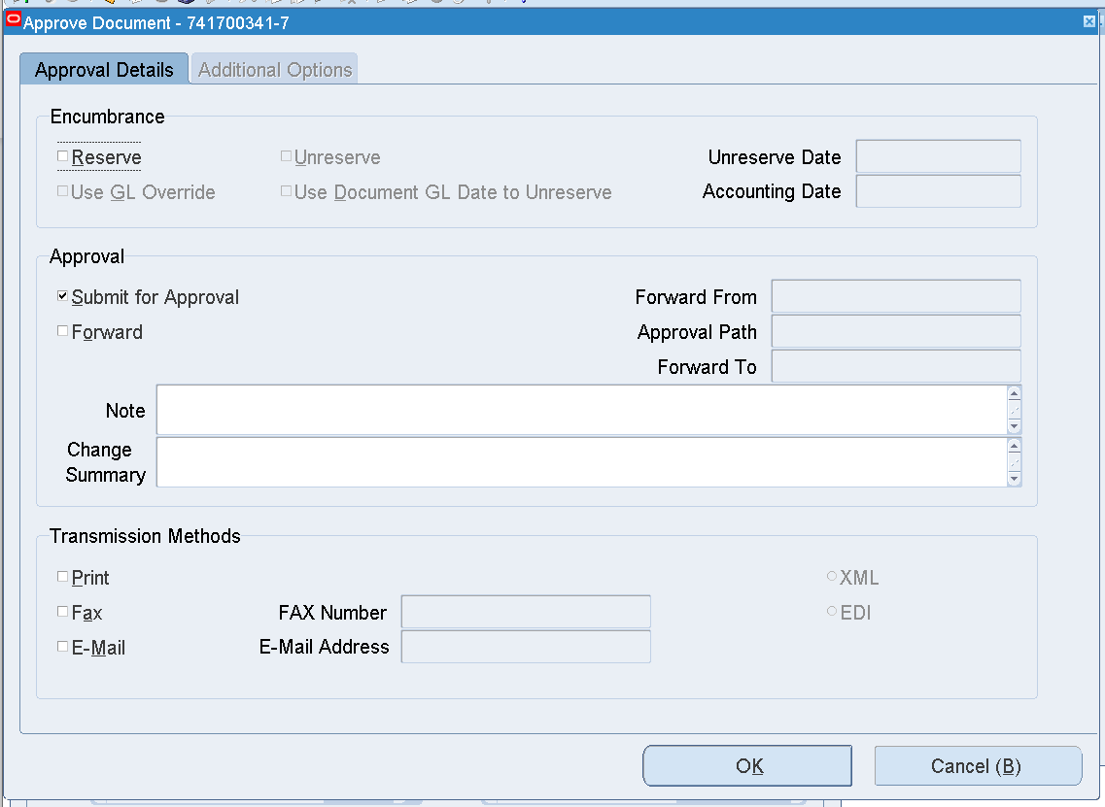

OK

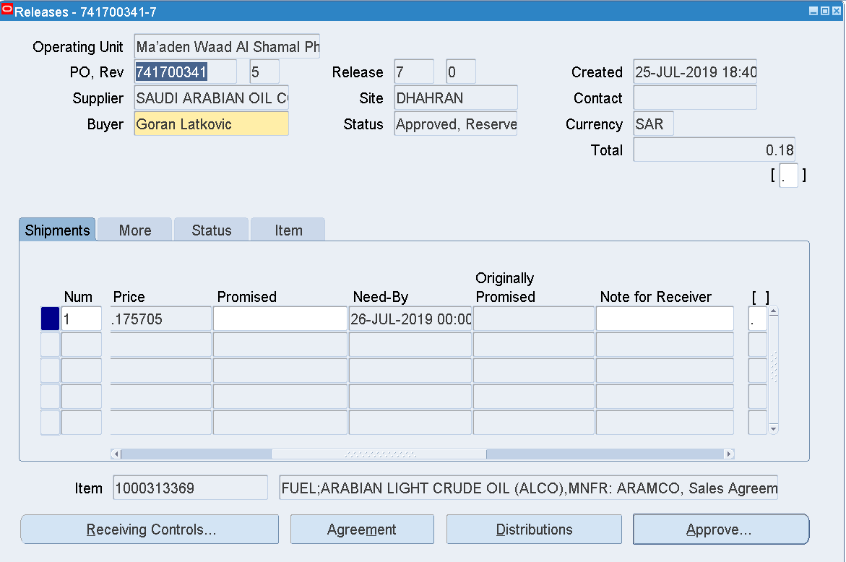

The Blanket Release has been Approved

Blanket Release 7 with the BPA – 741700341 has been created and Approved

Total = 0.18

The same amount will be updated in BPA – 741700341 in the Released field as below

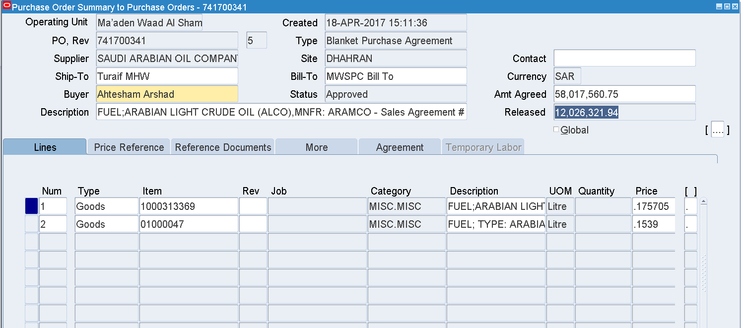

1. Standard PO creation without a PR 🡪PO Approval

MWSPC Purchasing Superuser

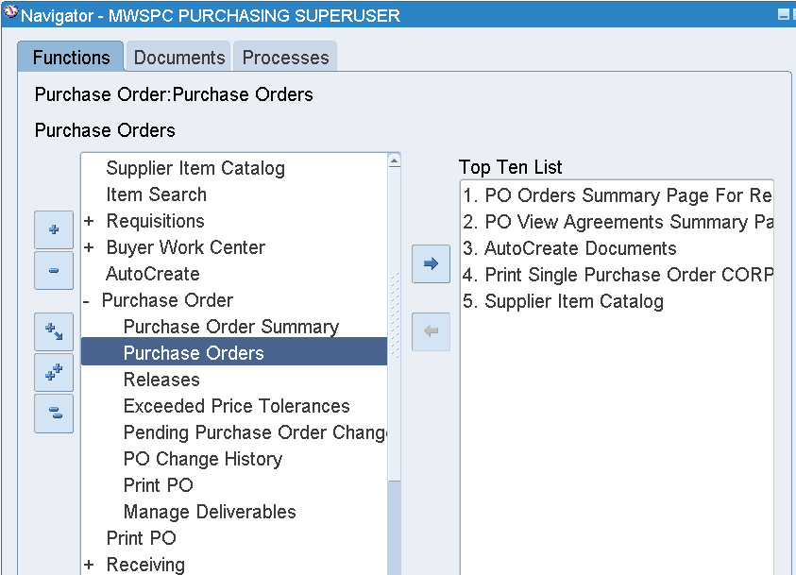

User – BAUTISTAMH

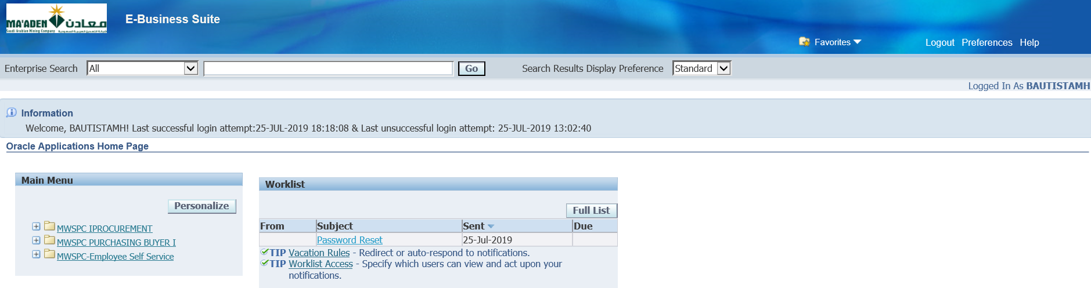

MWSPC Purchasing Buyer

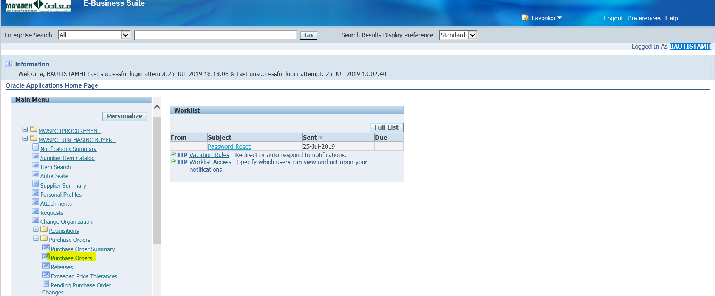

Purchase Orders 🡪 Purchase Orders

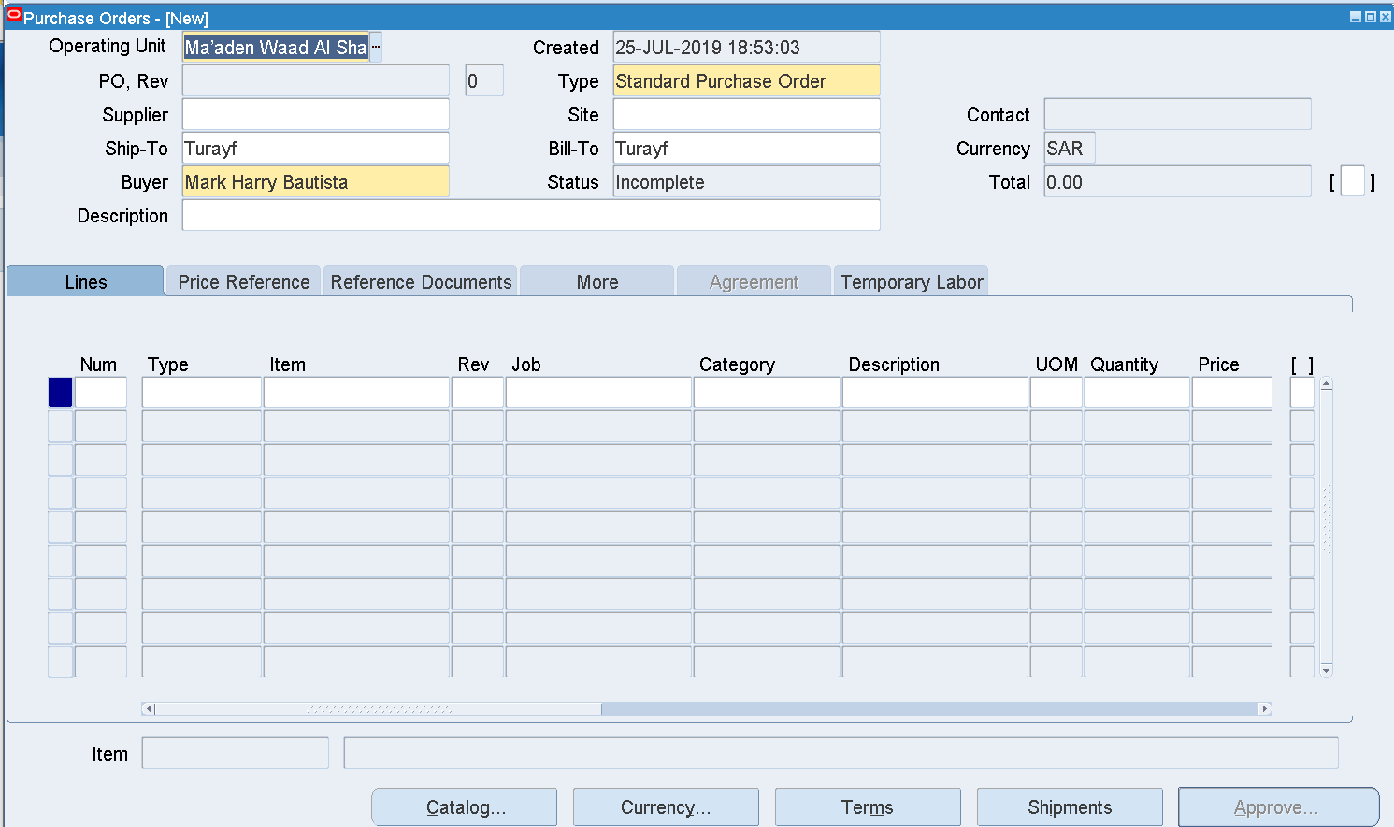

Enter Supplier – GENERAL INDUSTRIES Co. Ltd.

Site – AL KHOBAR

Contact - Mohideen, Aboothalib

Enter Inco Term – DDP

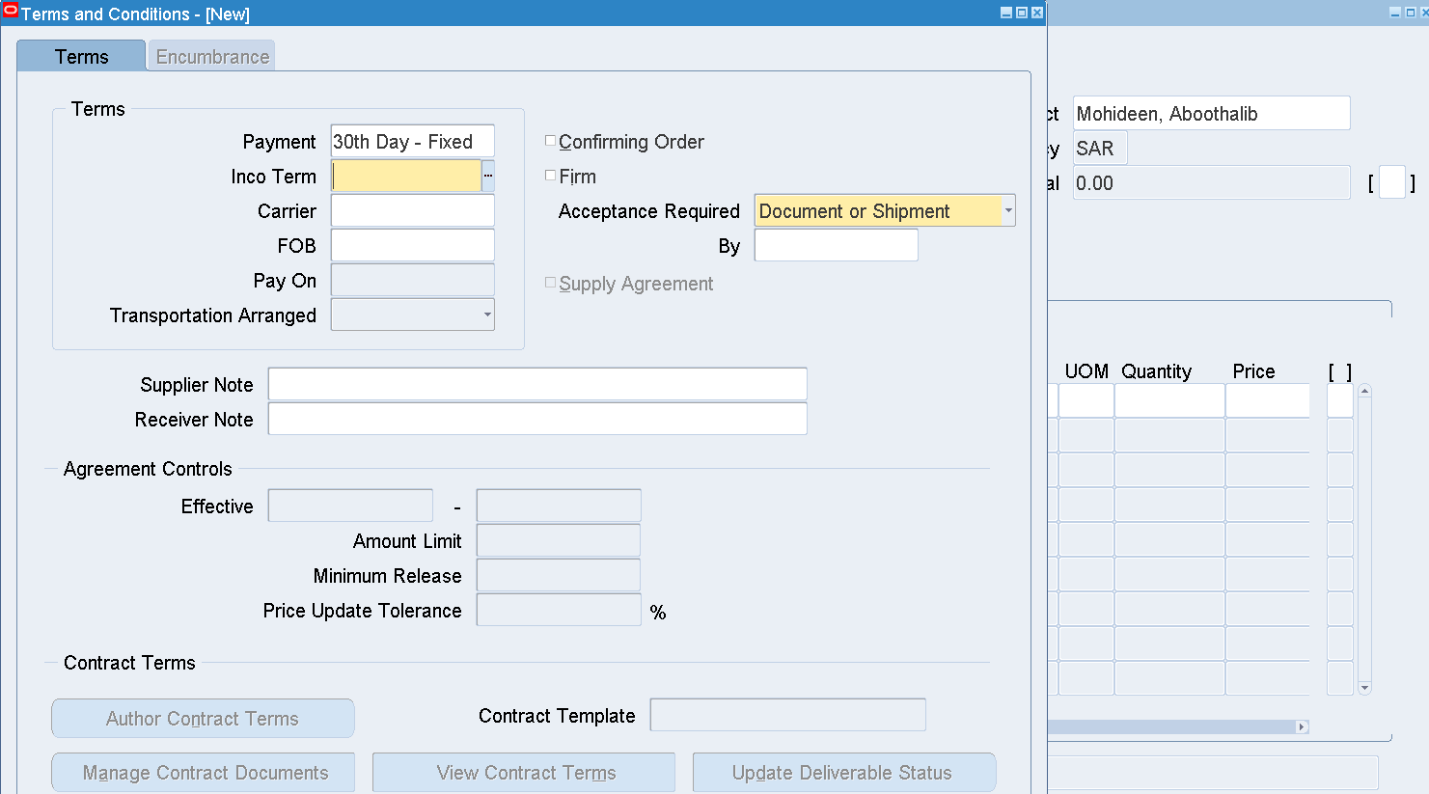

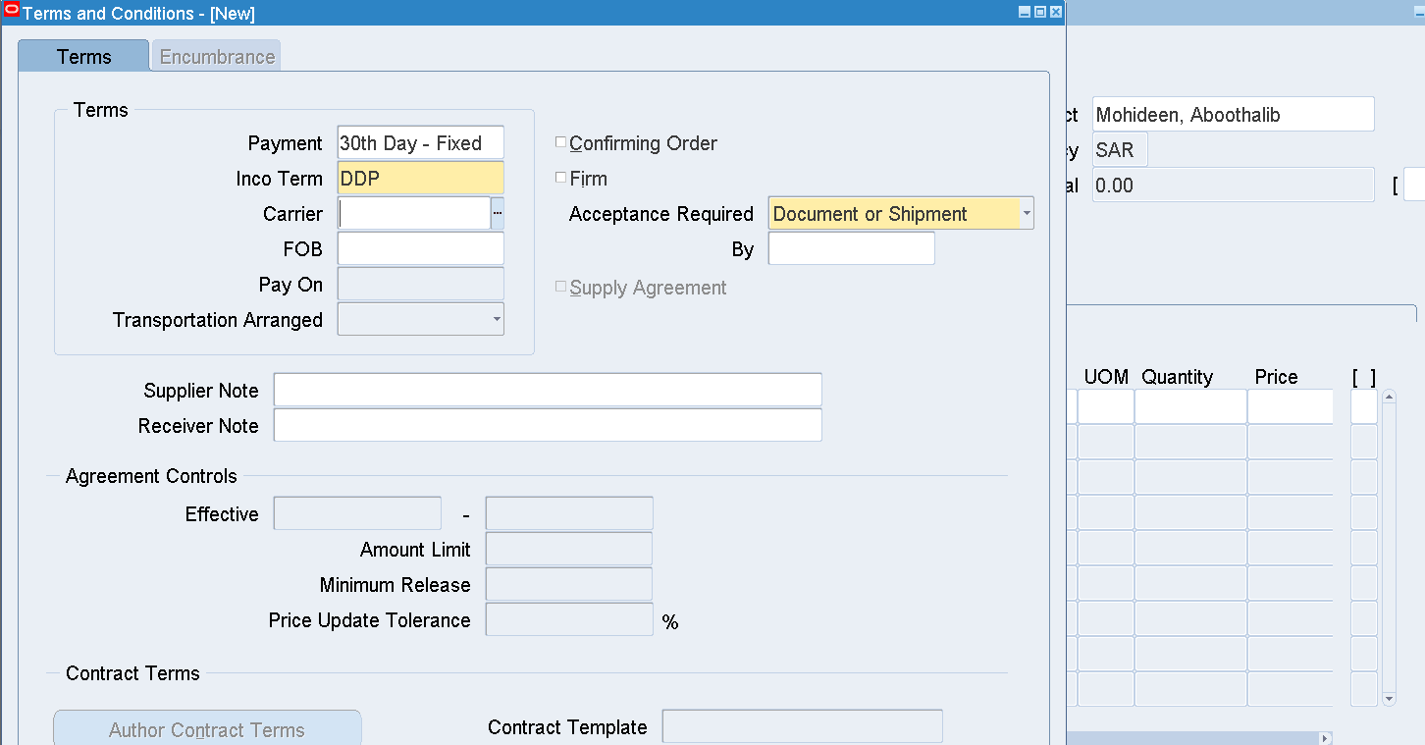

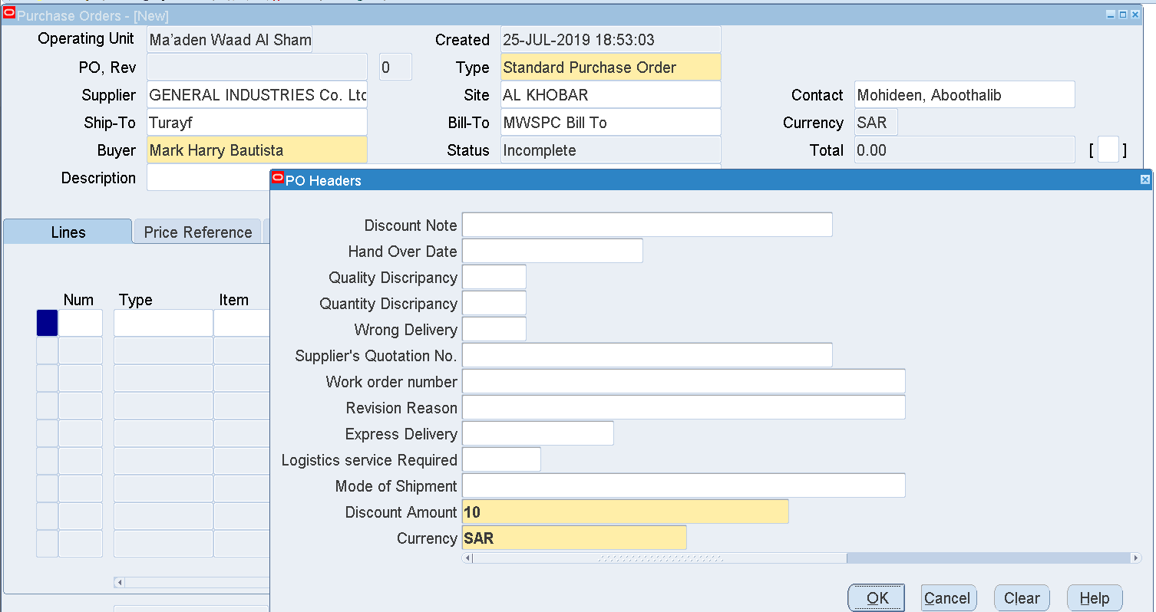

Enter Discount amount on the Header DFF

Currency - AED

Enter an Item – 1000350101

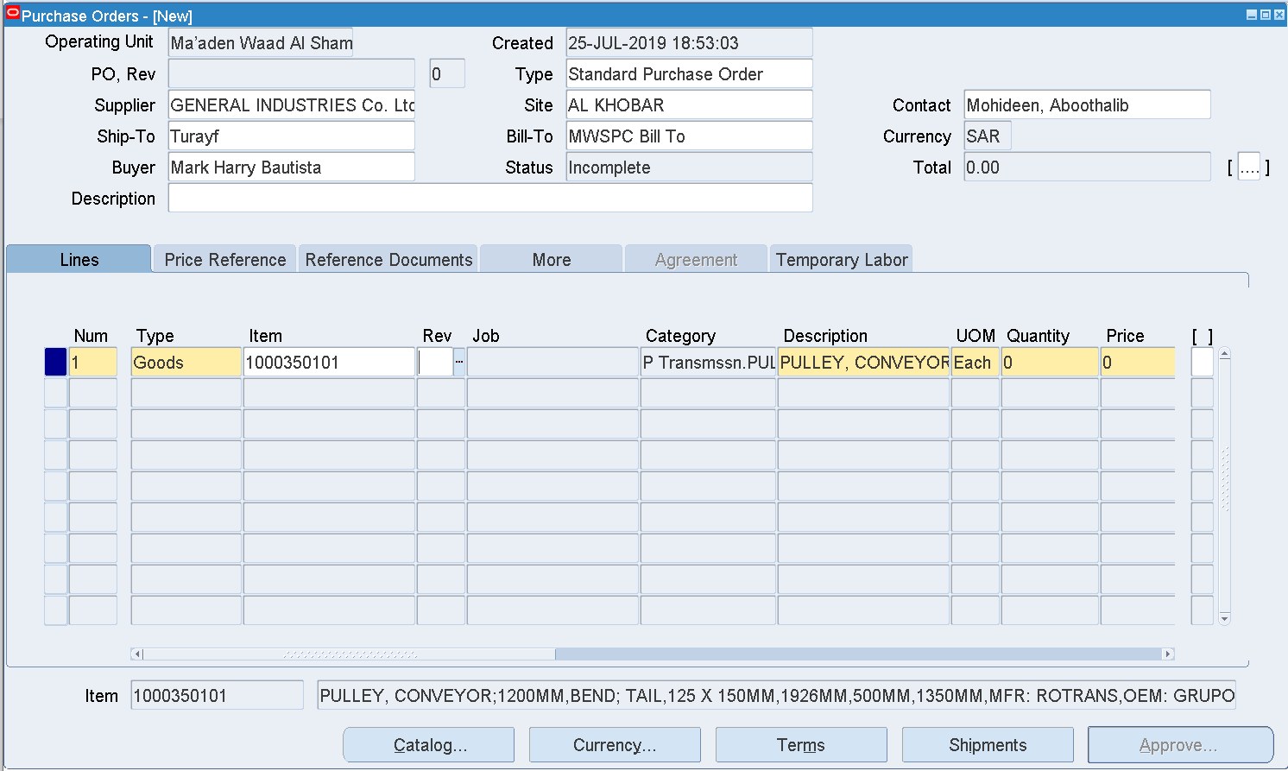

Enter Quantity –

Price

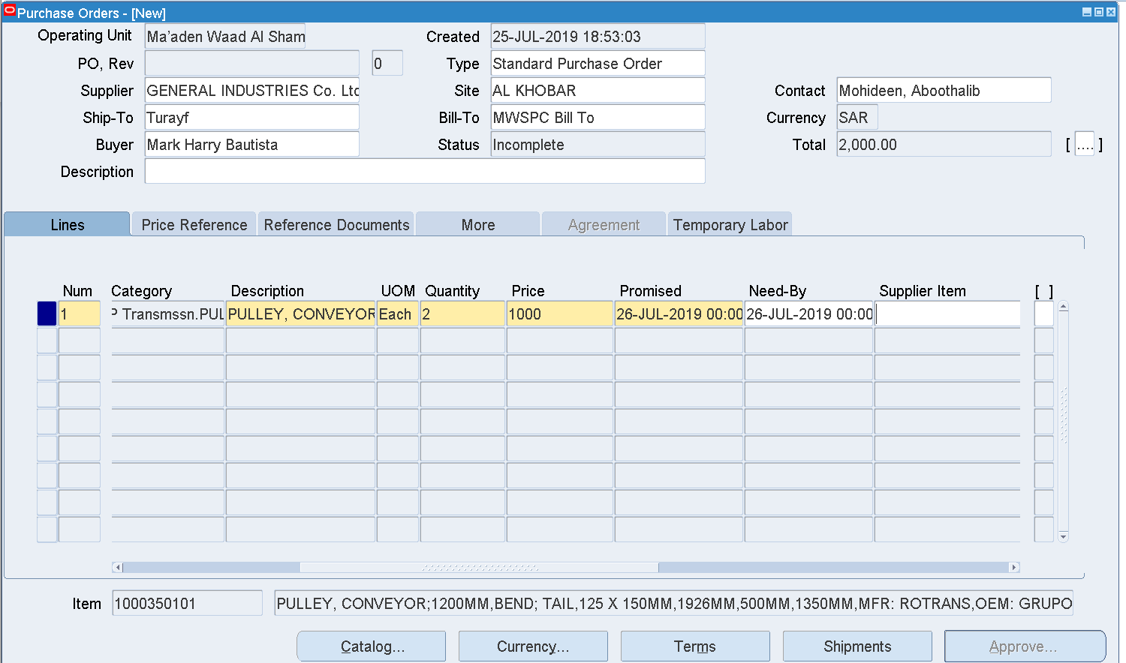

Enter Promised Date - 25-MAR-2025 00:00:00

Need by Date - 25-MAR-2025 00:00:00

Click Shipments

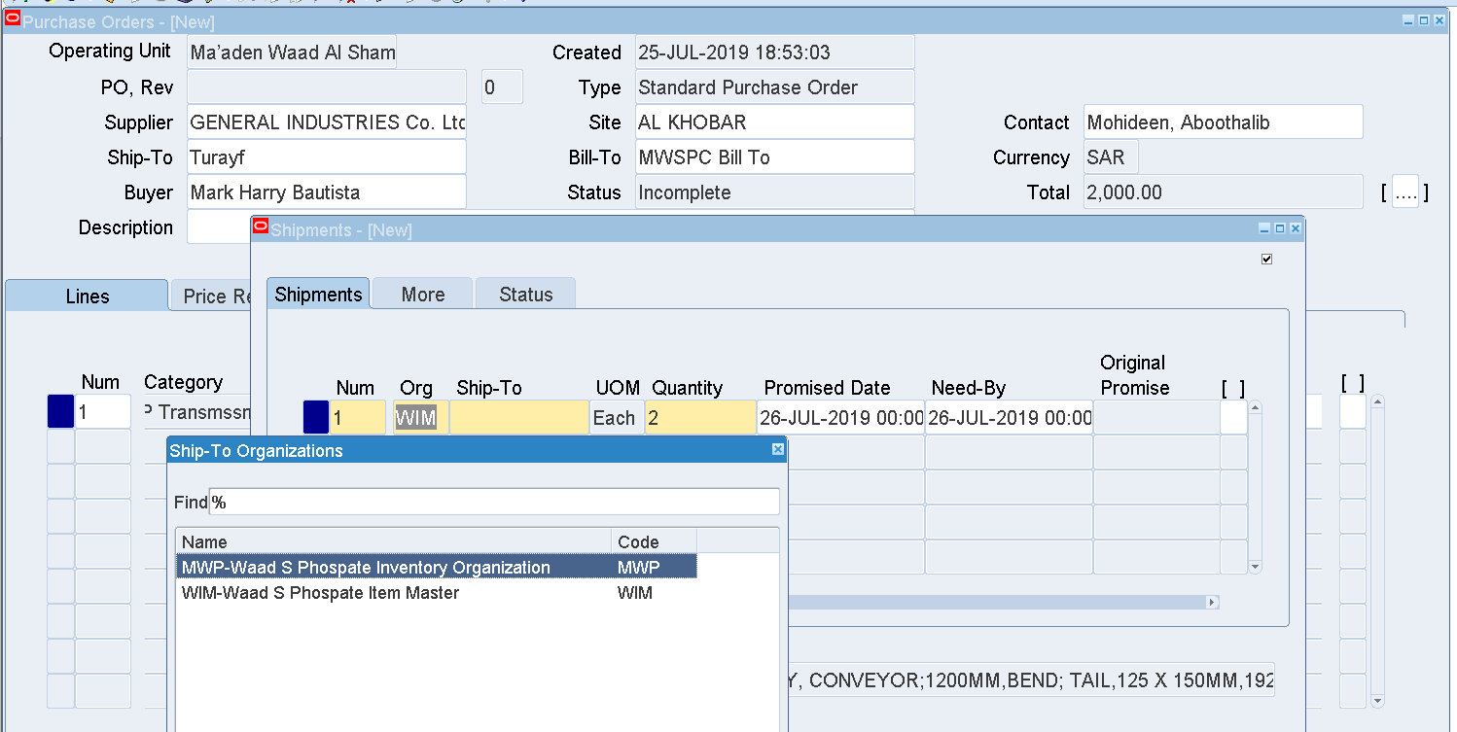

Enter Org – MWP

Ship to - AlKhobar

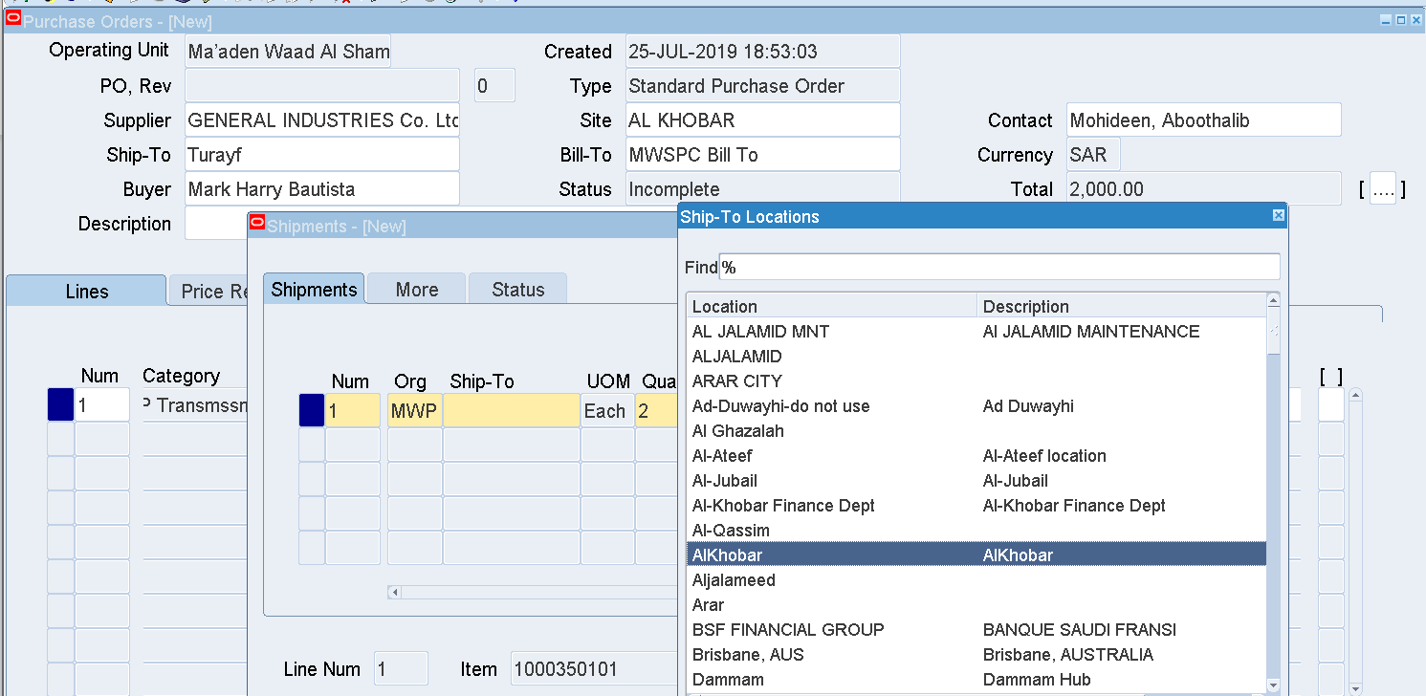

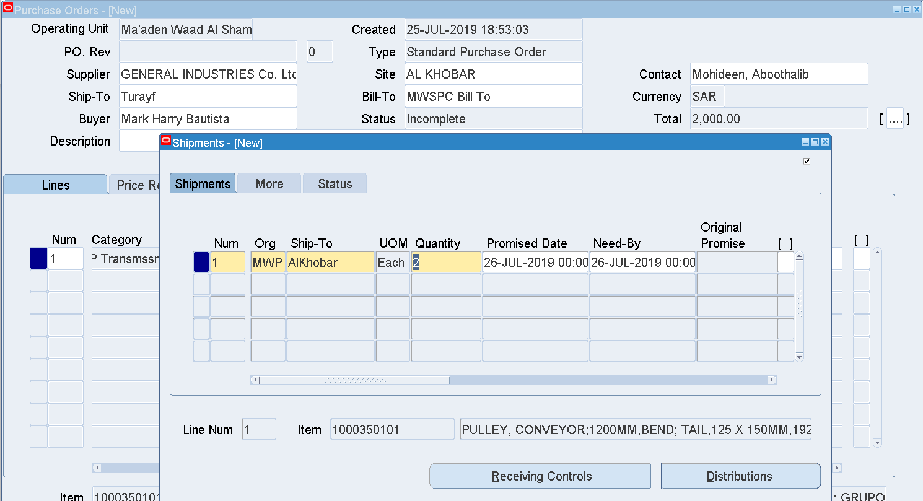

Save

Then a PO number will be generated

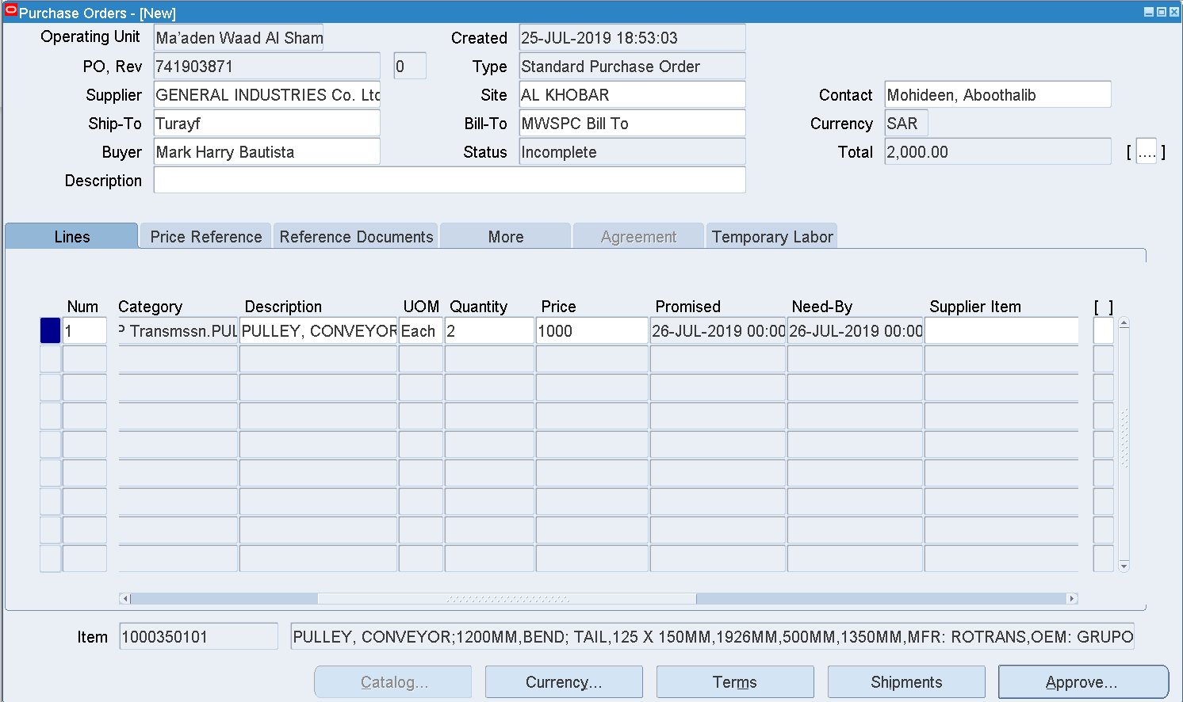

PO – 741903871

Approve

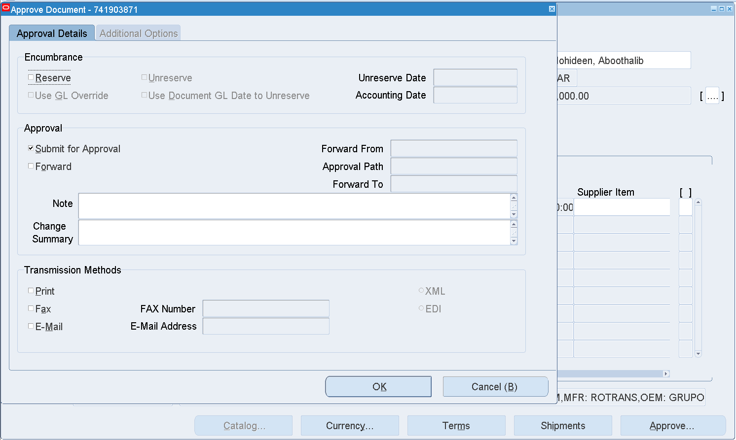

Check the Reserve check box

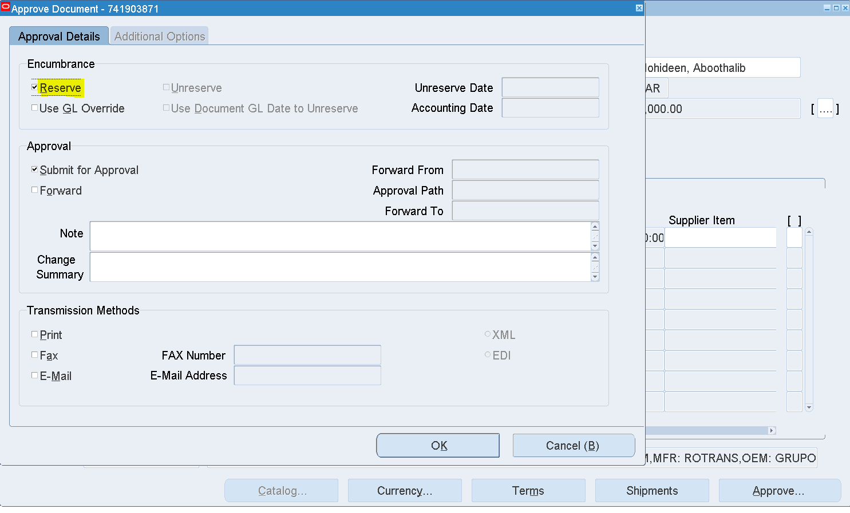

OK

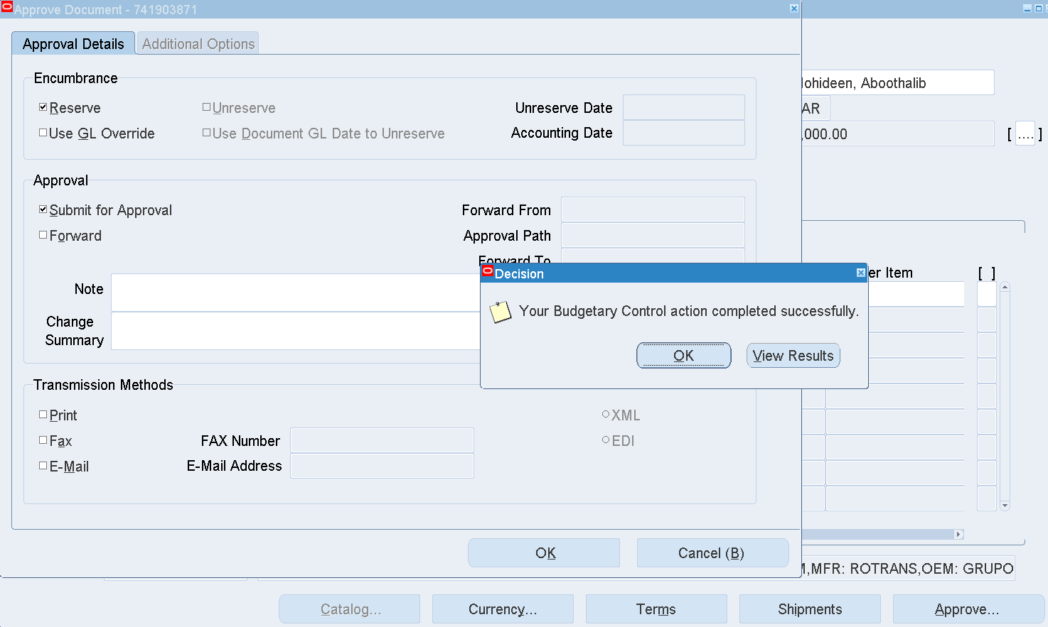

Funds are Reserved for this PO

OK

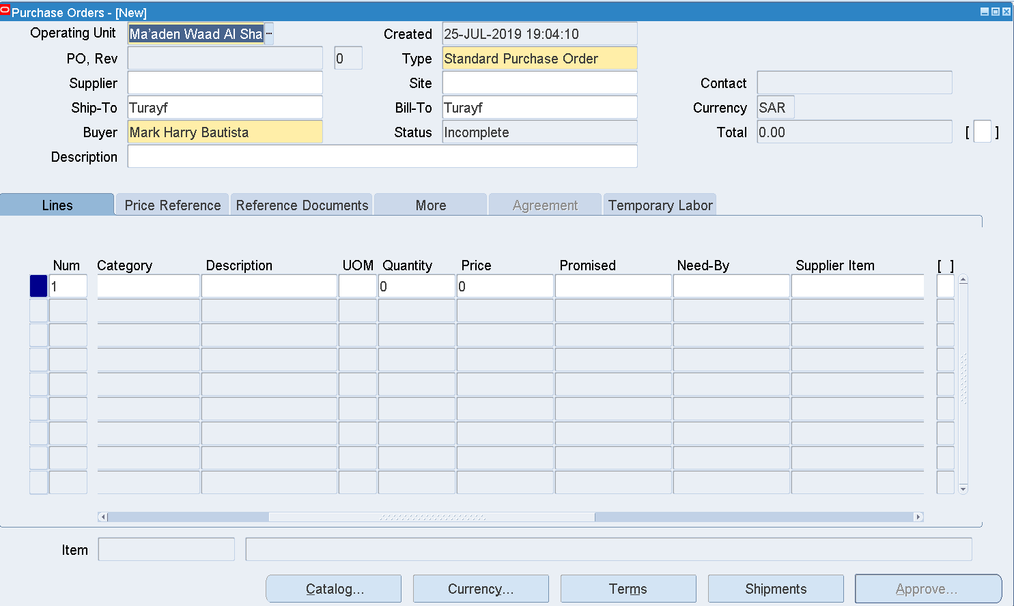

The PO is sent to an Approver for Approval

Check the PO status

Purchase Orders 🡪 Purchase Orders

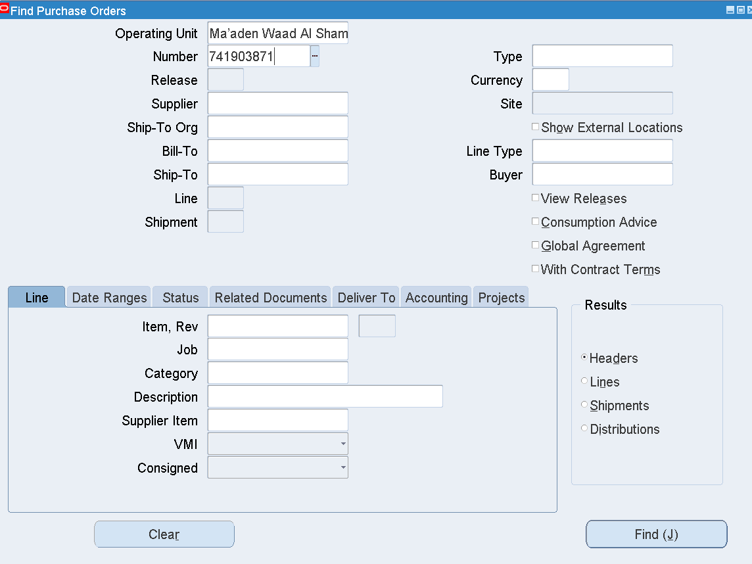

Enter the PO num and Find

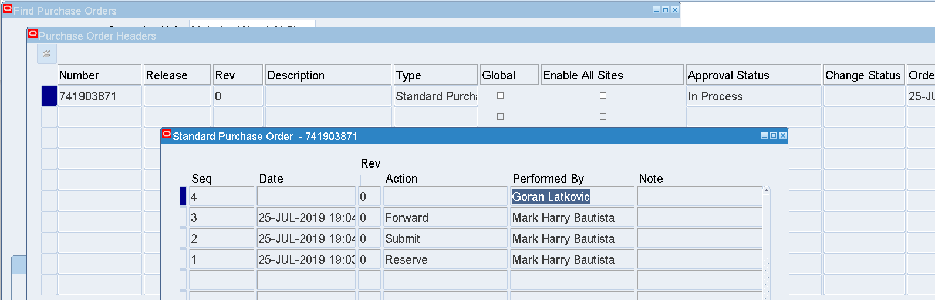

The PO status is In Process

The PO is forwarded to Goran Latkovic for Approval

Login as LATKOVICG

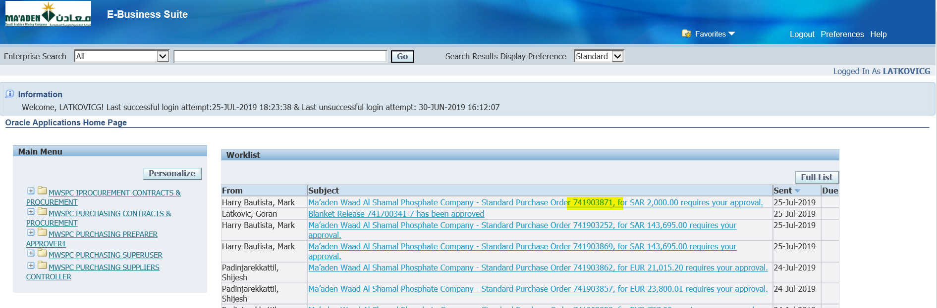

Select the Notification

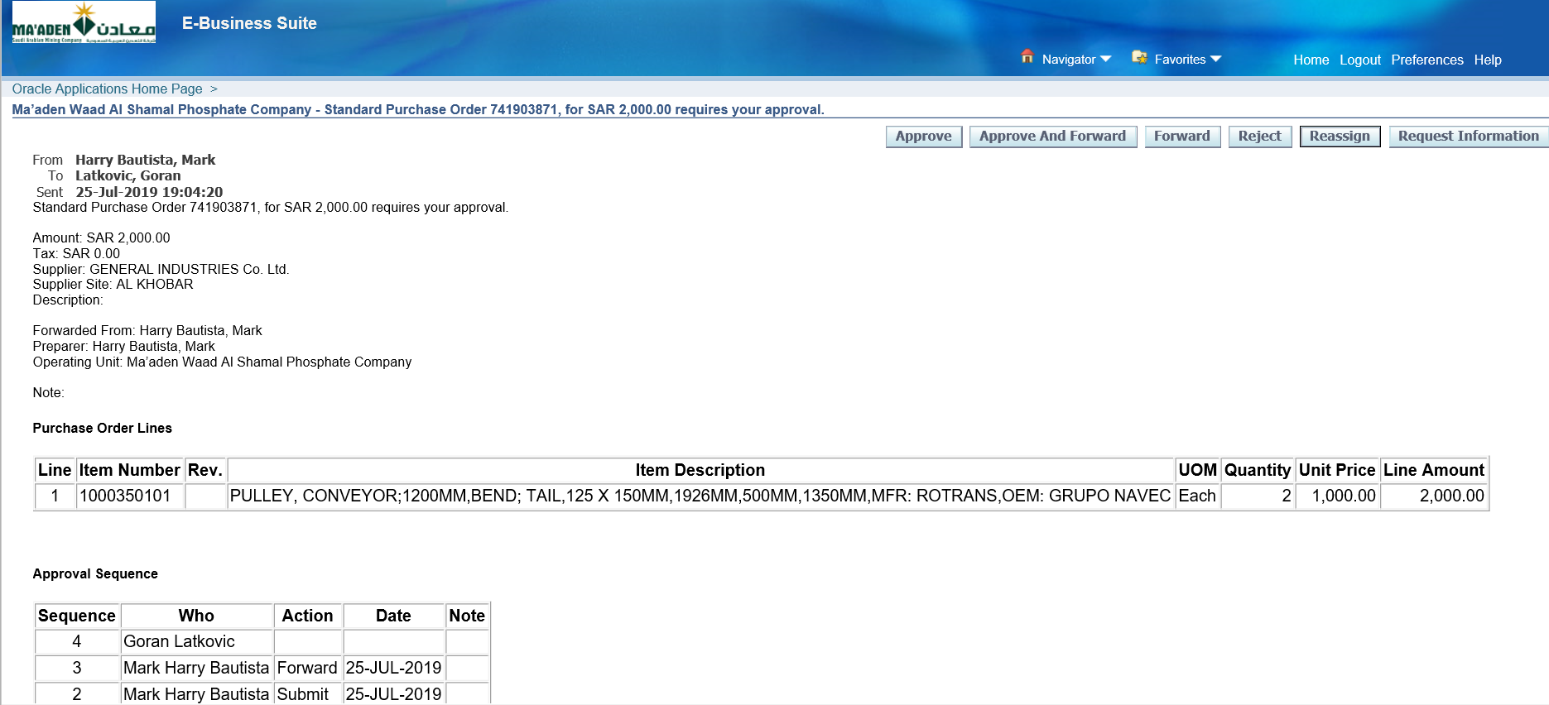

Click Approve

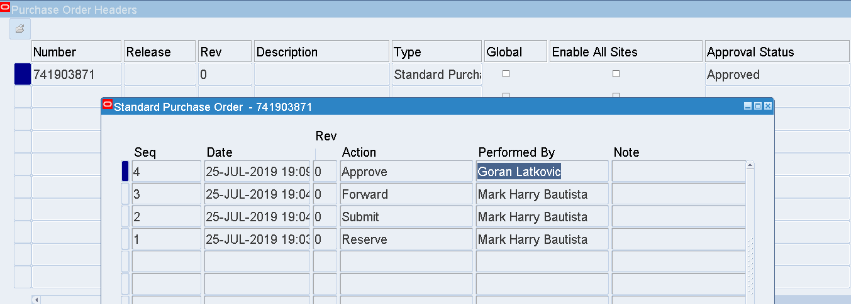

The PO has been Approved by Goran Latkovic

Login as BAUTISTAMH

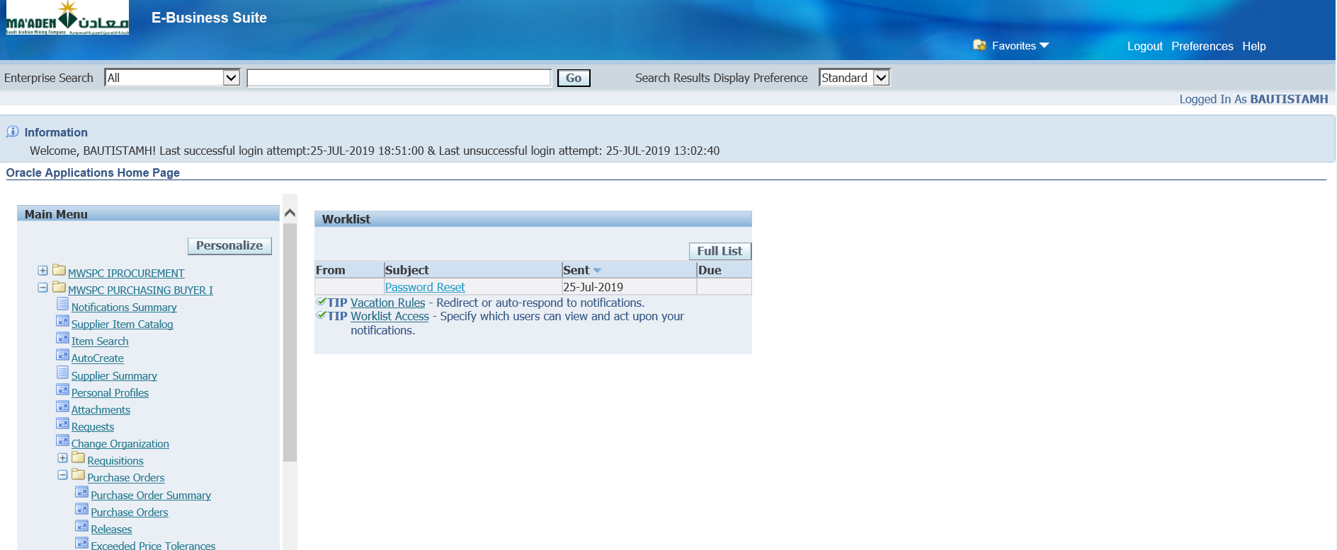

MWSPC Purchasing Buyer

Purchase Orders 🡪 Purchase Orders

1. Update a PO while In Process status

MWSPC Purchasing Buyer

User – BAUTISTAMH

Purchase Orders 🡪 Purchase Orders

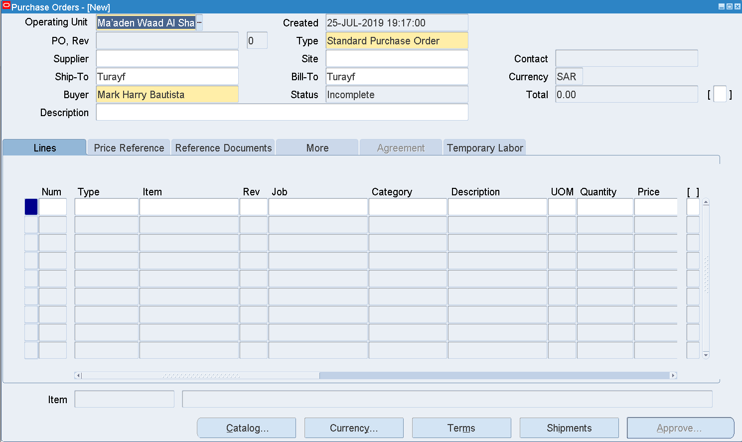

Enter Supplier - GENERAL INDUSTRIES Co. Ltd.

Site – AL KHOBAR

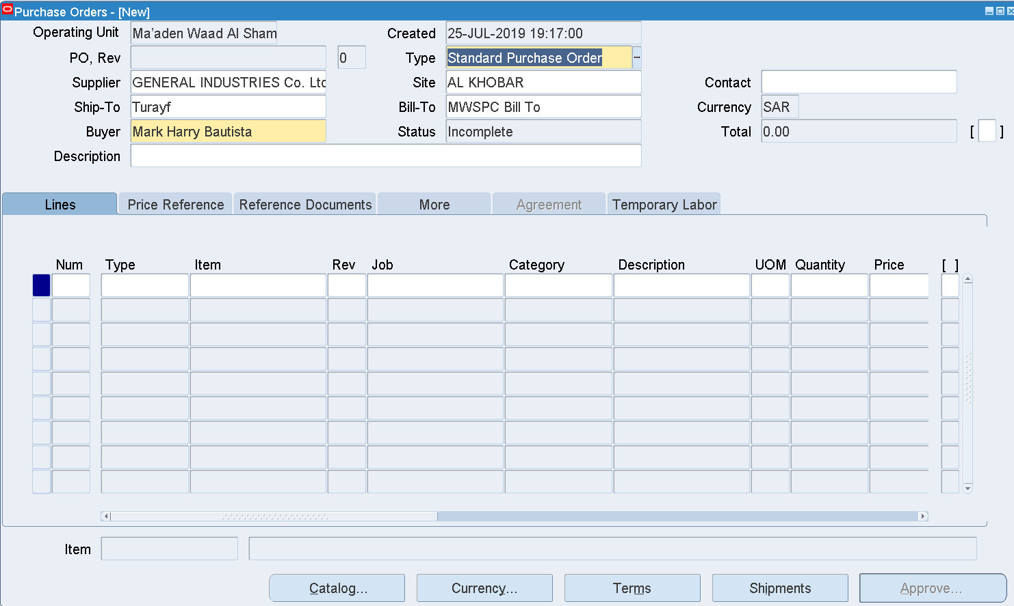

Enter Inco Term

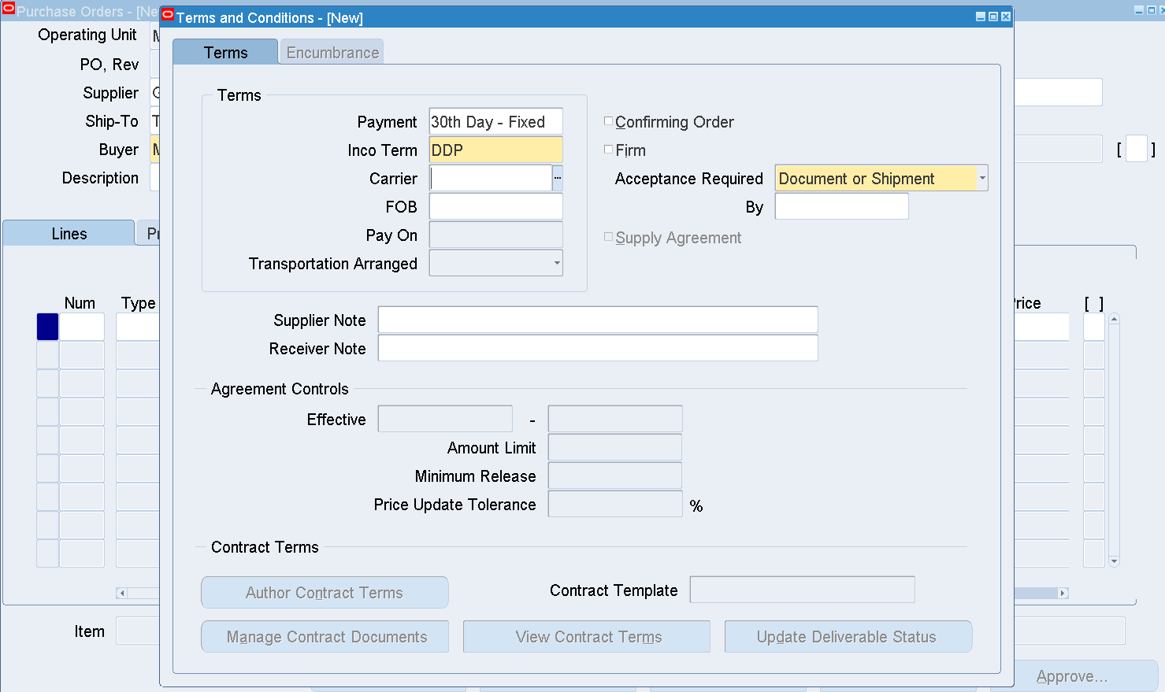

DDP

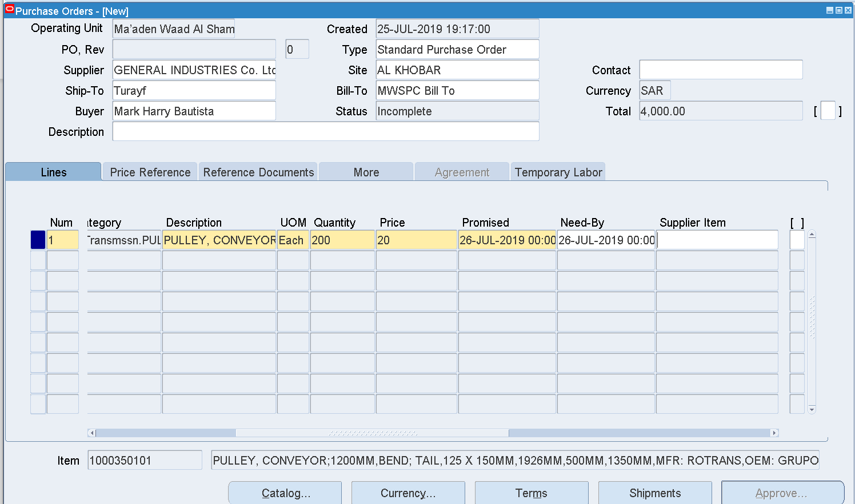

Enter Item – 1000350101

Quantity – 2

Price –660

Promised Date –01-SEP-2019 00:00:00

Need by Date –01-SEP-2019 00:00:00

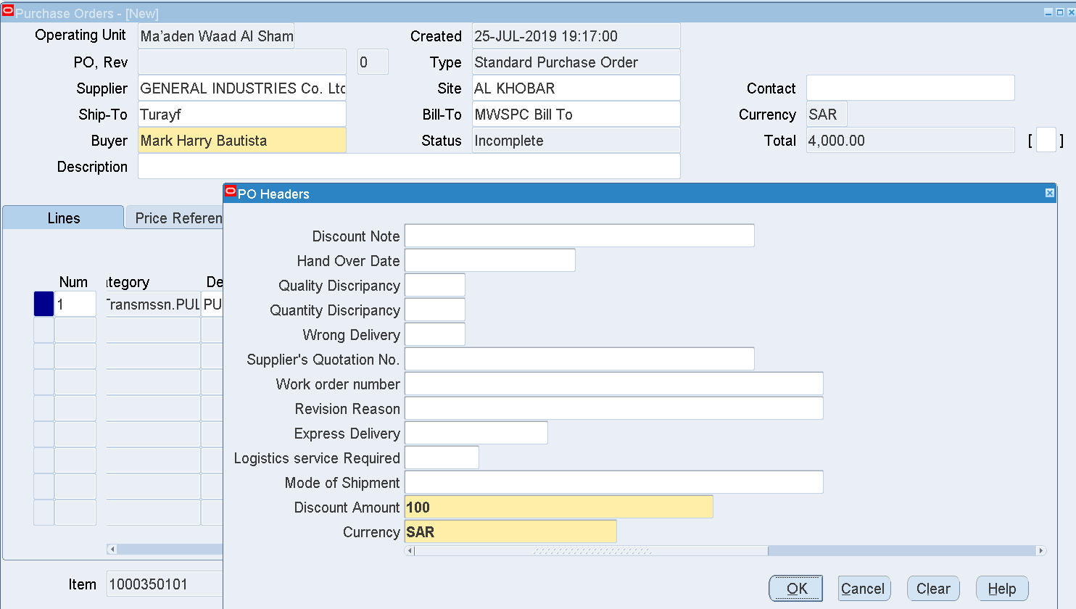

Enter Header DFF

Discount amt

Currency

OK

Shipments 🡪

Enter Org – MWP

Location 🡪 AlKhobar

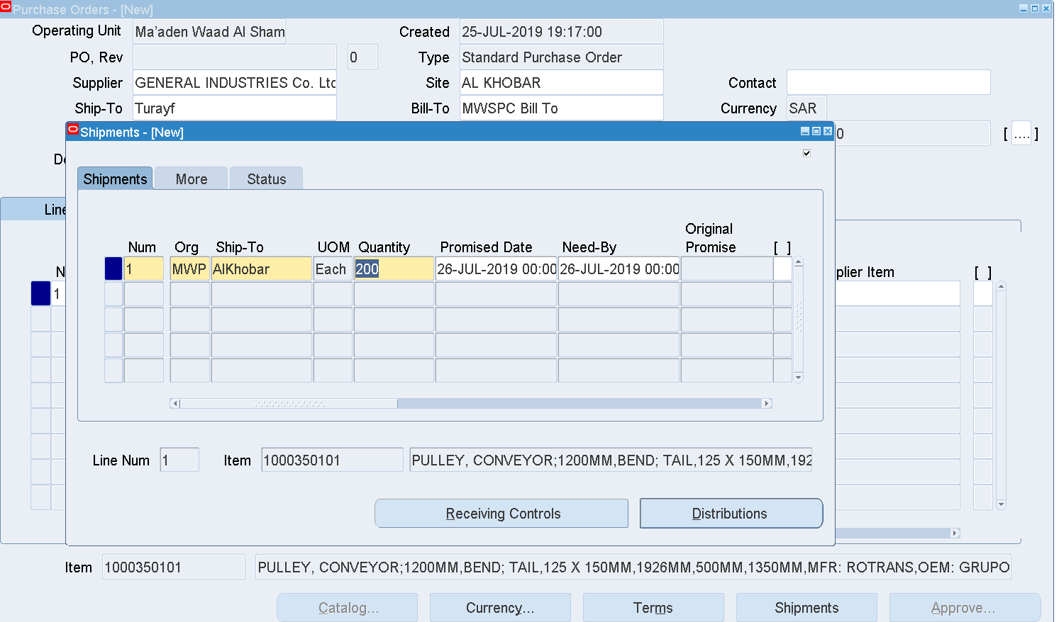

Distrbution-POCharges-> 01.05.530.25.0000.1260.00000

Save

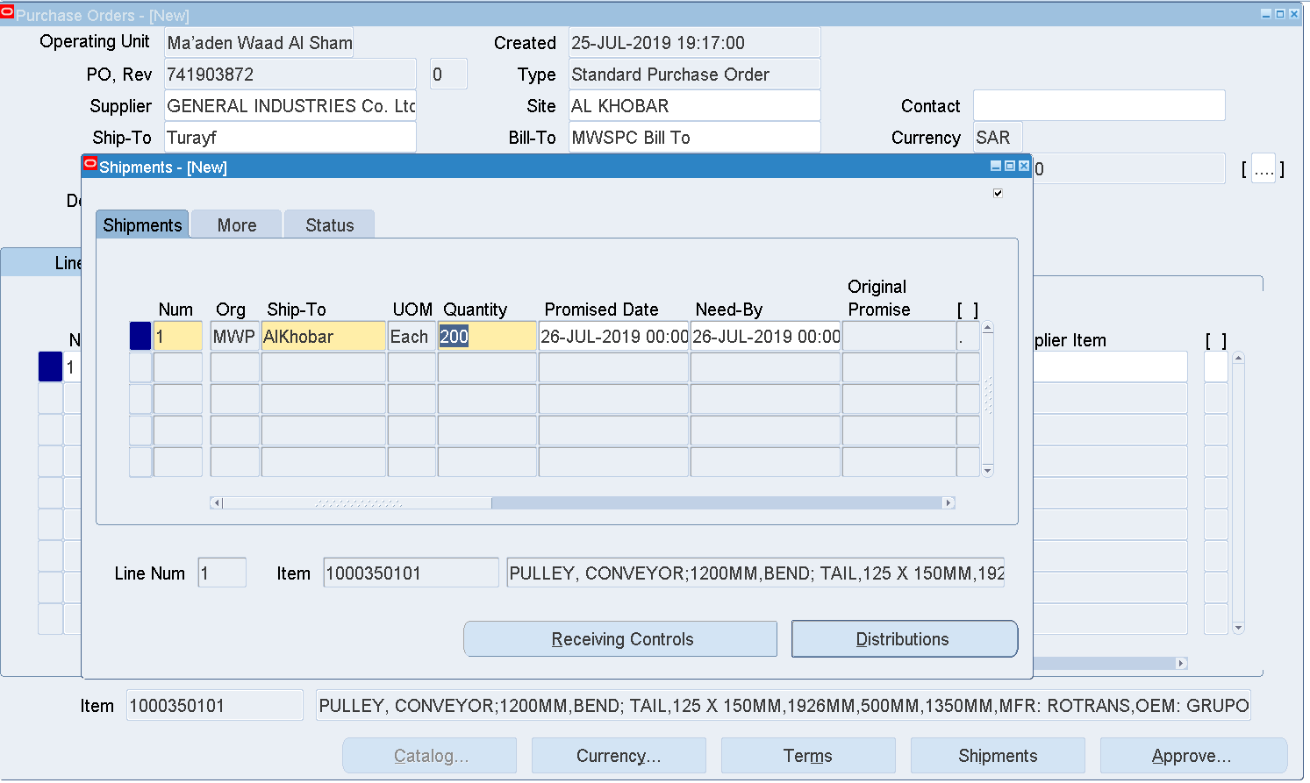

PO number 741903872 has been generated

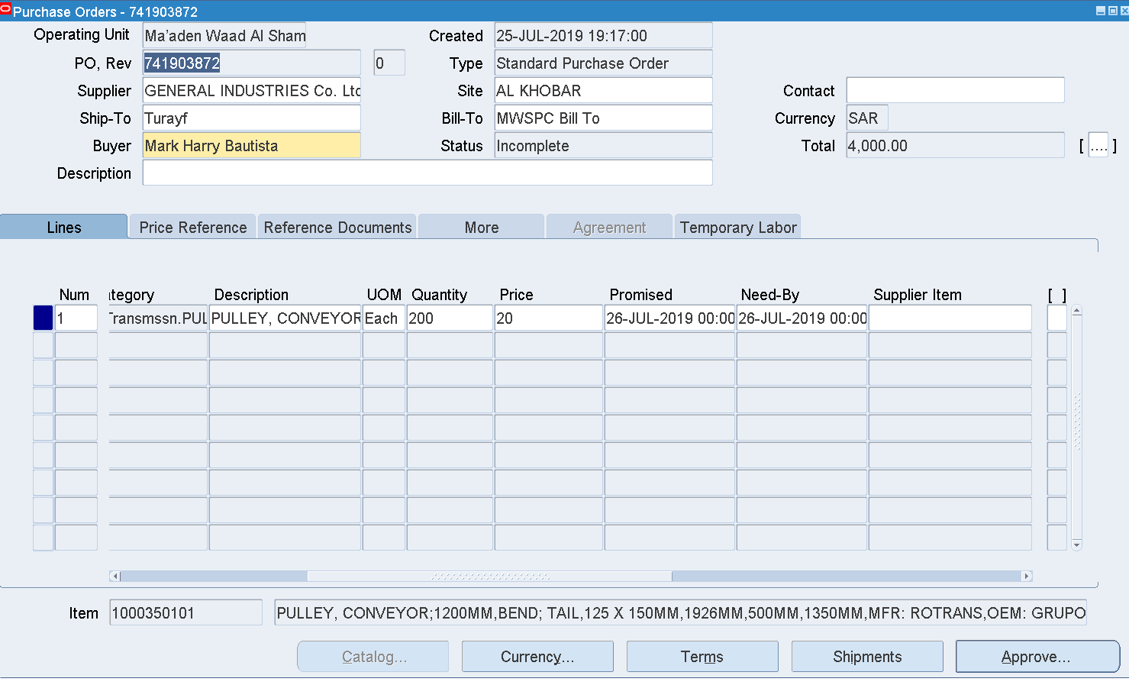

Approve

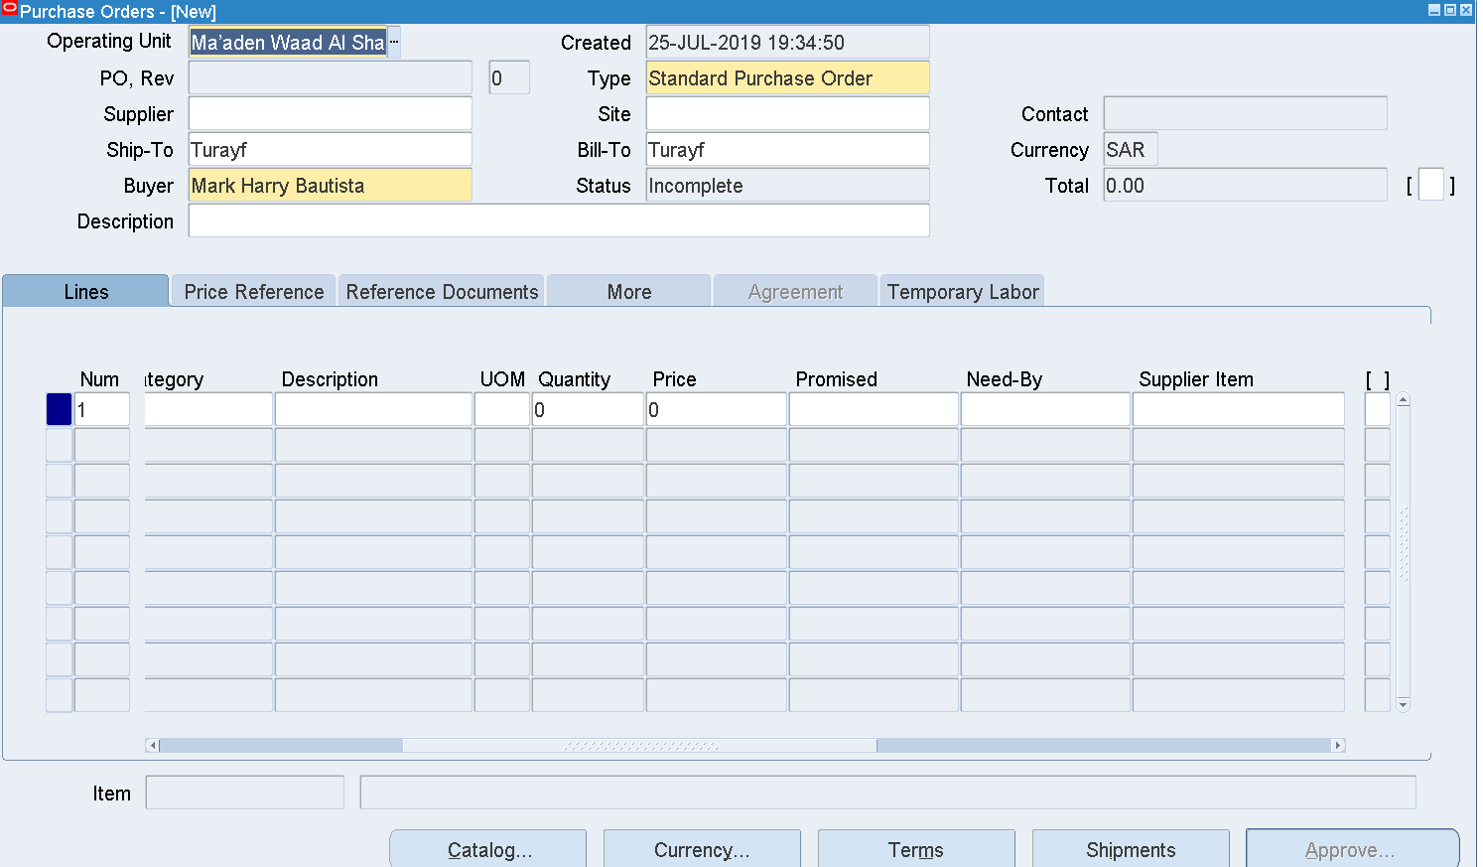

The PO has been sent for Approval

Check the PO status

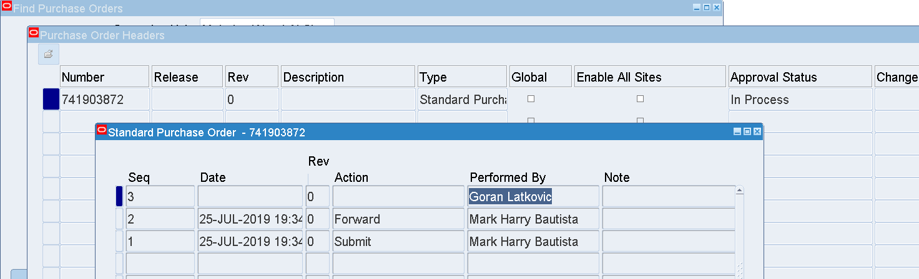

Purchase Orders 🡪 Purchase Orders

Enter Purchase order number 🡪 Find

The PO is sent for Goran Latkovic for Approval

Login as LATKOVICG

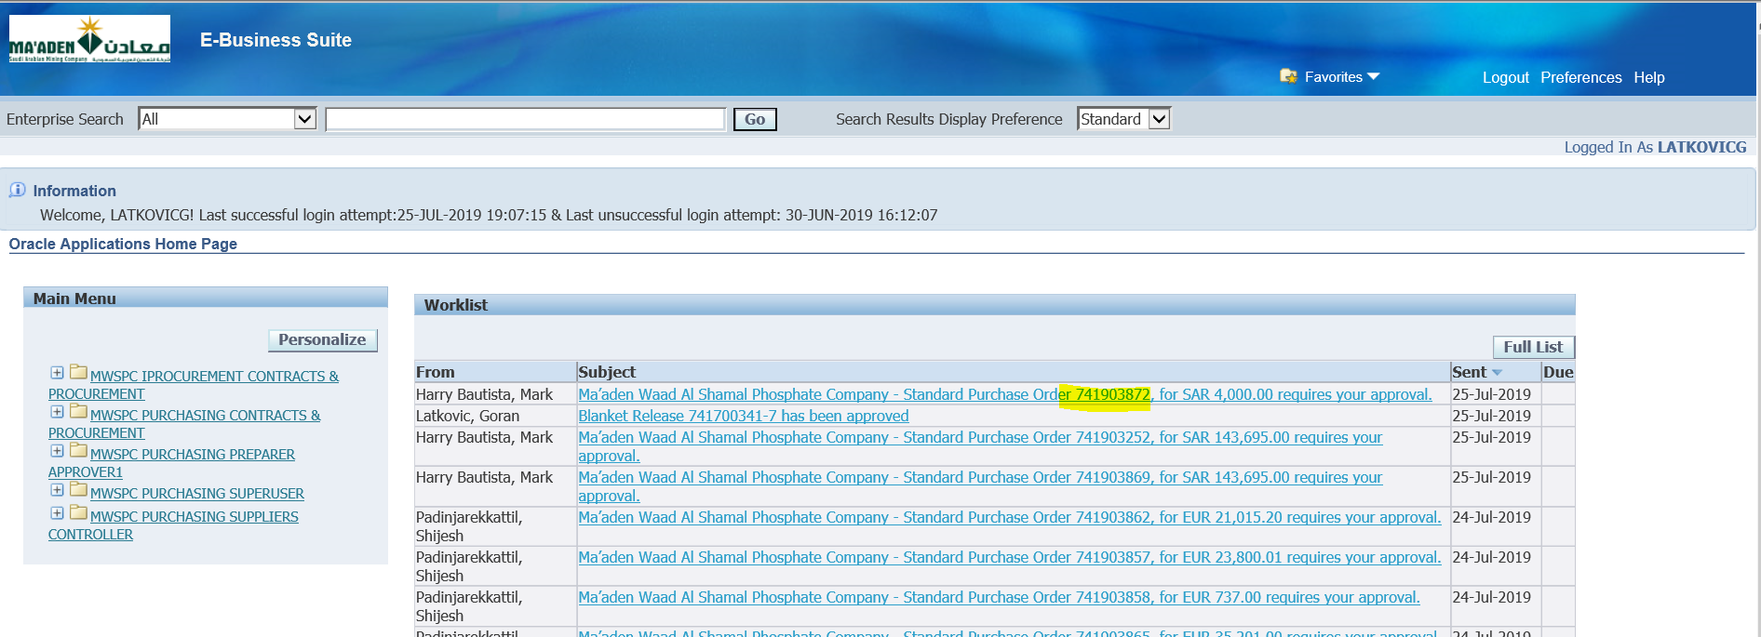

Select the Notification

Goran Latkovic wants more Information before approving the PO

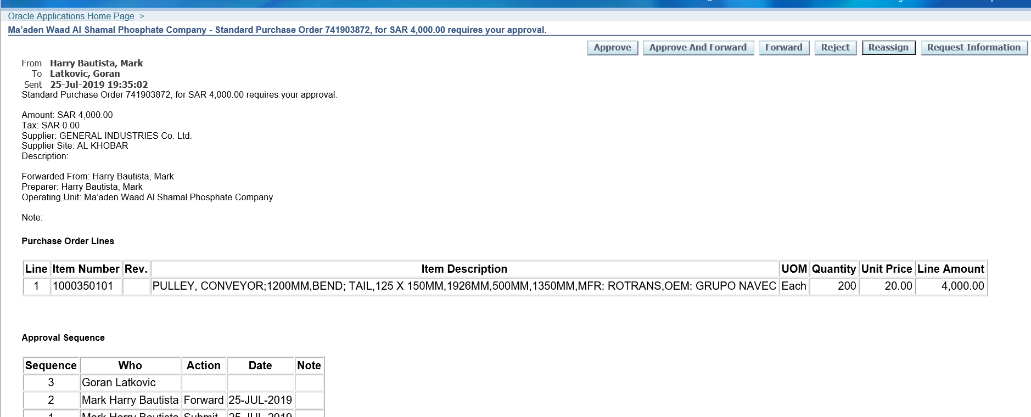

Request Information

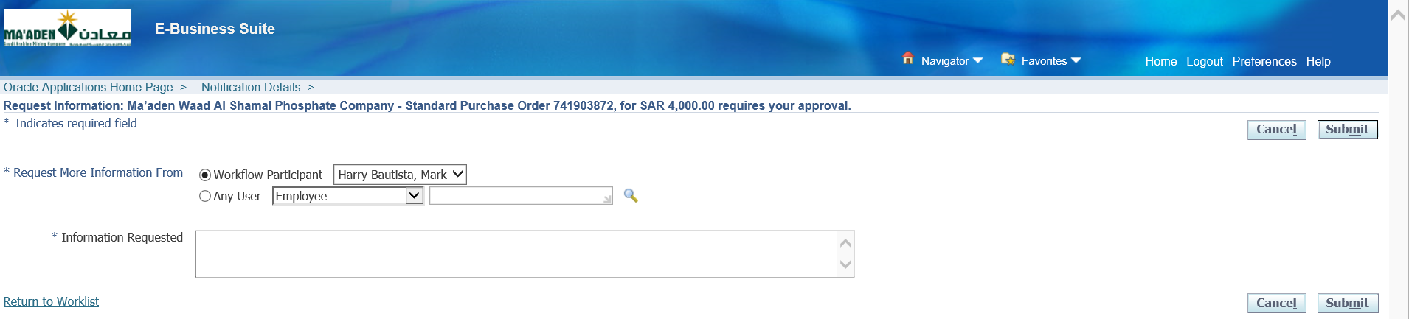

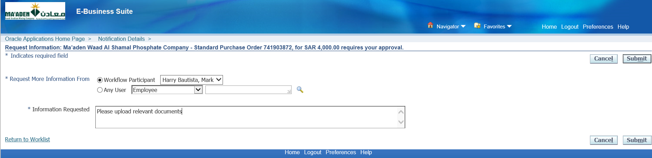

Goran Latkovic wants to see relevant Documents

So entered Information Requested

The Workflow Participant field is auto populated as the PO is sent by BAUTISTAM

Click Submit

Submitted

More Information Request has been sent to BAUTISTAM

Login as BAUTISTAM

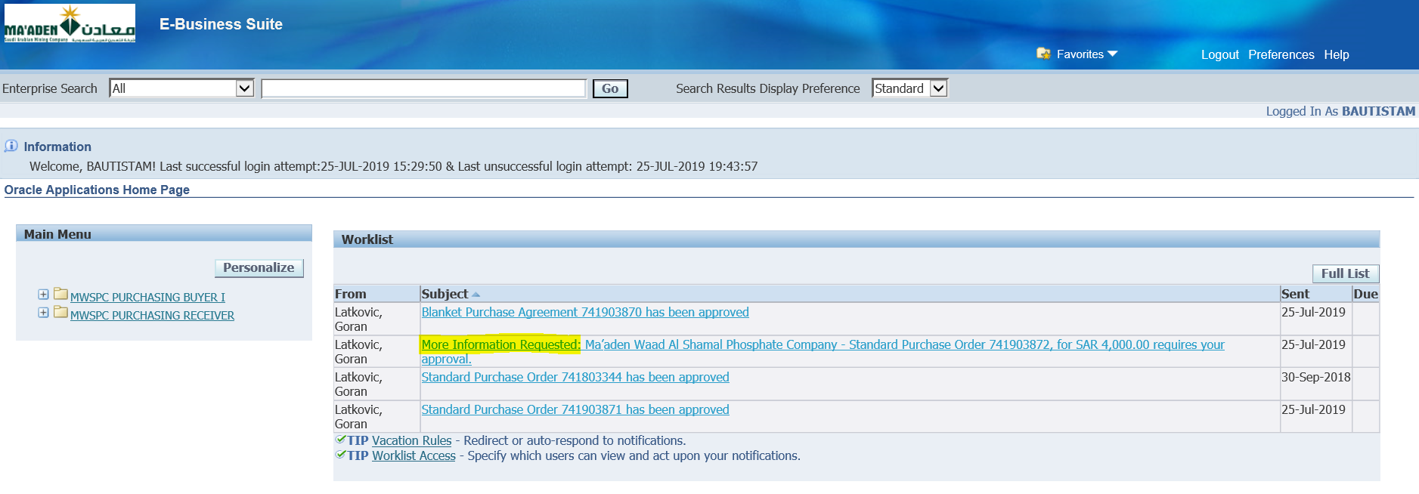

Select the More Information Request Notification link

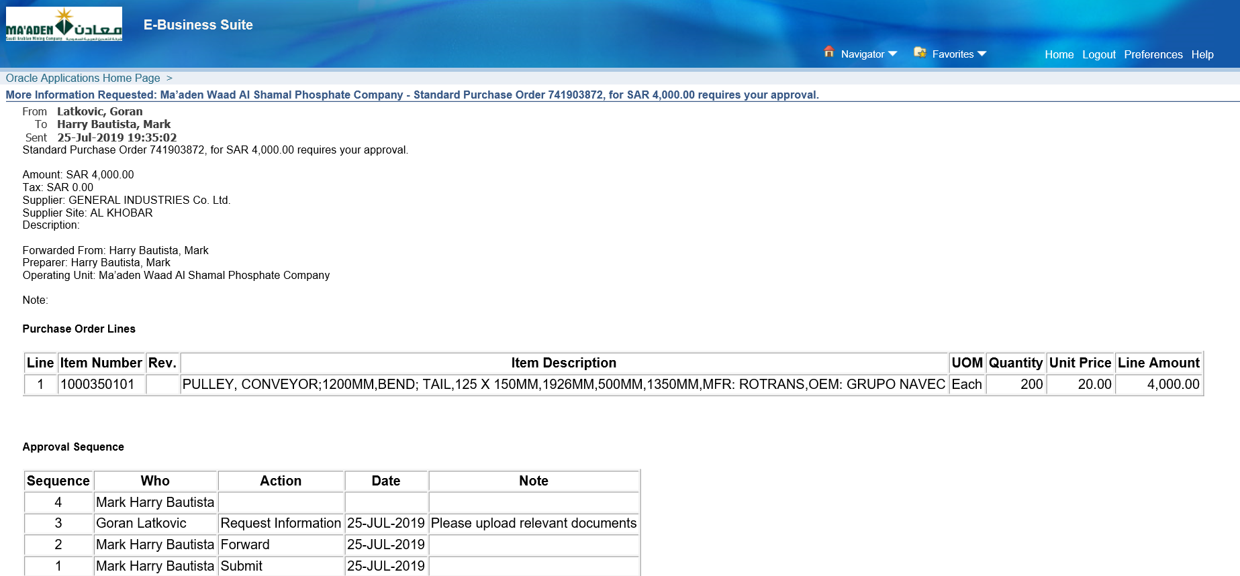

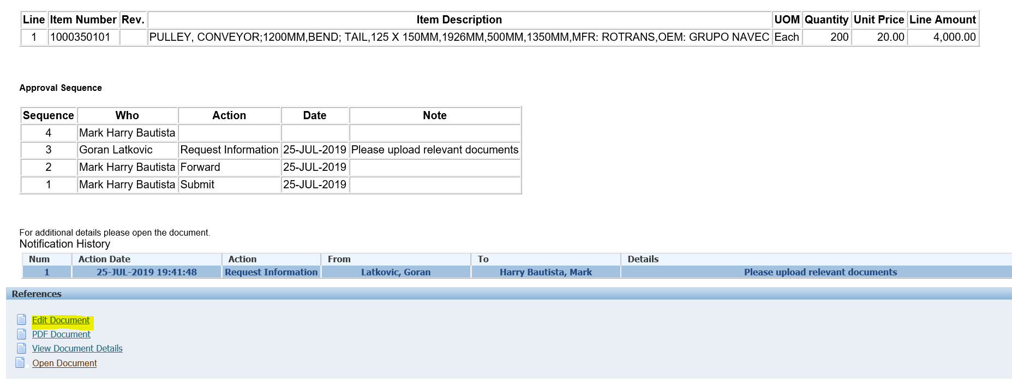

Click Edit Document

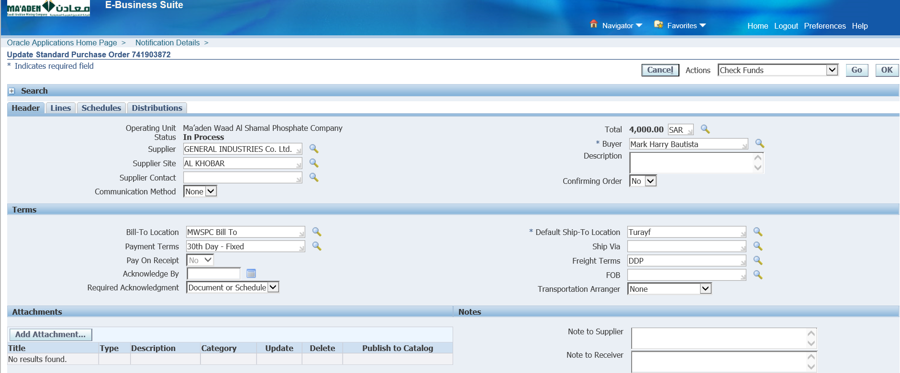

Click Add Attachment

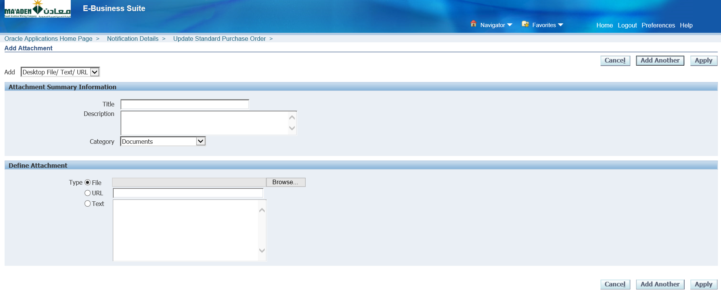

Select a File 🡪 Upload

Or Select Text 🡪 Enter Details

Or Enter URL

Select a File 🡪 Upload

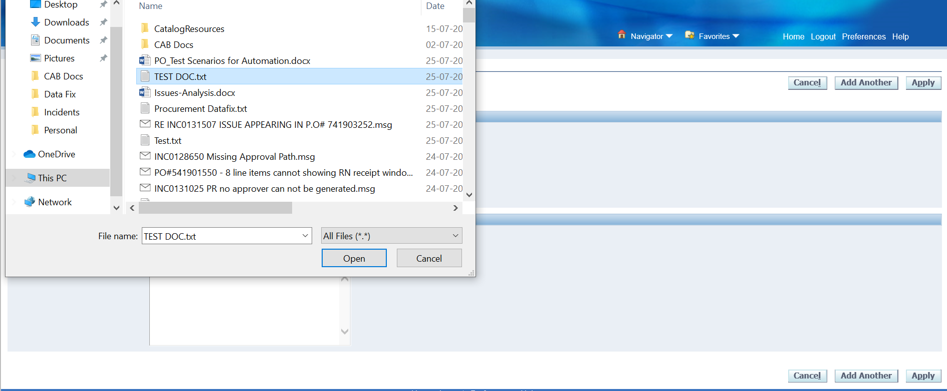

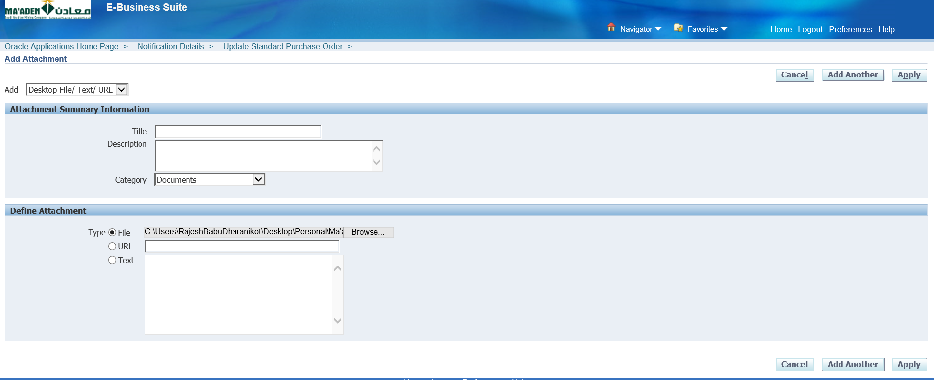

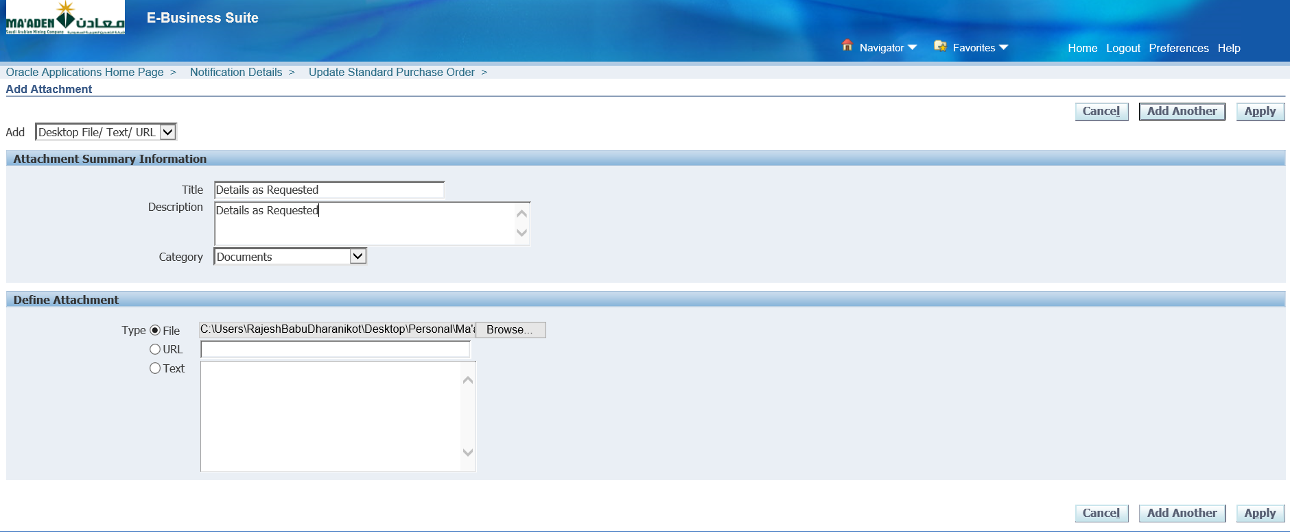

Enter Title

Apply

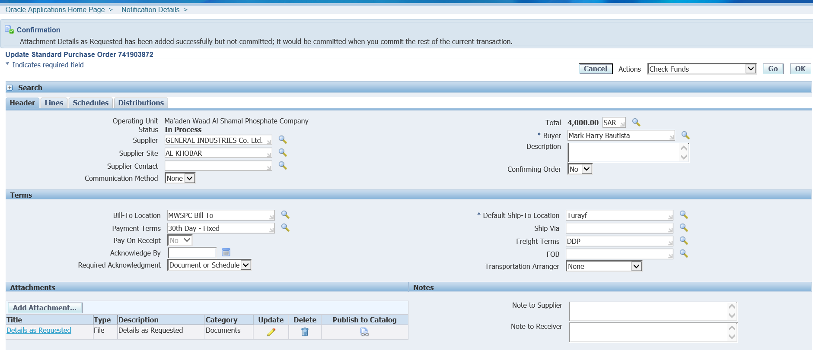

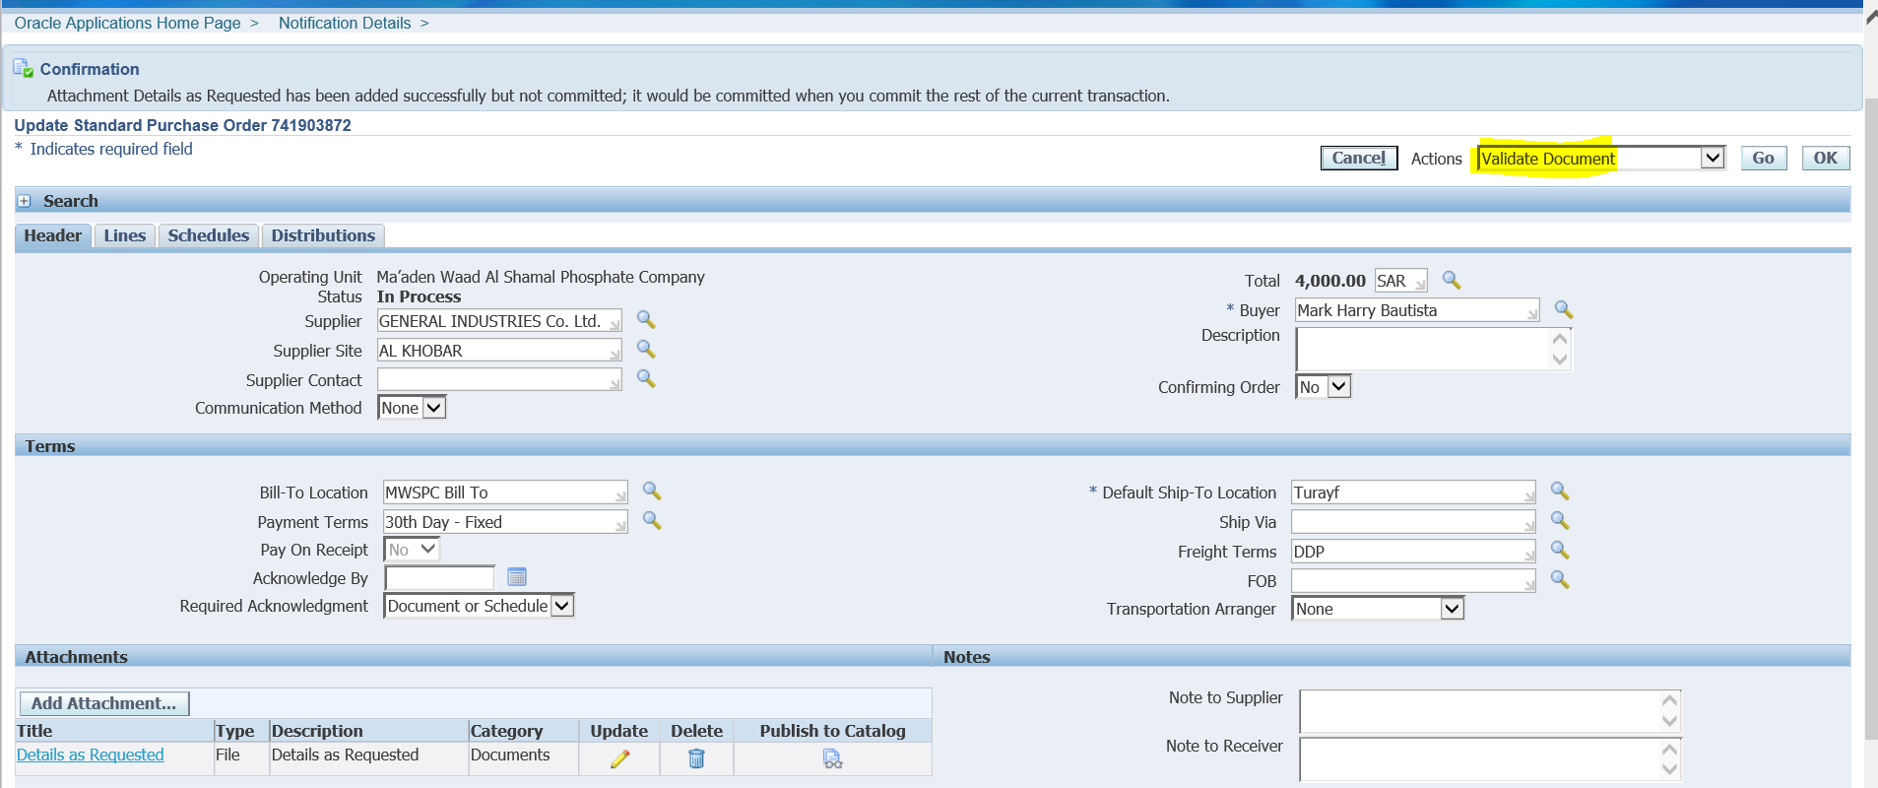

Actions 🡪 Validate Document

Go

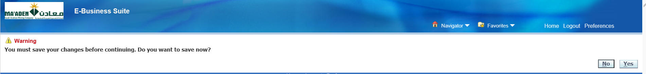

Yes

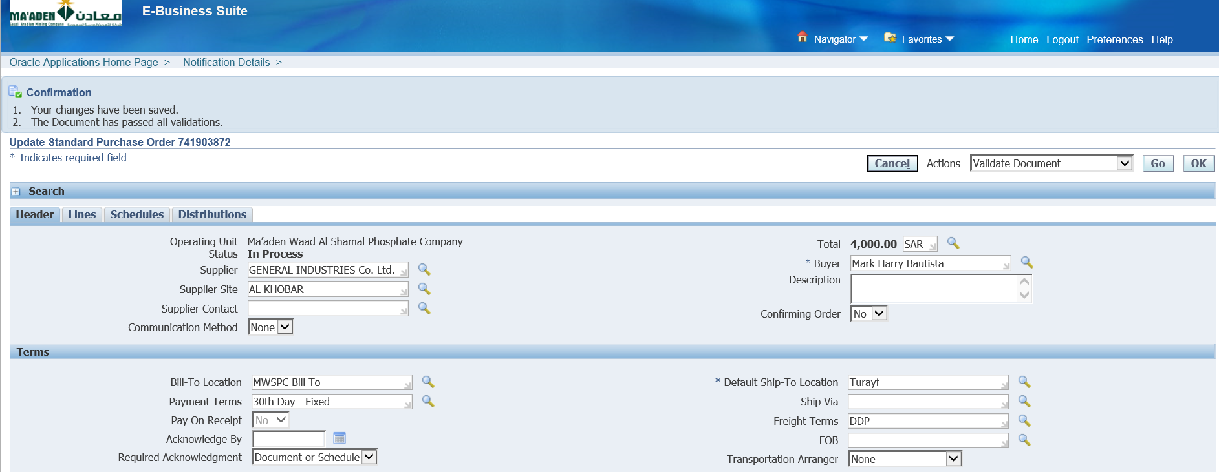

The Document has been validated

Click OK

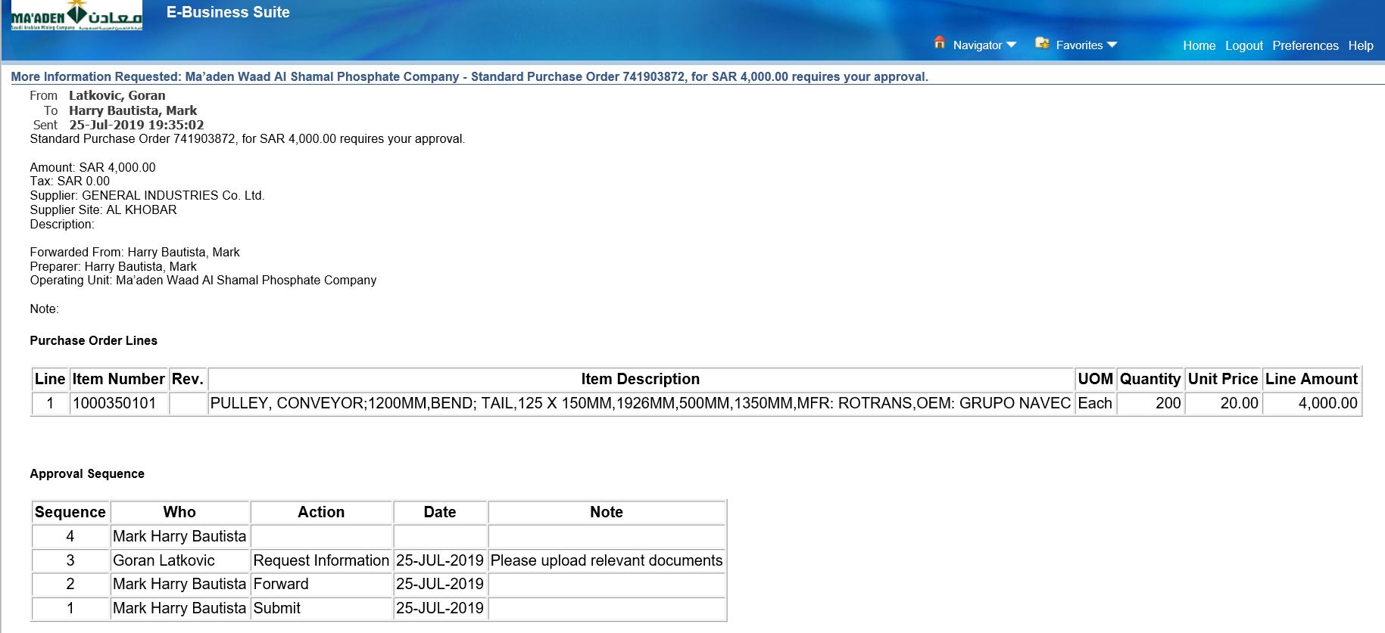

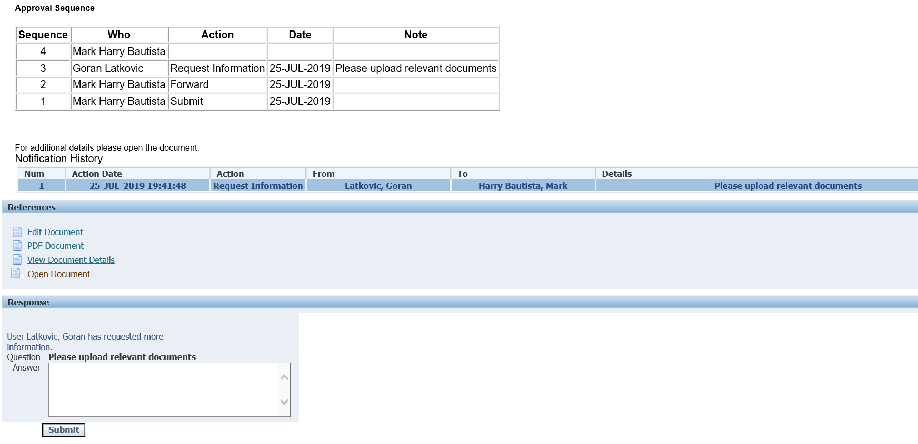

Enter Answer and Submit

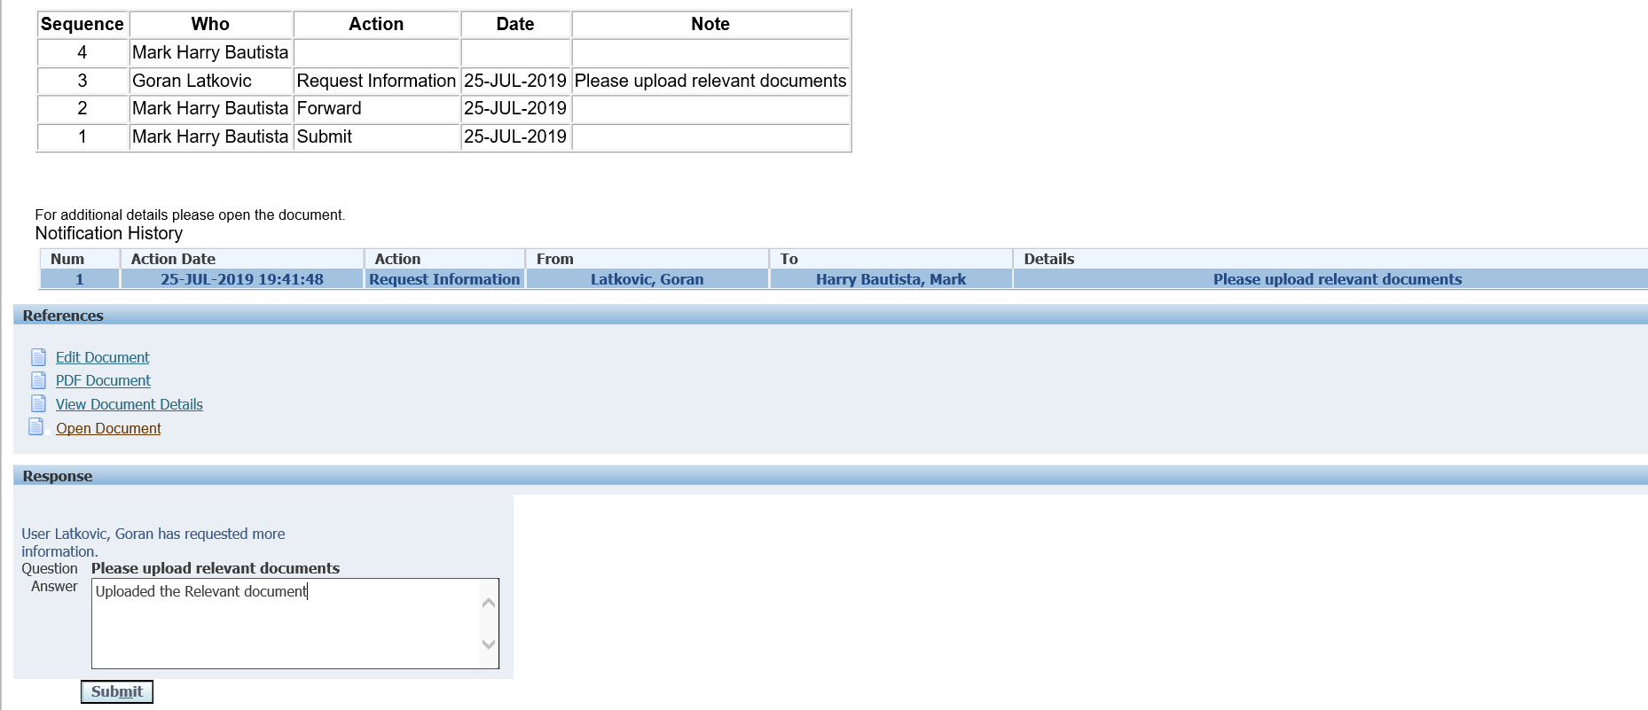

Submit

This will be sent to Goran Latkovic for Approval

Login as LATKOVICG

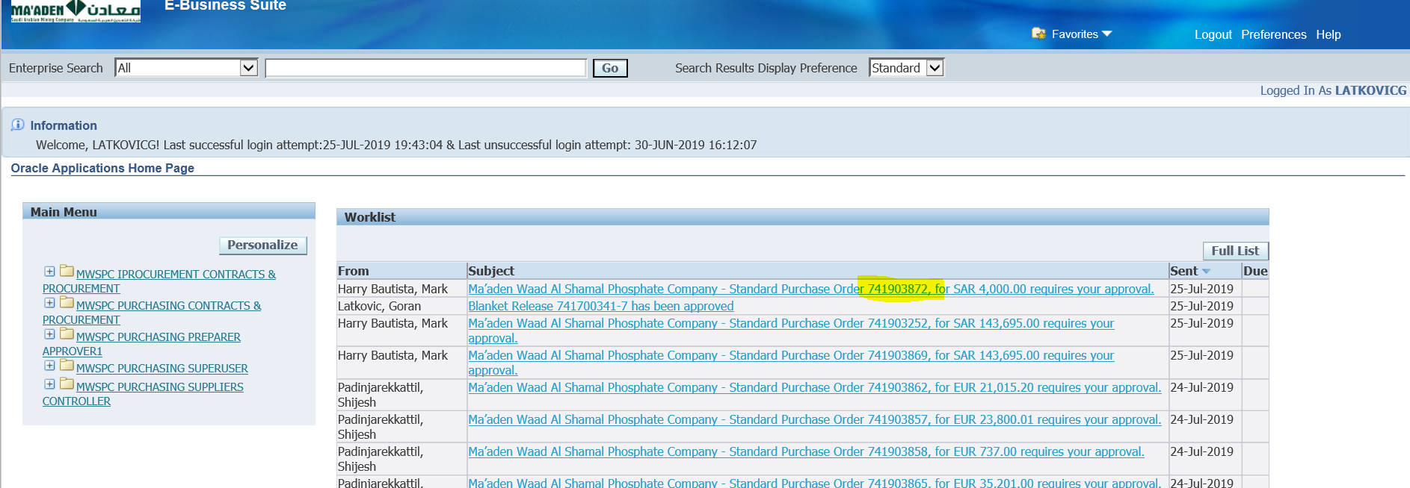

Select the PO

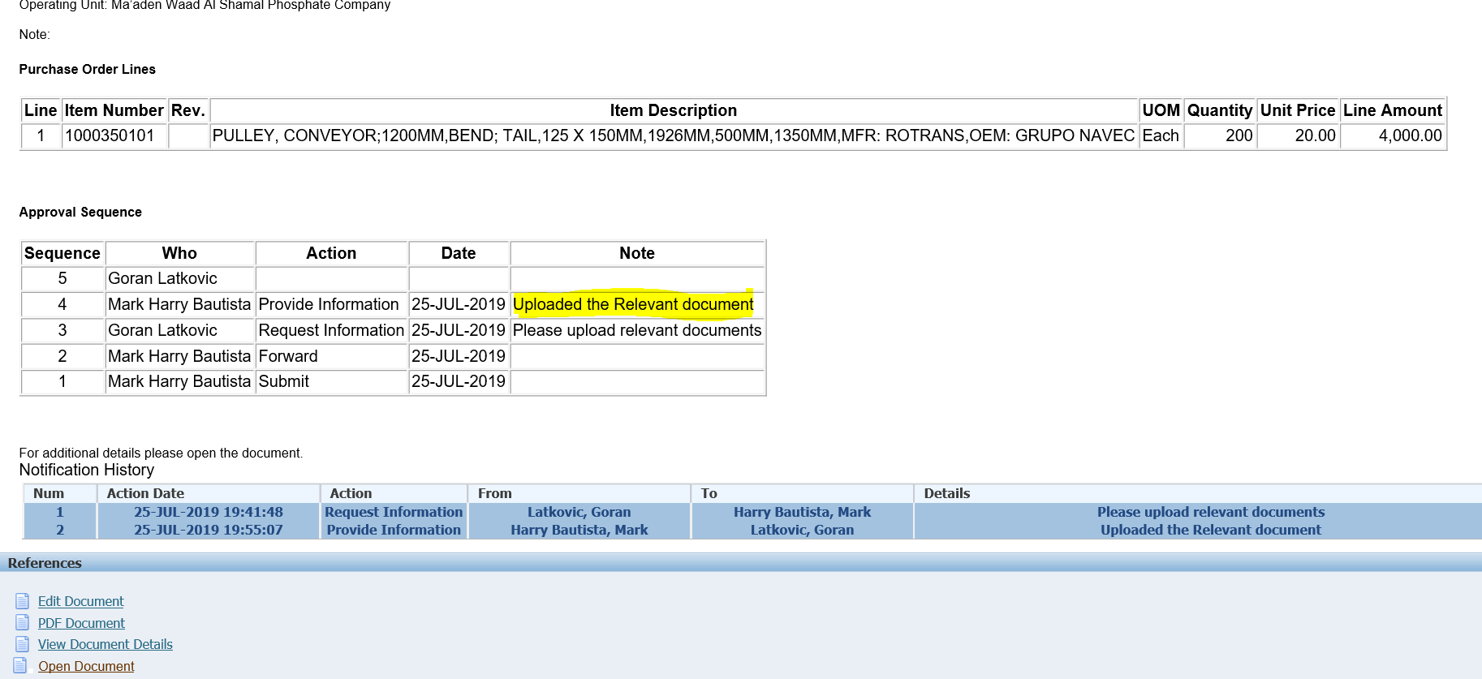

Check the Note from Bautista

To verify the attachment

Click View Document Details

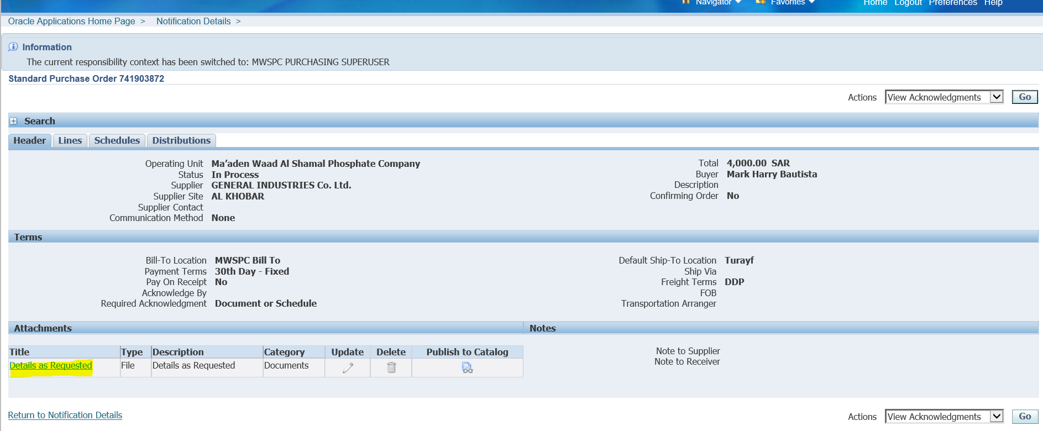

Click the Title

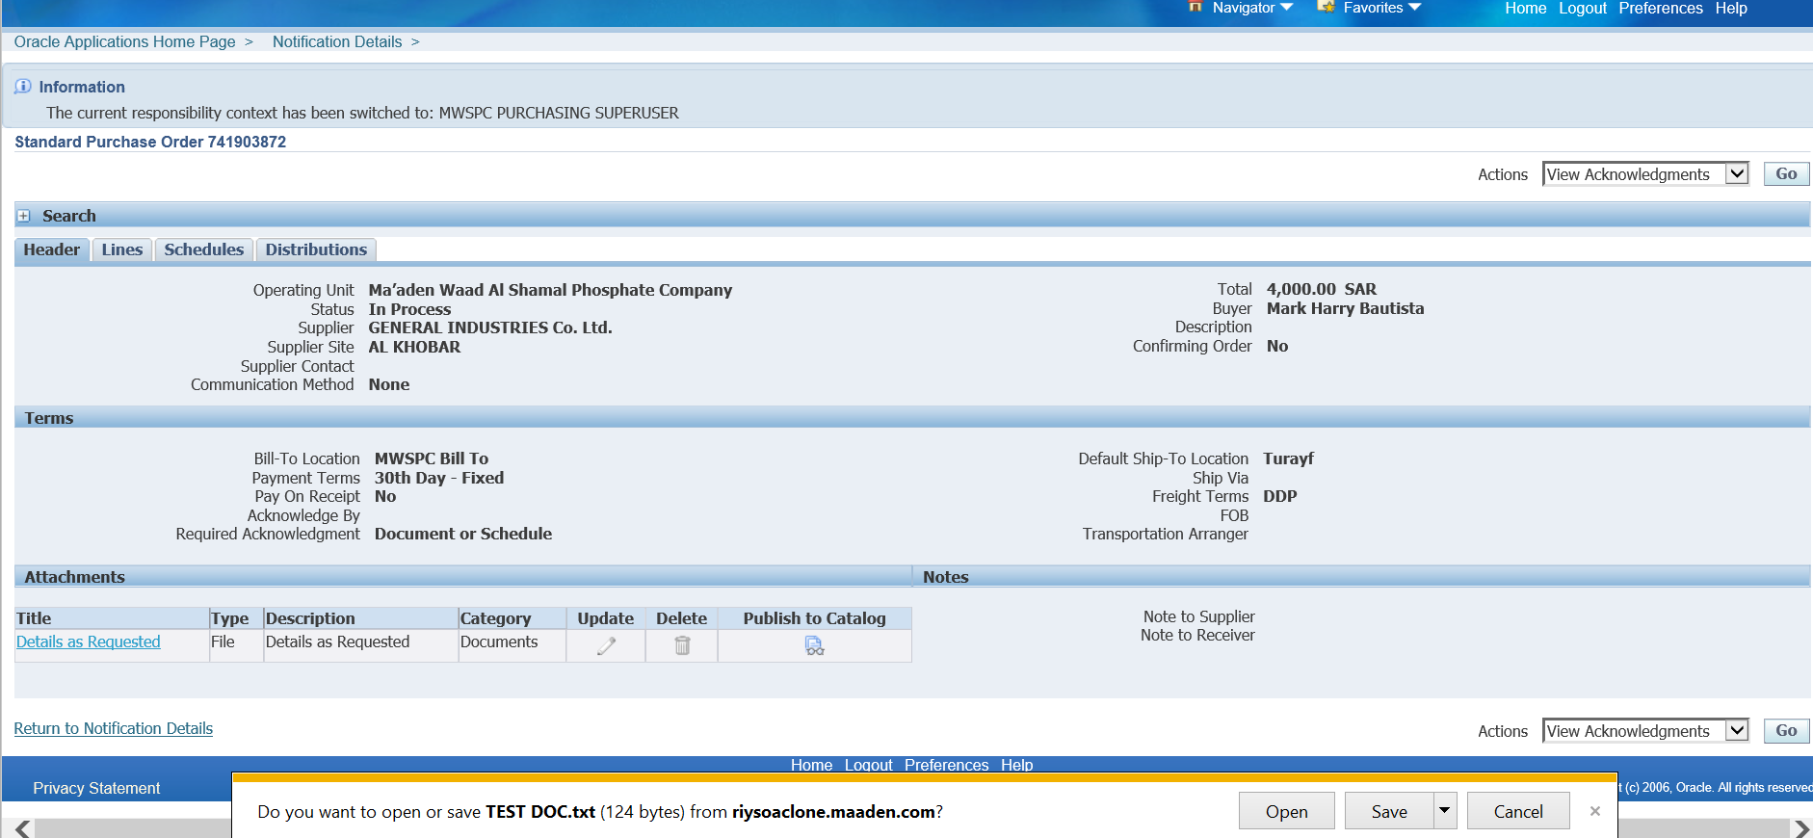

Save

Open the attachment

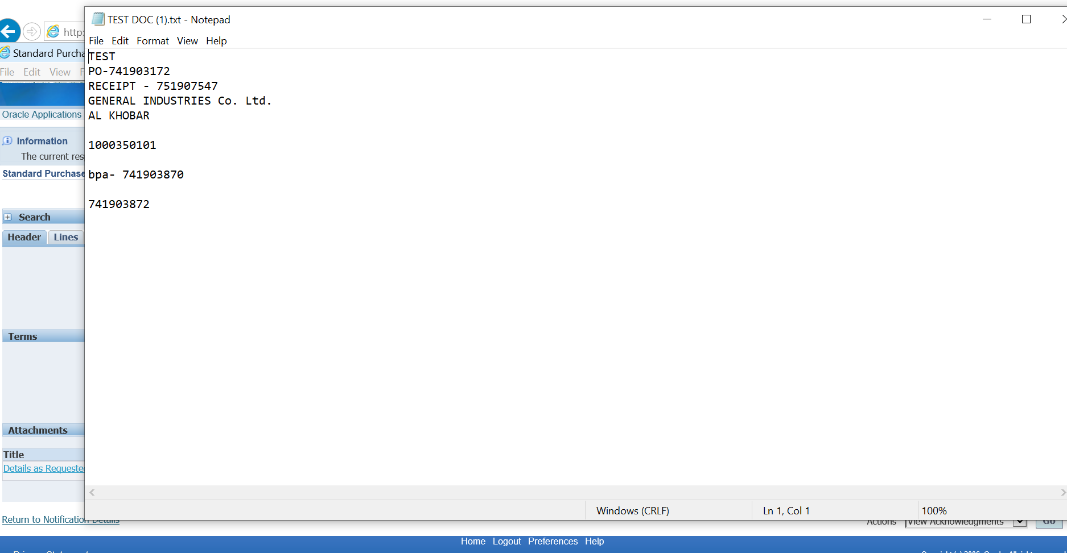

Close

Now, Approve the PO

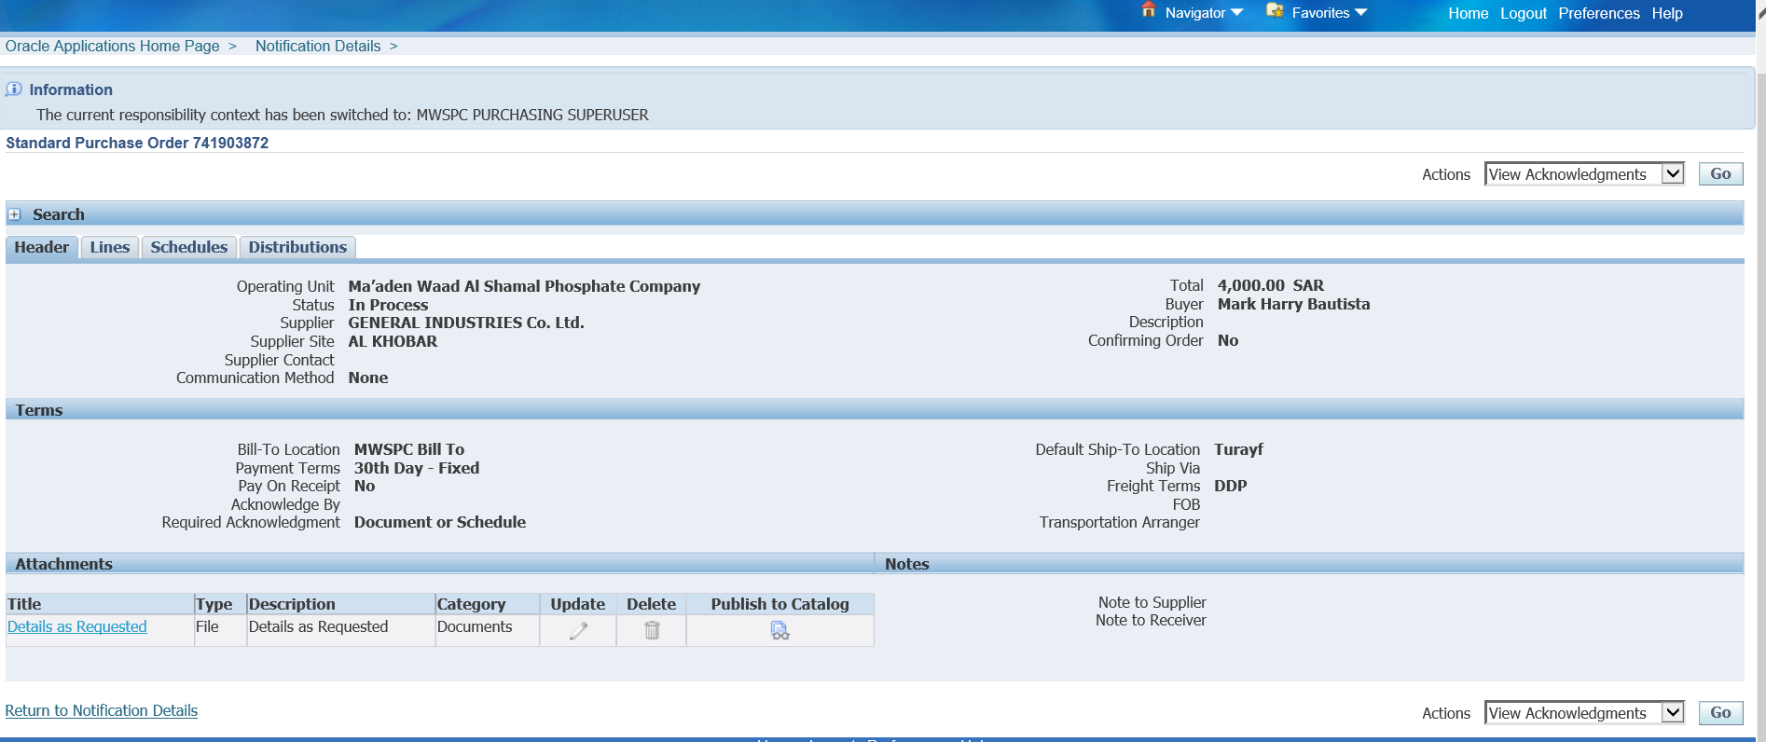

Click Return to Notification Details

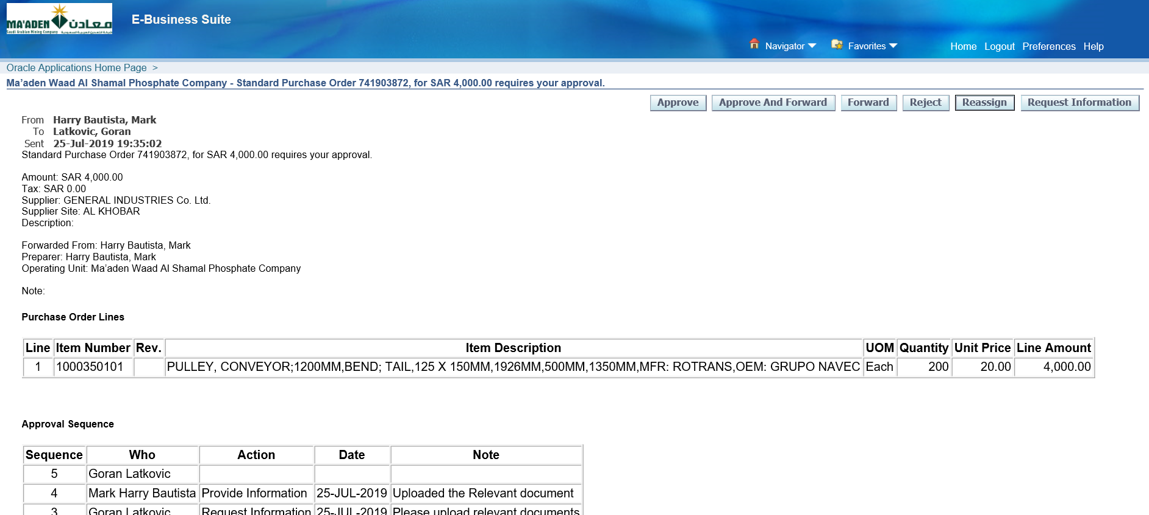

Approve

Login as BAUTISTAM to check the PO

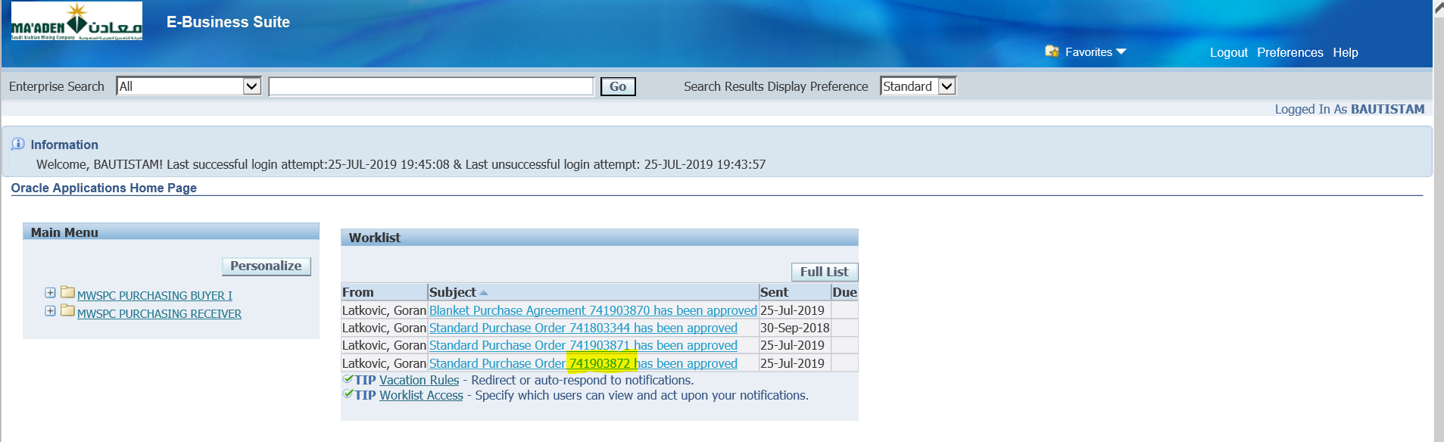

The PO has been Approved

1. PO Receiving and Deliver to Sub Inventory

PO – 741902260

If the Receipt Routing is Standard Receipt then it has to be Received and then Deliver to Subinventory

Receipt Routing scenario->

PO Summary->provide the PO-> Find->Shipment->Receiving Control->Miscellaneous->Receipt Routing ->Standard Receipt

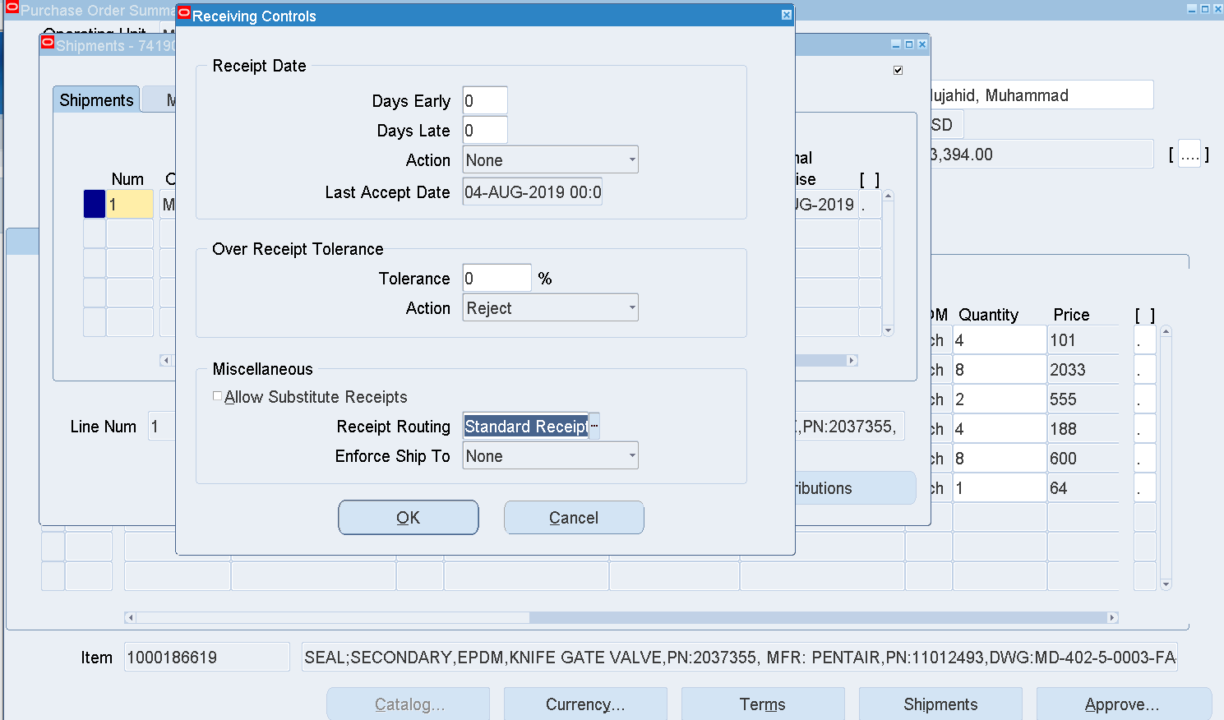

**PEETHAMBARANS**

MSWSCP SUPER USER

Receiving 🡪 Receipts

Select the Org – MWP

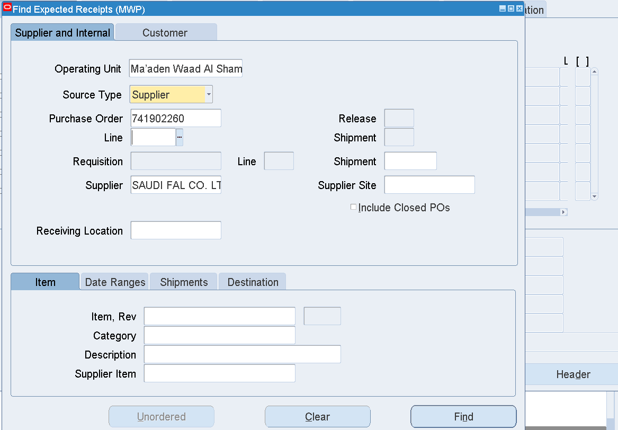

Enter the PO

Find

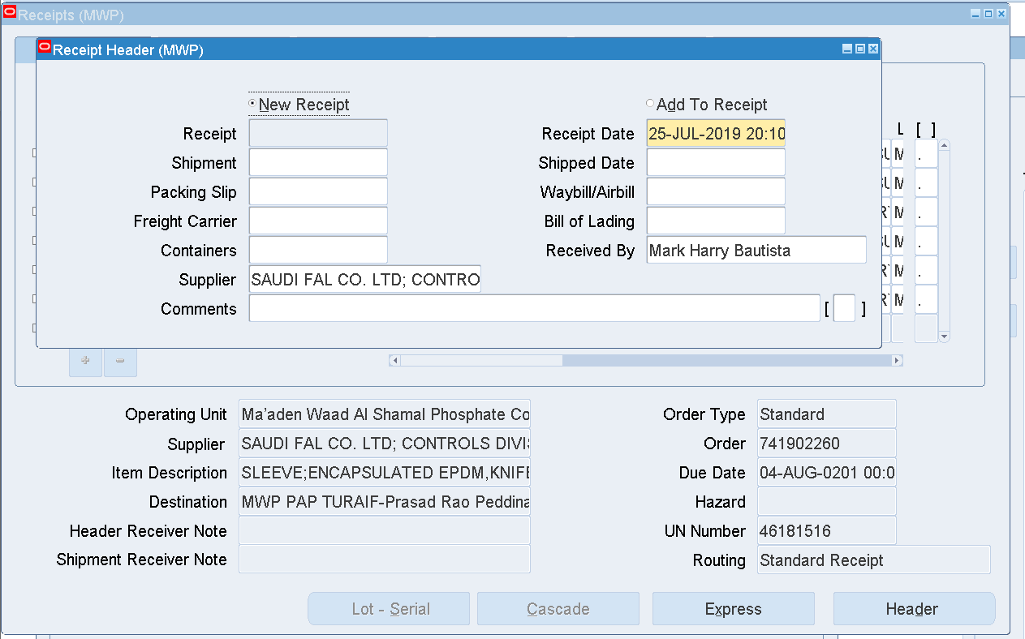

Select the Line to be received

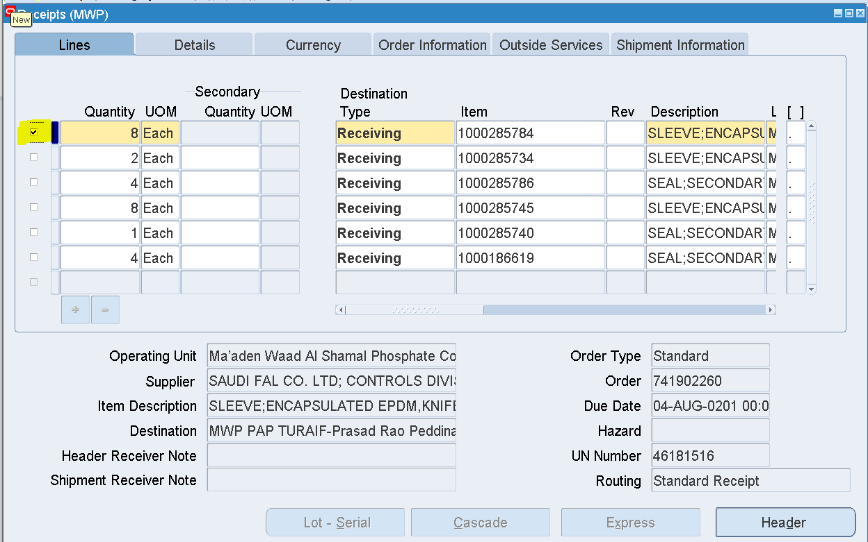

Save

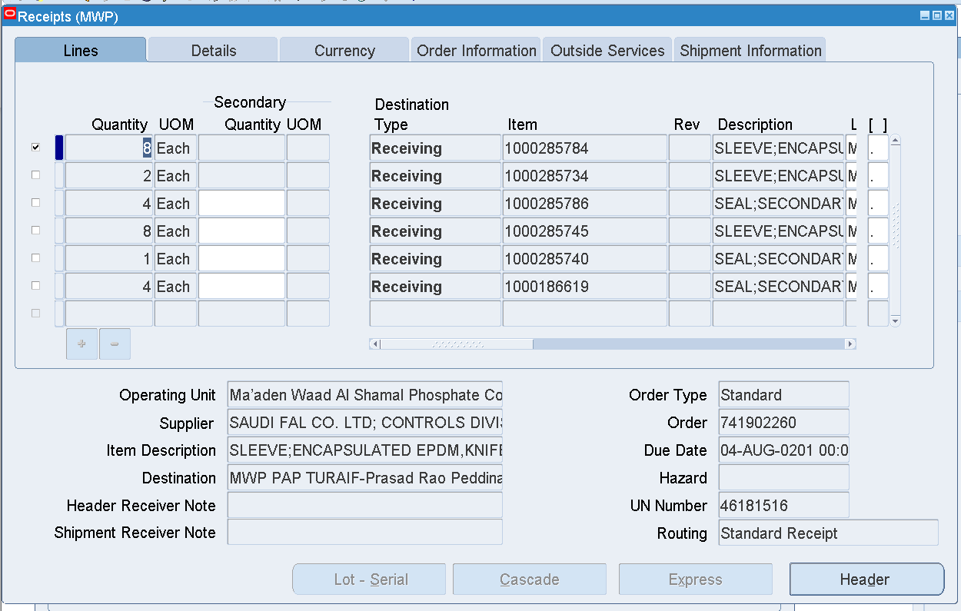

Click Header

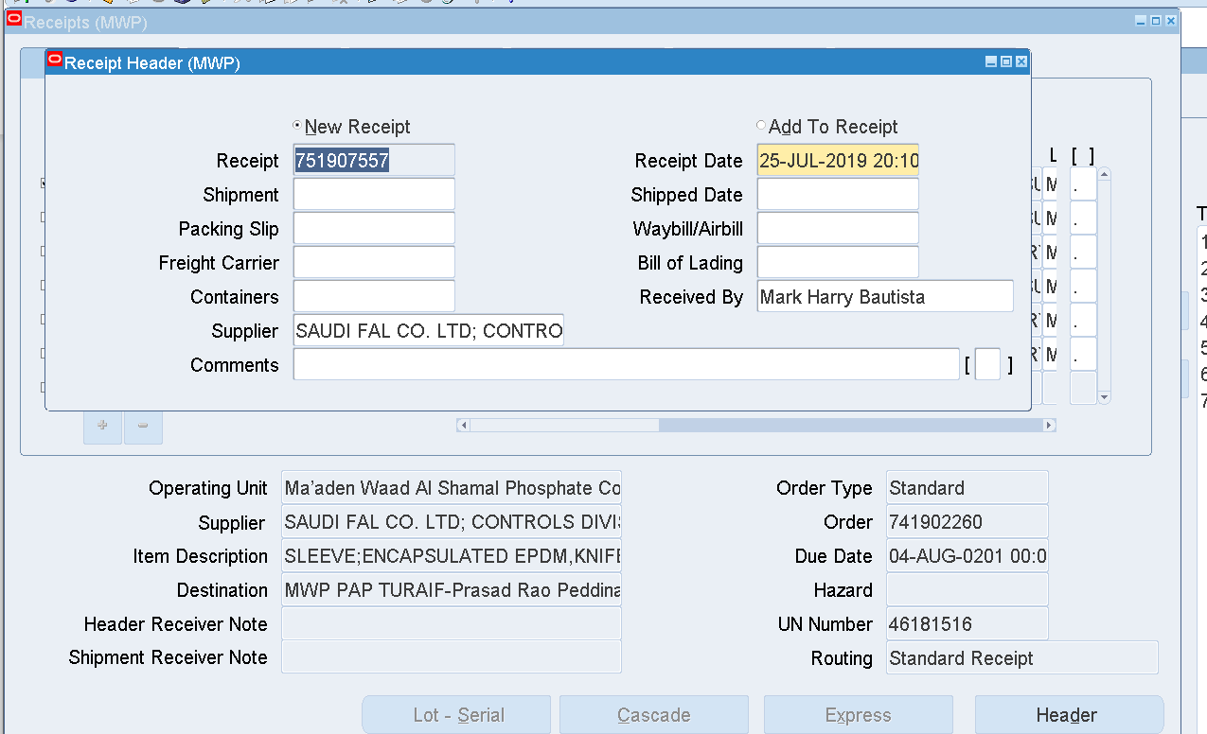

Receipt number has been generated

Receipt – 751907557

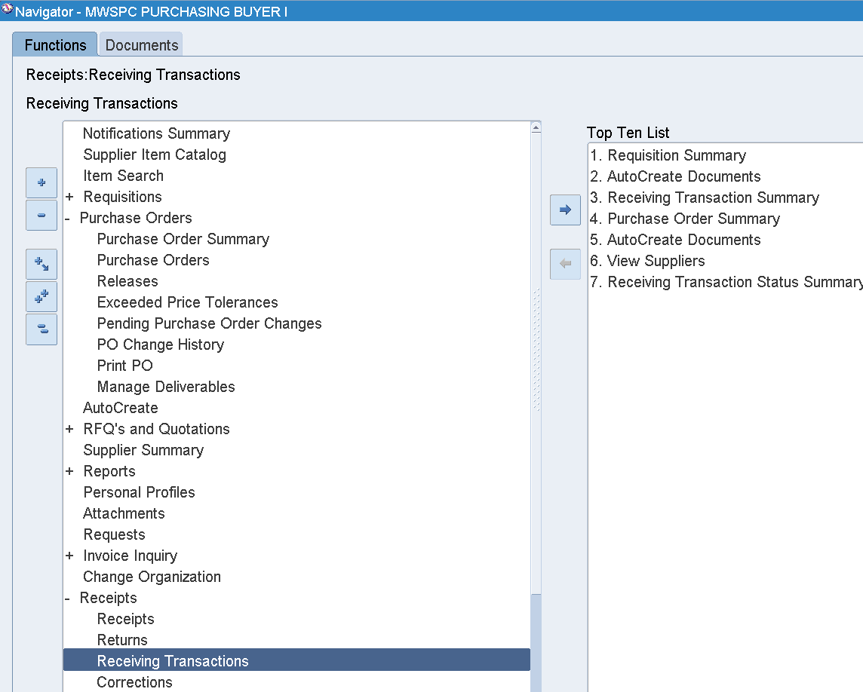

Receipts 🡪 Receiving Transactions

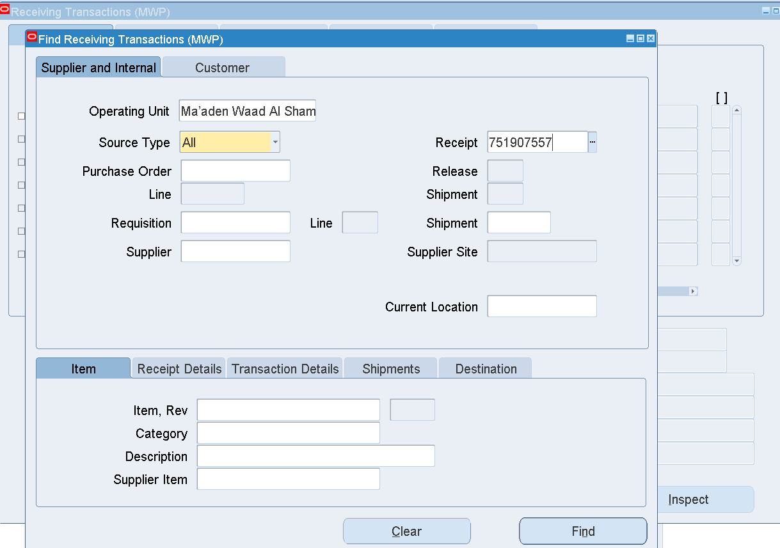

Enter Receipt number 🡪 Find

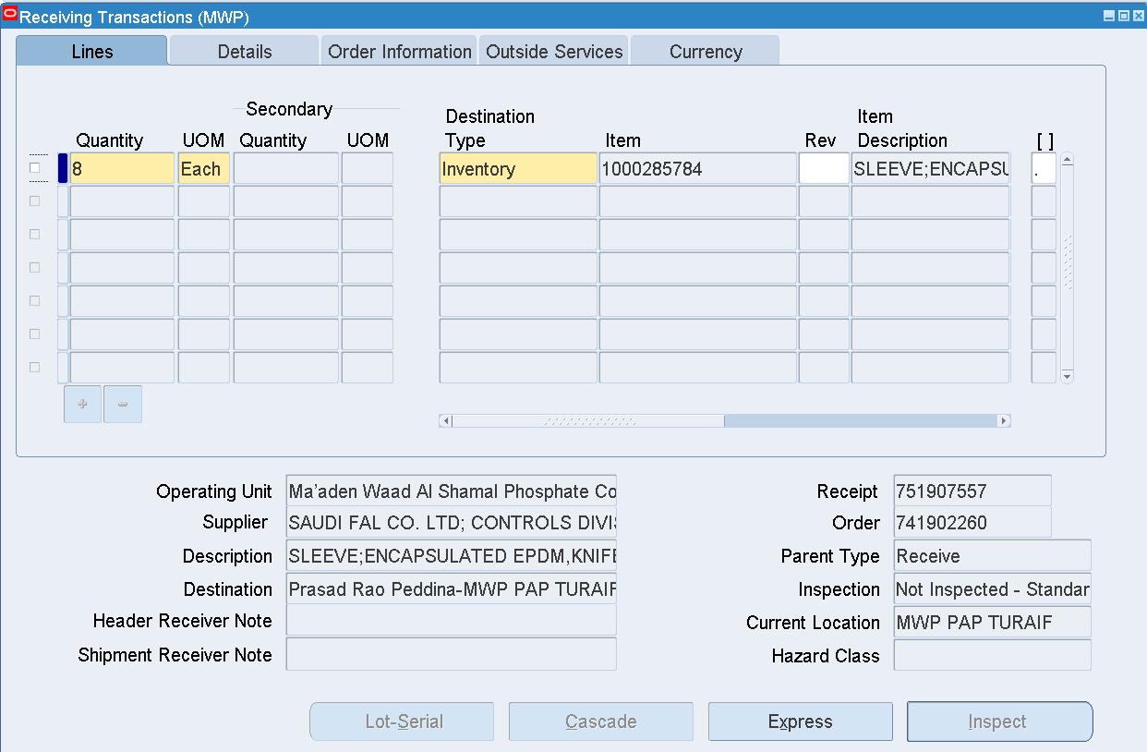

Select the Line

Enter Subinventory

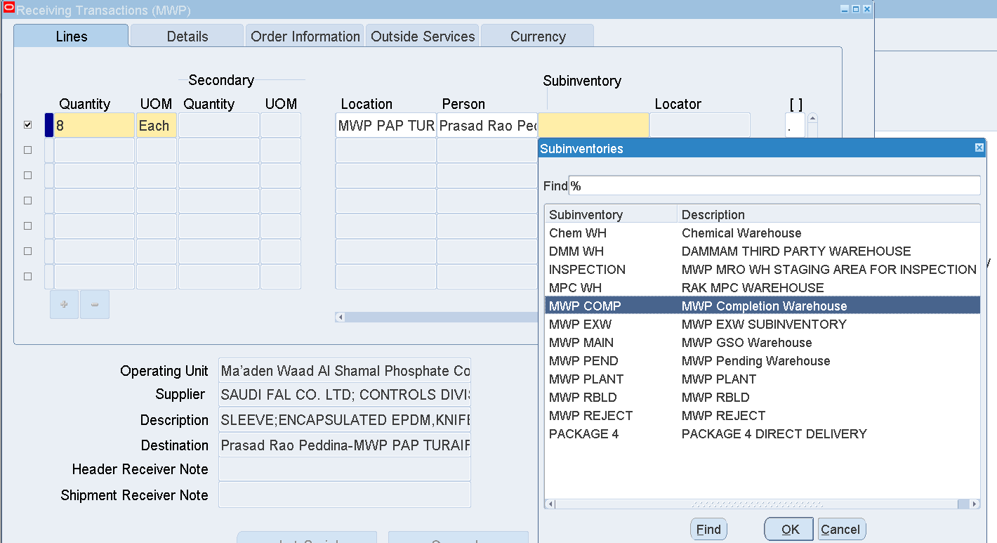

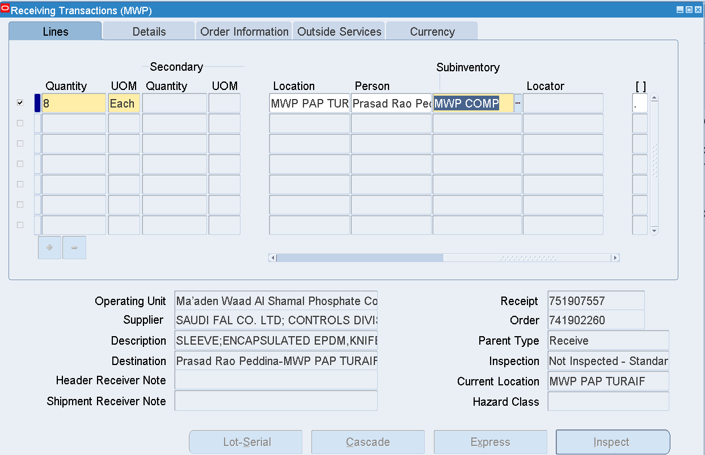

Press Tab

Enter Locator

NEW.01.COM

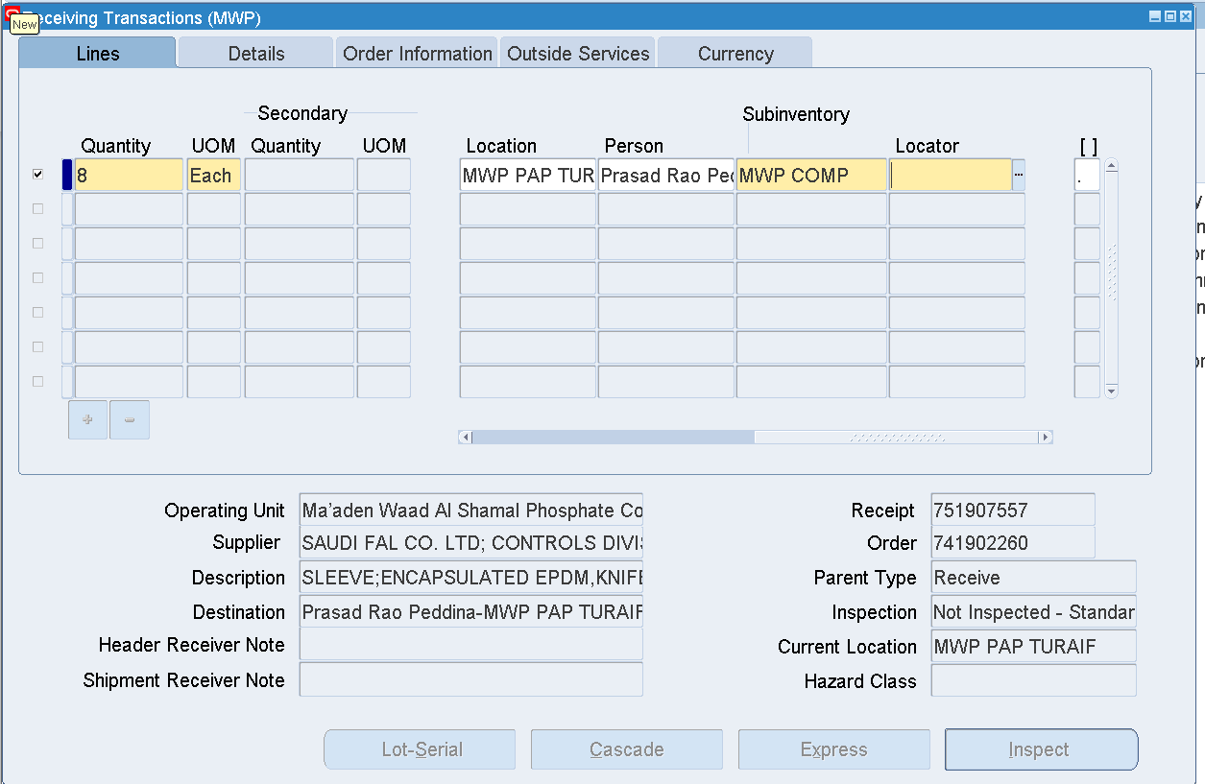

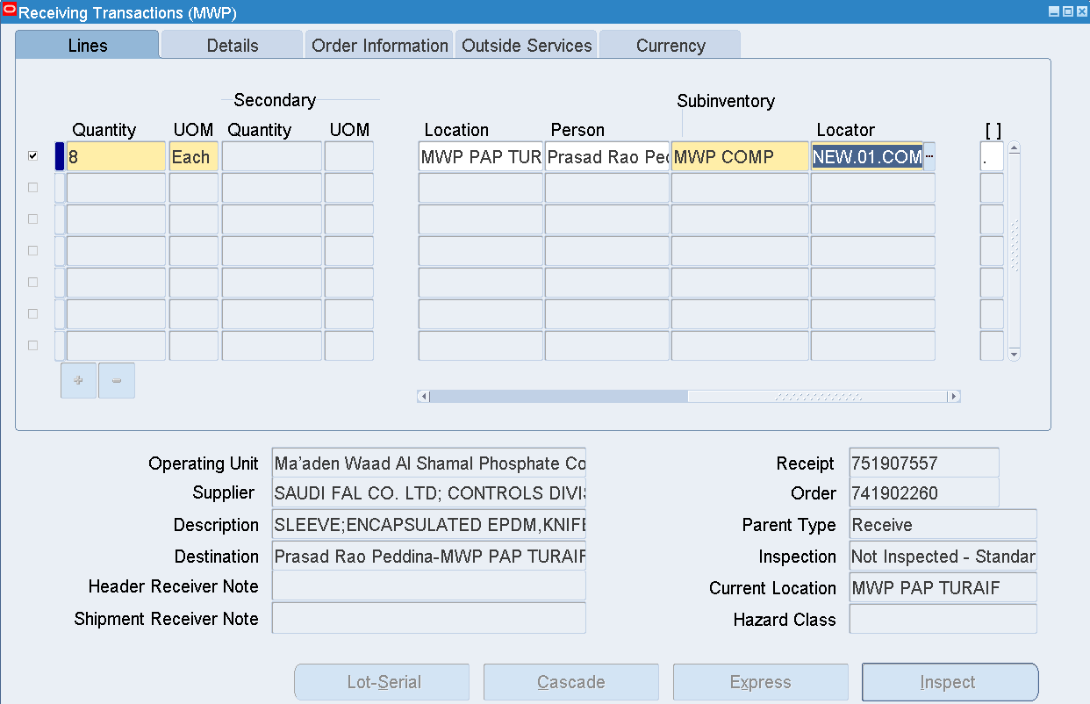

Save

Receiving and Deliver have been completed

Verify these details in Receiving Transactions Summary form

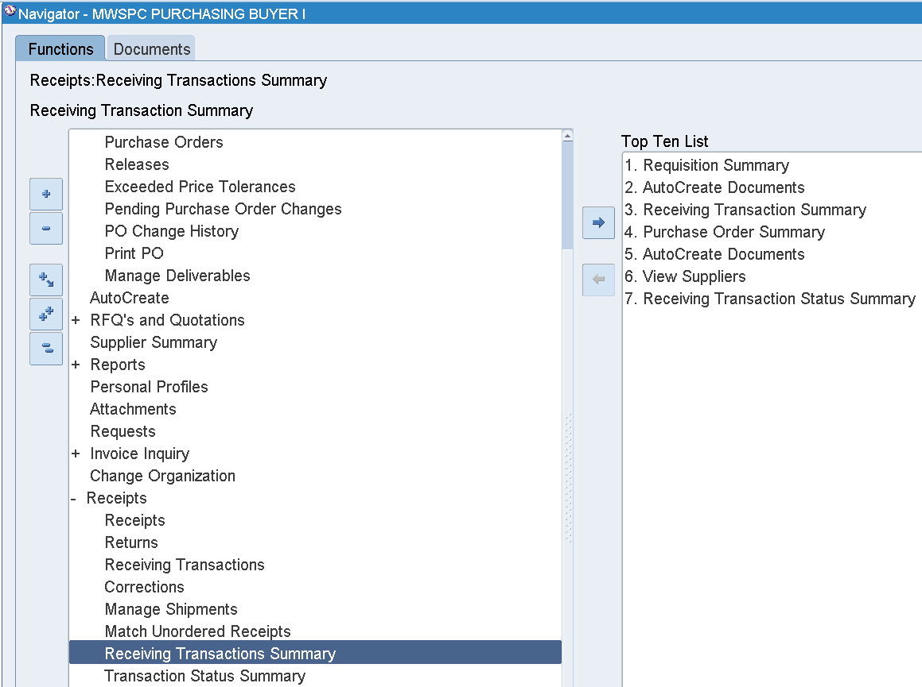

Receiving Transactions Summary

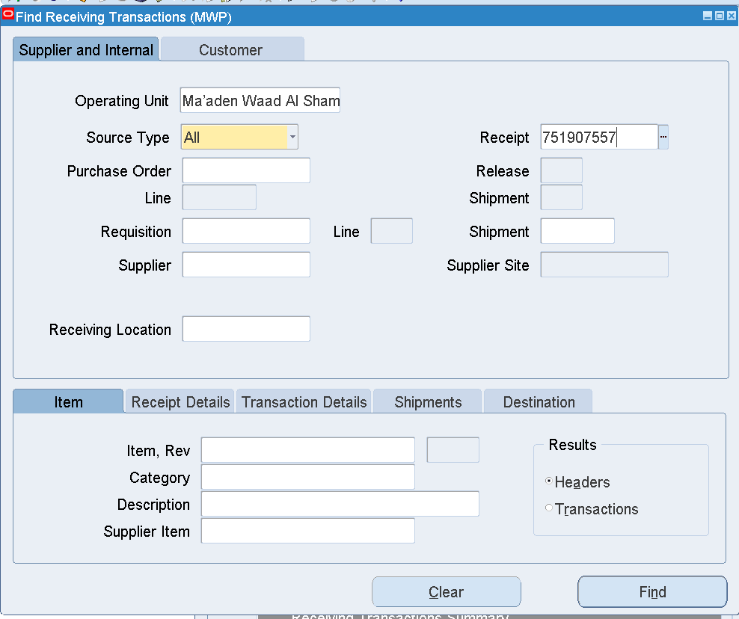

Enter Receipt Number 🡪 Find

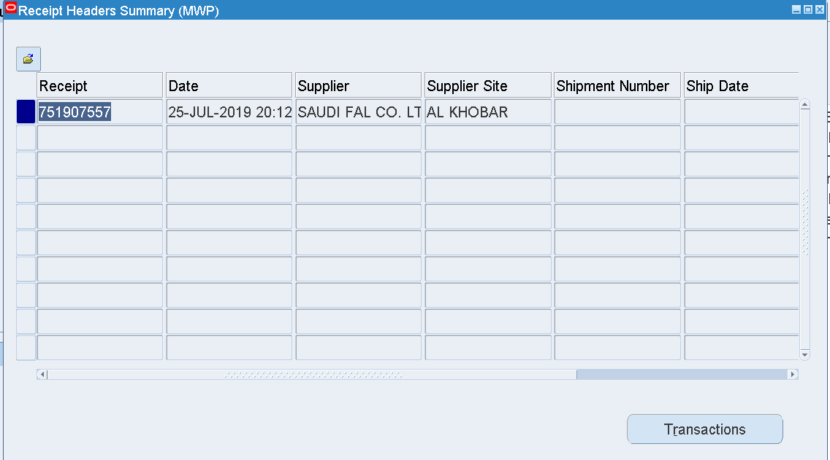

Click Transactions

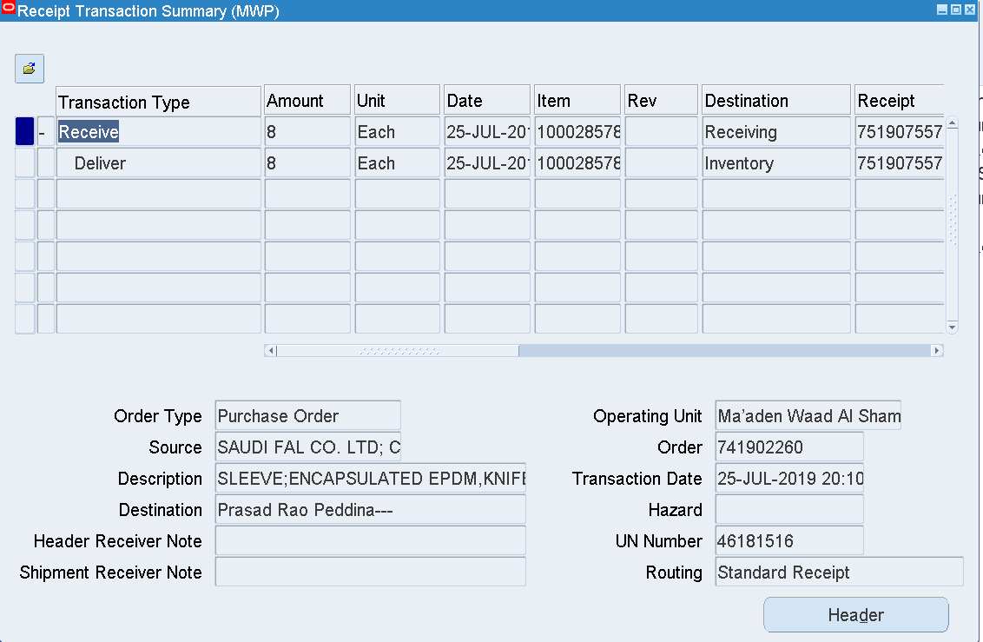

In the PO Shipments form, the Quantity Received will be updated with this transaction

1. Requisition creation in iProcurement

Login as TOLENTINORM_CORP

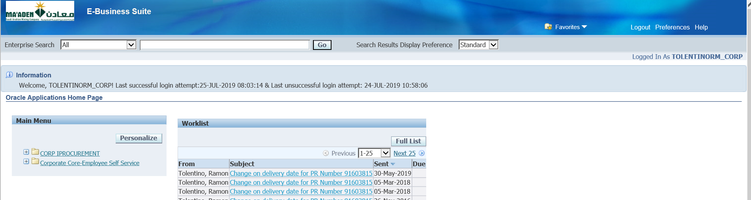

CORP IPROCUREMENT 🡪

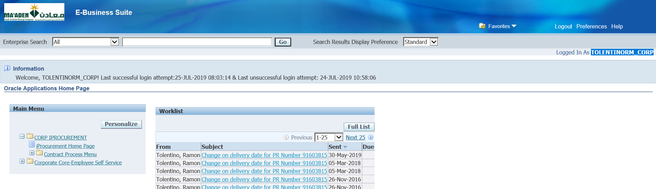

iProcurement Home Page

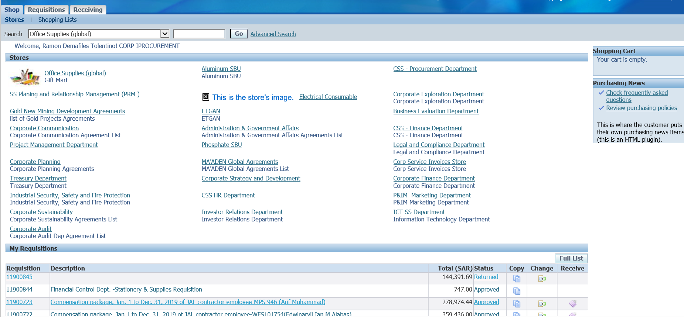

Copy the Existing Requisitions or Create a new Requisition by selecting the Items in Search field

Select one of the Items and Add to Cart

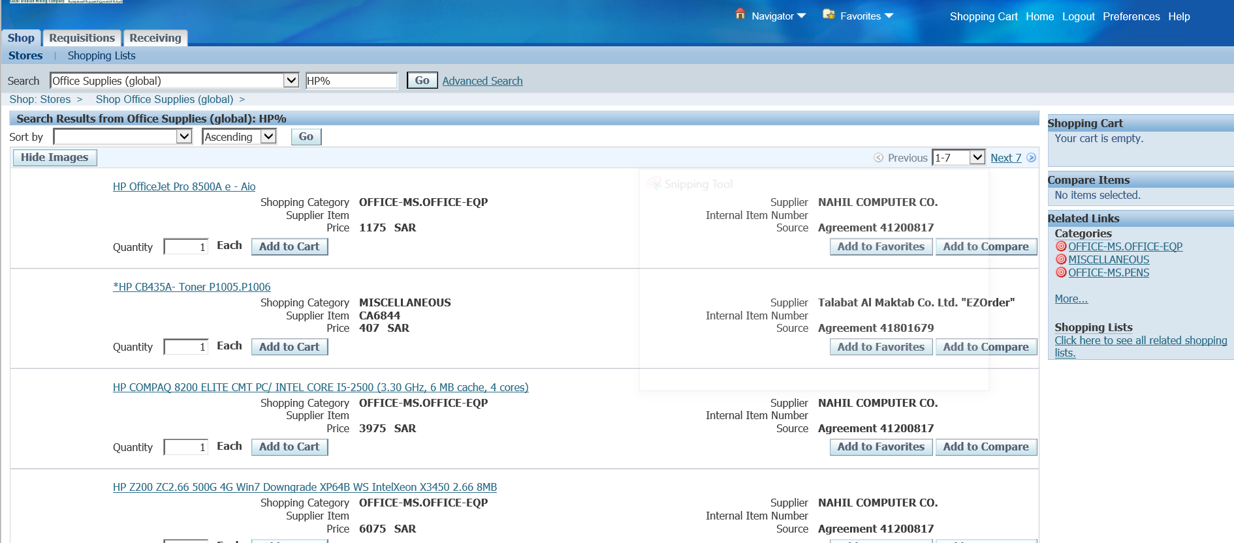

Quantity can be updated and then add to cart

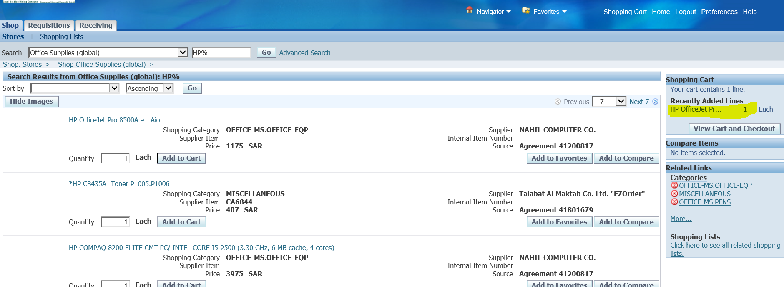

View Cart and Checkout

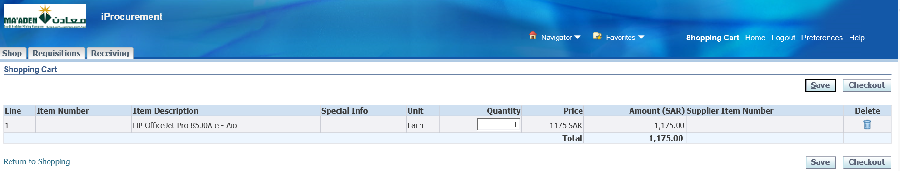

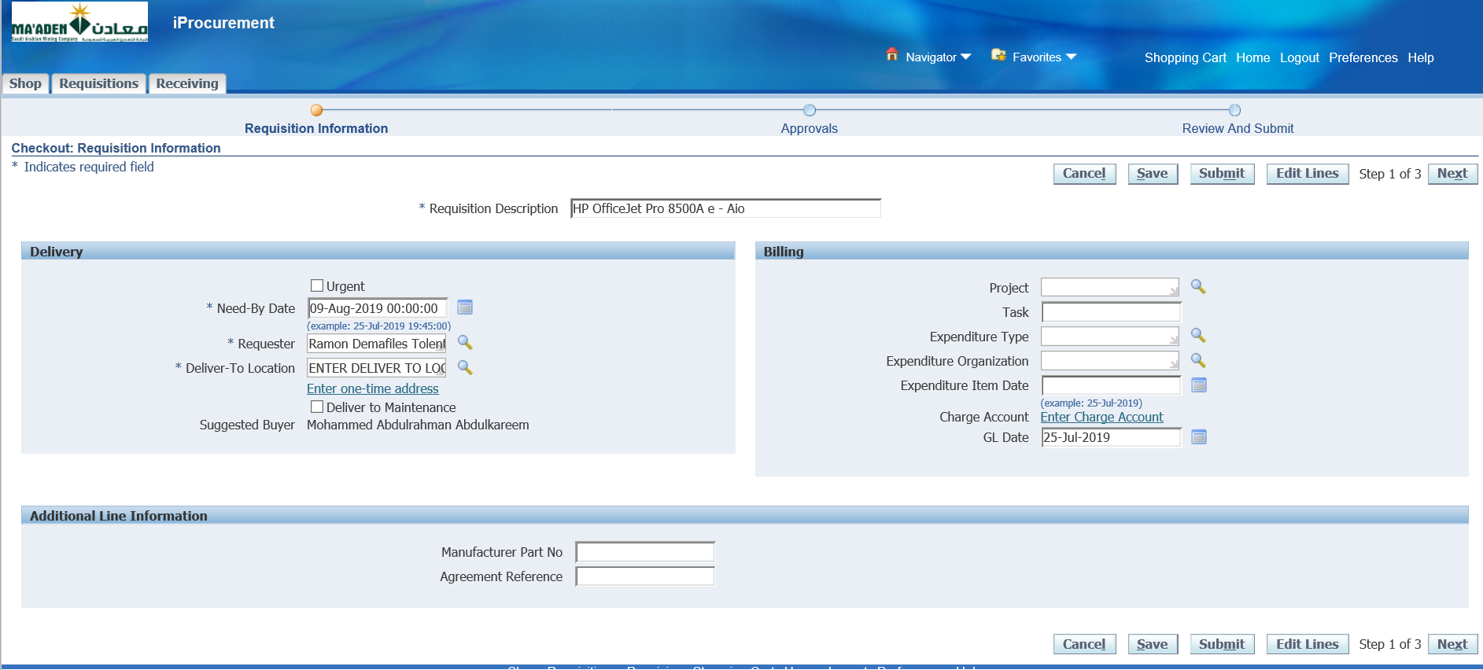

Update Deliver to Location

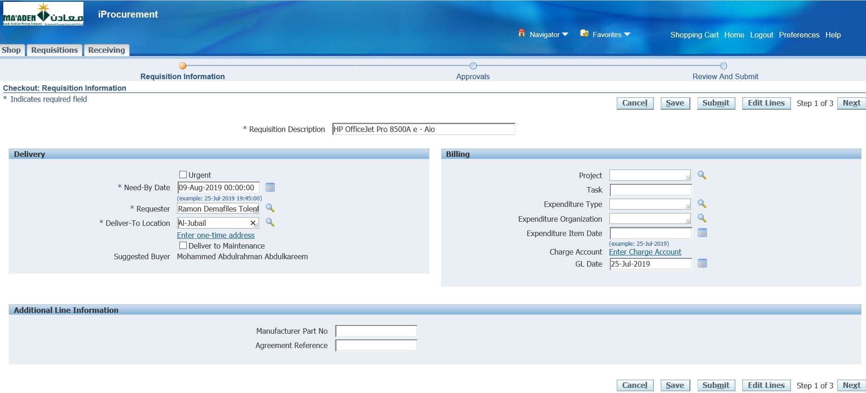

Apply

Click Next

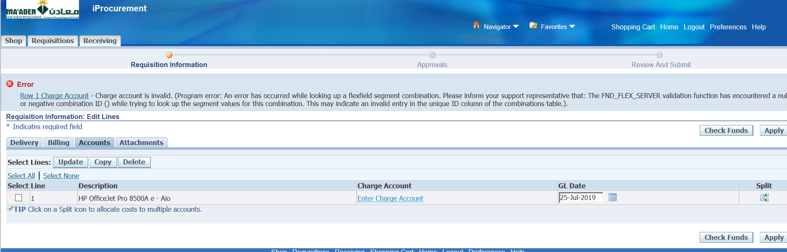

Enter charge account

Click the Charge account field

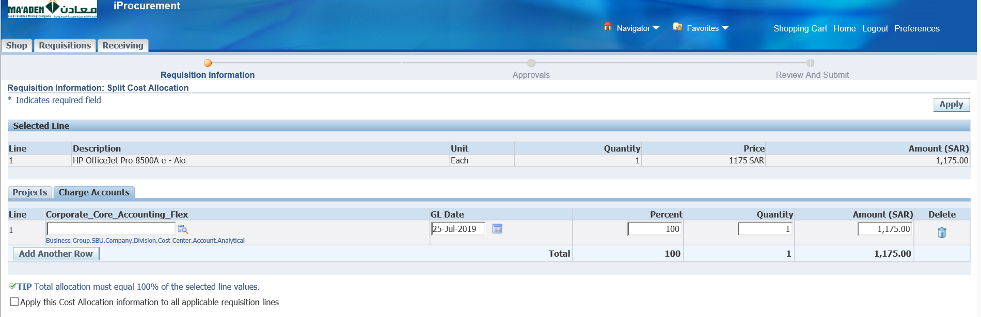

Enter the charge account

Enter 01.01.100.30.7511.5615.00000

Apply

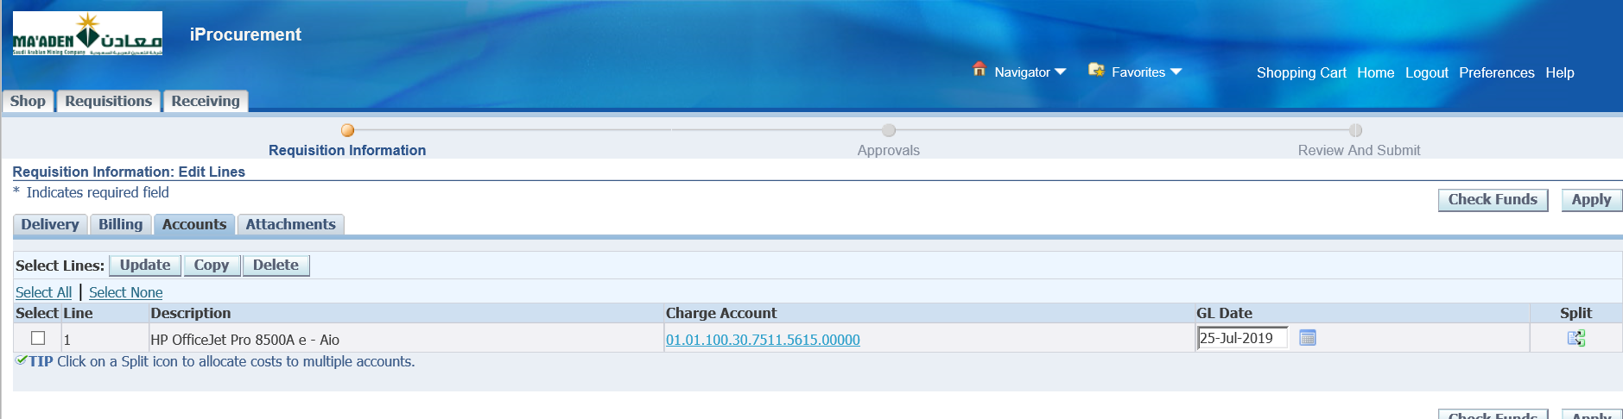

Apply

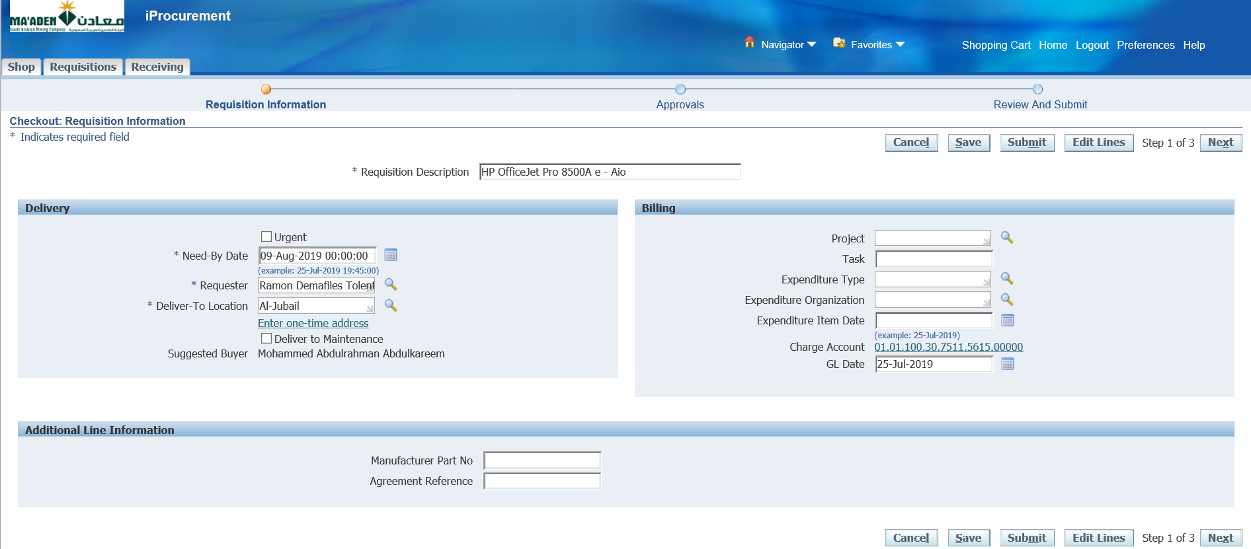

Next

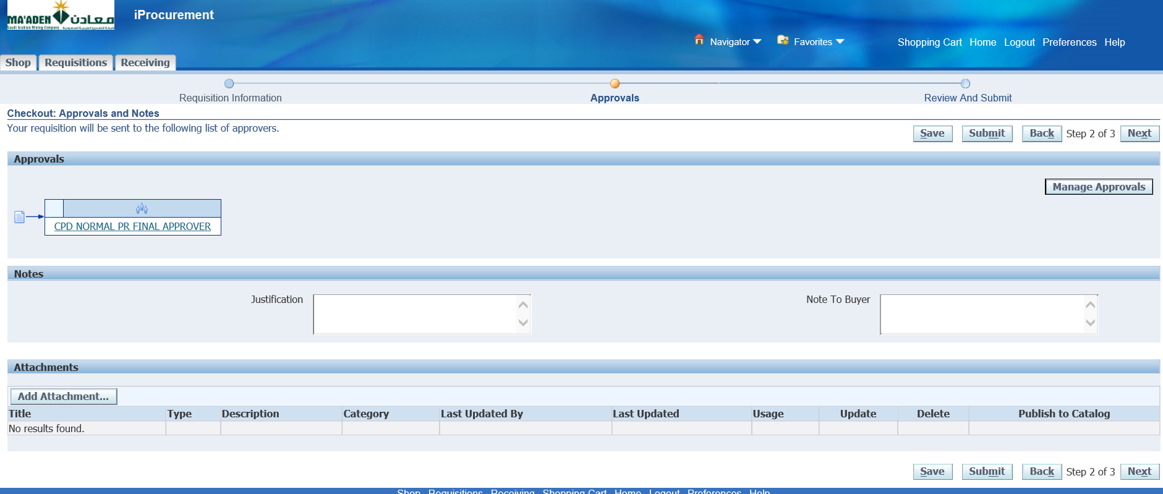

Verify Approval list is generated or not

CPR NORMAL PR FINAL APPROVER is available

Click that link to see who will be the Approver of this Purchase Requisition

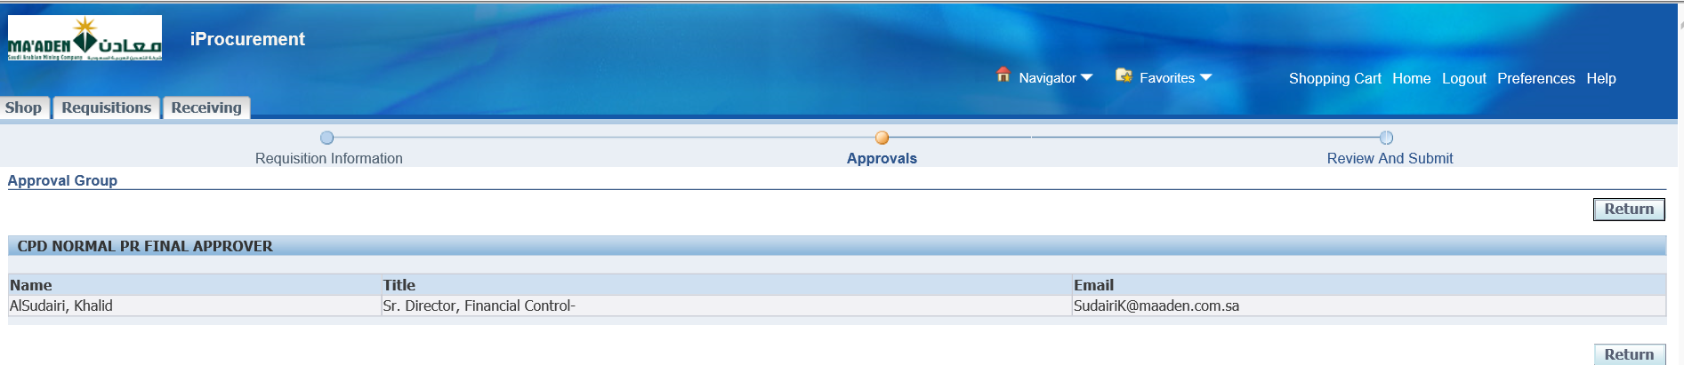

AlSudairi, Khalid is the Approver

Click Return

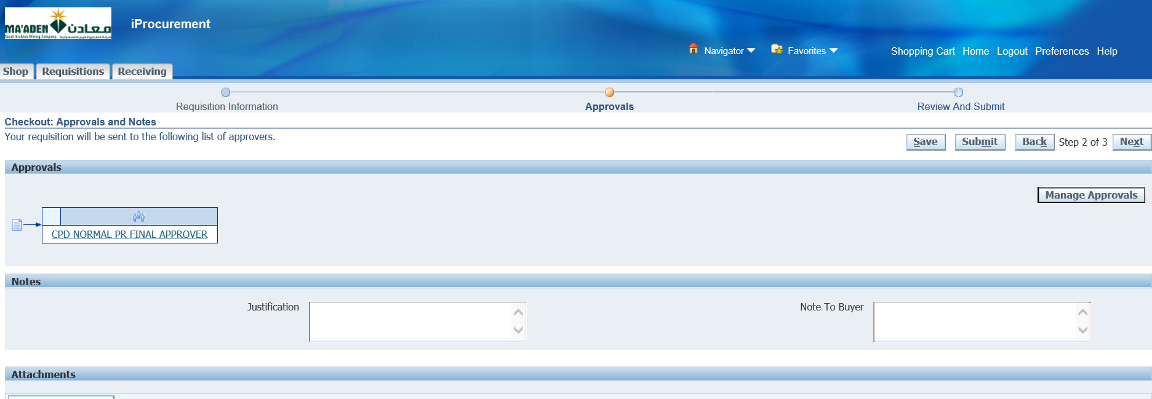

Submit for Approval

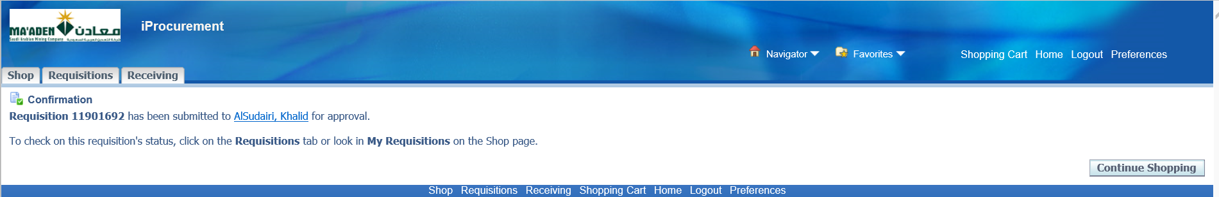

Continue Shopping

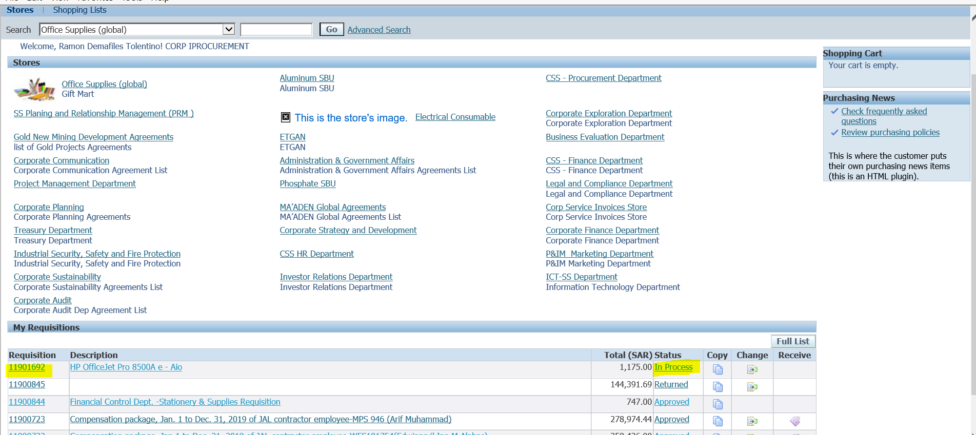

Select the Requisition status

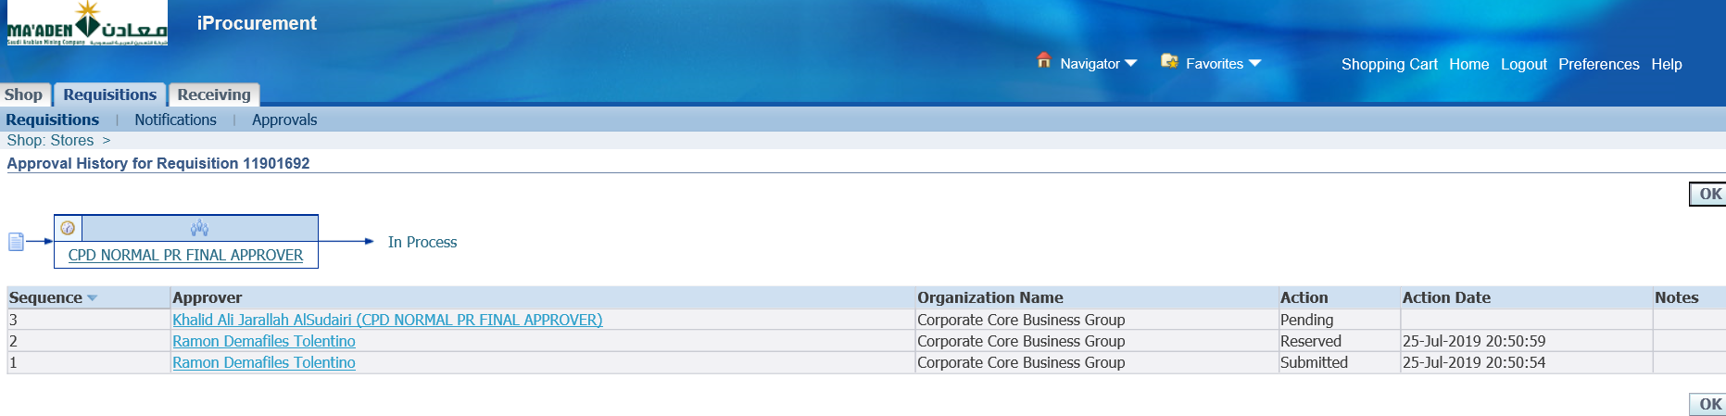

It’s with [Khalid Ali Jarallah AlSudairi (CPD NORMAL PR FINAL APPROVER)](mailto:SudairiK%40maaden.com.sa) for Approval

Login as SUDAIRIK

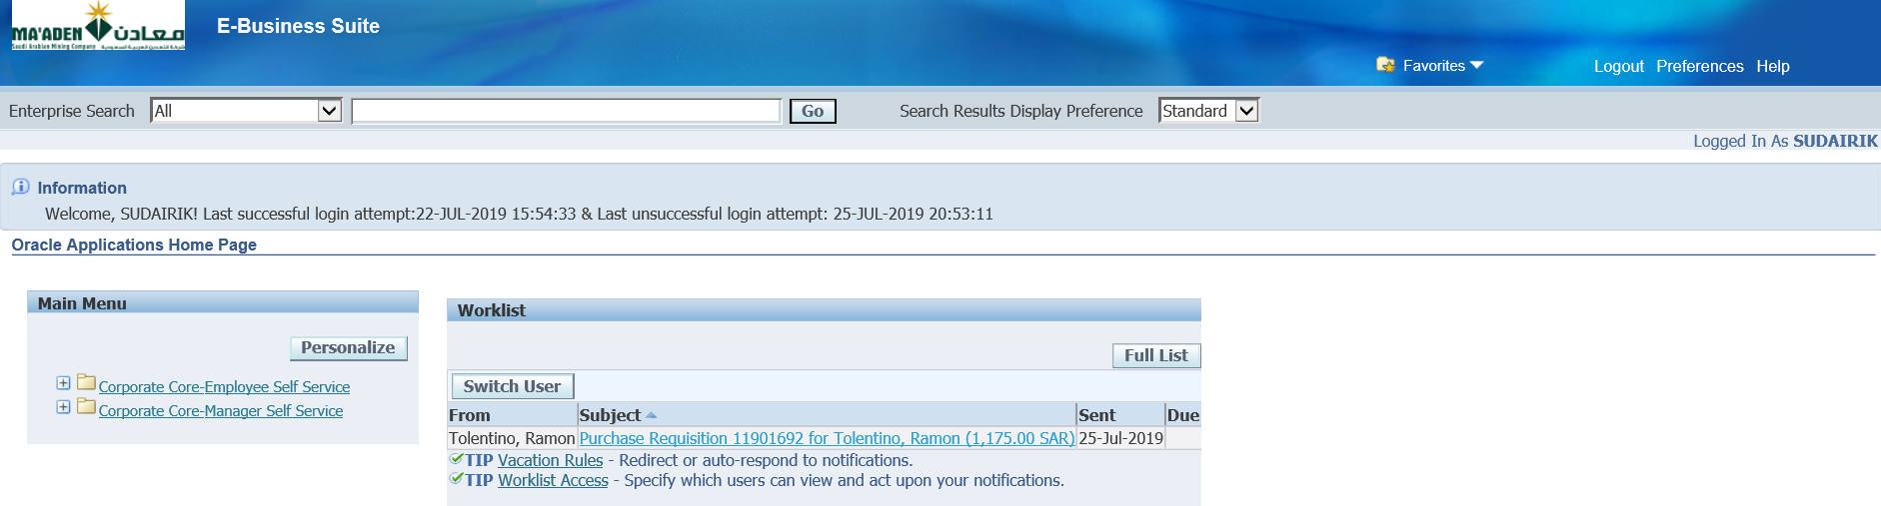

Select the Requisition notification link

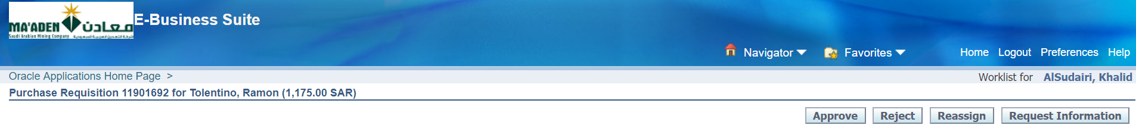

Approve

**Process to make the Generated PR to Express Receive**

Login with below user and approve it.

KHAWAJAH and SUDAIRIK

Log back with TOLENTINORM_CORP and perform below Task

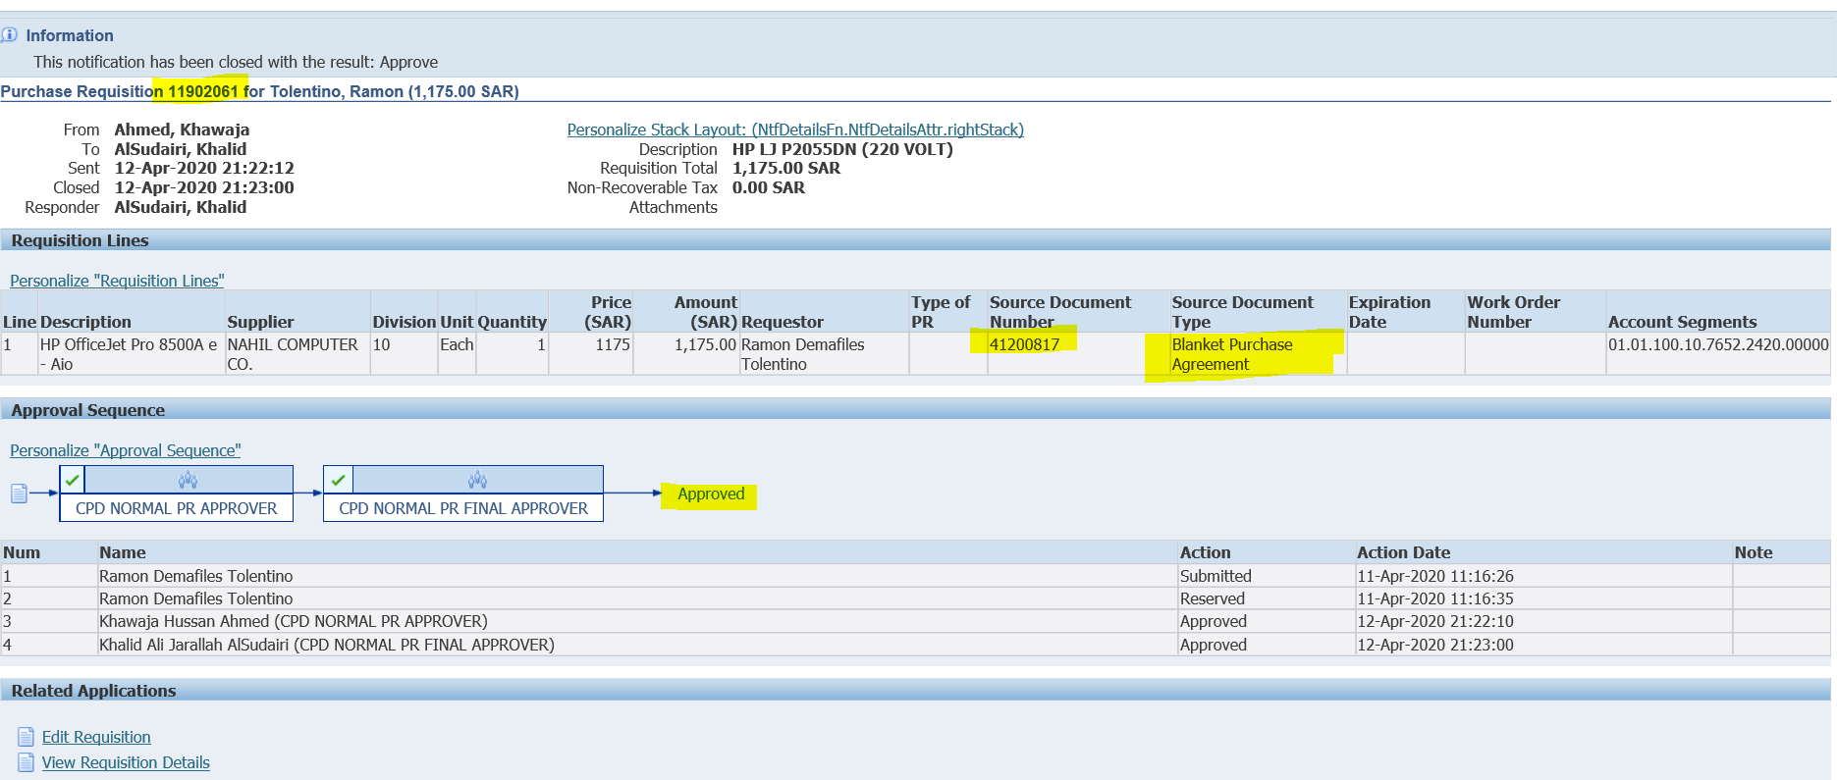

Once the PR is approved, then the PR can be converted into a PO by submitting the below concurrent request from System administrator responsibility

Workflow - Run - Submit - Workflow Background process with the below parameters

 - Requisition

-Yes

-Yes

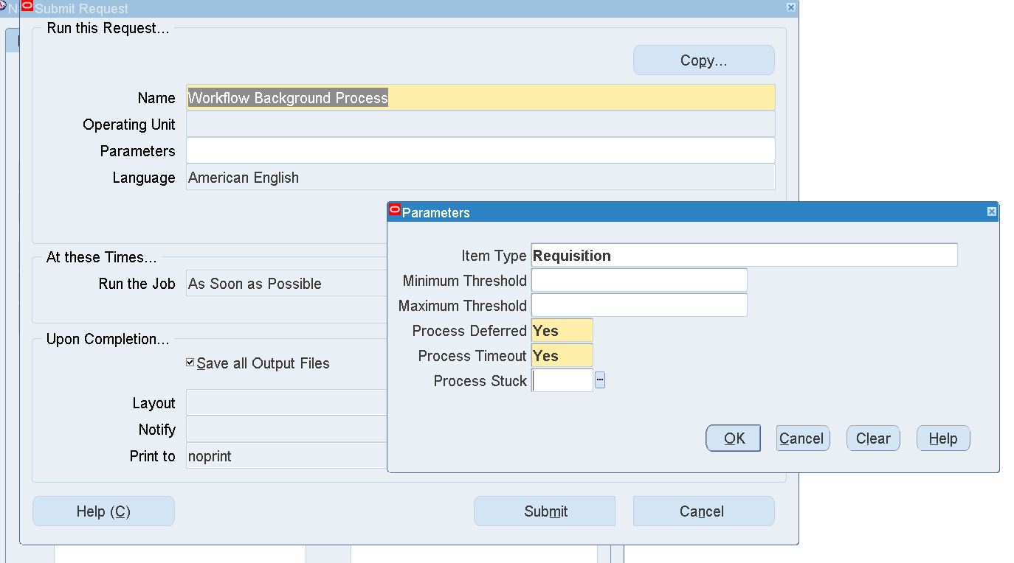

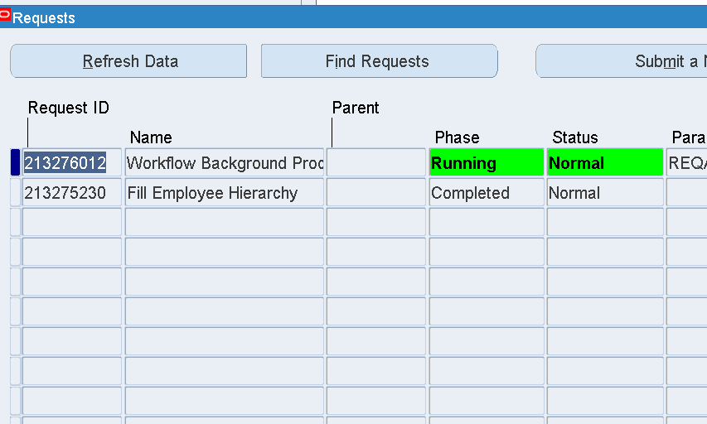

PO will be generated for the PR mentioned above automatically the system as the PR is referenced to a Blanket Purchase agreement.

The PO has to be approved then the PR/PO will be available in iProcurement to create a Receipt - Express Receive will be enabled.

41902673

PO has been Approved by the user - CORP_AUTOMATED_BUYER /welcome123

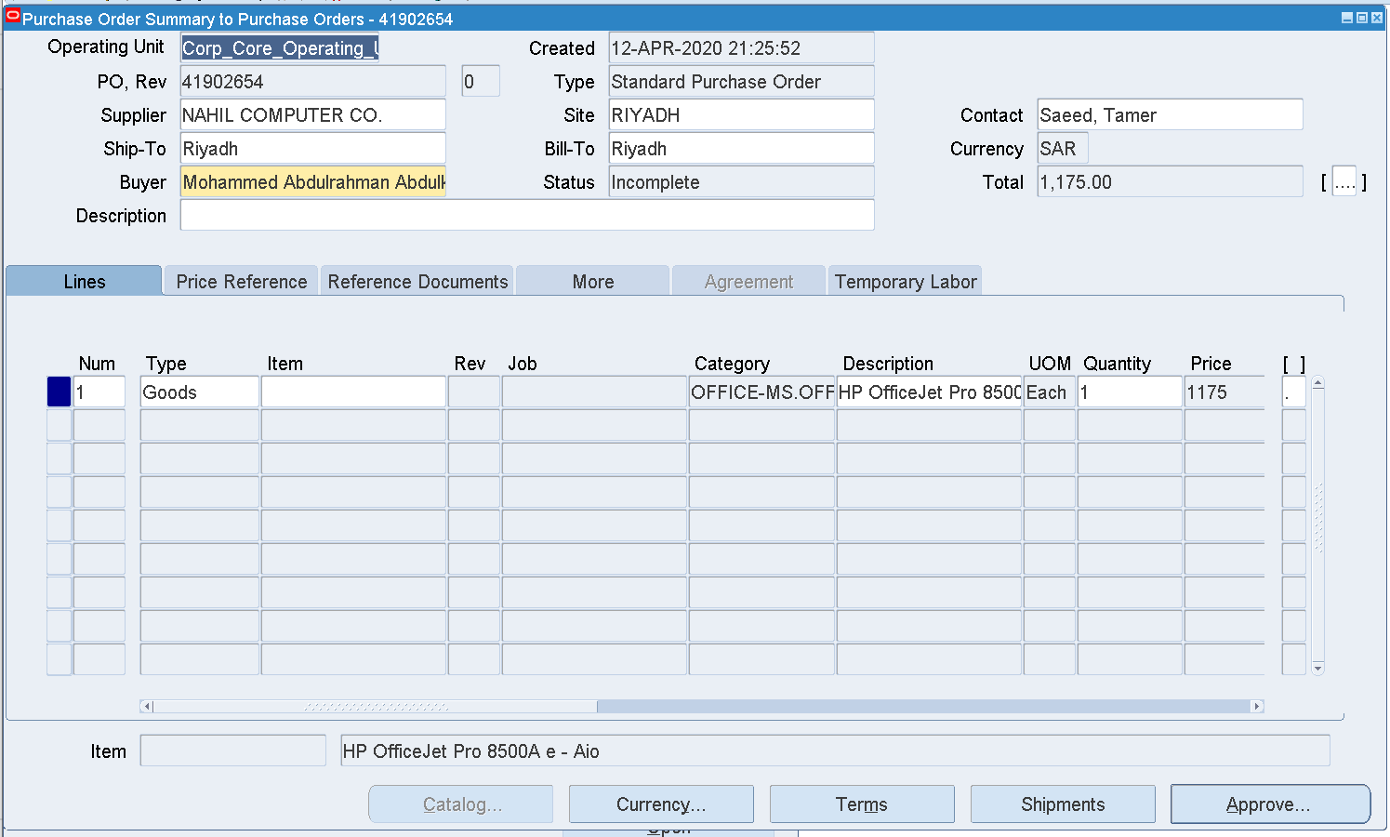

Once it is approved then the PR /PO will be available for Express Receive.

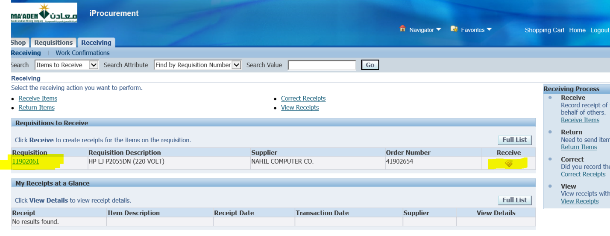

1. Receive in iProcurement

Once a Requisition is created in iProcurement, PO has to be generated with the PR then it will be able to receive

Login as TOLENTINORM_CORP

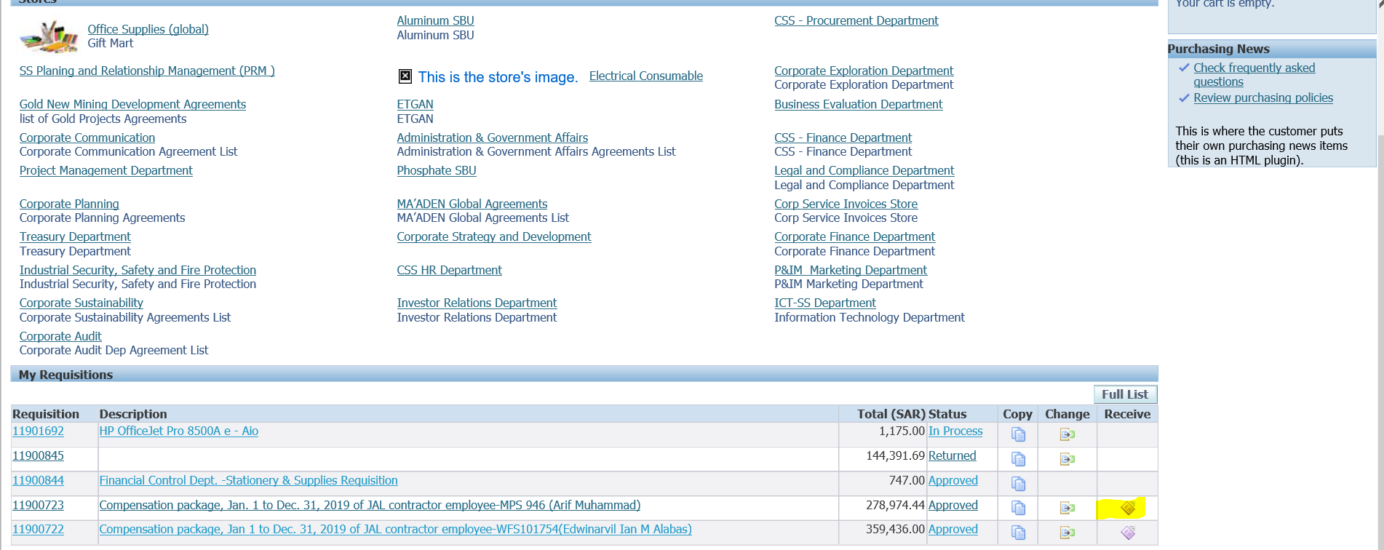

Select the available requisition which is available for Receiving

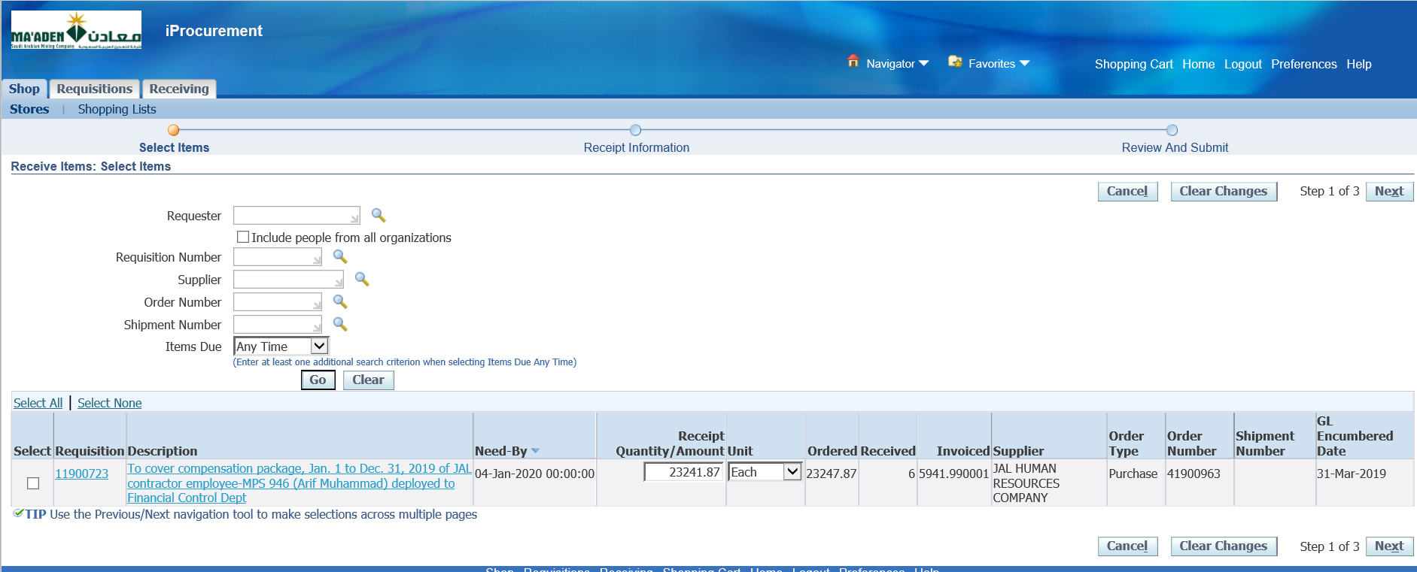

Update the Quantity if required

Click Next

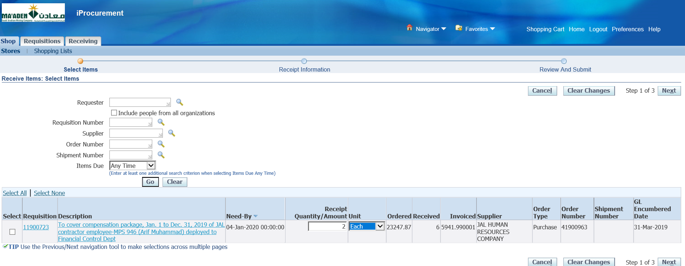

Click Next

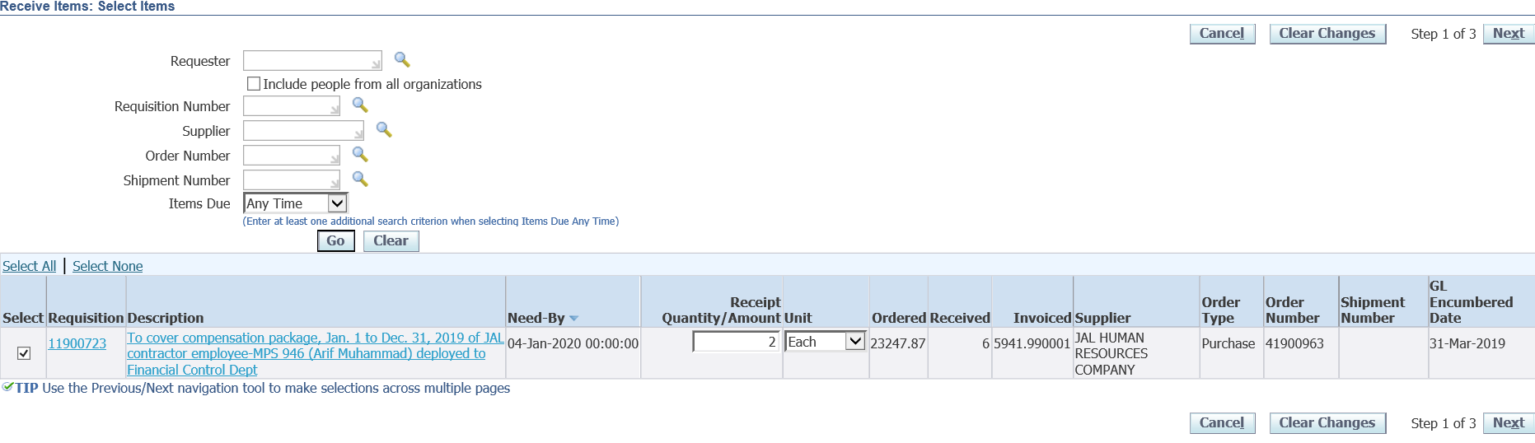

Select the Line 🡪 Next

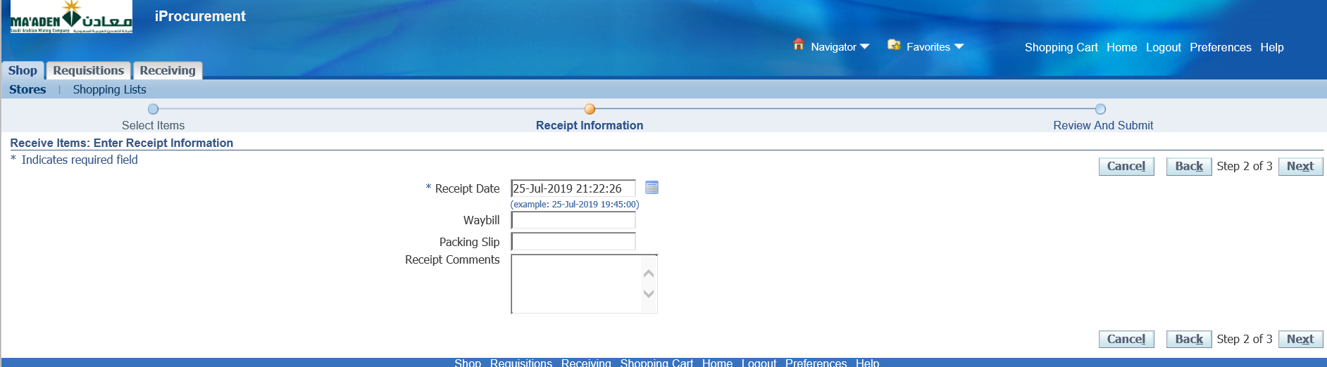

Enter Receipt Comments, if required

Next

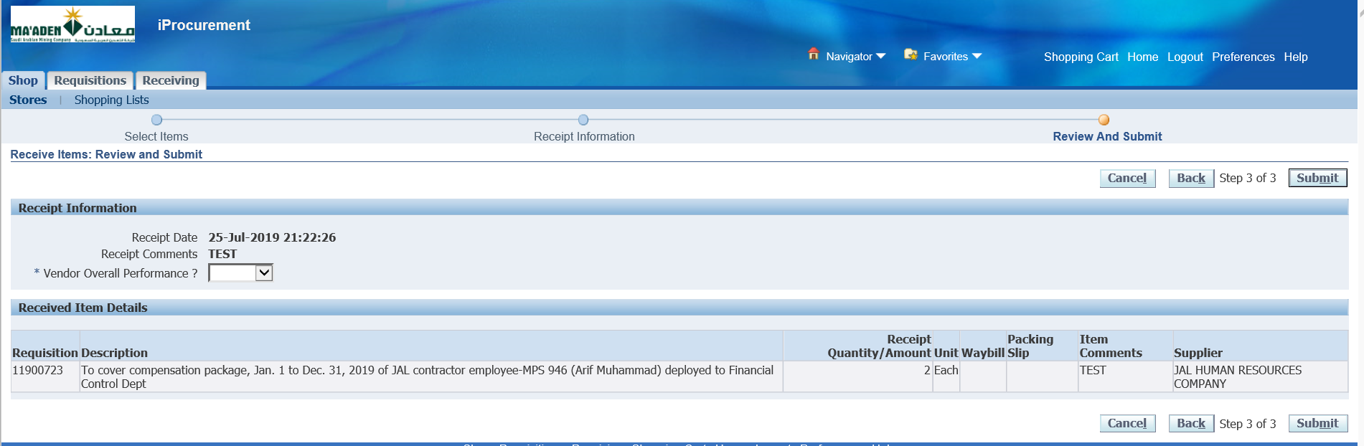

Select Vendor Overall Performance

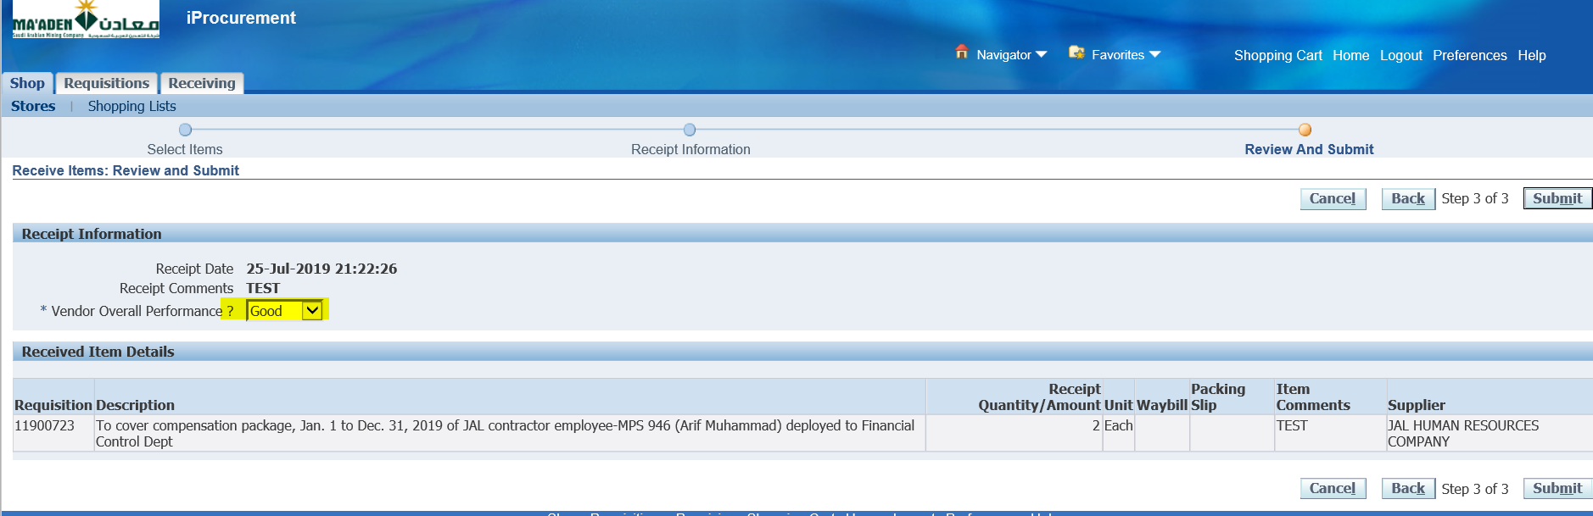

Submit

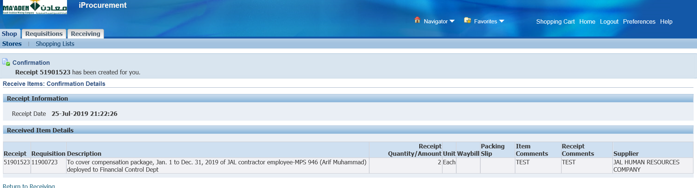

Receipt 51901523 has been generated

1. PO Corrections

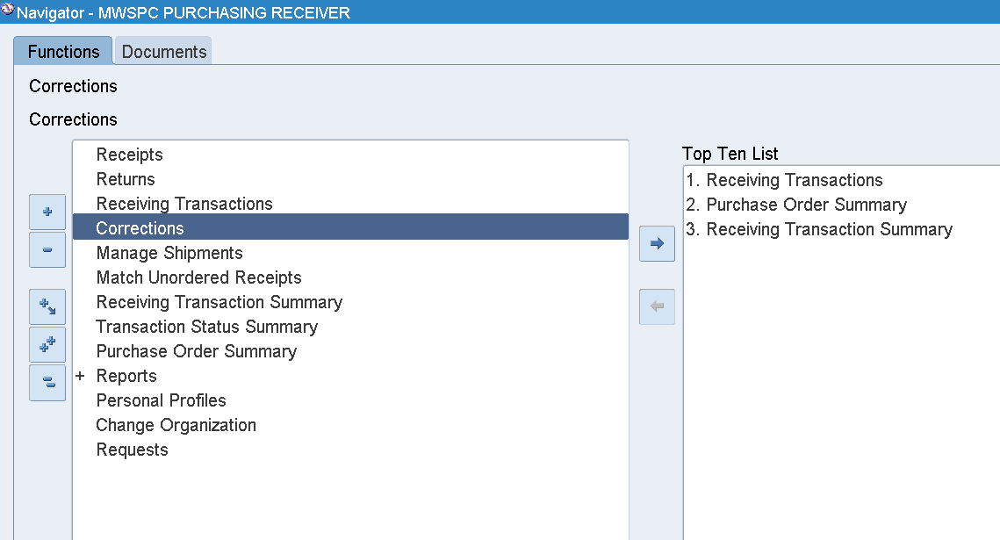

Login as BAUTISTAM

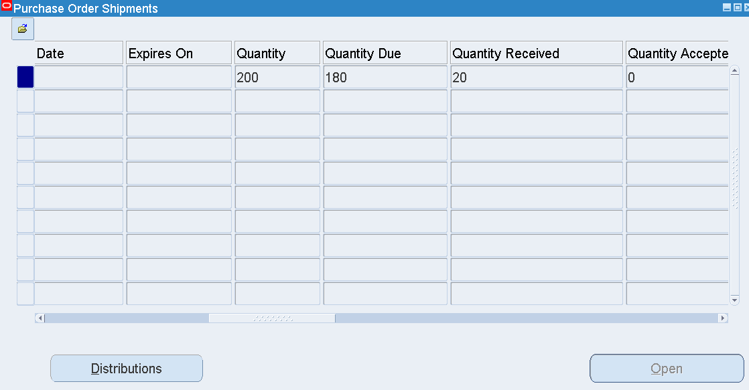

PO – 741903872 / 741900812

Qty ordered = 200 / 2040000

Qty received = 20 / 1788545

Check the Receipt num –

Inquire 🡪 View Receipts

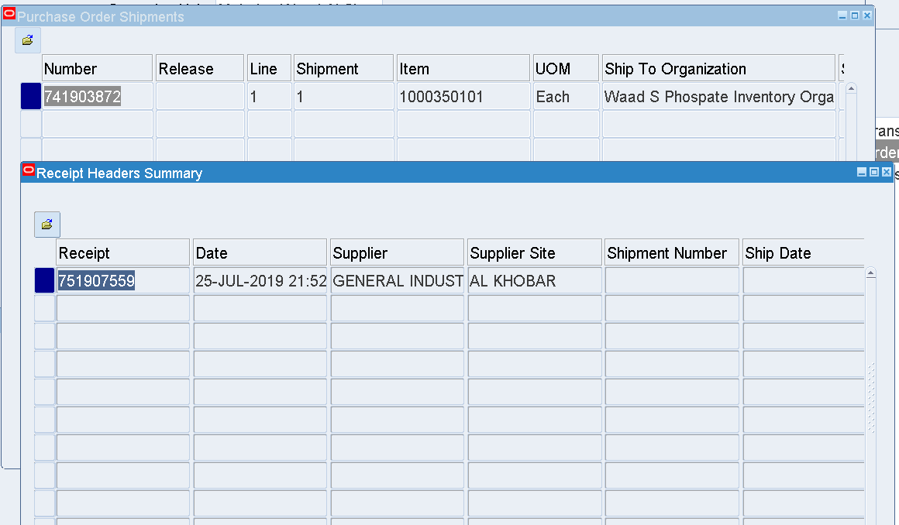

Corrections

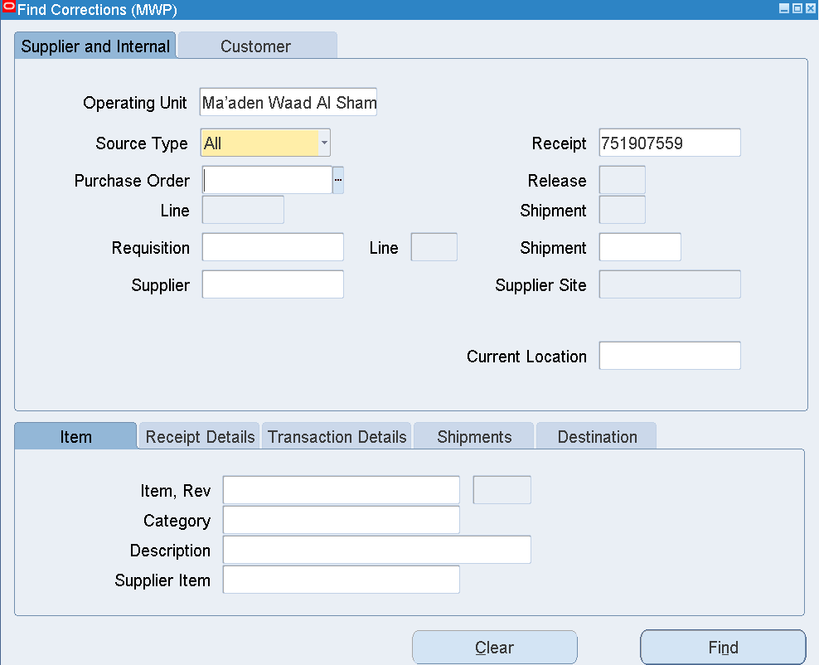

Enter Receipt Number-751907559 741903872(751908643)

Find

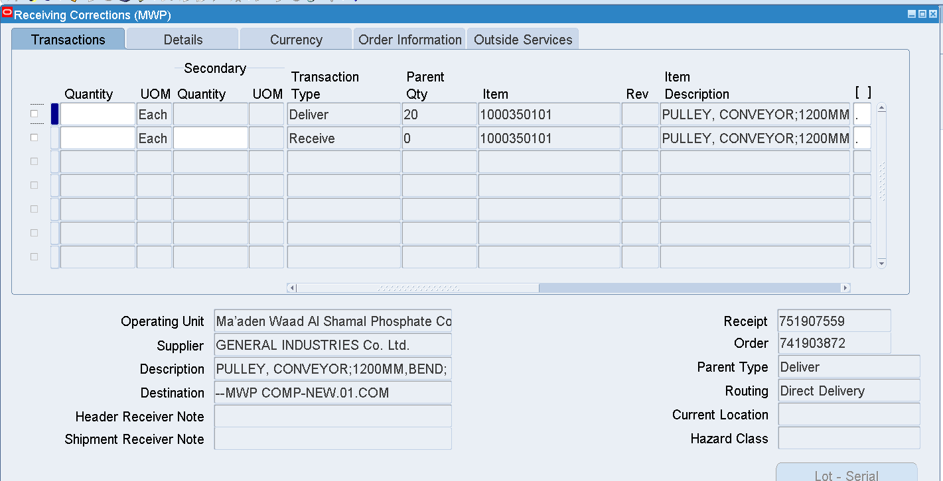

Received Qty = 20

Correct the Received Qty = 10

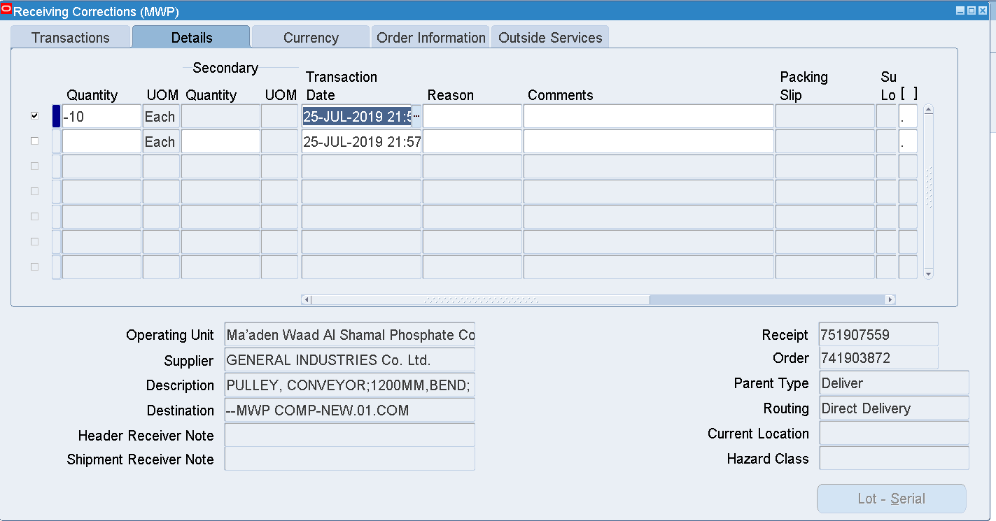

Enter the Negative Qty -10

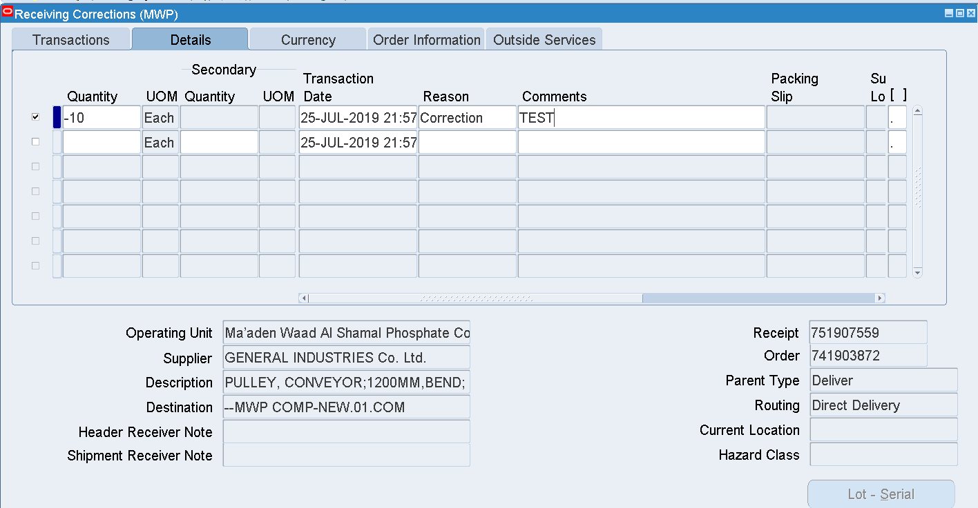

Select Reason from the LOV

Enter Comments

Save

Check the Corrections again

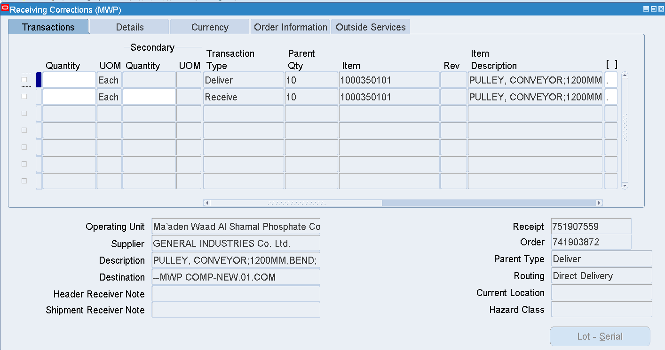

Now the Qty 10 has been transferred to Receiving location from Delivery

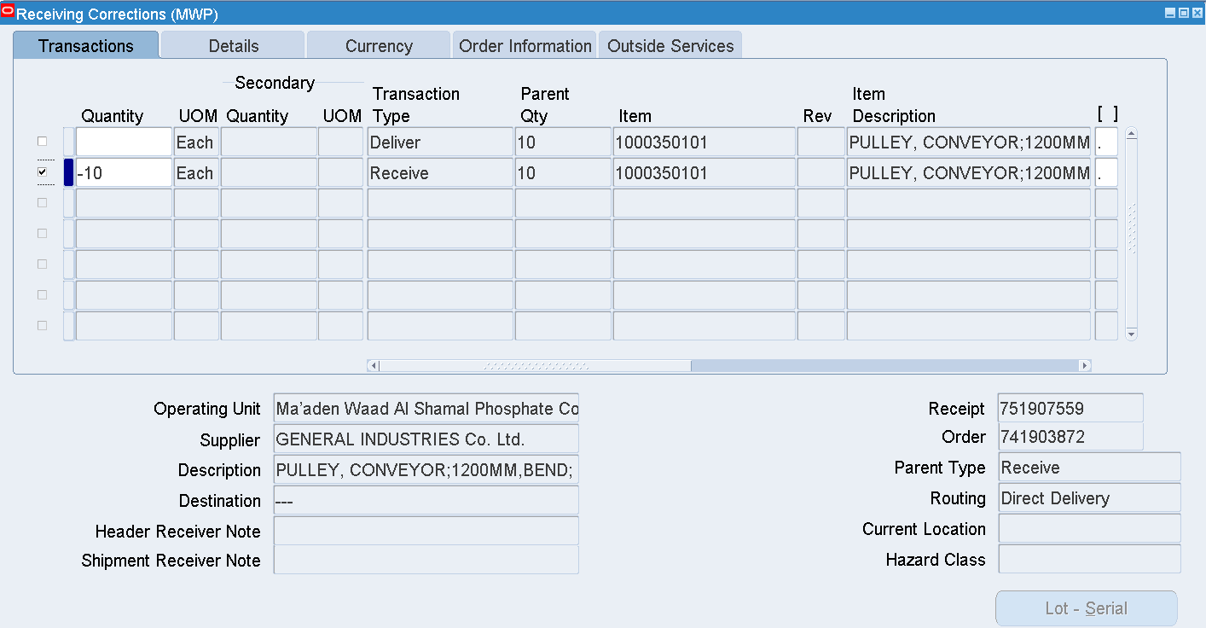

Enter -10 in the 2nd Line – Receive Transaction Type

Save

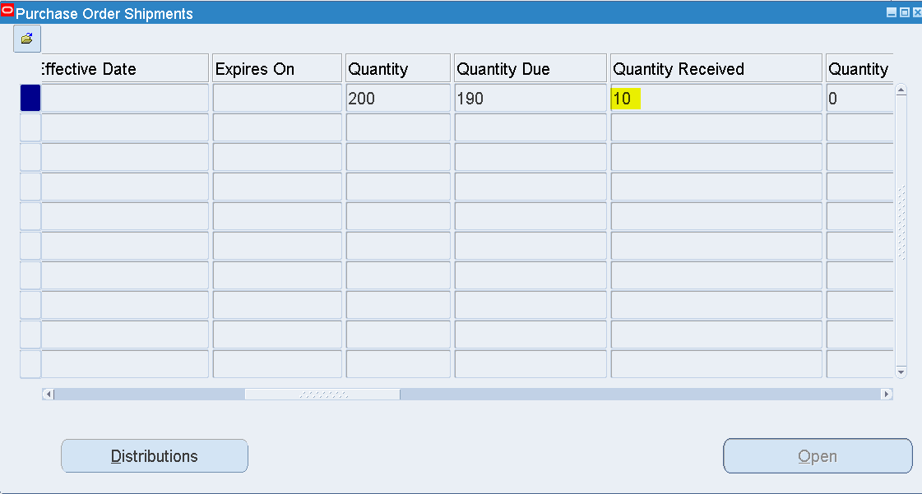

Check the PO Shipments

Now the Quantity Received has been updated

Earlier it was 20

After Correction, Qty received = 10

Check the details in the Receiving Transactions Summary

Receipt – 751907559

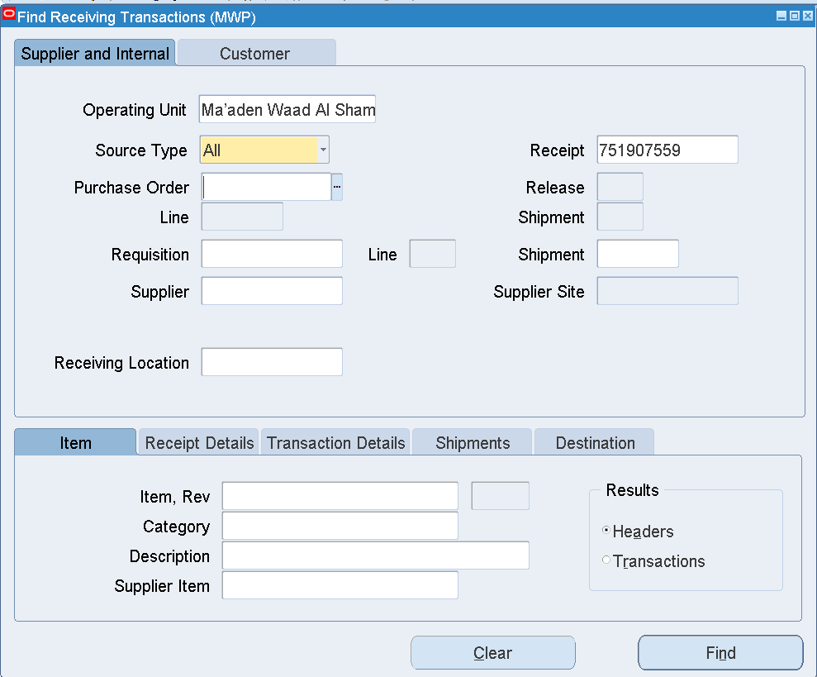

Find

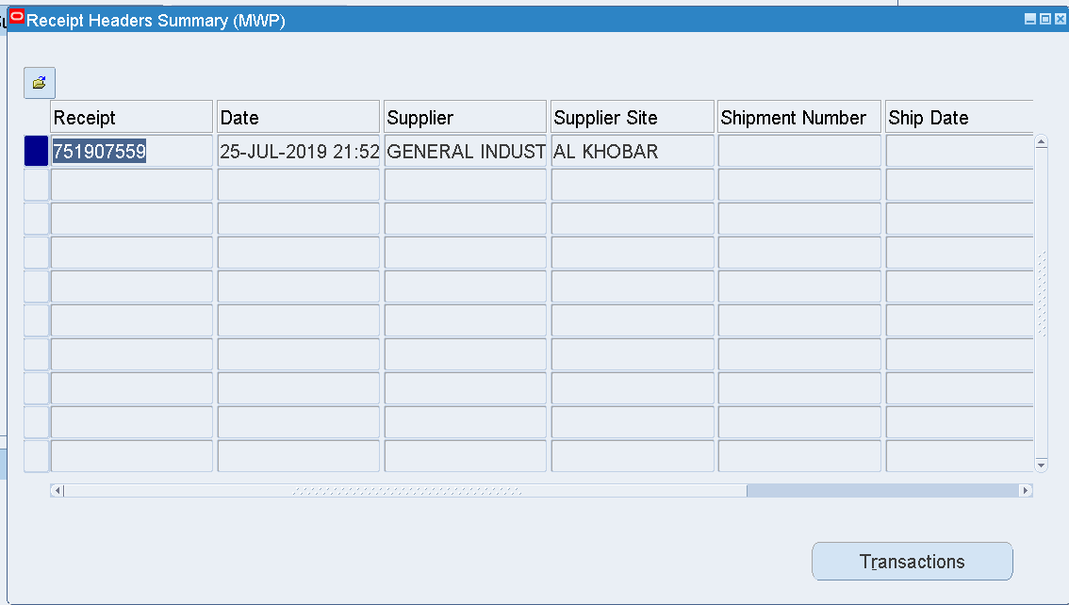

Transactions

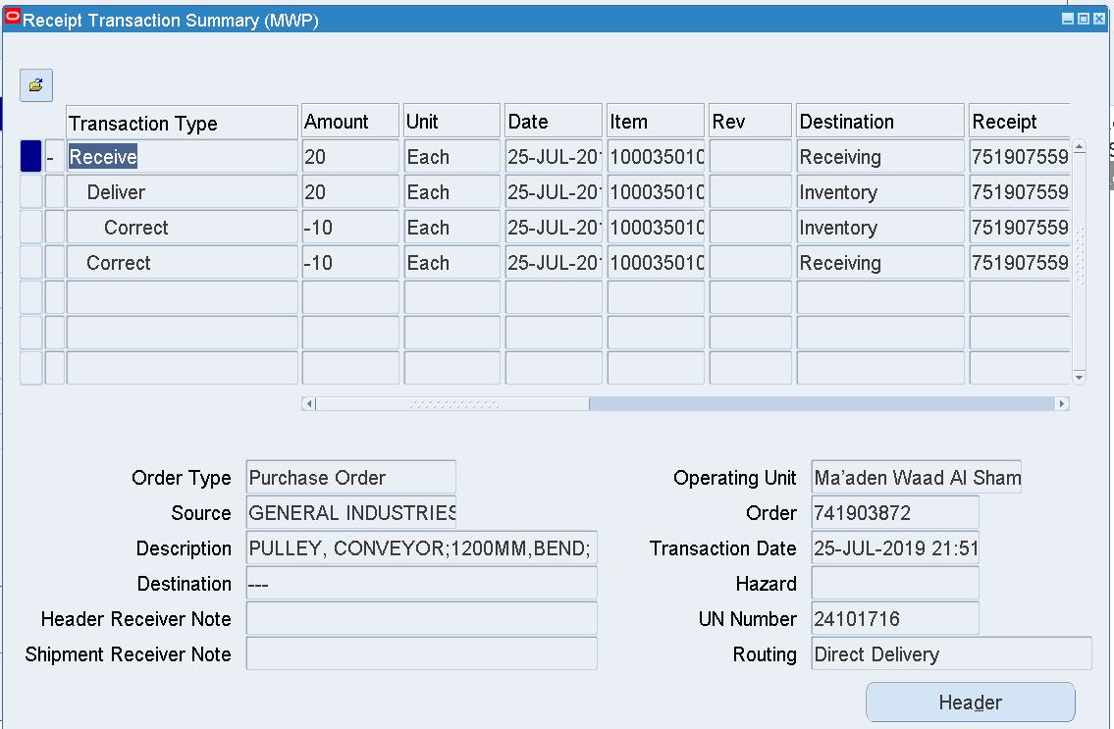

Initially received Qty =20

Correction - Qty 10 from Inventory and then 10 from Receiving

Received Qty and the Quantity Due have been updated in the PO Shipments form

1. Creation of RFQ- Approval

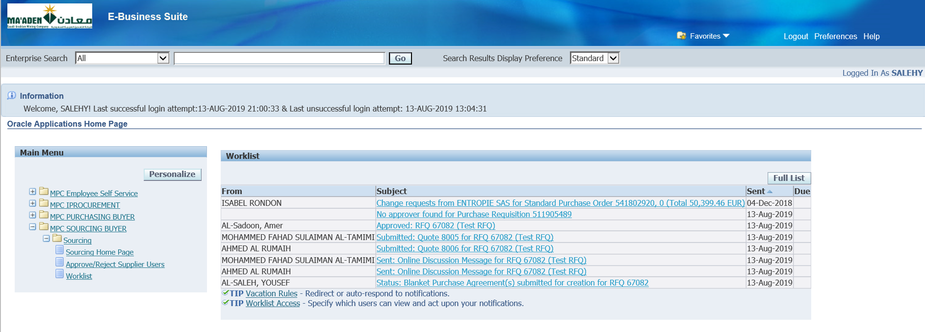

Login as SALEHY

MPC Sourcing Buyer

Sourcing 🡪 Sourcing Home Page

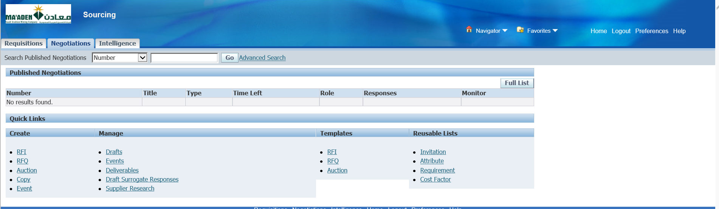

Requisitions tab

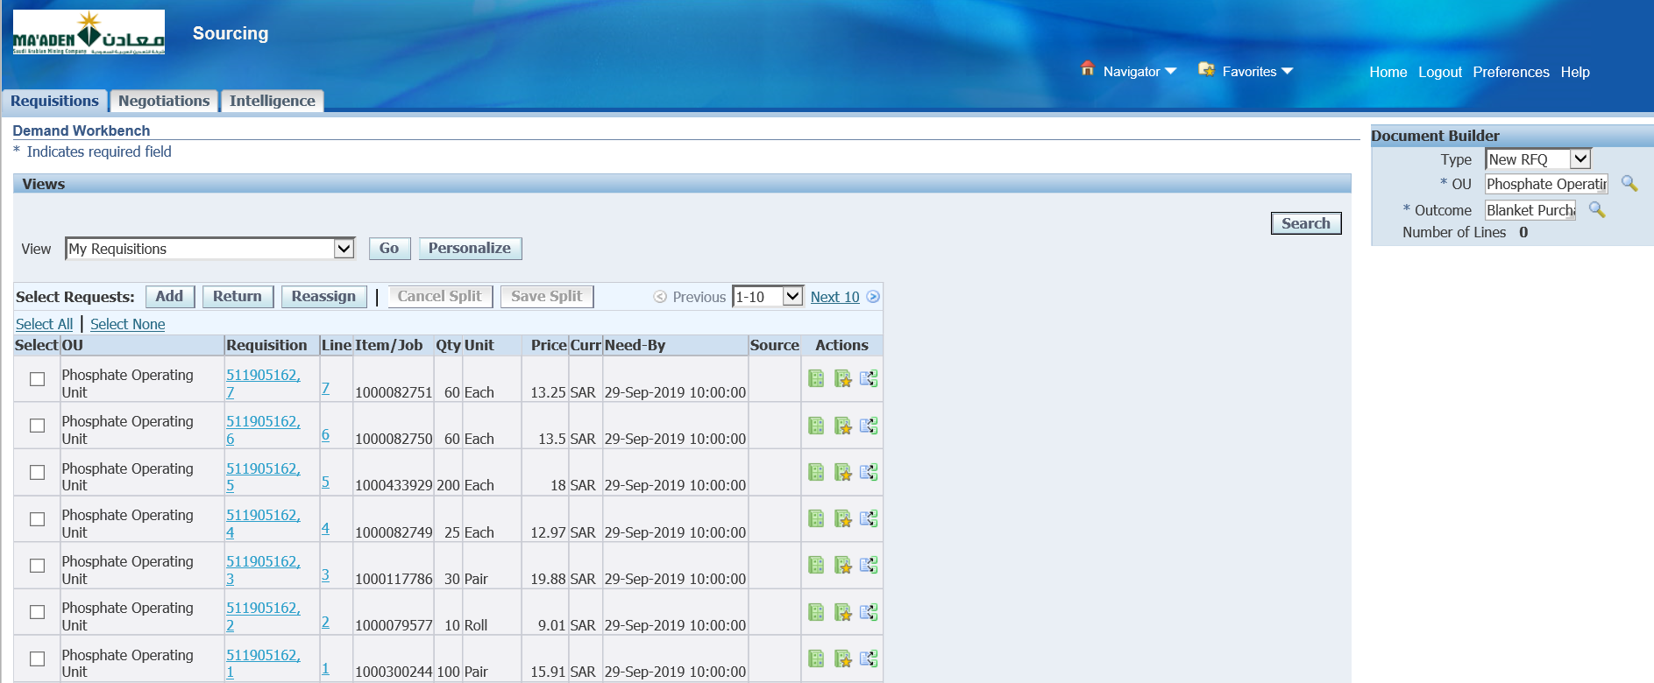

Select the Requisition lines to be added to the RFQ – Add->Search

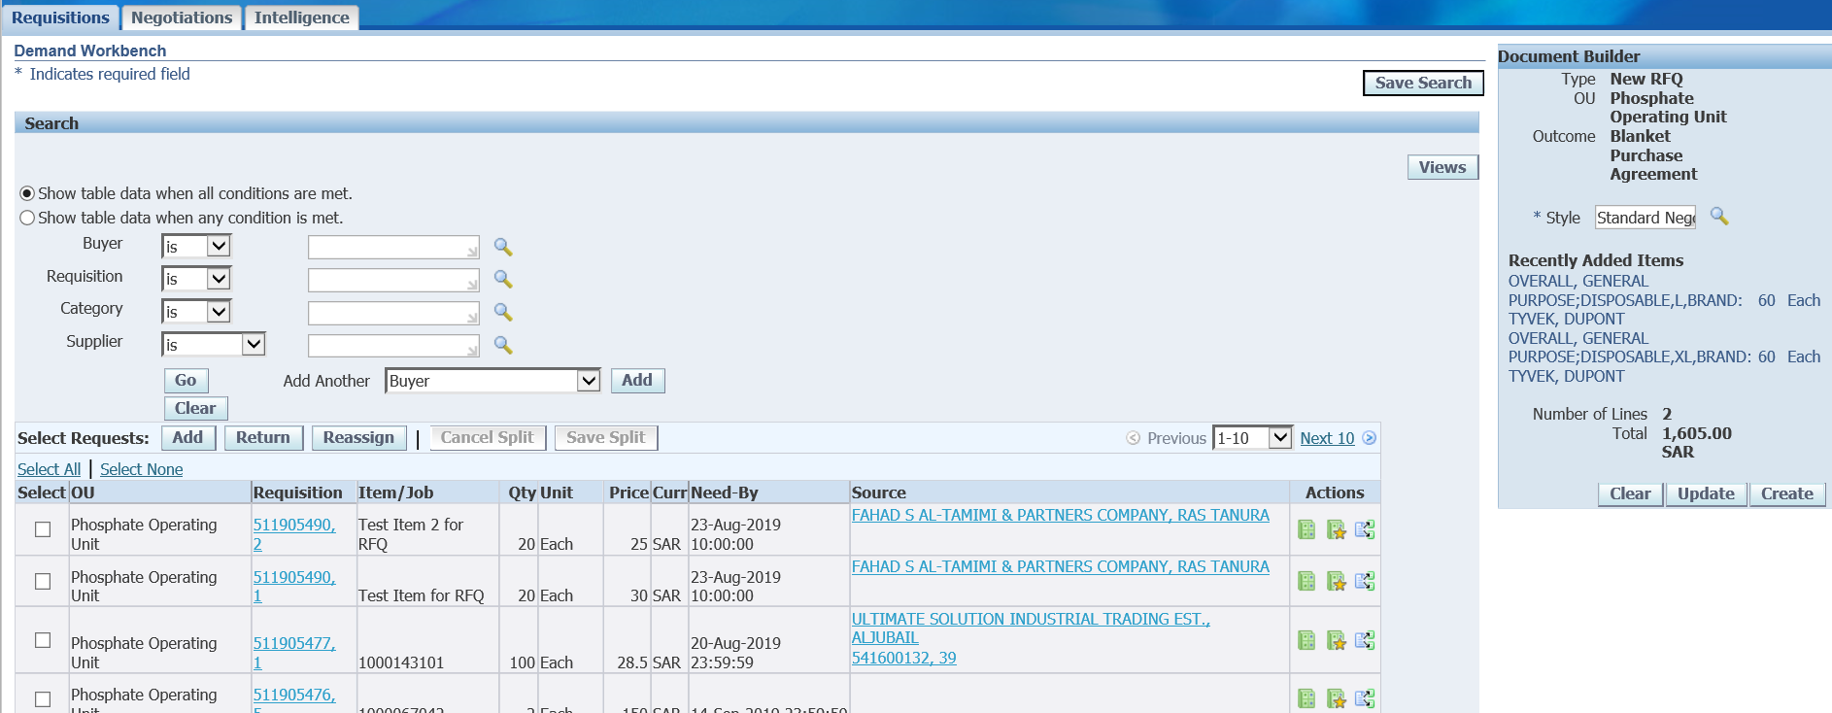

Create

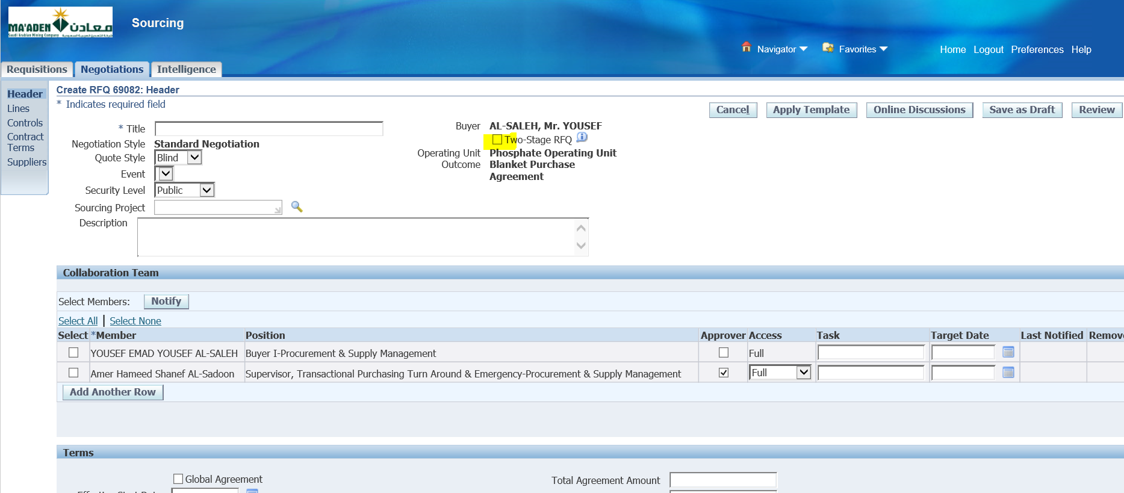

Select Two-Stage RFQ

Enter Title

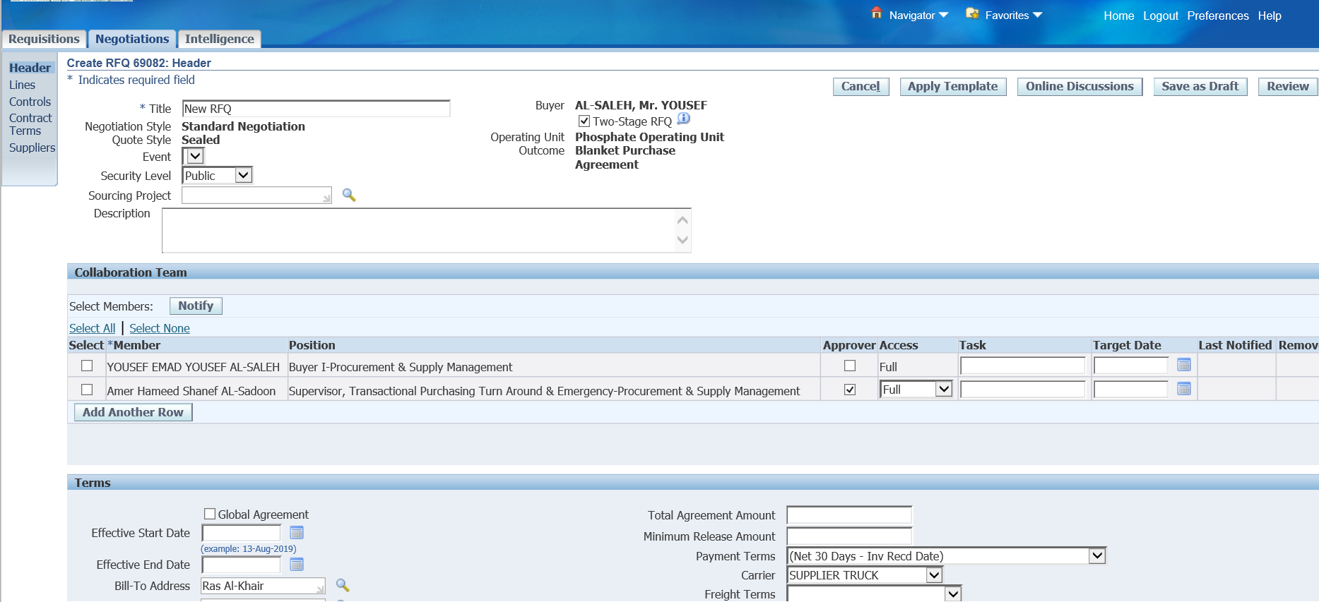

Save as Draft

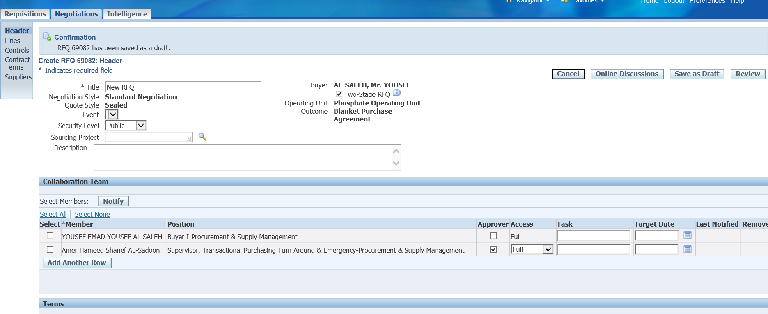

Add Another Row

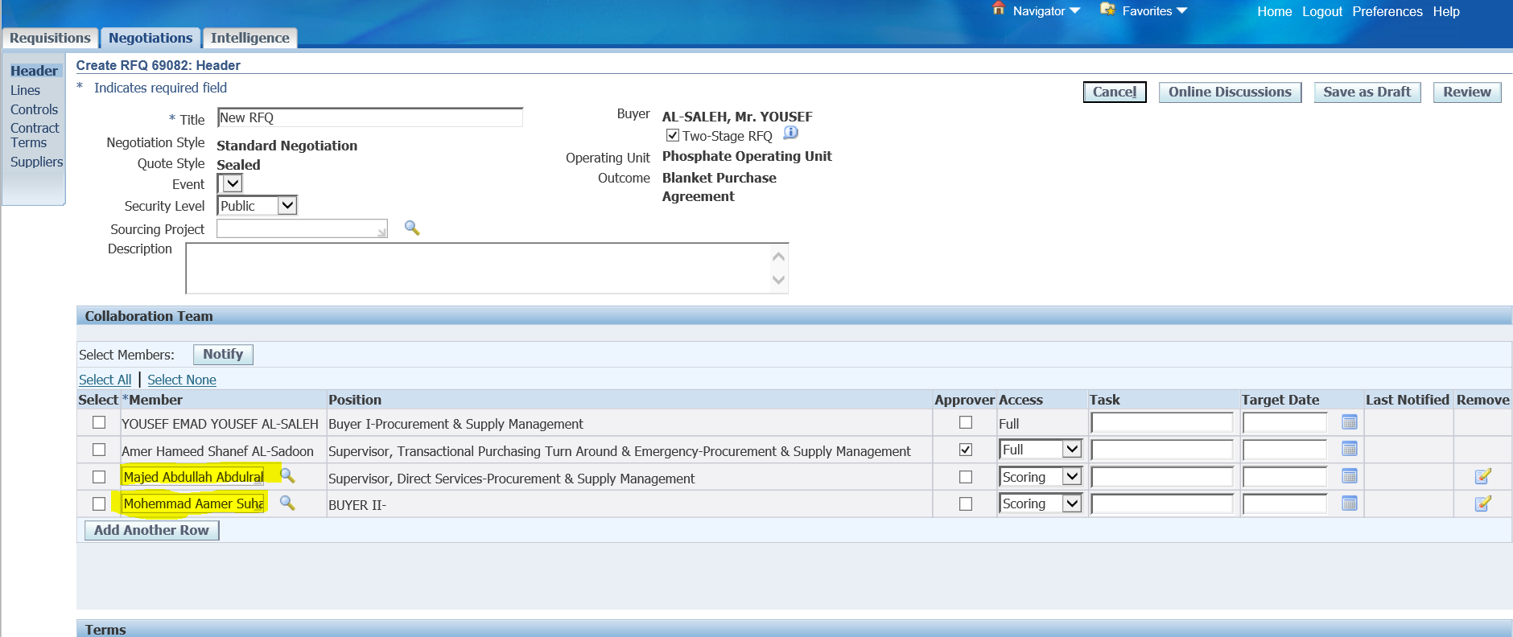

Add the Scoring Team Members

Majed Abdullah Abdulrahman Al-Yahya -> Save as Draft

Mohemmad Aamer Suharwardi -> Save as Draft

Save as Draft

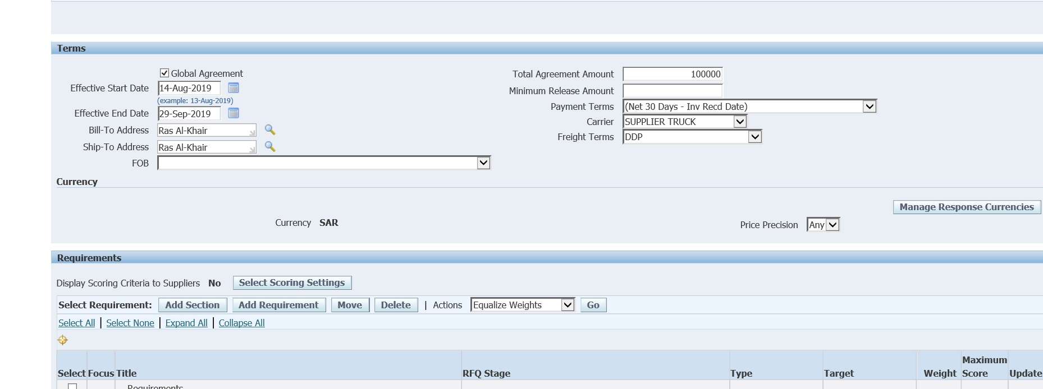

Enter Terms

Tick Global Agreement

Effective Start Date - 01-Sep-2019

Effective End Date – 29-Sep-2019

Total Agreement Amount - 100000

Freight Terms- DDP

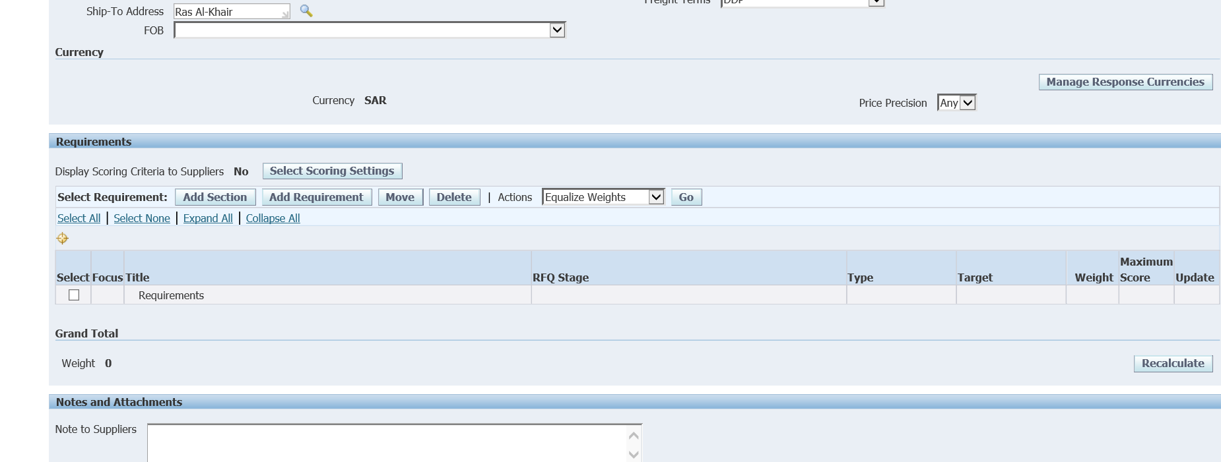

Add Section and Requirements

Select the focus title 🡪 Add Section

Name- Section

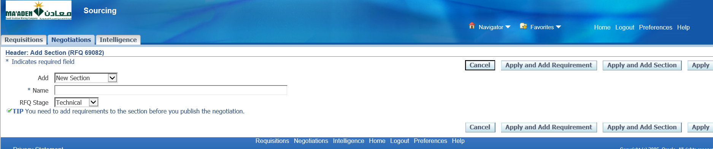

~~Apply And add section~~

~~Add Technical Section~~

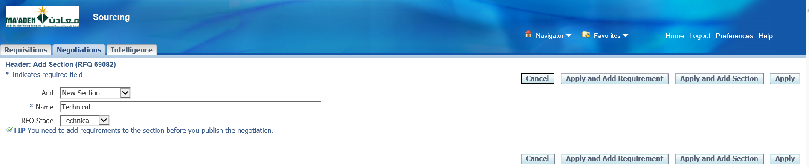

Name - Techinical

Apply and Add Requirement

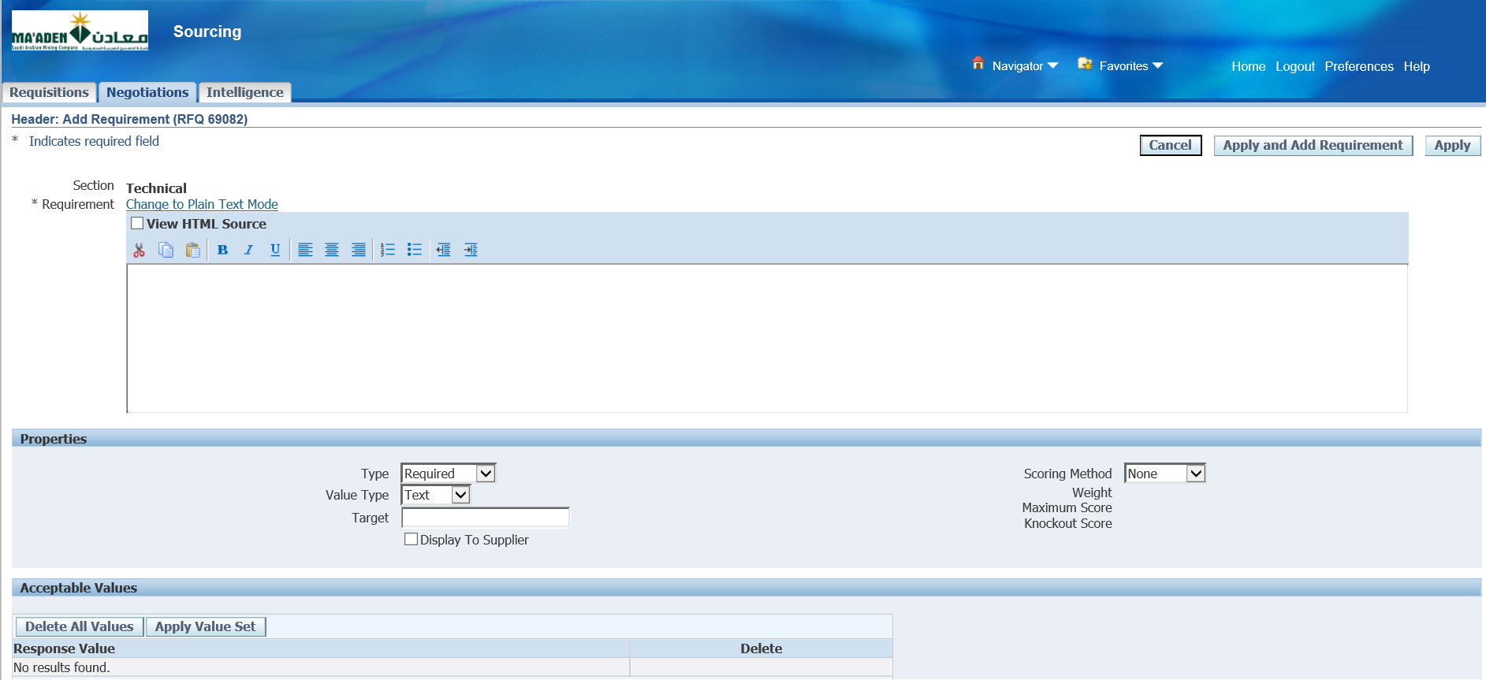

Select Scoring Method – Manual

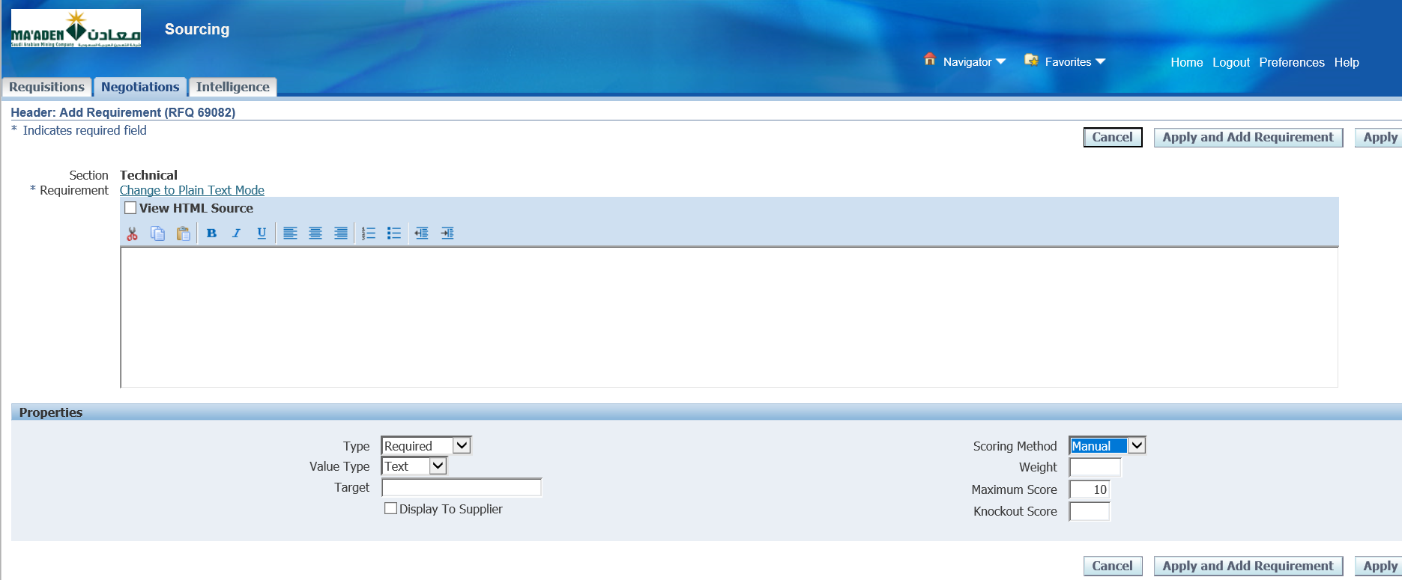

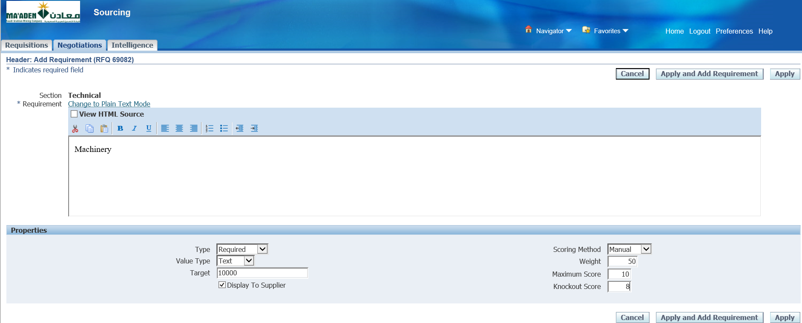

Enter Some Technical Question

Text Area- Machinery

Enter Target - 10000

Enter Weight - 50

Knockout Score-8

Apply

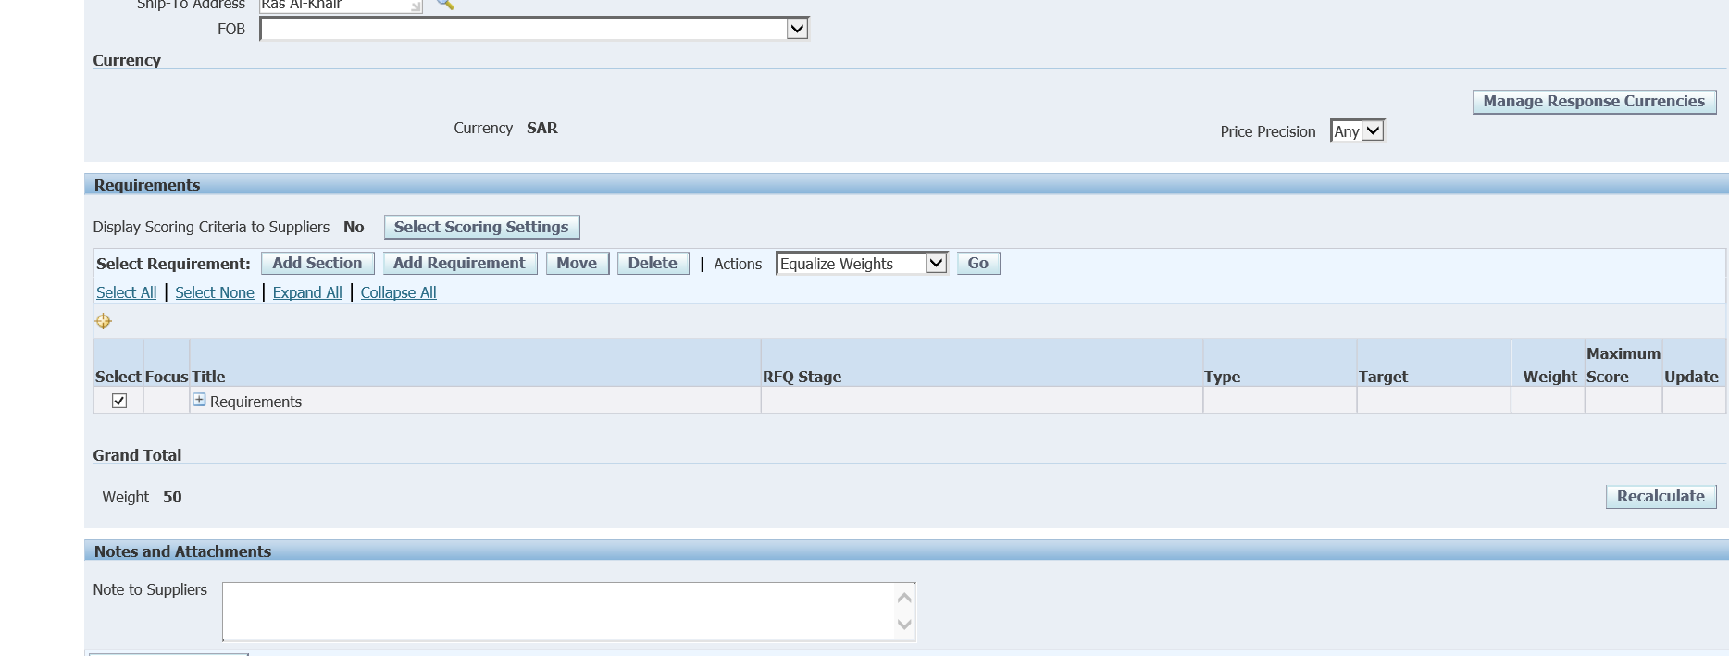

Select and click Add Section

This is for Commercial

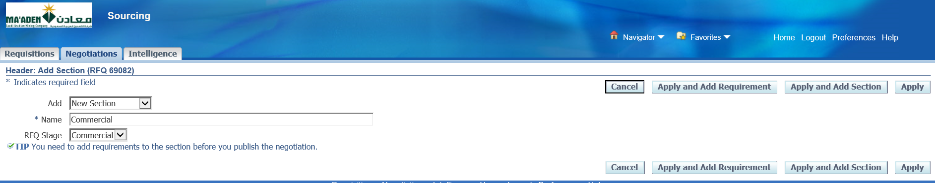

Name_ Commercial-> Commercial

Apply and Add Requirement

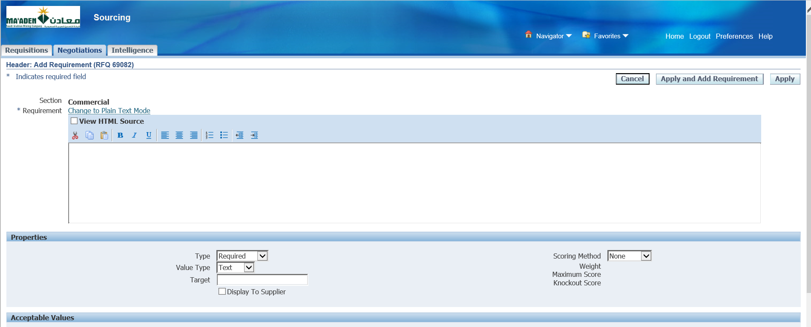

Scoring method – Manual

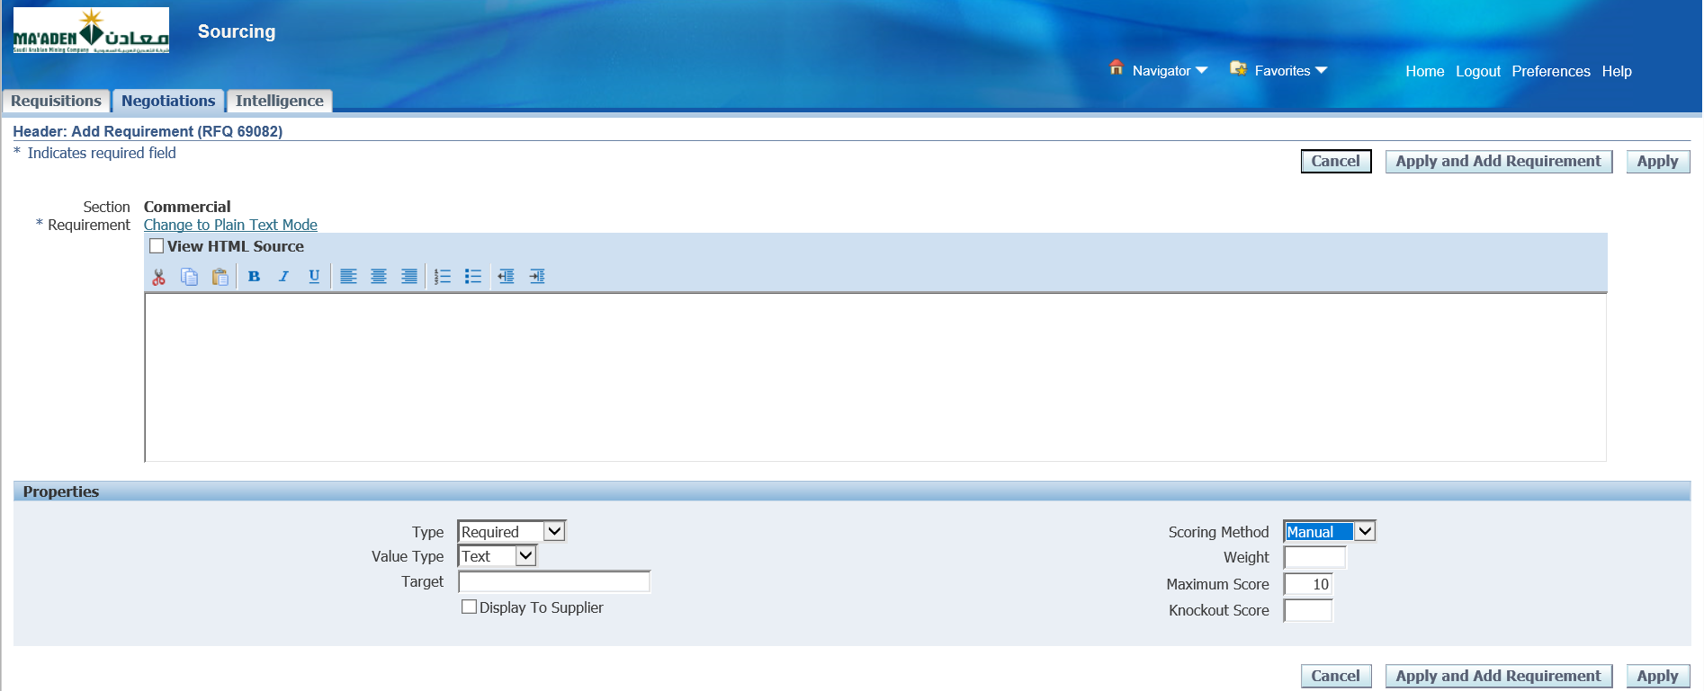

Enter some Commercial question

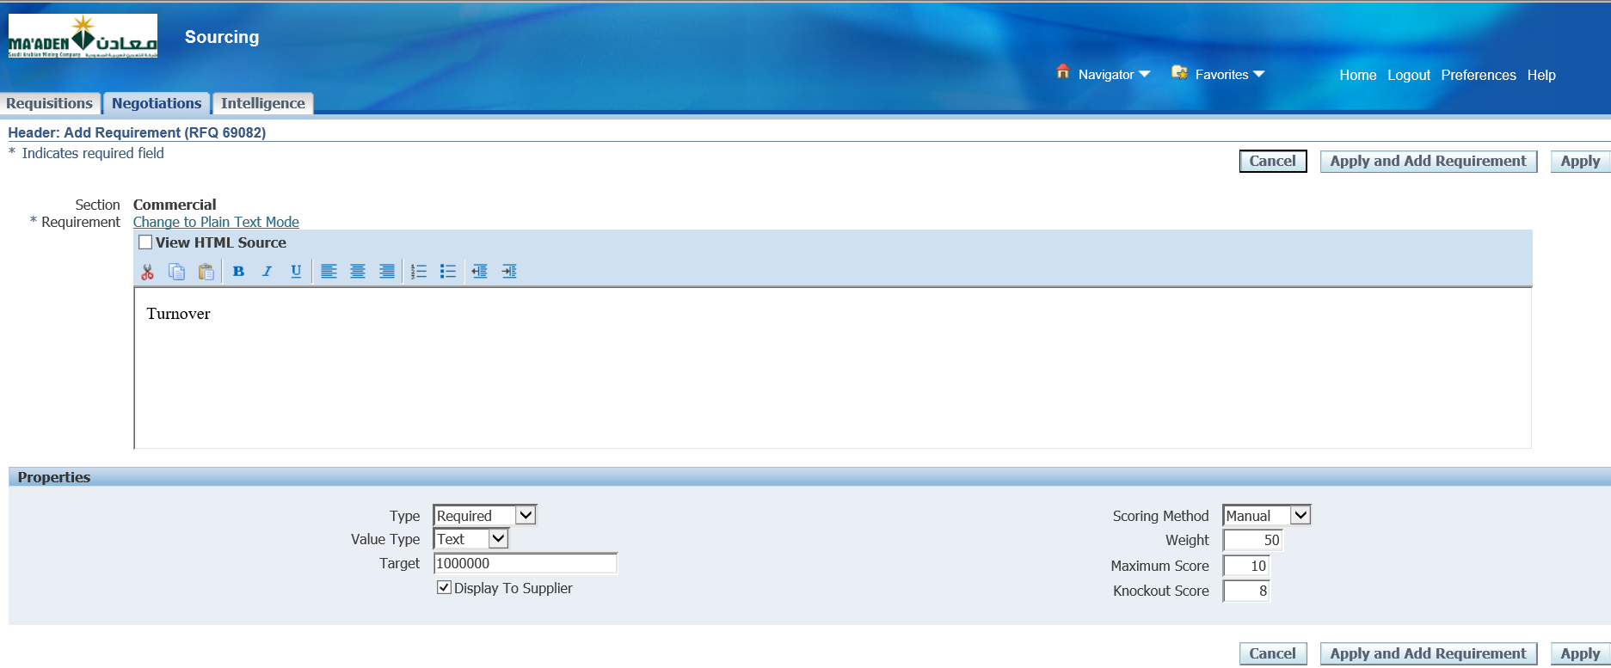

Commercial_TextArea -> TurnOver

Commercial_target-100000

Commercial_Weight->50

Commercial_Score->8

Tick the Display to Supplier check Box

Apply

Save as Draft

Select Lines

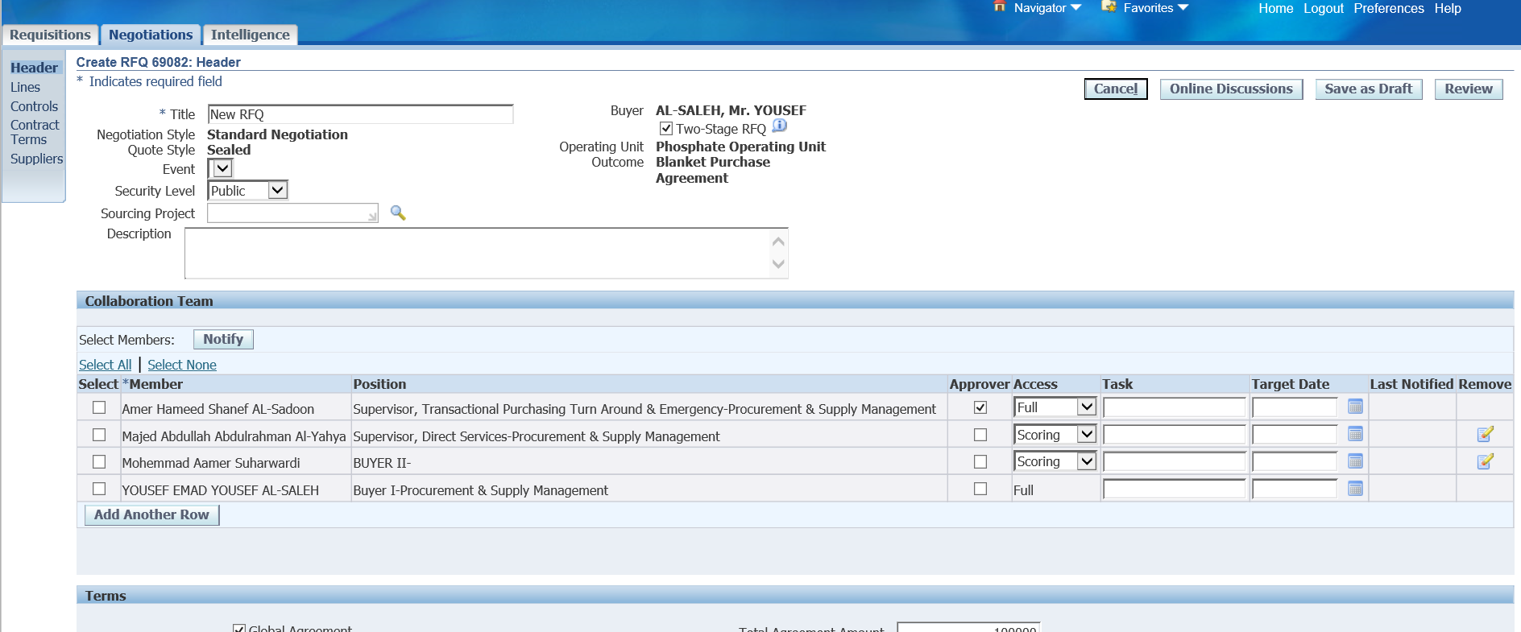

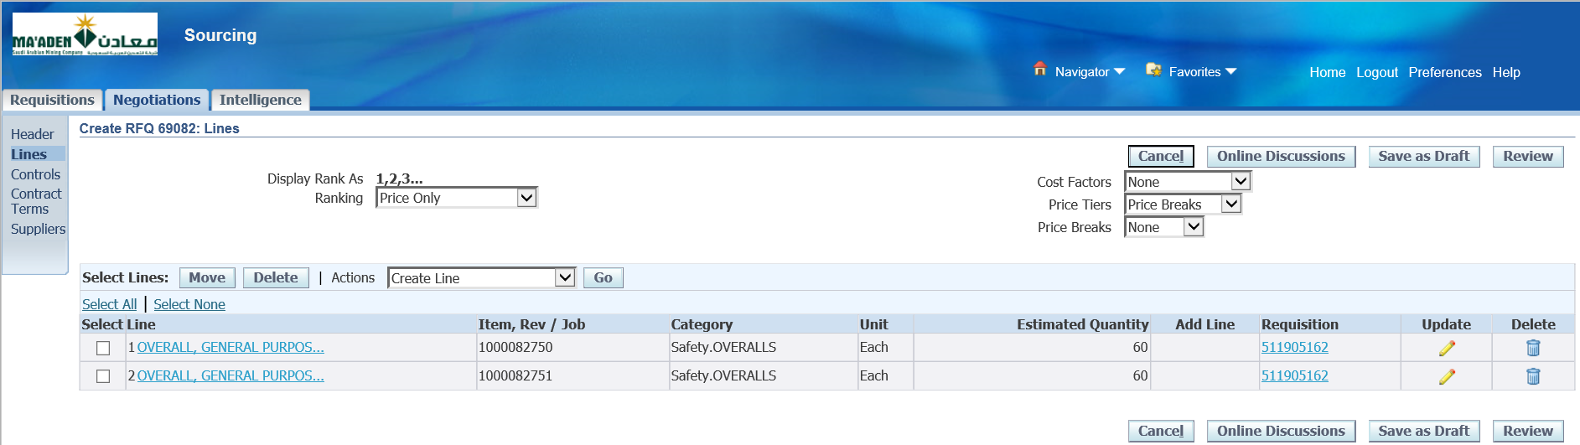

Click Update for Lines

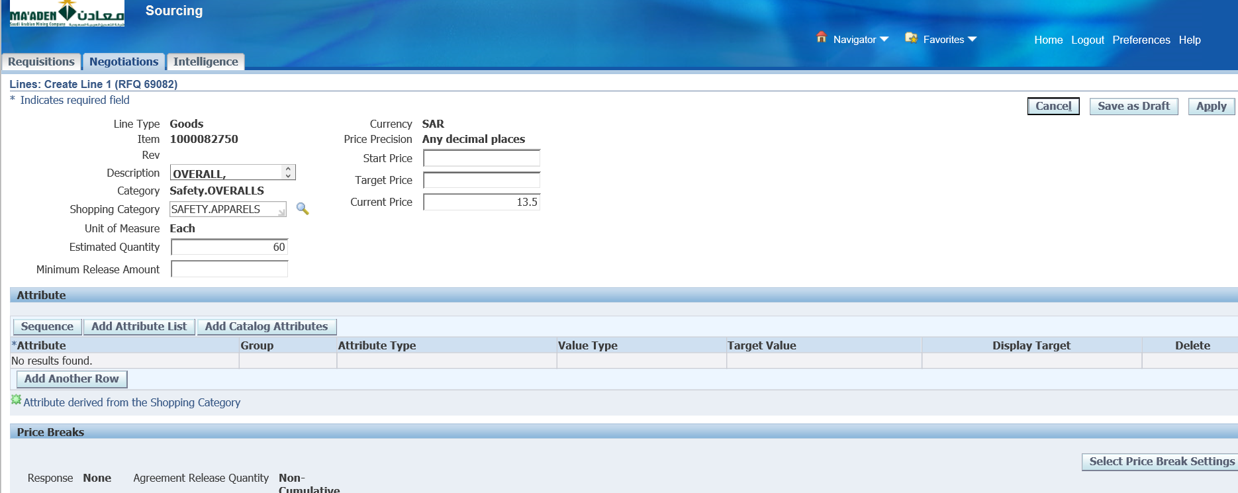

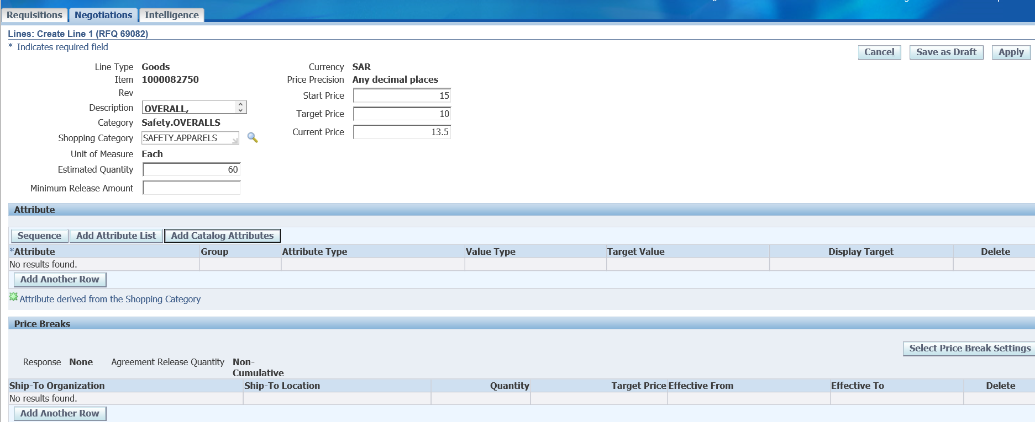

Enter Start Price ->15

Target Price - > 10

Add Attributes ( Optional ) - Add Catalog Attributes-Not Consider

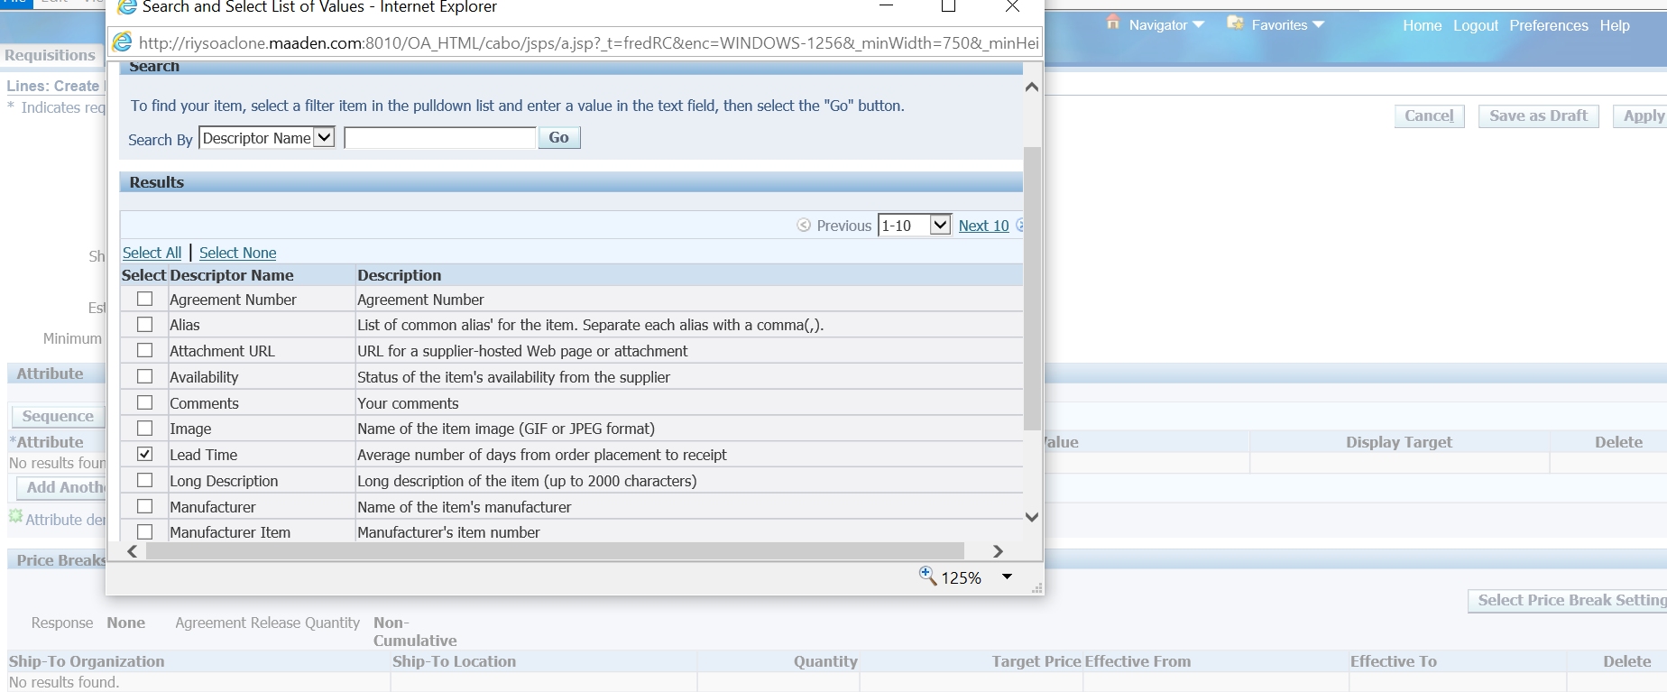

Select one of the Catalog Attributes

Lead Time

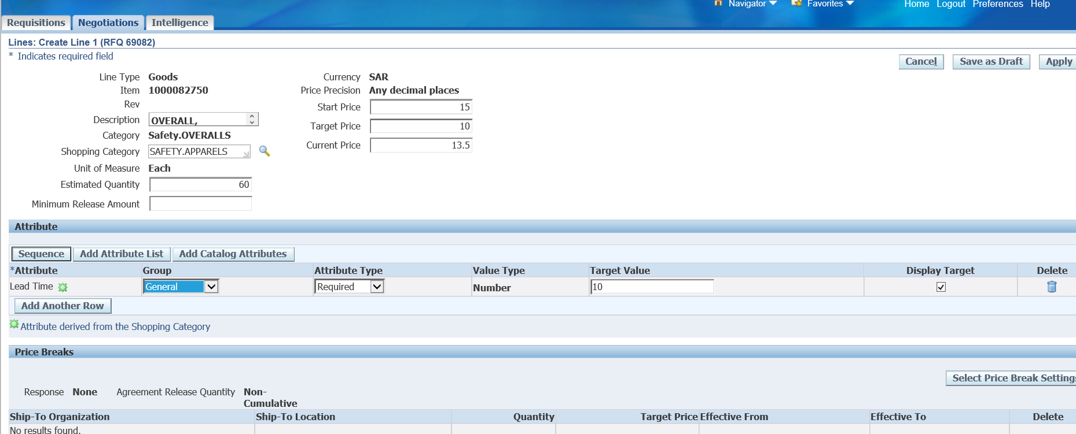

Select Group

Attribute Type

Enter Target Value

Select Display Target

Save as Draft

Apply

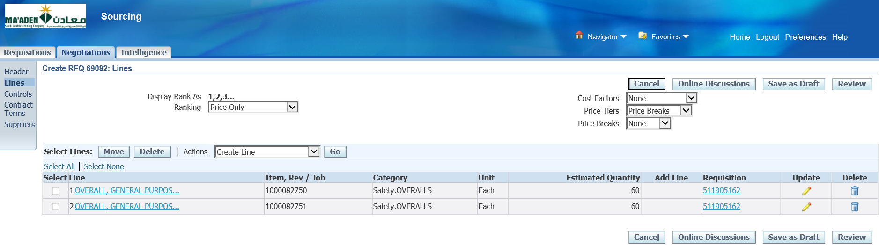

Update Line 2

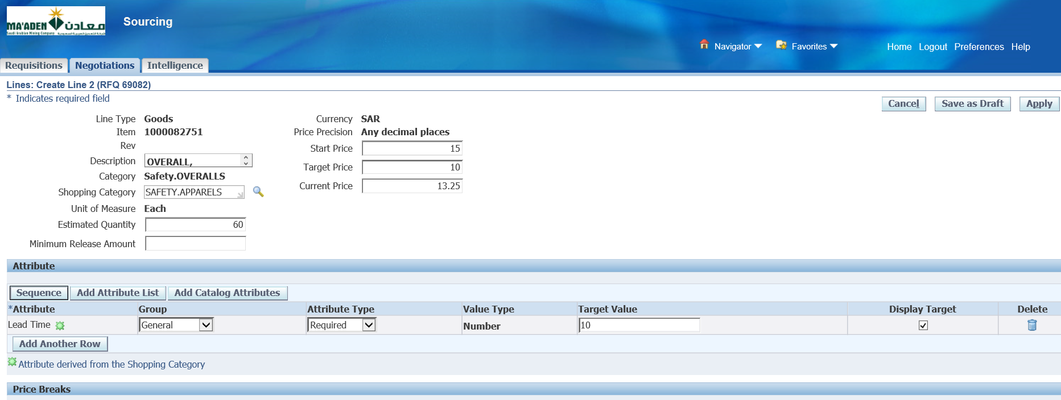

Enter Start Price

Target Price

Add Attributes

Save as Draft

Apply

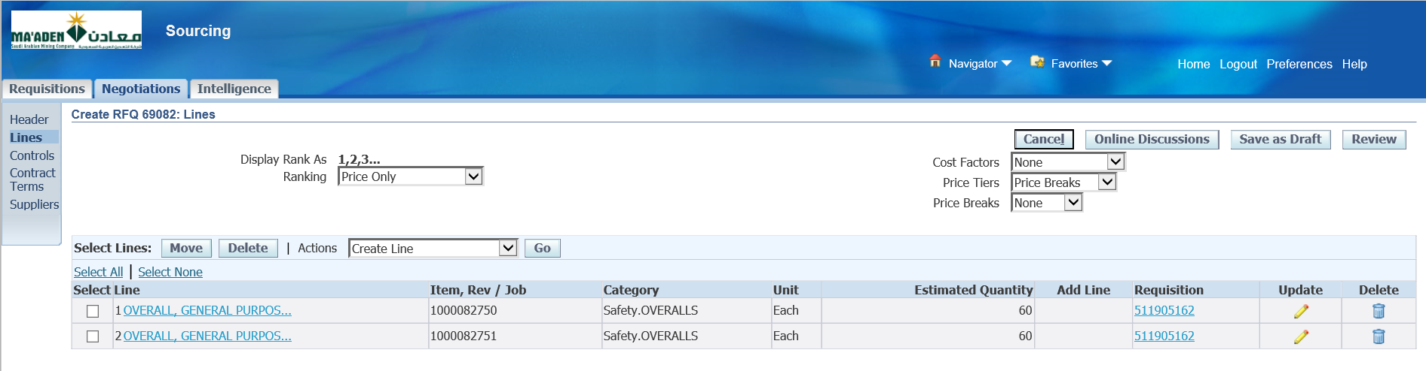

Select Controls

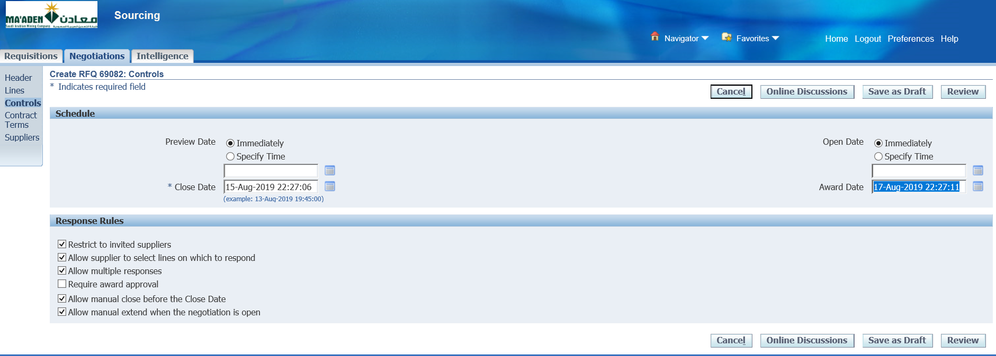

Select Response Rules

Tick as shown above

Select Preview date and Open Date

Enter Close Date- 29-Sep-2019 13:19:14

Award Date- 03-Sep-2021 20:04:22

Save as Draft

Select Suppliers

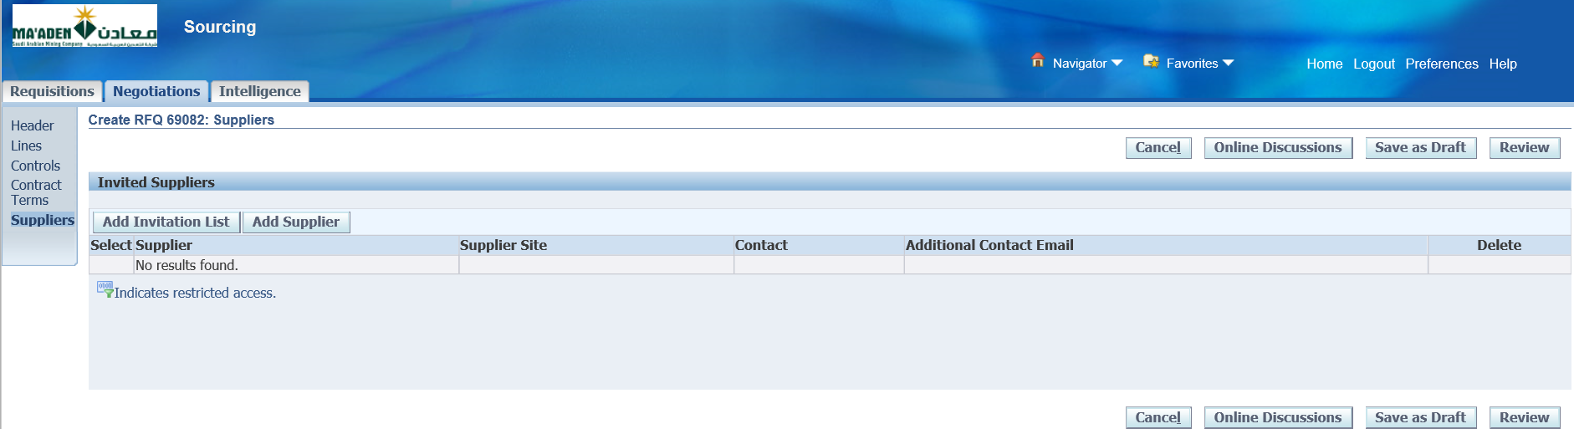

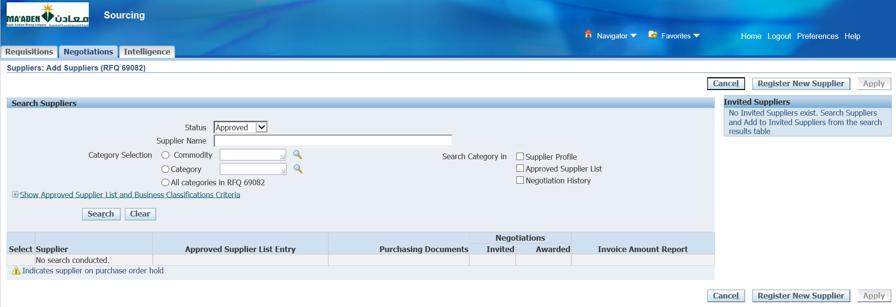

Add Supplier

Enter some Supplier –

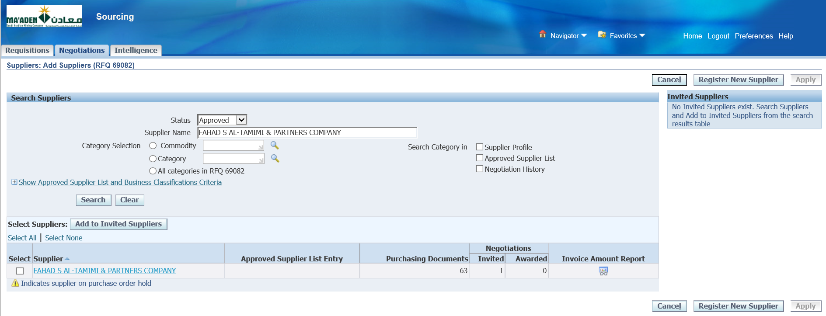

FAHAD S AL-TAMIMI & PARTNERS COMPANY

Search

~~Find~~

Select and Add to Invited Suppliers

Apply

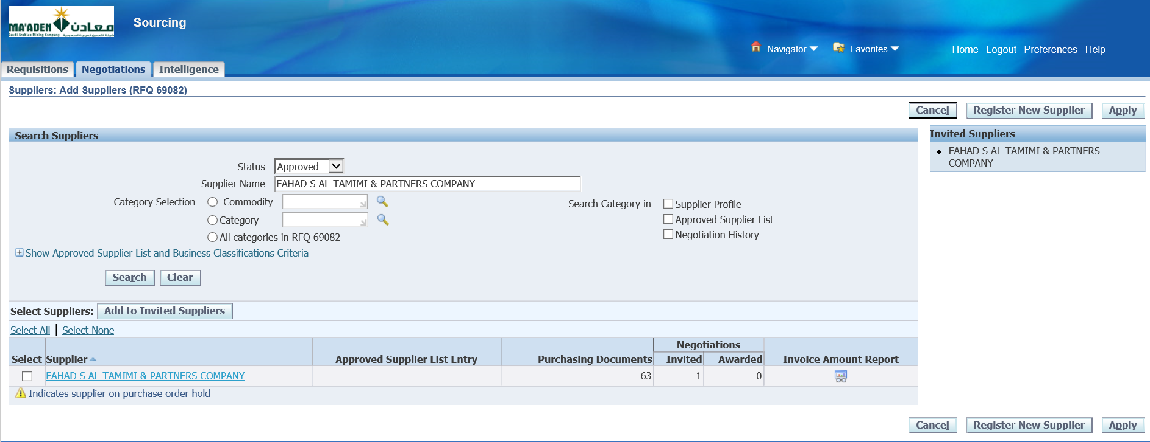

Search for another supplier

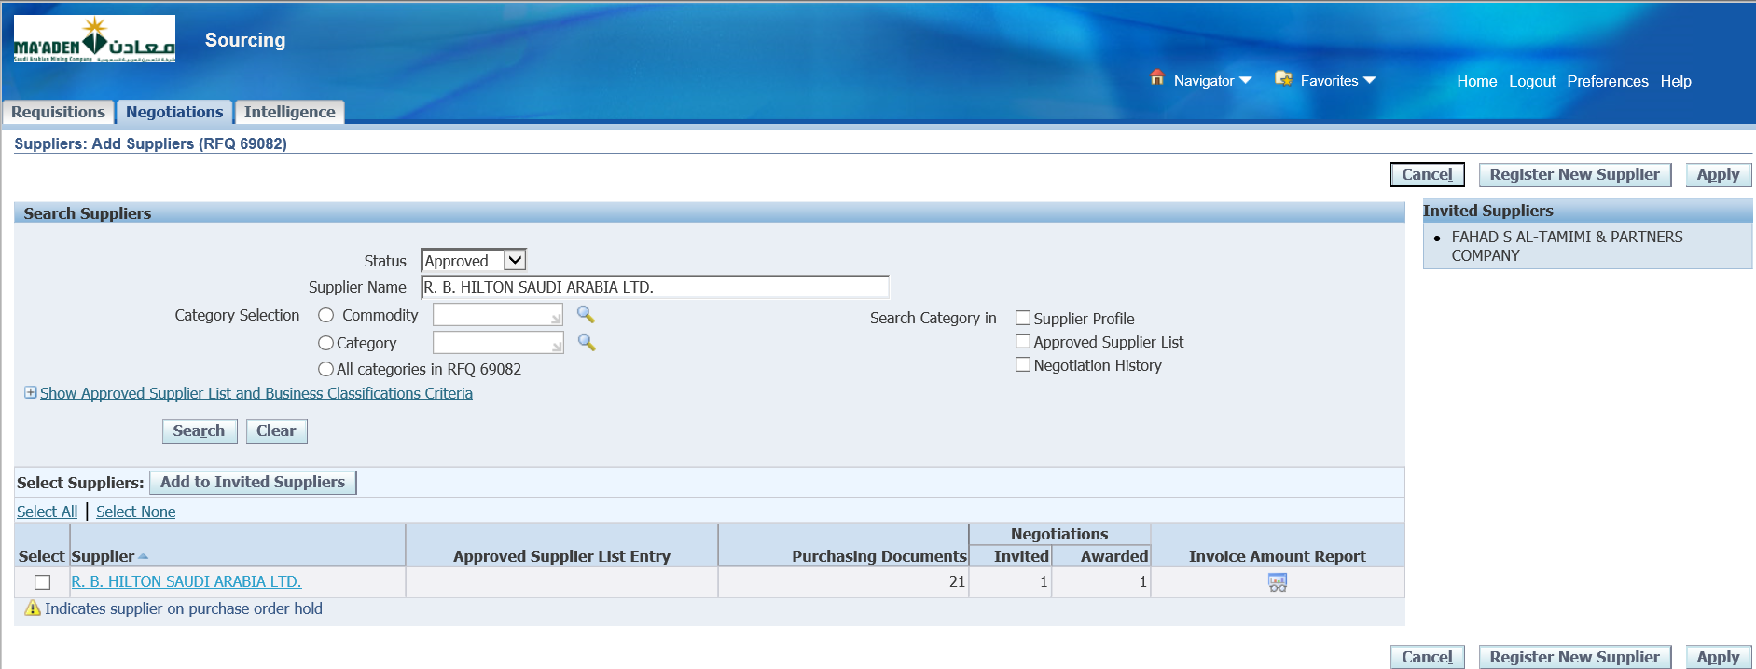

Add to Invited suppliers

R. B. HILTON SAUDI ARABIA LTD.

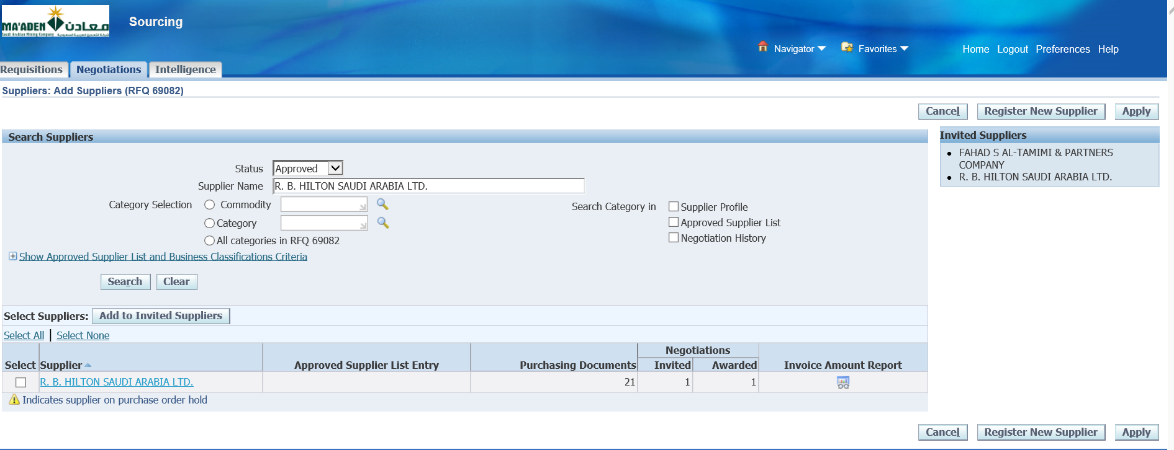

Apply

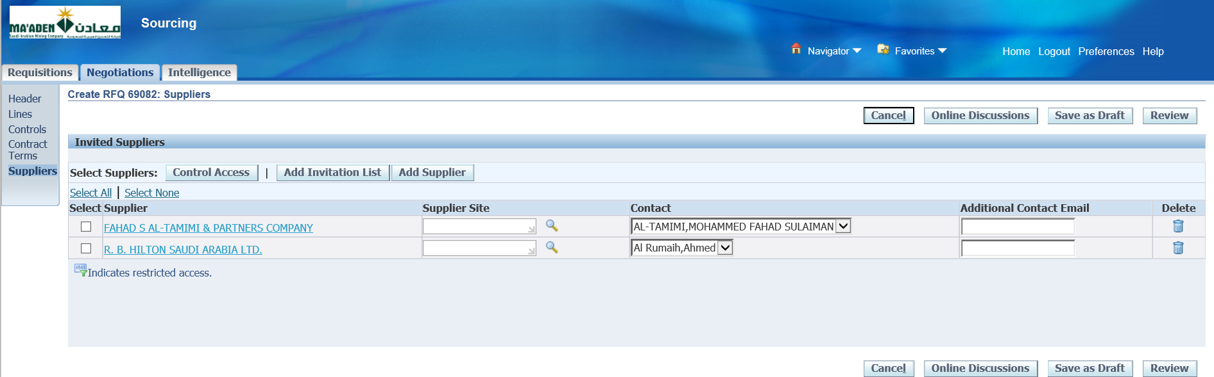

Save as Draft

Review

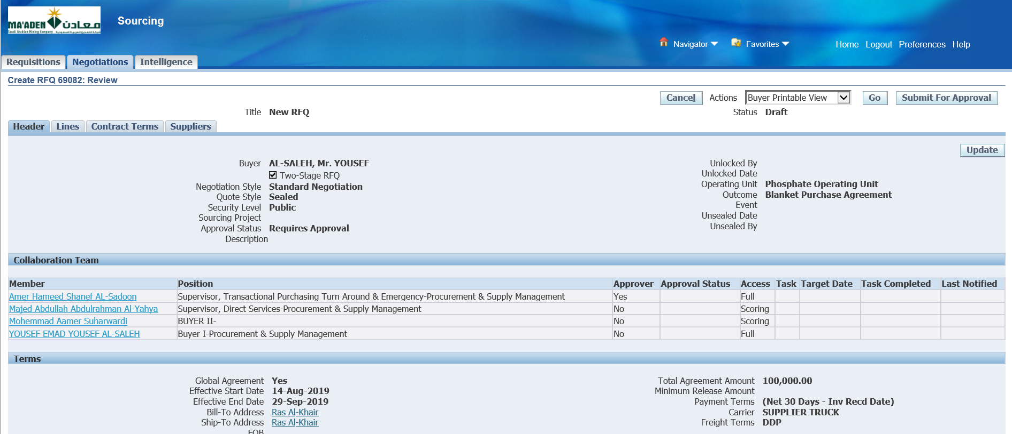

Submit for Approval

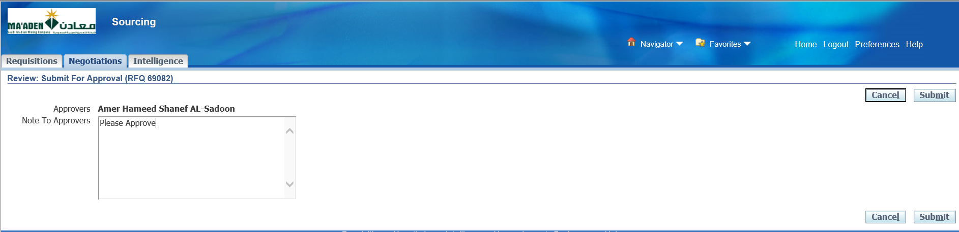

Submit

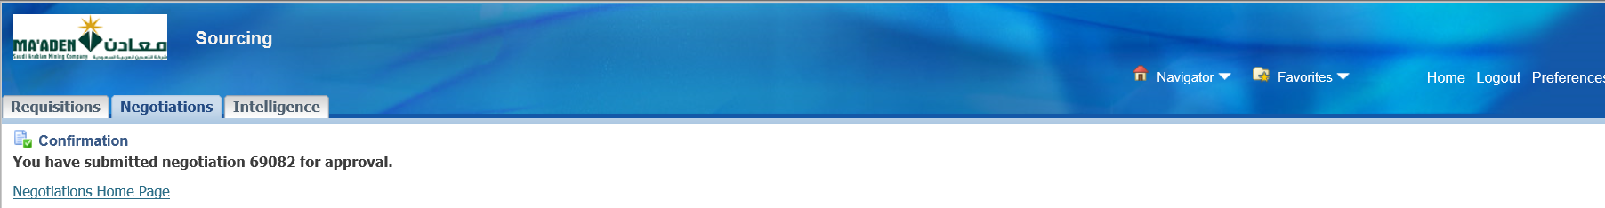

Login as SADOONA

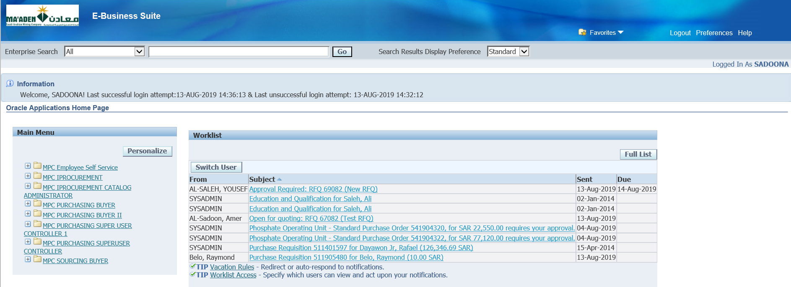

Select the RFQ from the worklist

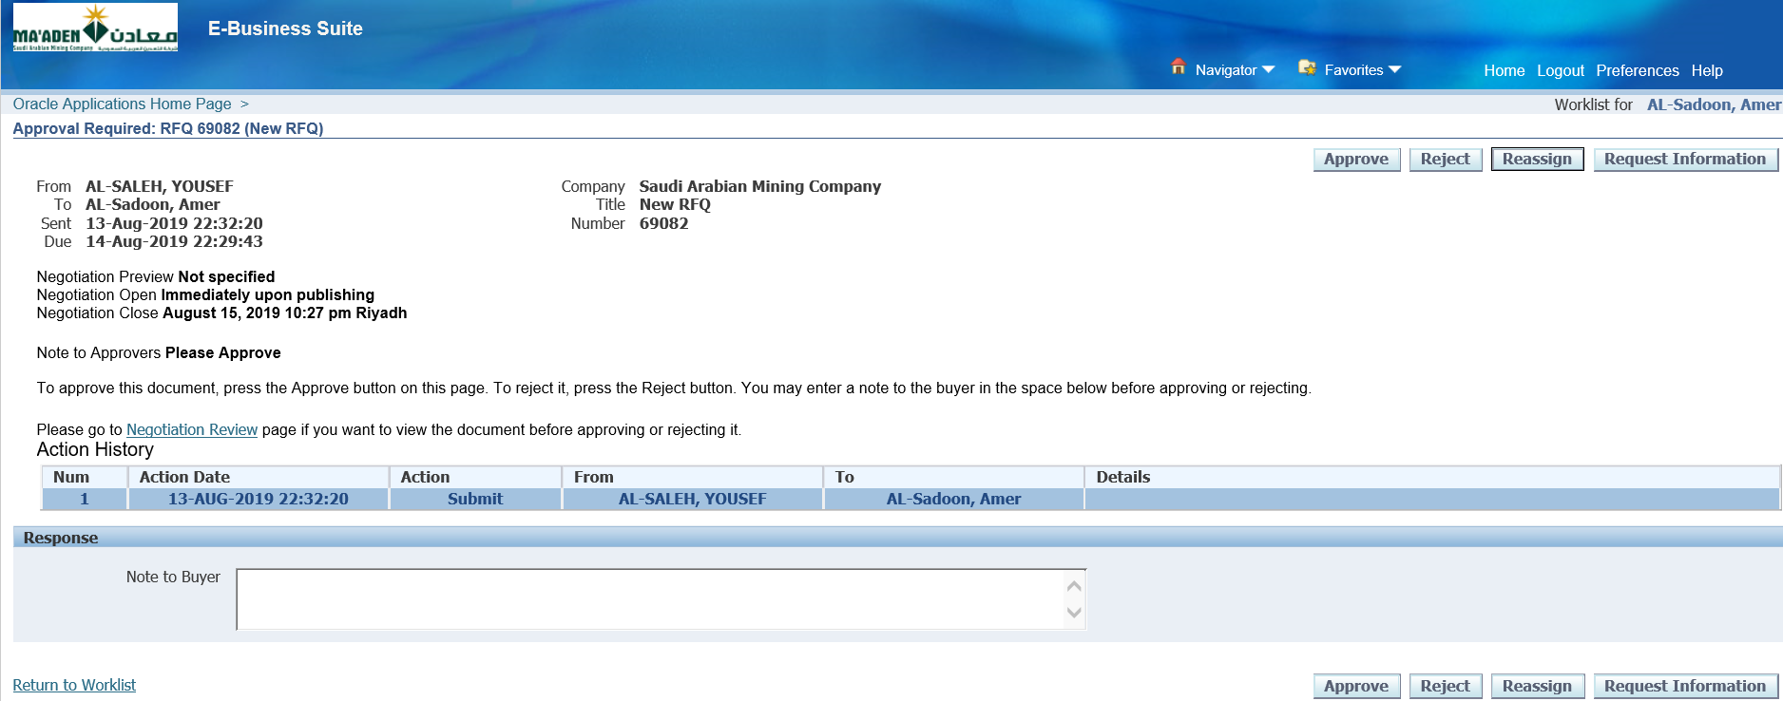

Select Negotiation Review if required

Approve

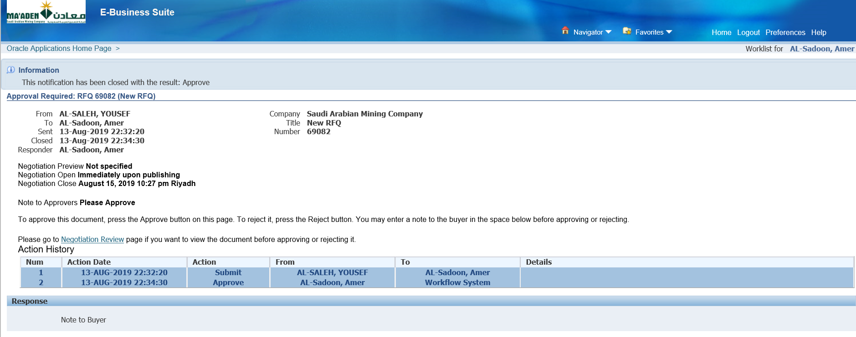

Approved

1. Publish RFQ

Login as the Buyer – SALEHY

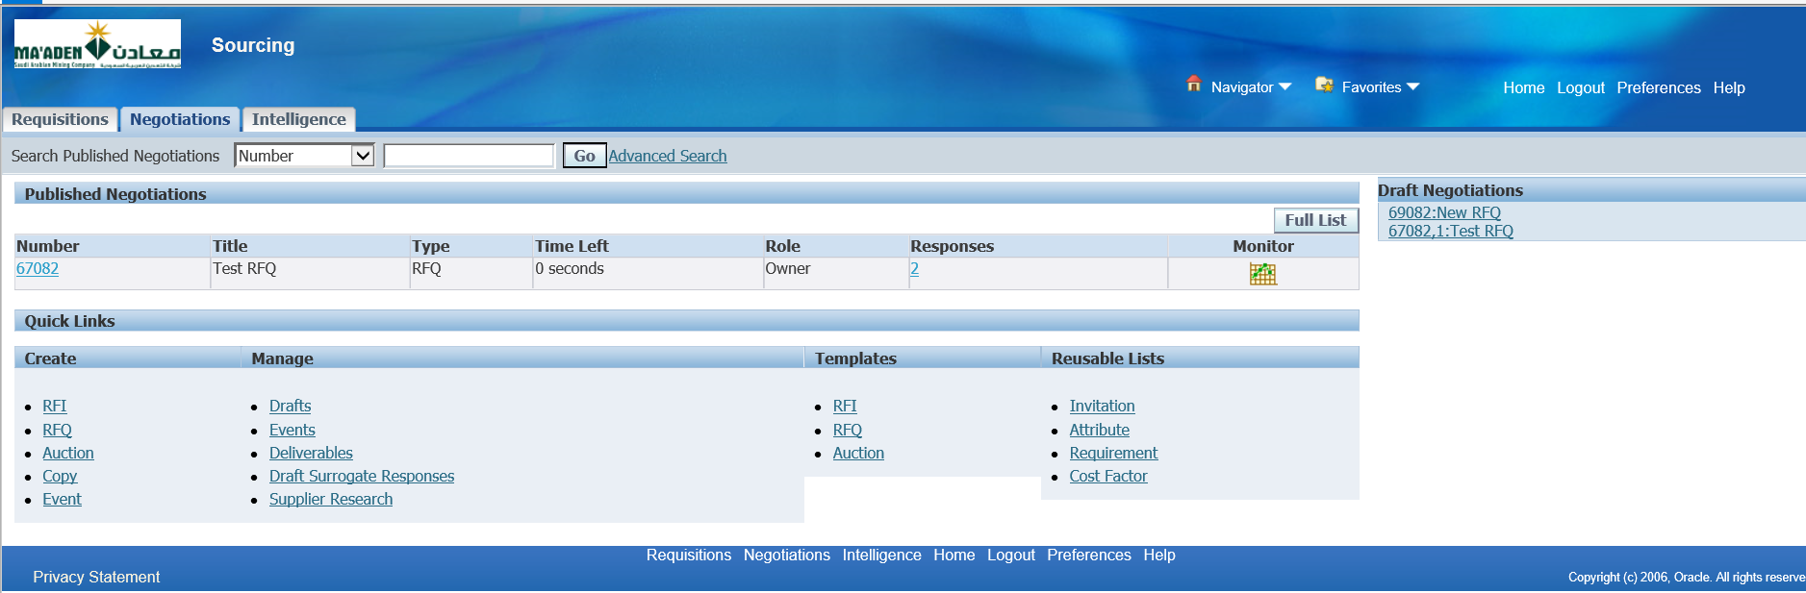

Select the Draft Negotiation

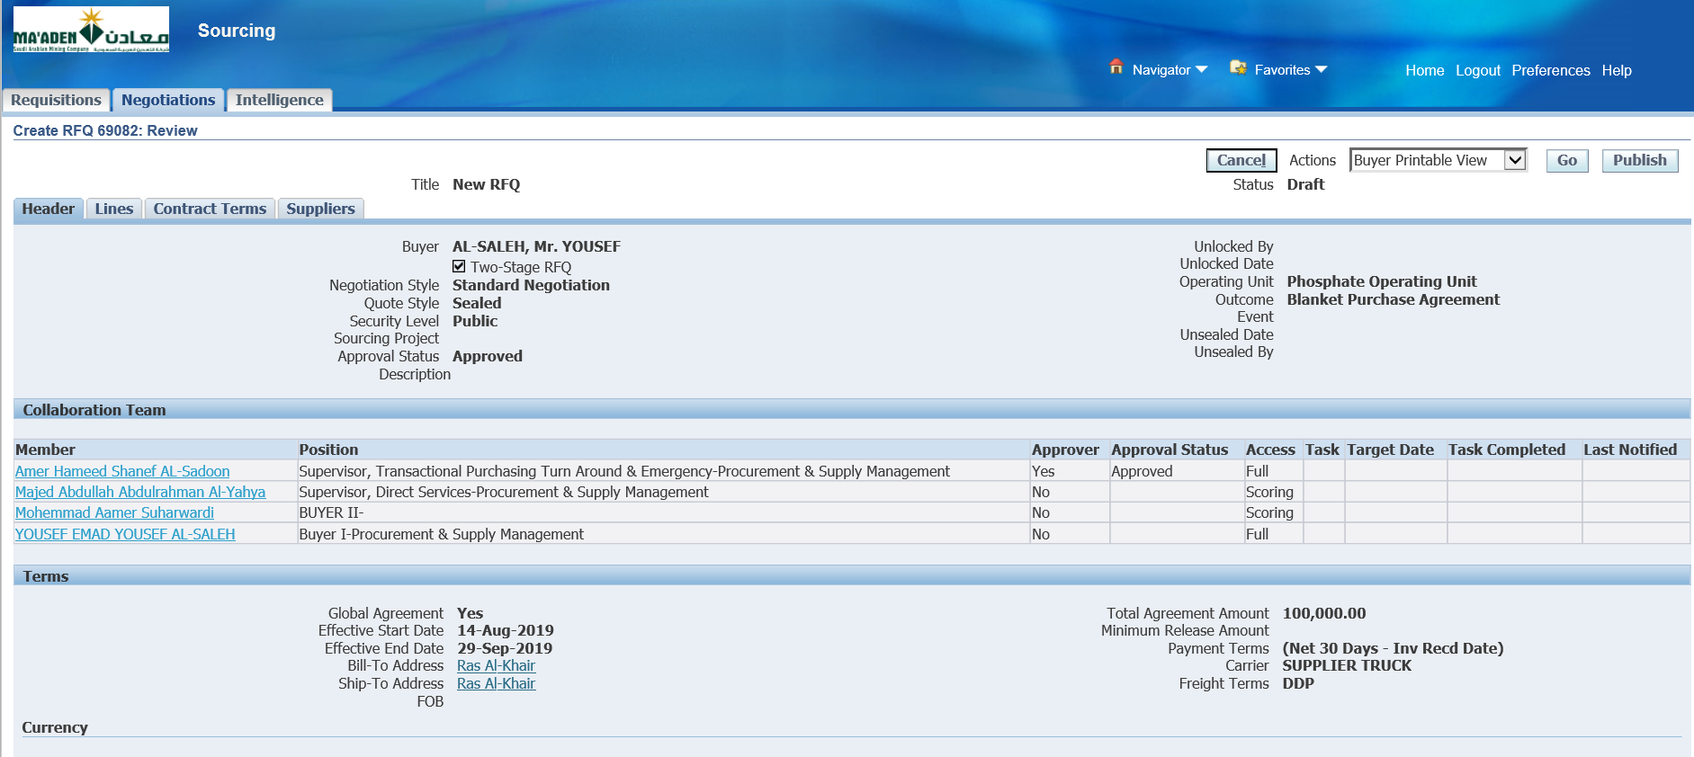

Publish

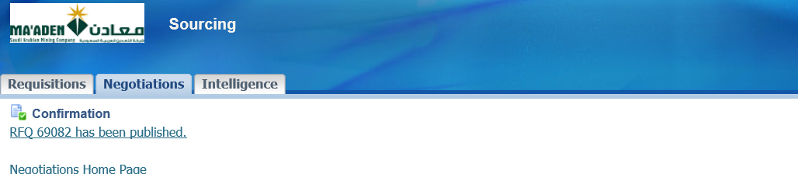

1. Quotation by Suppliers

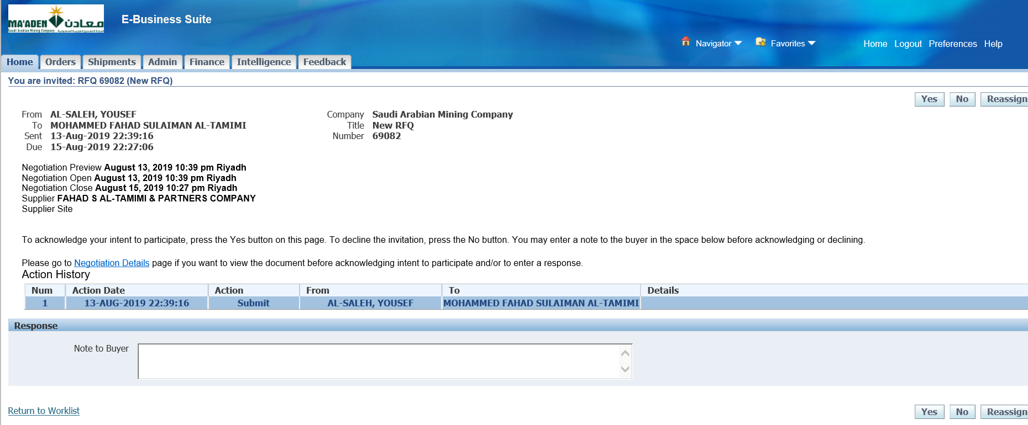

Select the Invitation

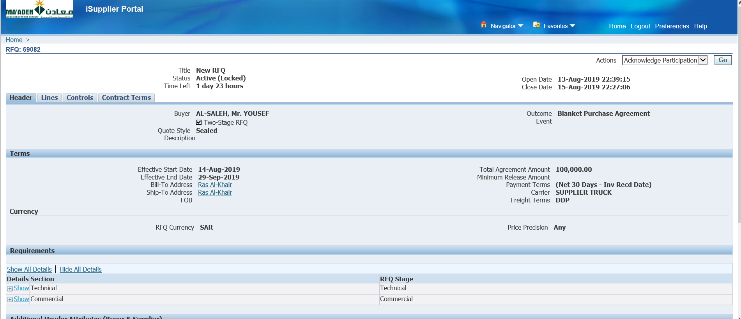

Select Negotiation Details

Acknowledge Participation

Go

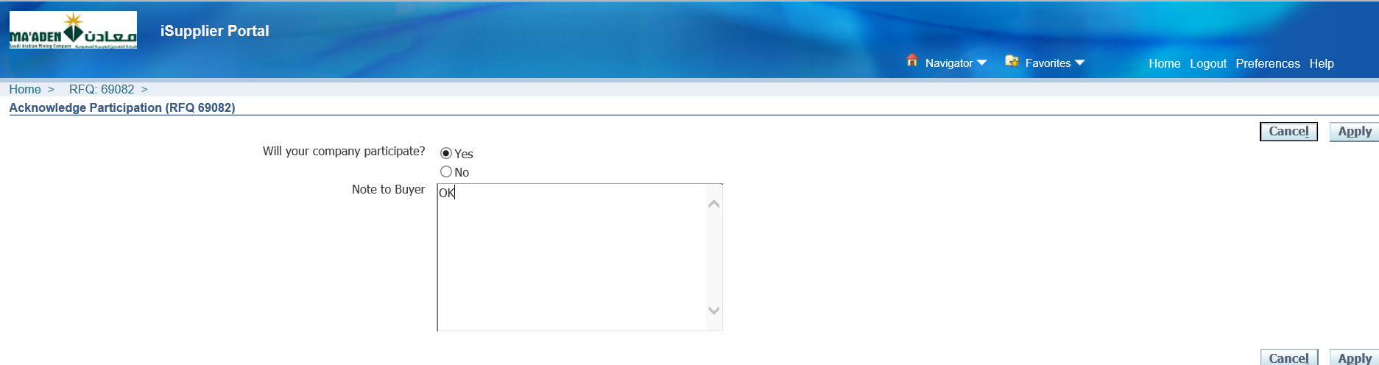

Apply

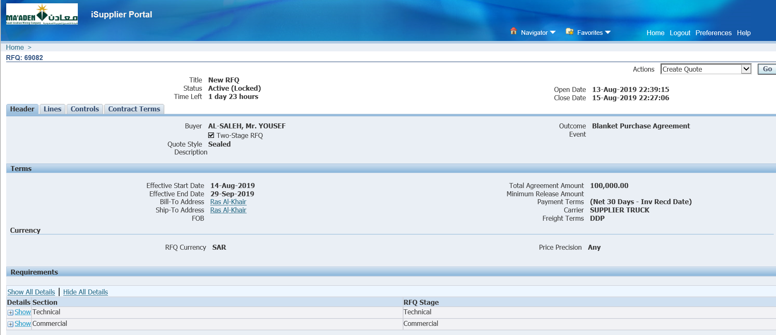

Create Quote 🡪 Go

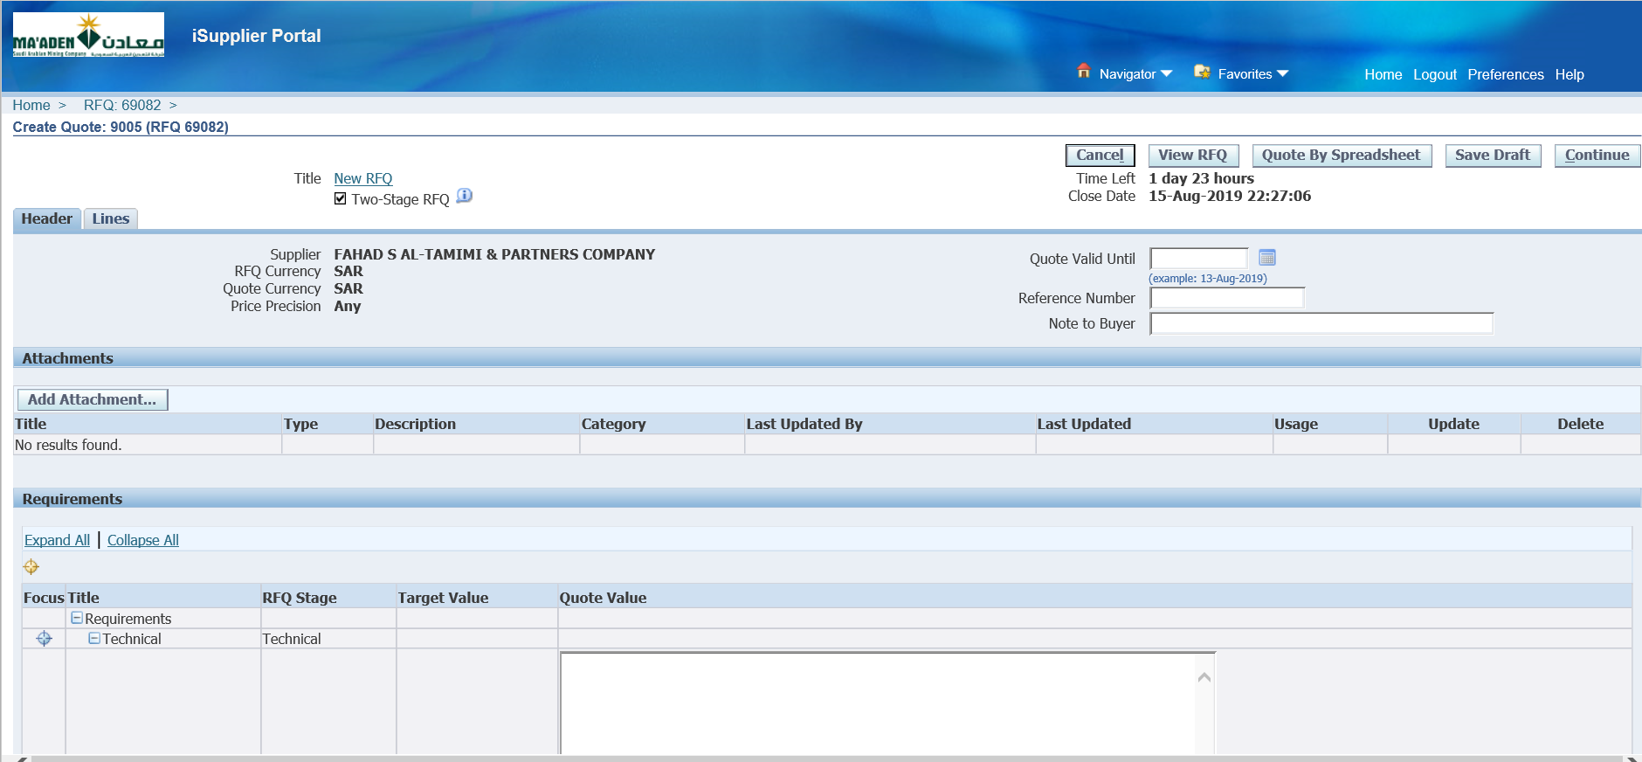

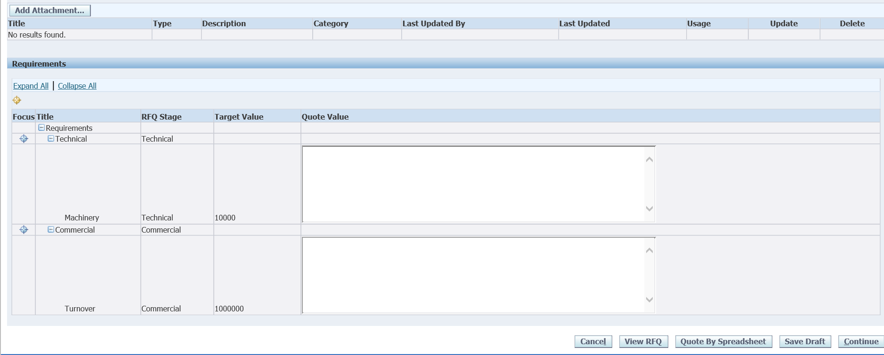

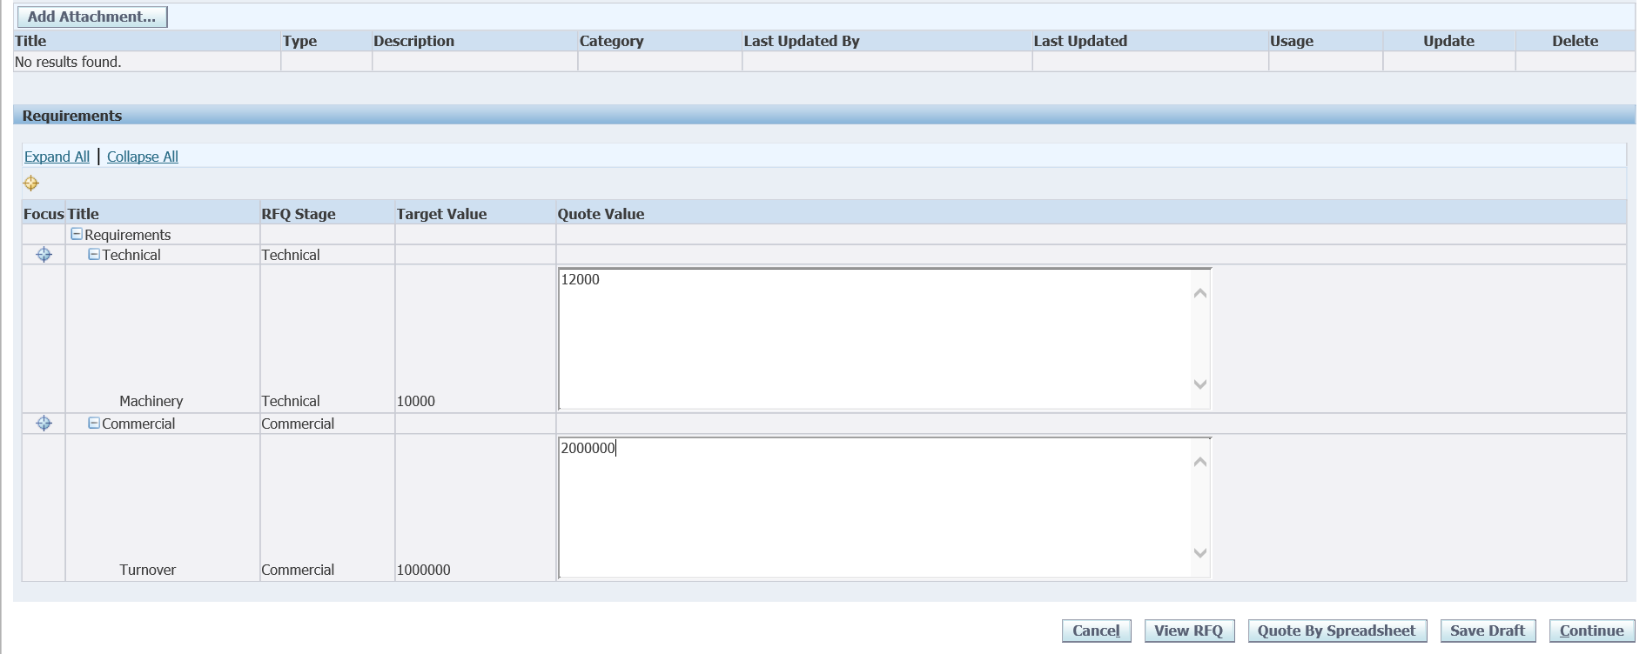

Enter values

Save Draft

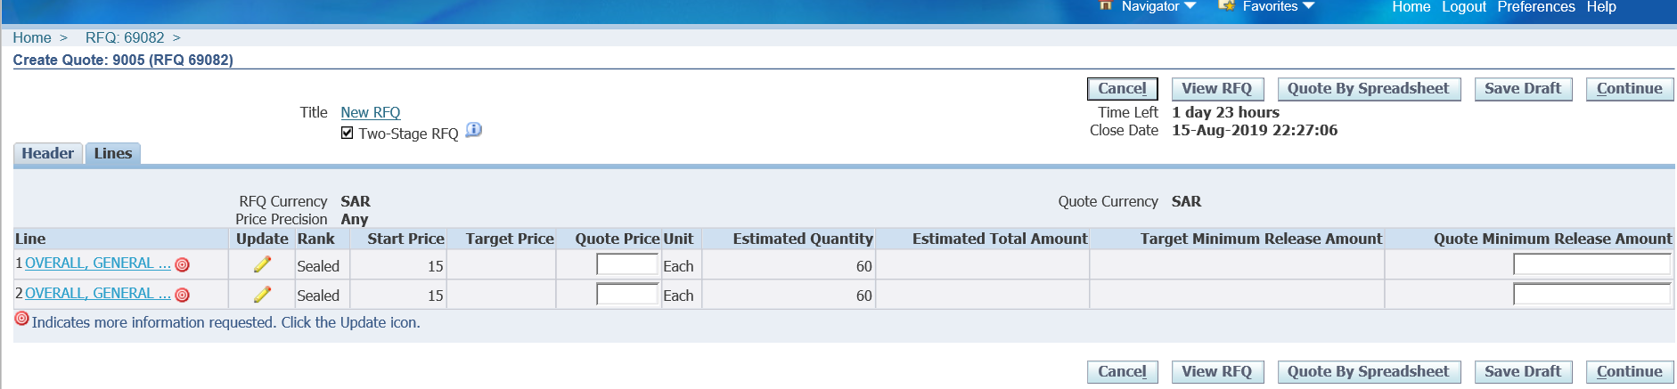

Select the Lines and Enter

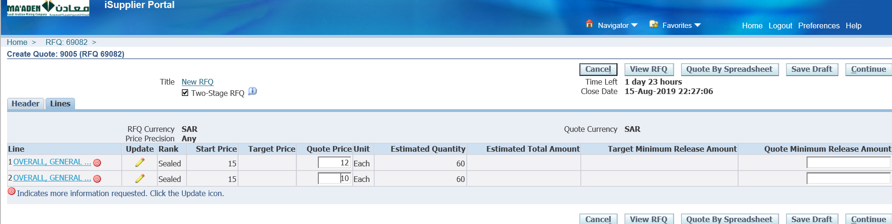

Enter Quote price for the lines

Update

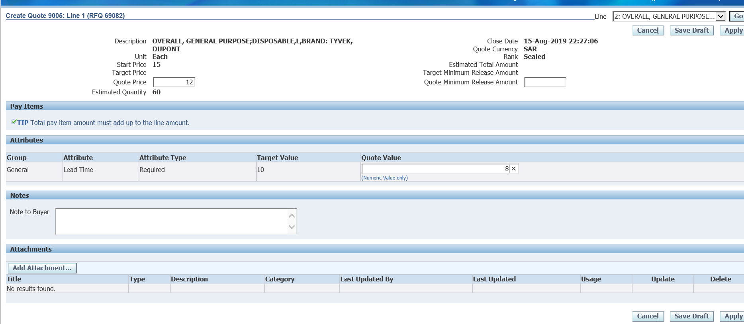

Enter Lead time

Apply

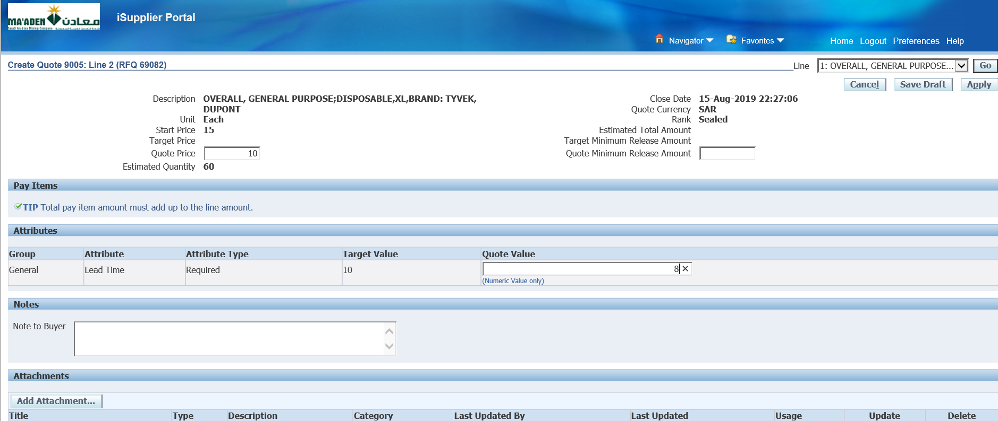

Select the 2nd line and enter Lead time

Apply

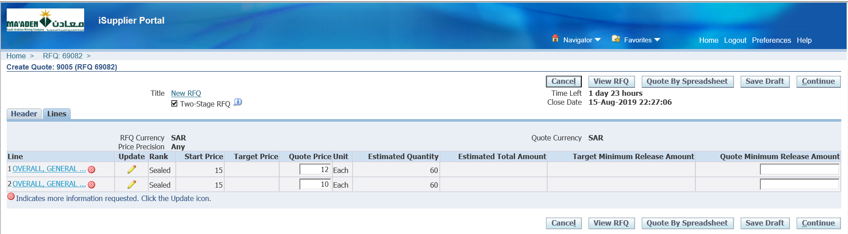

Continue

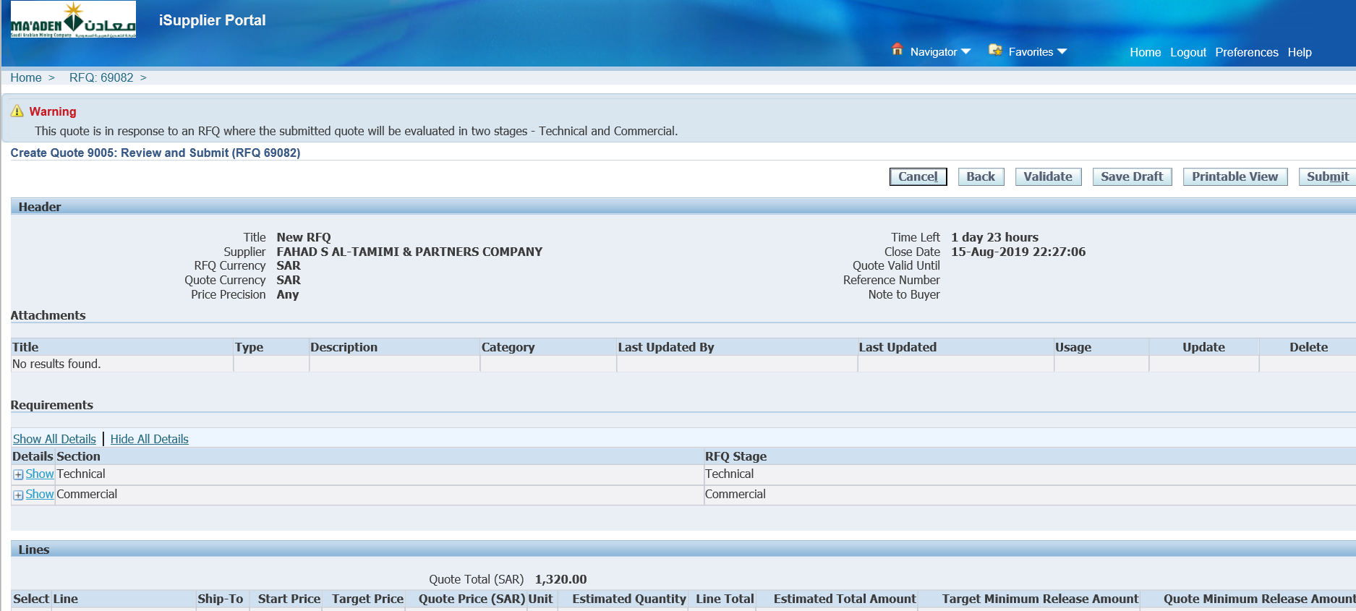

Validate

Submit

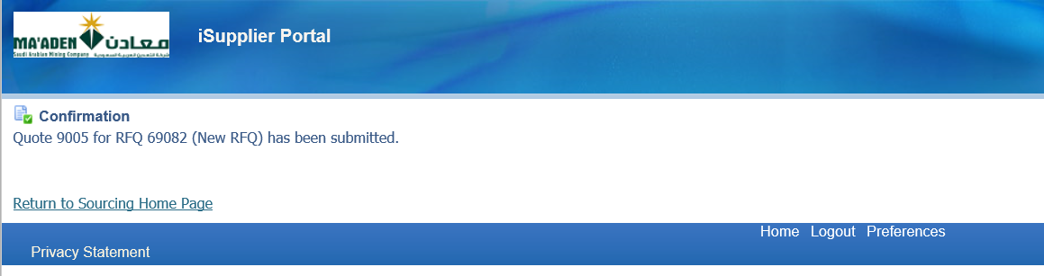

Quote 9005 has been submitted by the supplier 1

Now Login as the Supplier 2

[ahmed.alrumaih@capeplc.com](mailto:ahmed.alrumaih@capeplc.com)

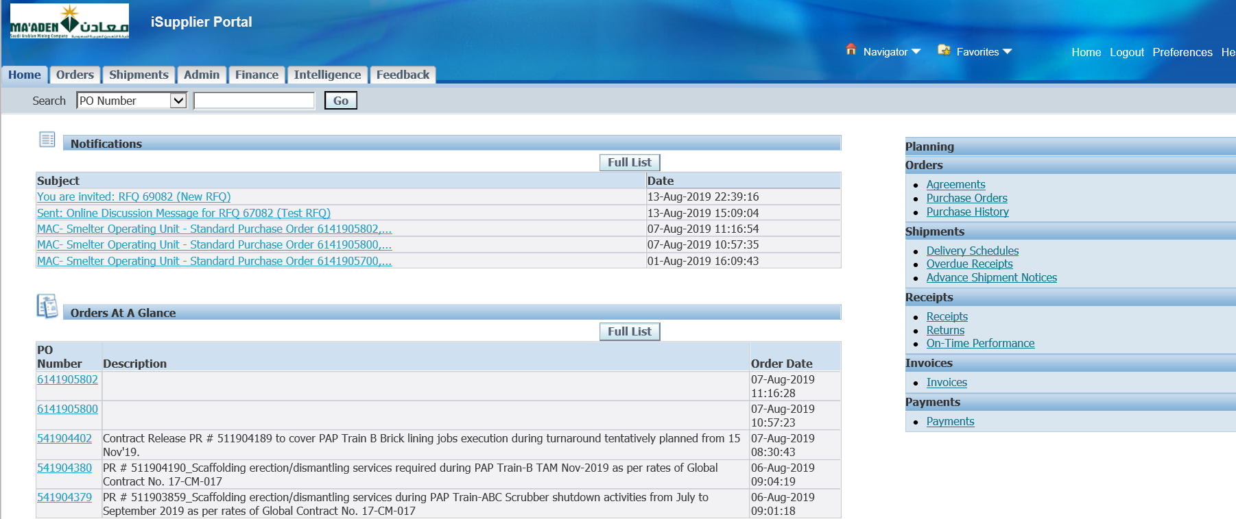

Select the RFQ

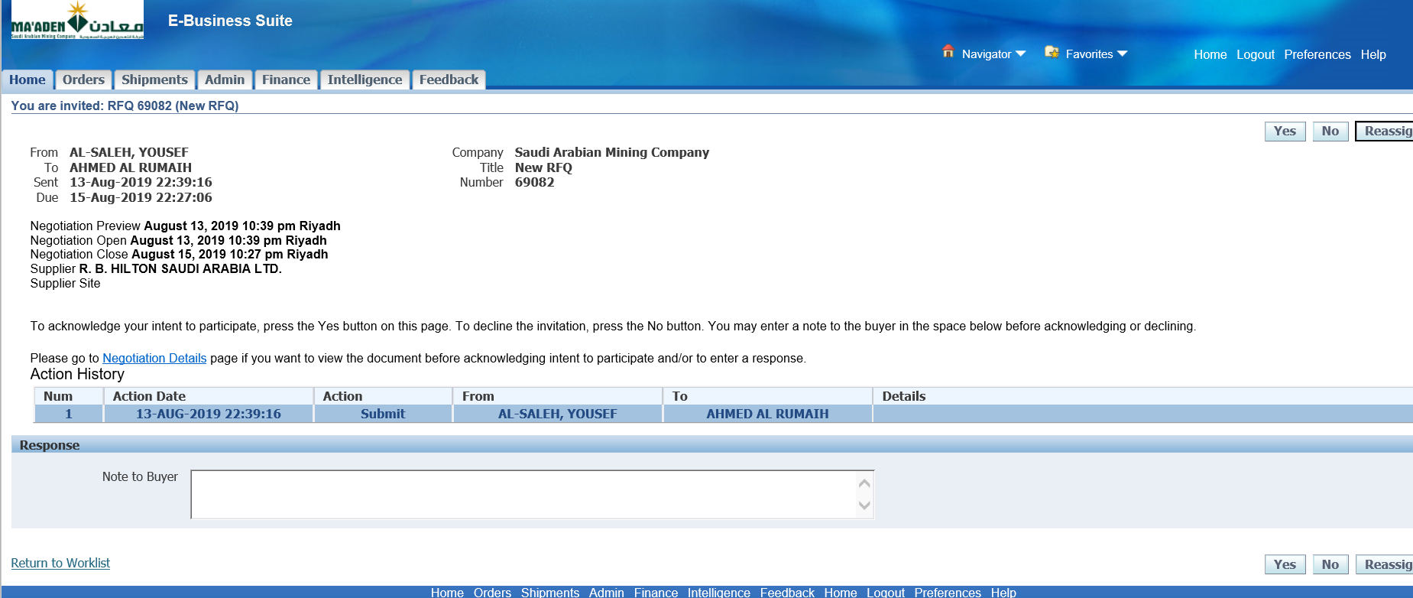

Negotiation details

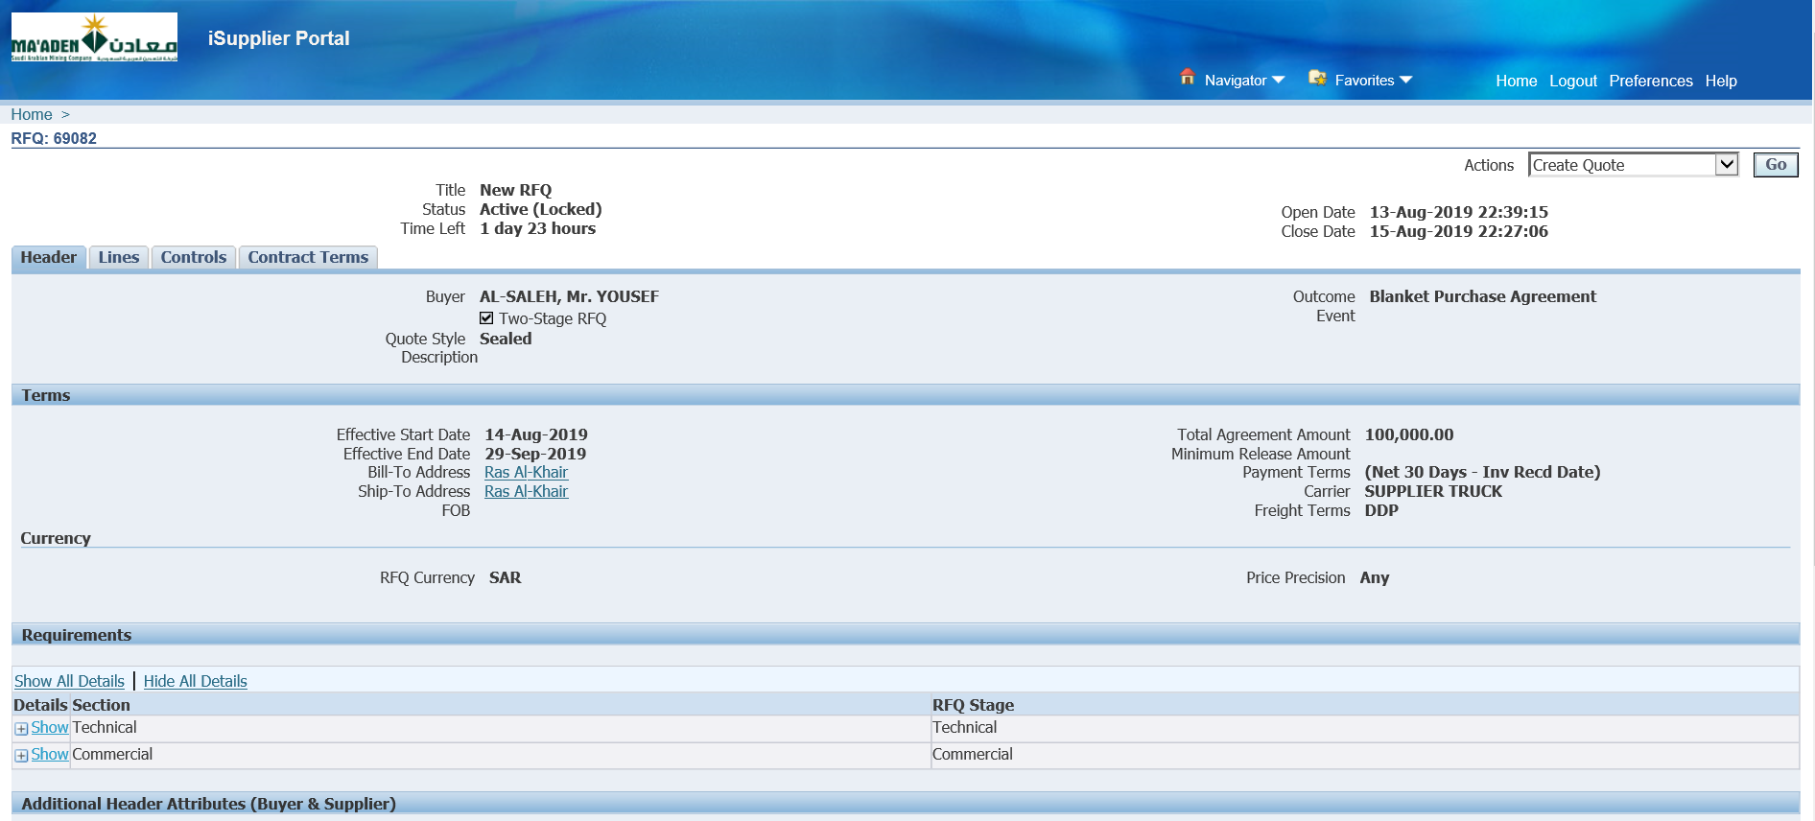

Acknowledge participation and Create Quote

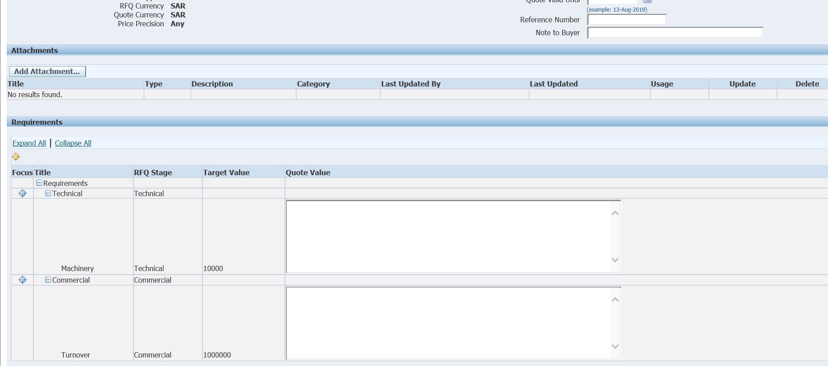

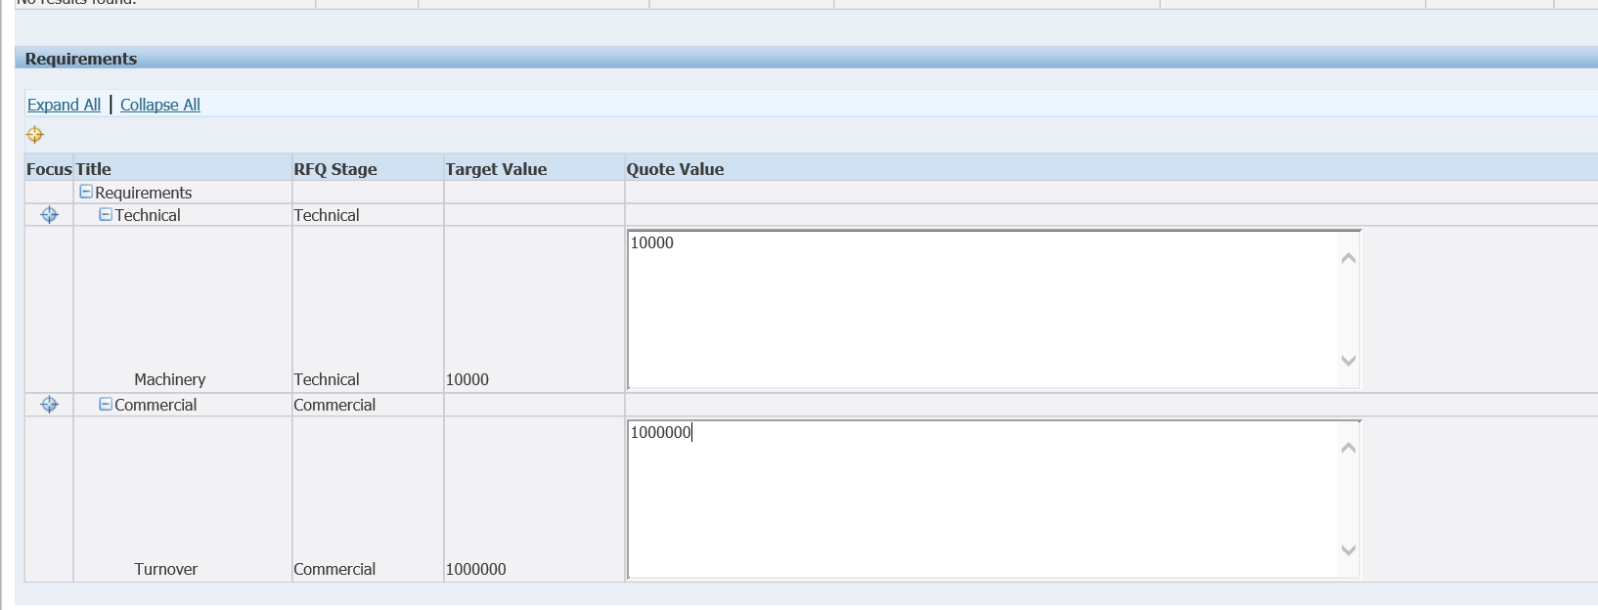

Select Lines

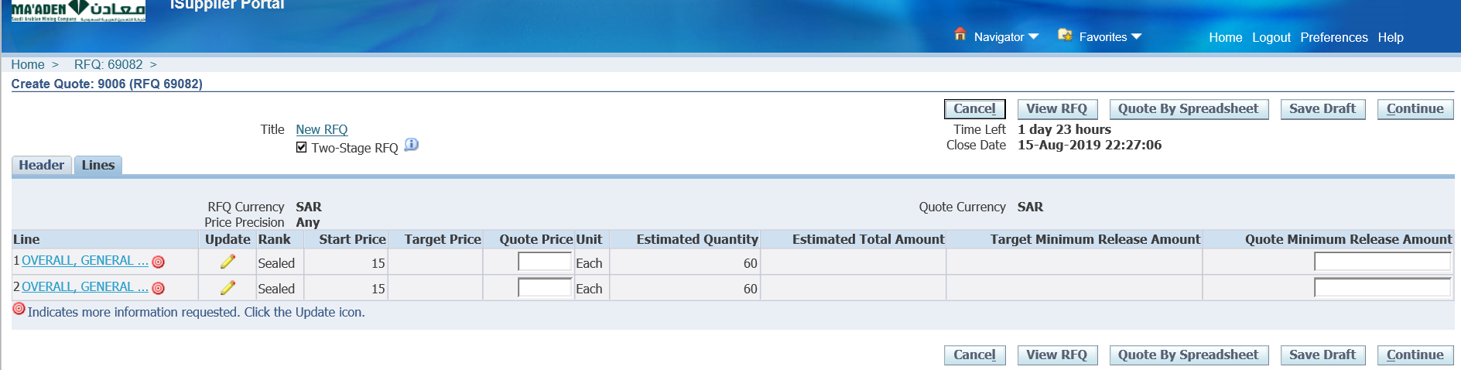

Enter Quote price

Update both the lines and then enter Attribute value

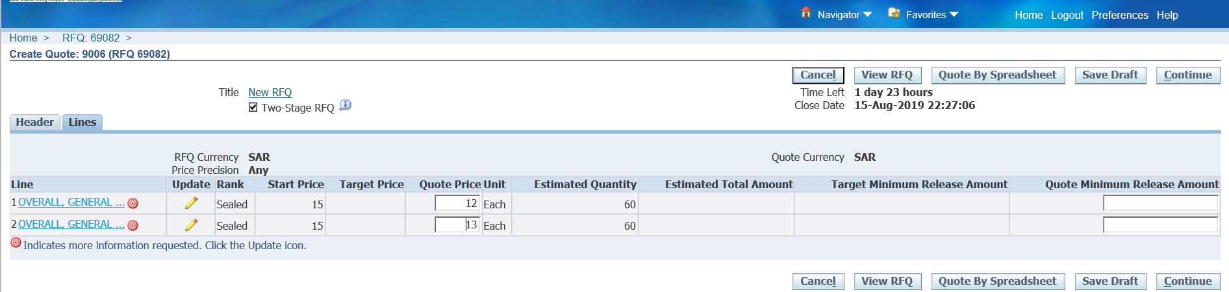

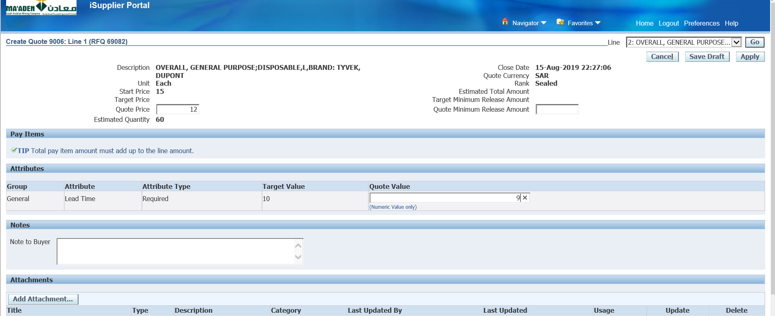

Apply

Continue

Submit

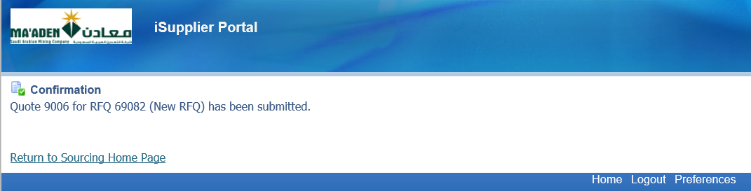

1. Close RFQ

Login as SALEHY

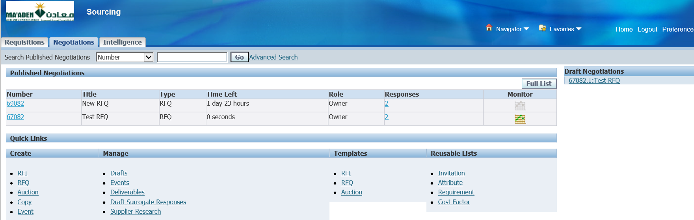

Select the RFQ

Close RFQ

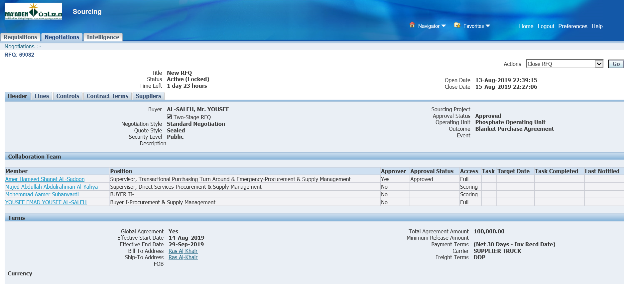

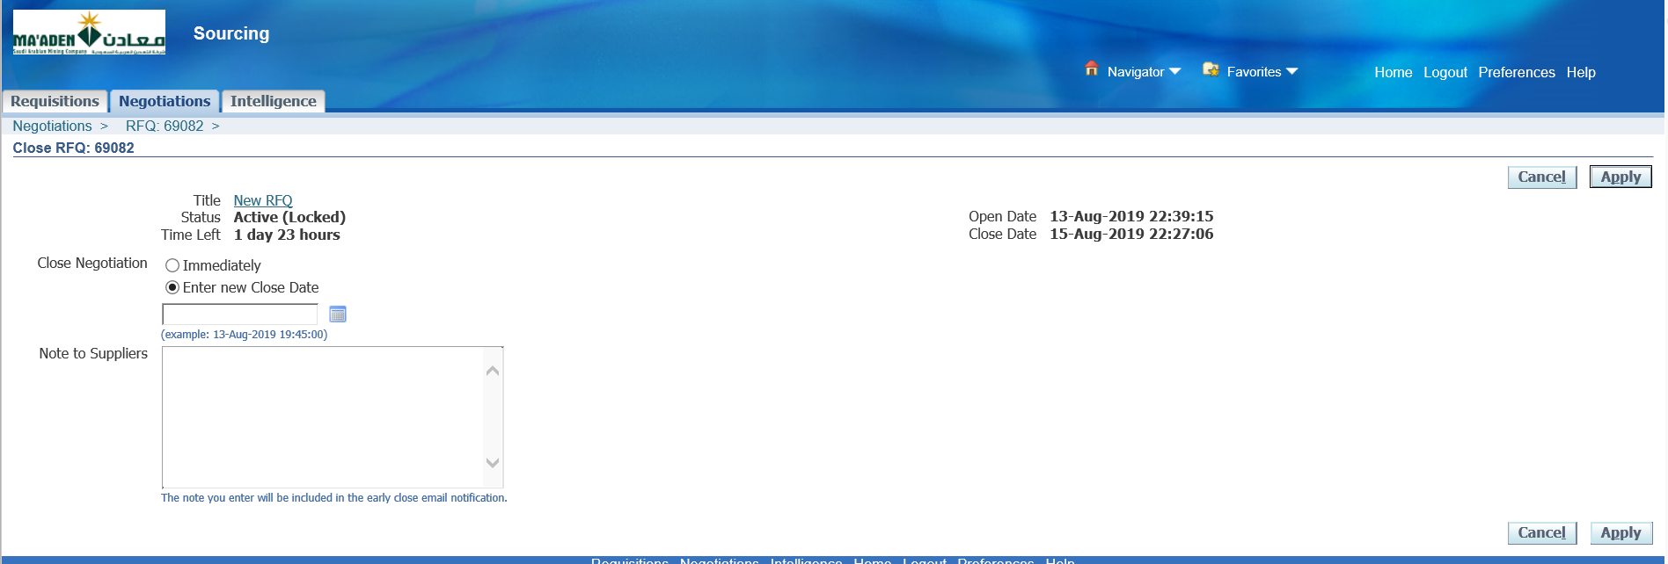

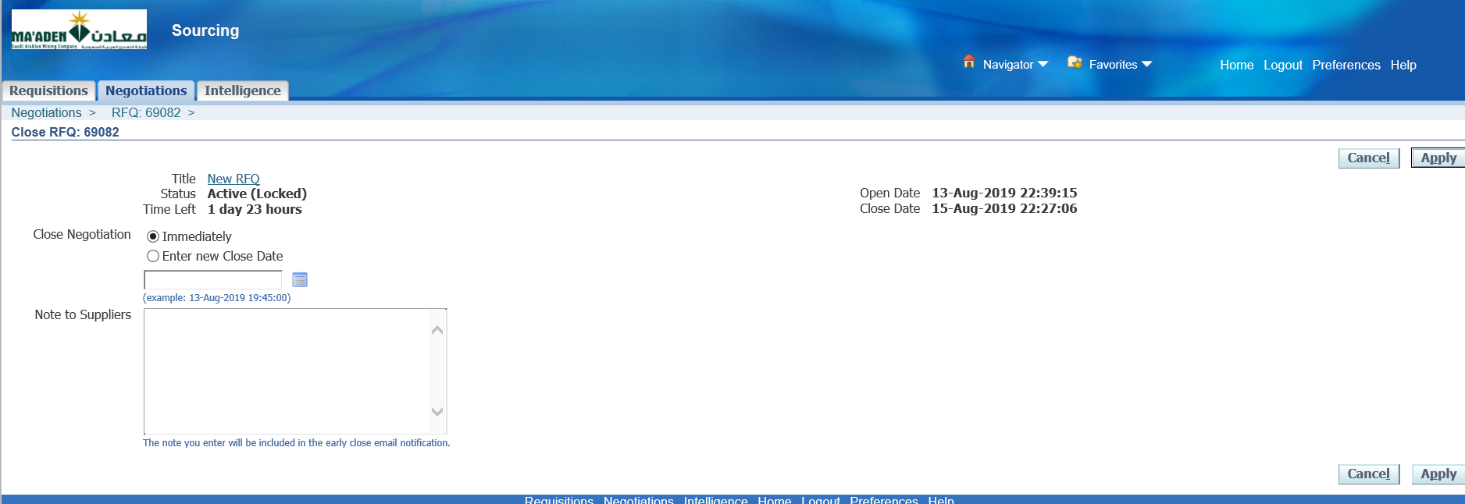

Select Immediately if required or mention Enter new Close Date

Enter Note to suppliers

Apply

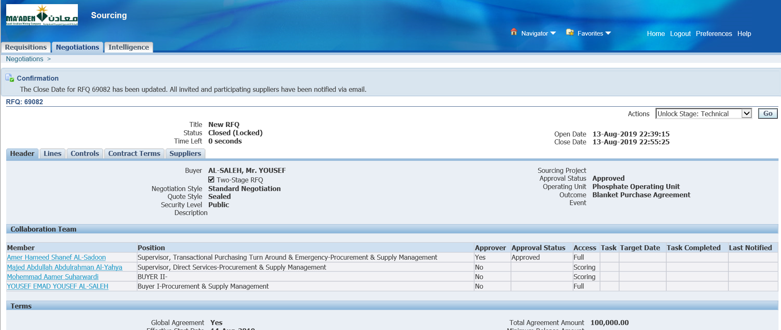

The Close Date for RFQ 69082 has been updated. All invited and participating suppliers have been notified via email.

1. Unlock Technical

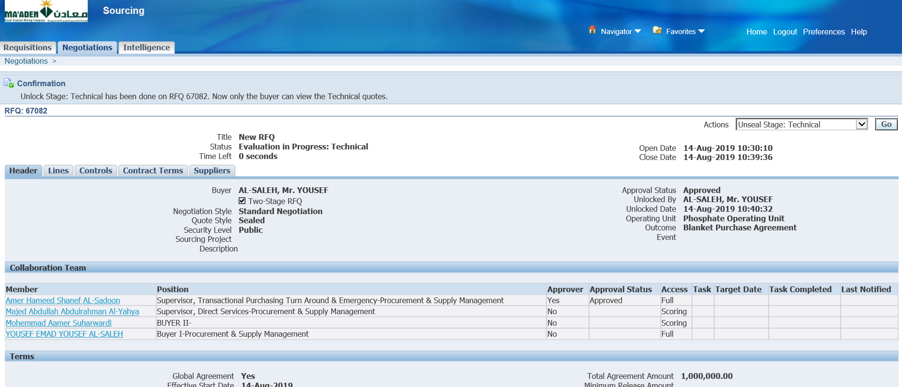

Unlock Stage: Technical has been done on RFQ 67082. Now only the buyer can view the Technical quotes.

1. Enter Technical Score

Login as Technical member -- ALYAHYAM

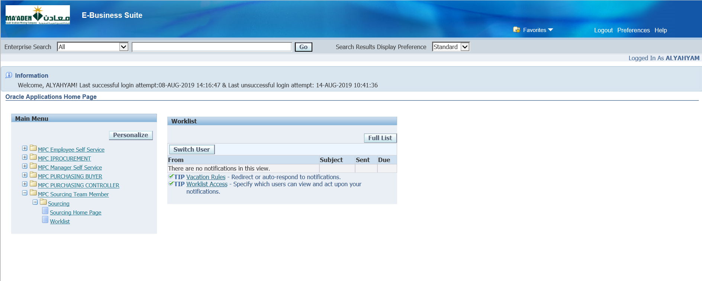

MPC Sourcing Team Member

Sourcing Home Page

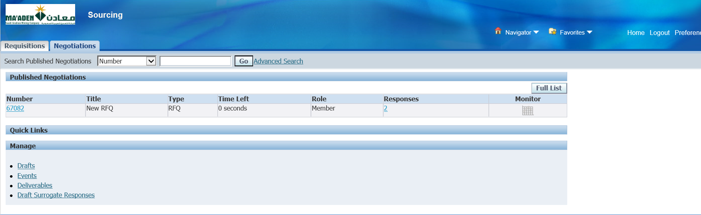

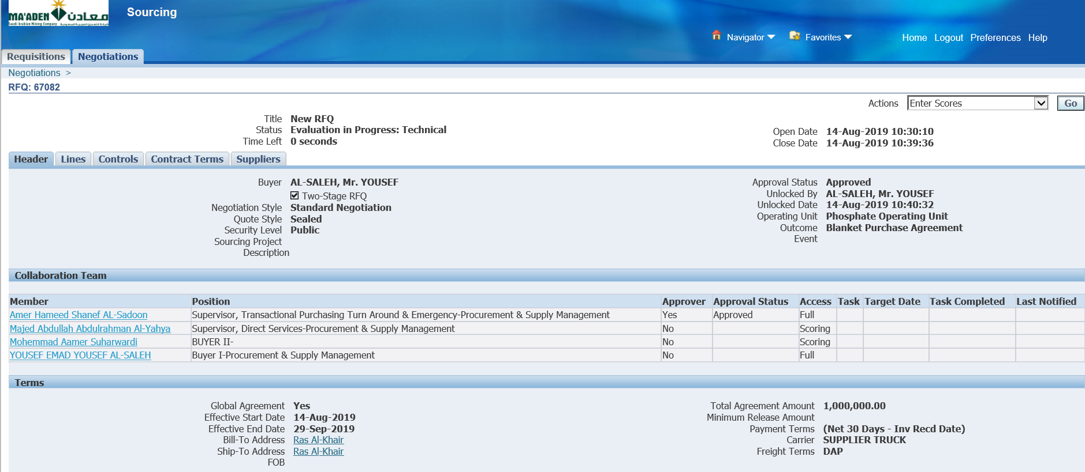

Enter Scores

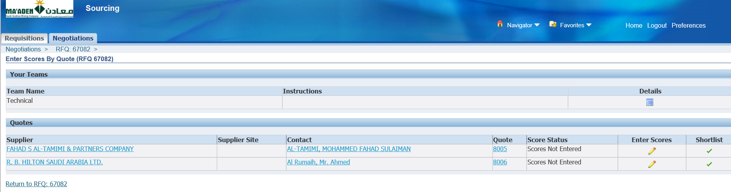

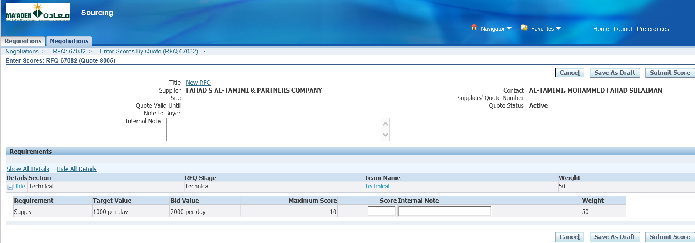

Enter Score for the 1st Supplier

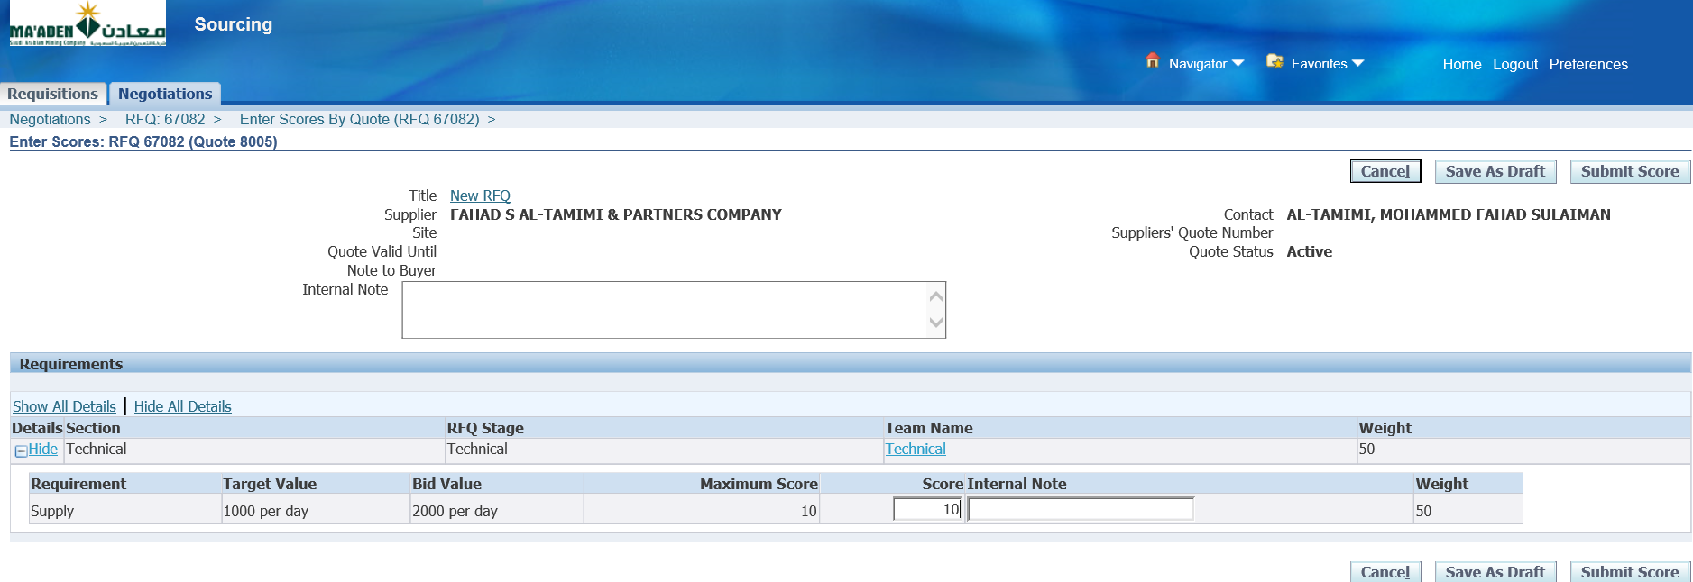

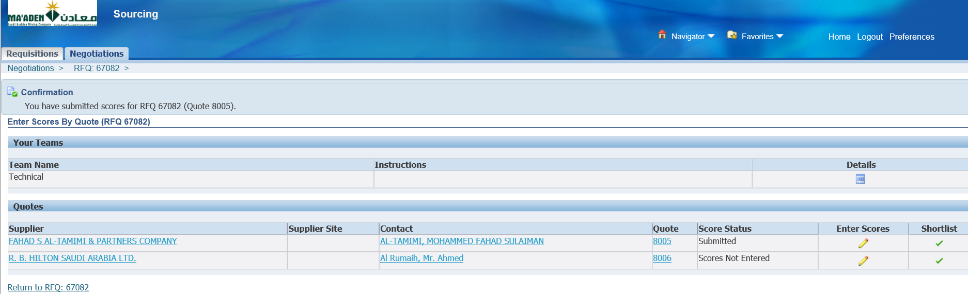

Enter Score for the 2nd Supplier

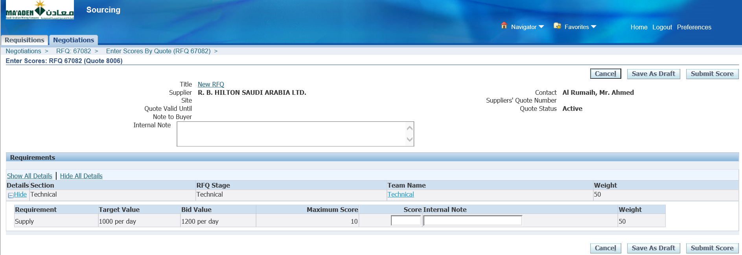

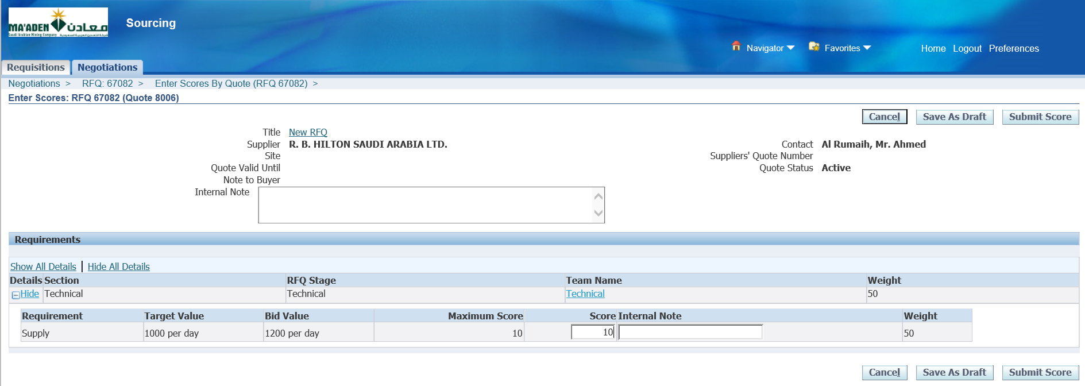

Save as Draft

Submit Score

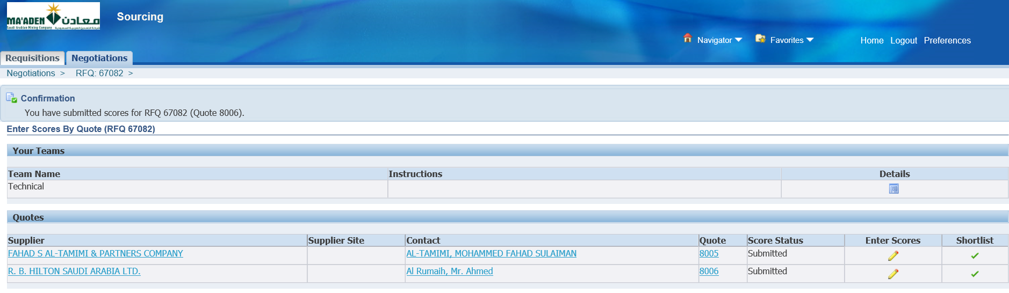

Technical scoring is done

1. Unseal Stage: Technical

Now login as the Owner of the RFQ – SALEHY

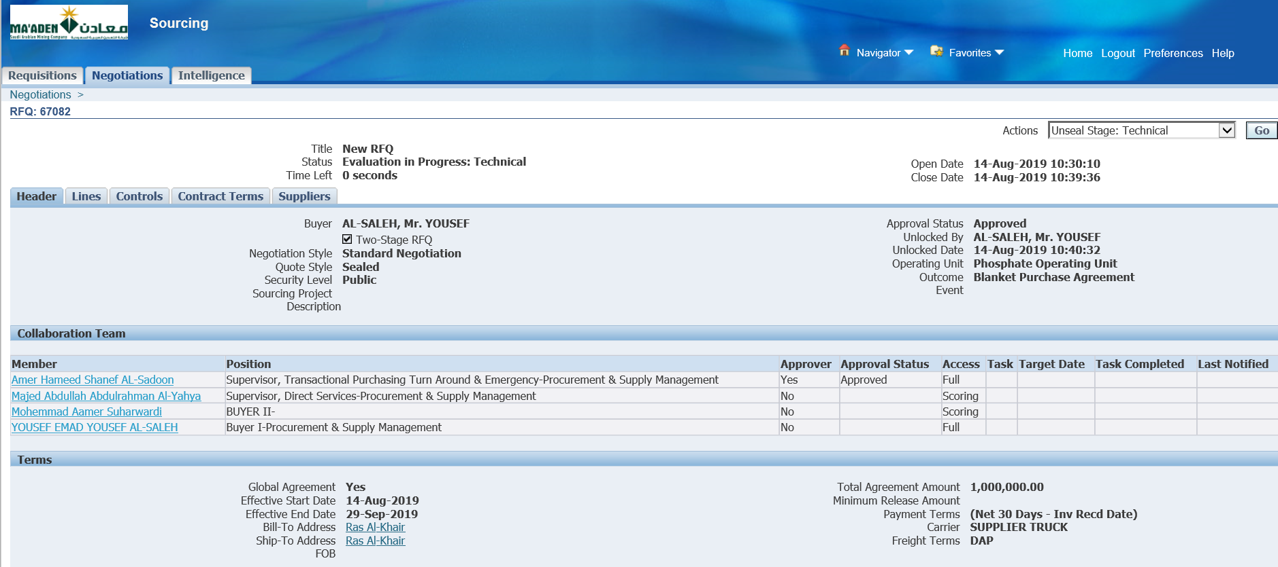

Unseal Stage: Technical

Go

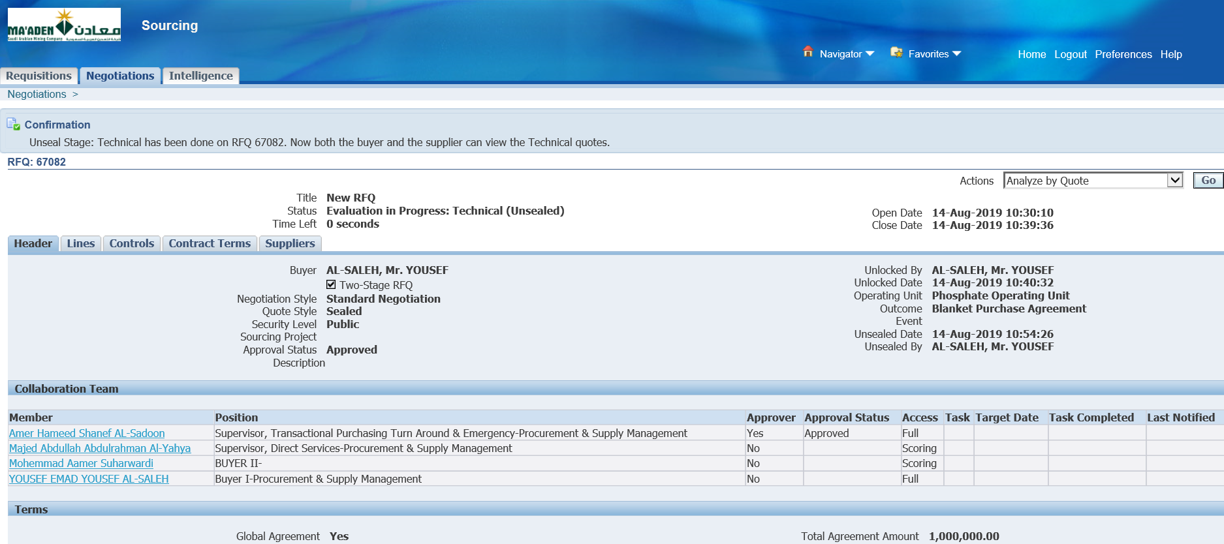

Unseal Stage: Technical has been done on RFQ 67082. Now both the buyer and the supplier can view the Technical quotes.

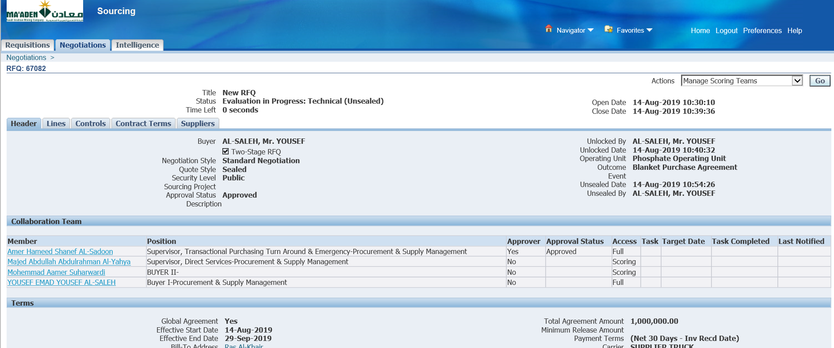

1. Lock Scoring and Complete Technical Evaluation

Manage Scoring Teams

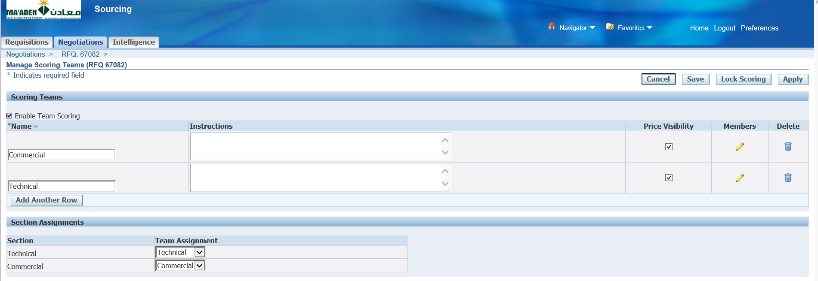

Lock Scoring

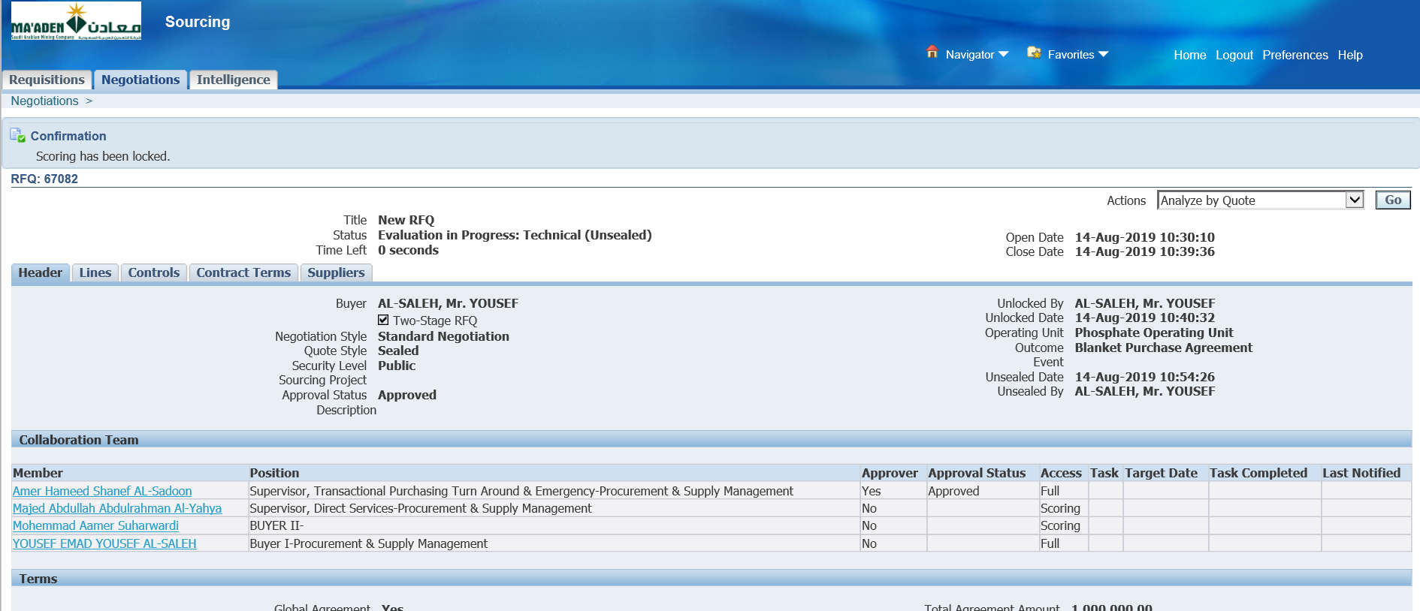

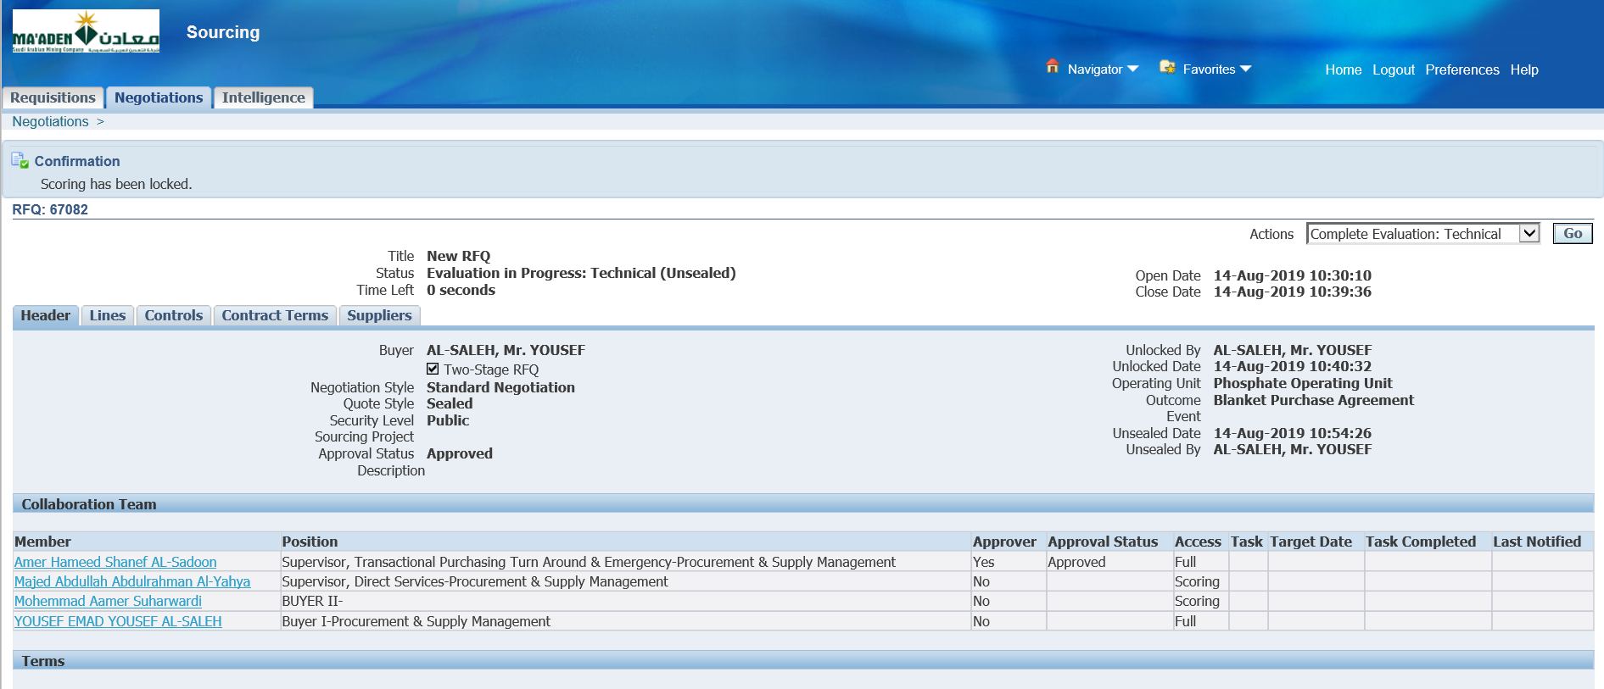

Complete Technical Evaluation



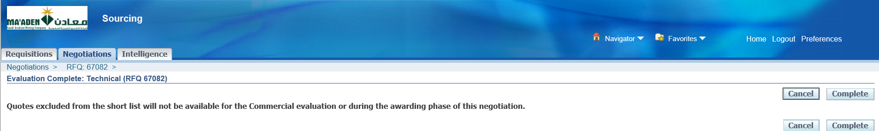

Complete

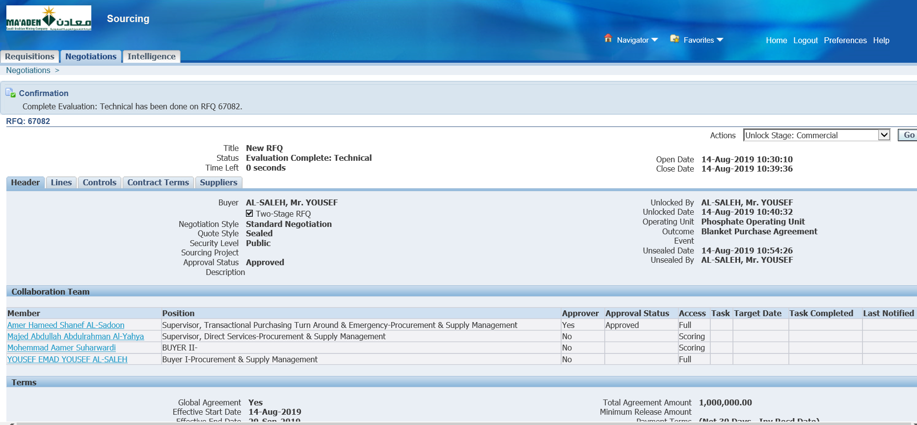

1. Unlock Stage: Commercial

Unlock Stage: Commercial

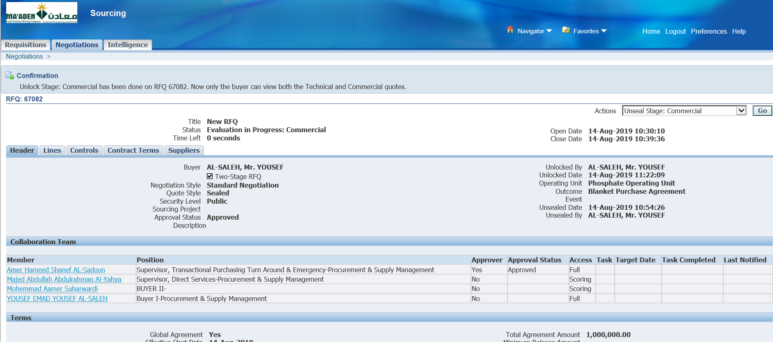

Unlock Stage: Commercial has been done on RFQ 67082. Now only the buyer can view both the Technical and Commercial quotes.

1. Enter Commercial Score

Login as the Commercial Evaluator

Login as SUHARWARDIM

Login as the Commercial team member - SUHARWARDIM

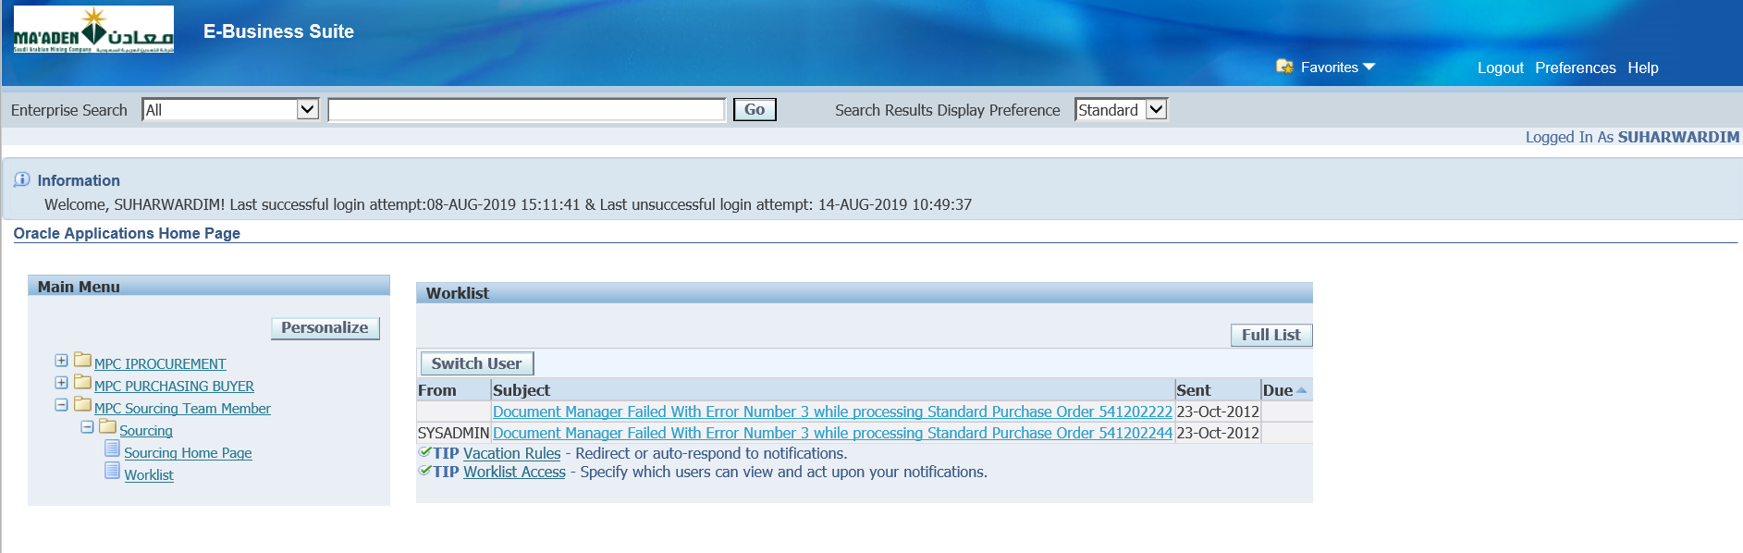

Sourcing Home Page

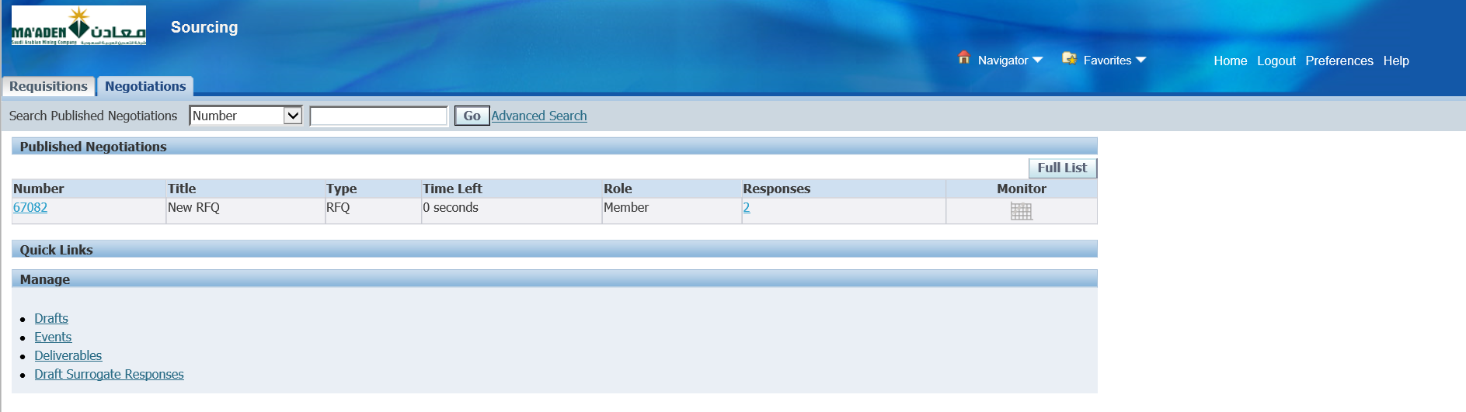

Select the RFQ

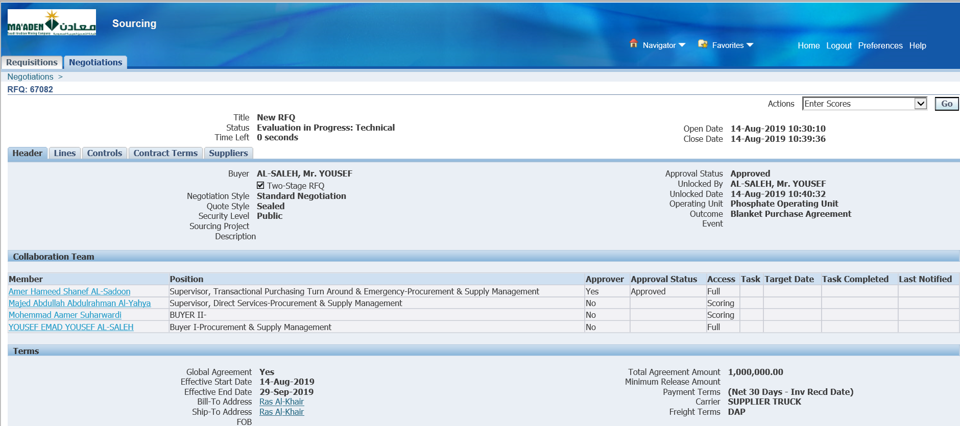

Enter Scores

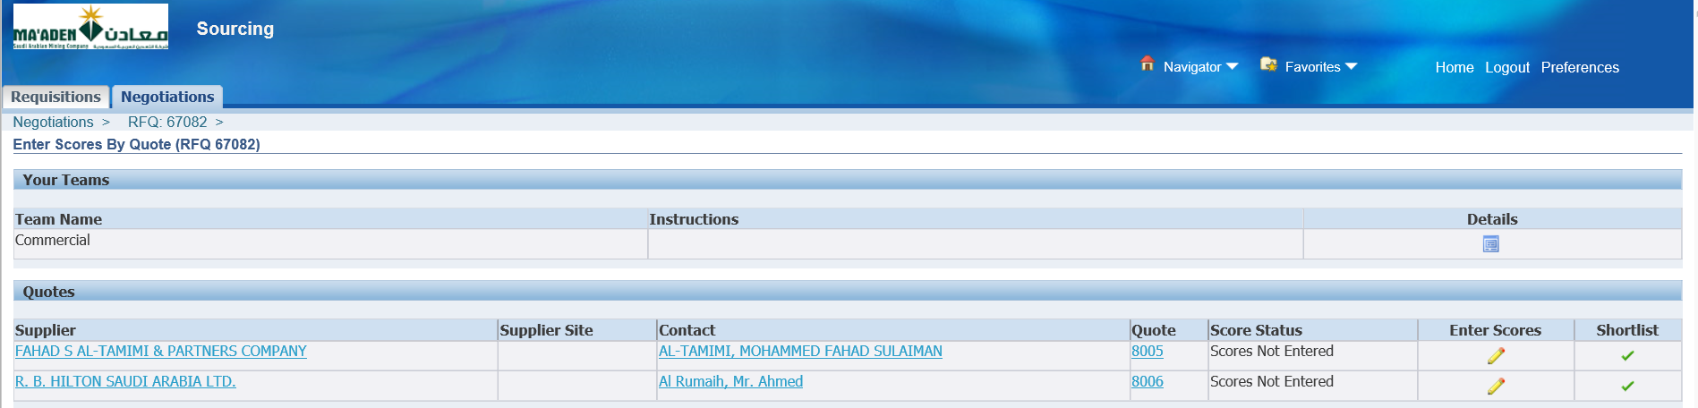

Enter Scores for both the Suppliers

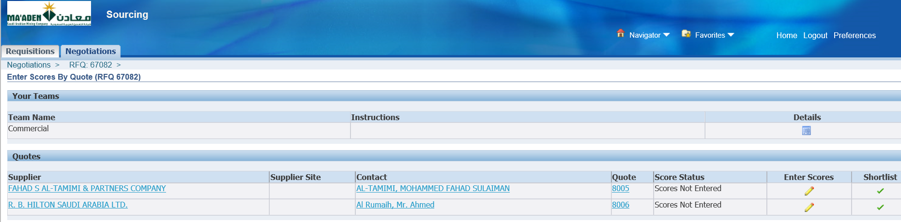

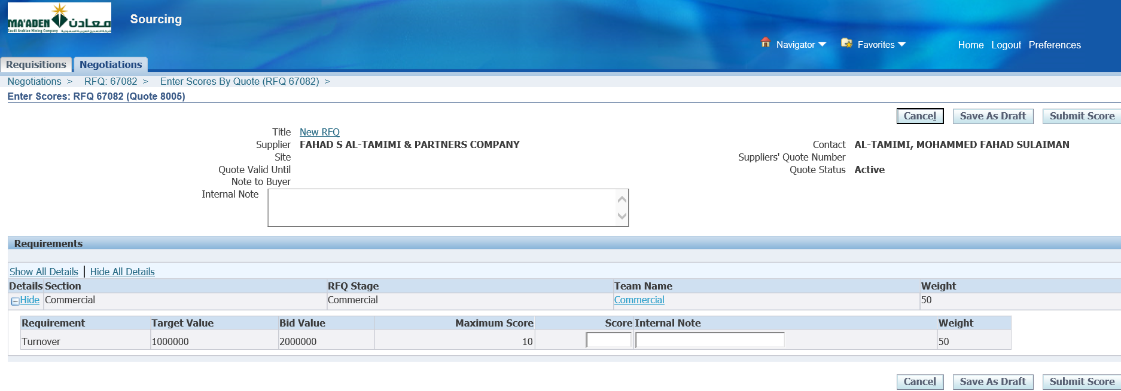

Enter Score and Submit

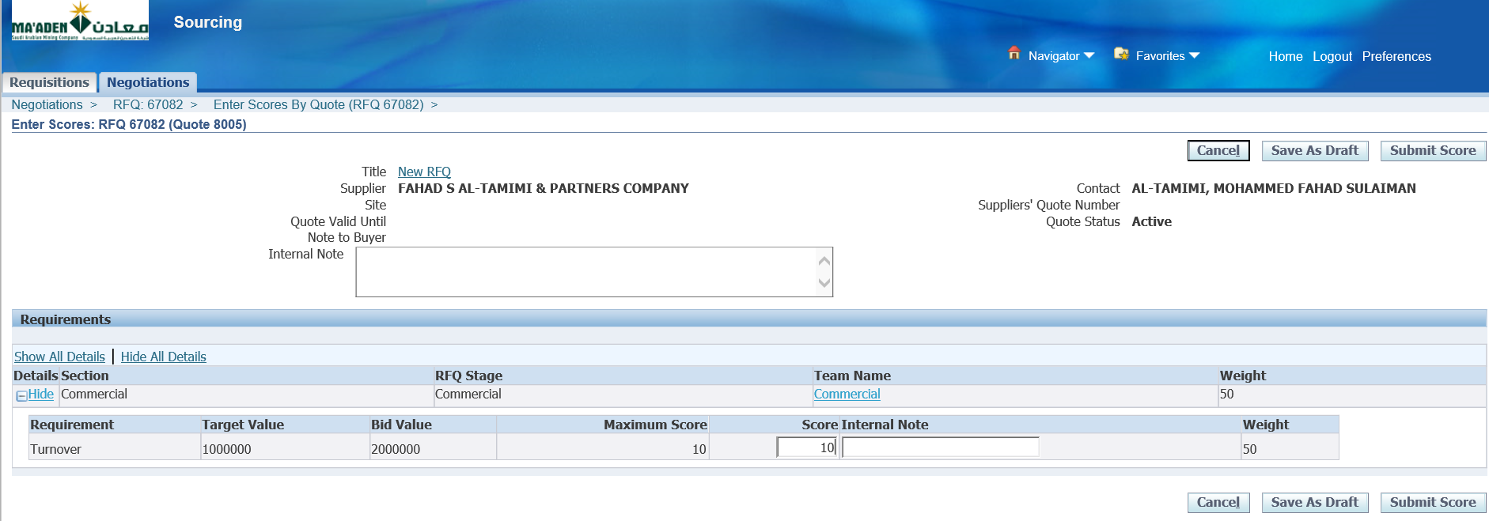

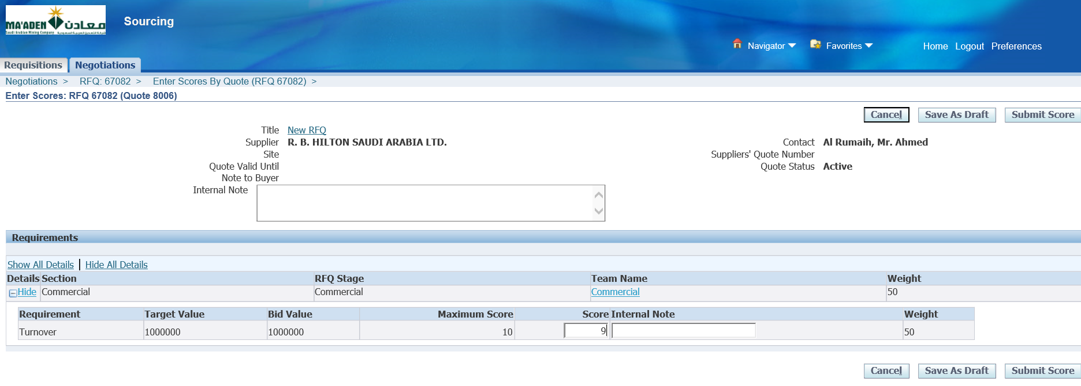

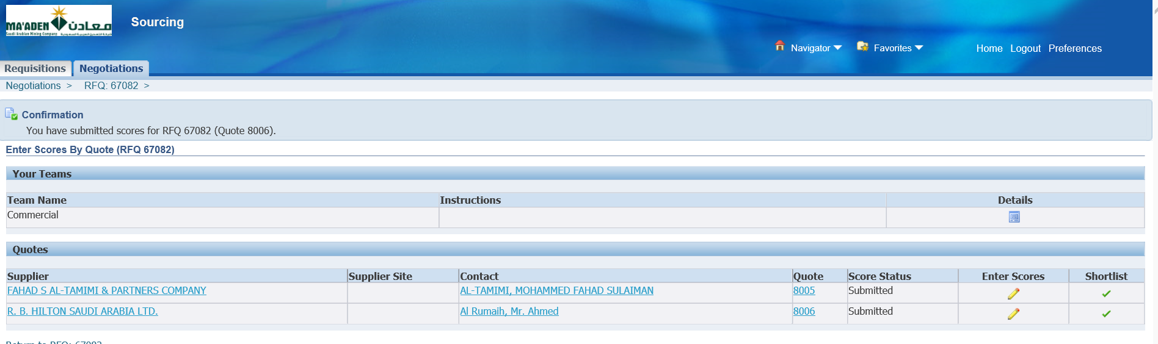

1. Unseal Stage: Commercial and Lock Scoring

Login as the RFQ Owner – SALEHY

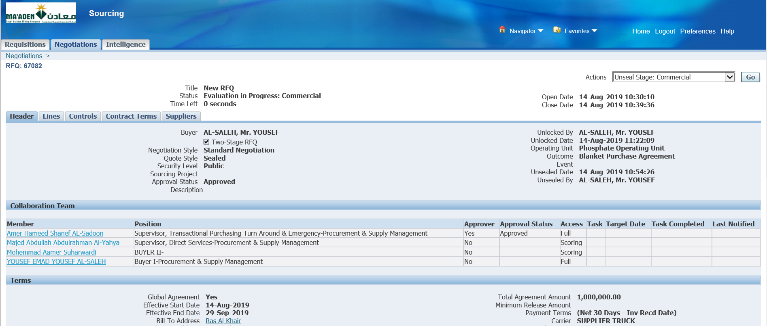

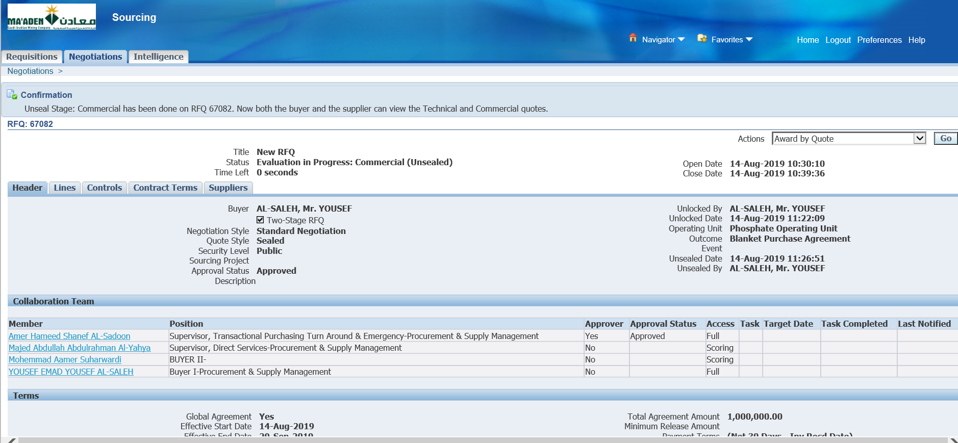

Unseal Stage: Commercial has been done on RFQ 67082. Now both the buyer and the supplier can view the Technical and Commercial quotes.

Manage Scoring Teams

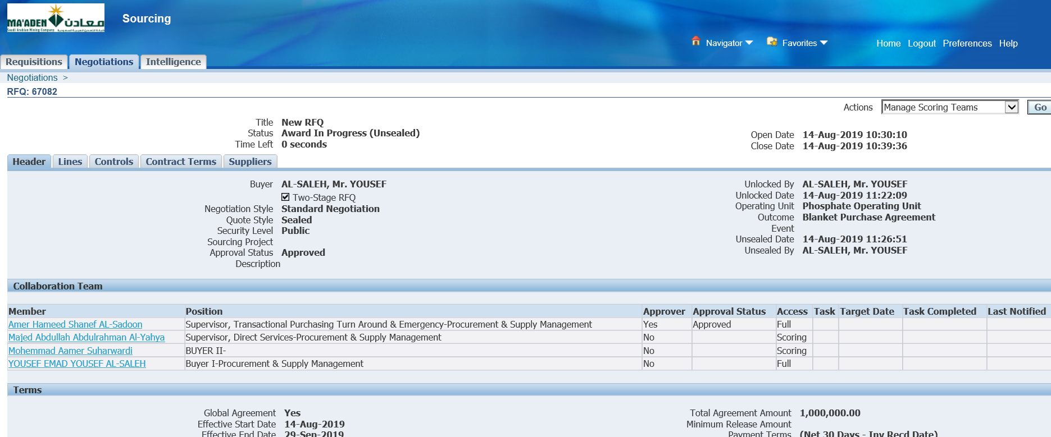

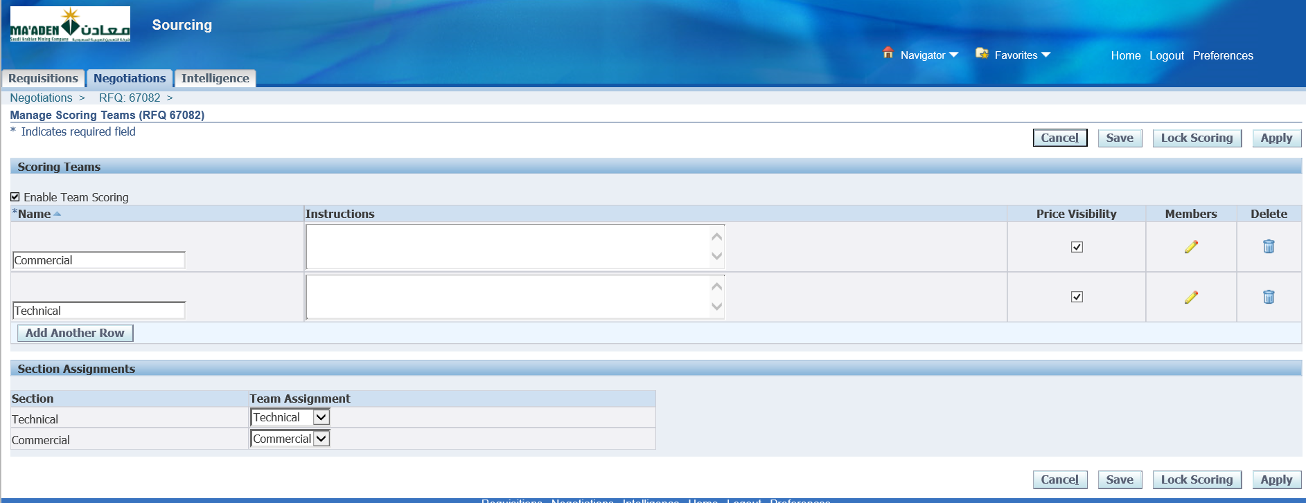

Lock Scoring

Apply

1. Award by Quote

Award by Quote

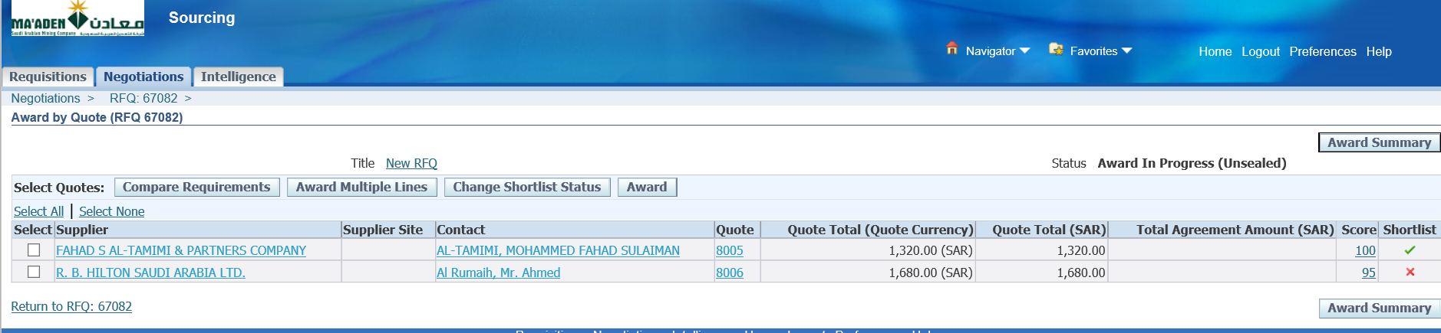

Select the Suppliers and Award based on the Quote total and the Score

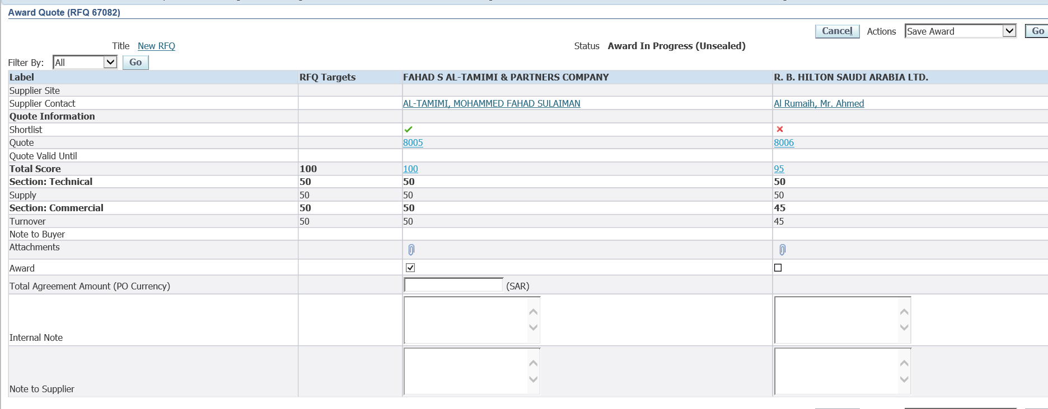

Award

Save Award

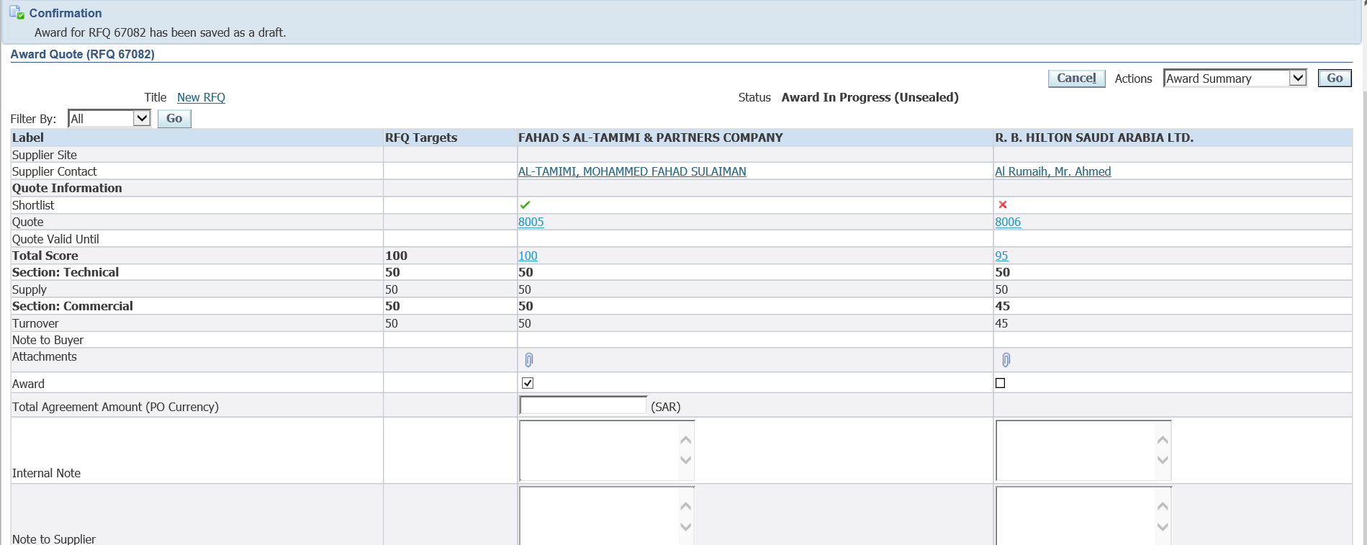

Award Summary

Return to RFQ

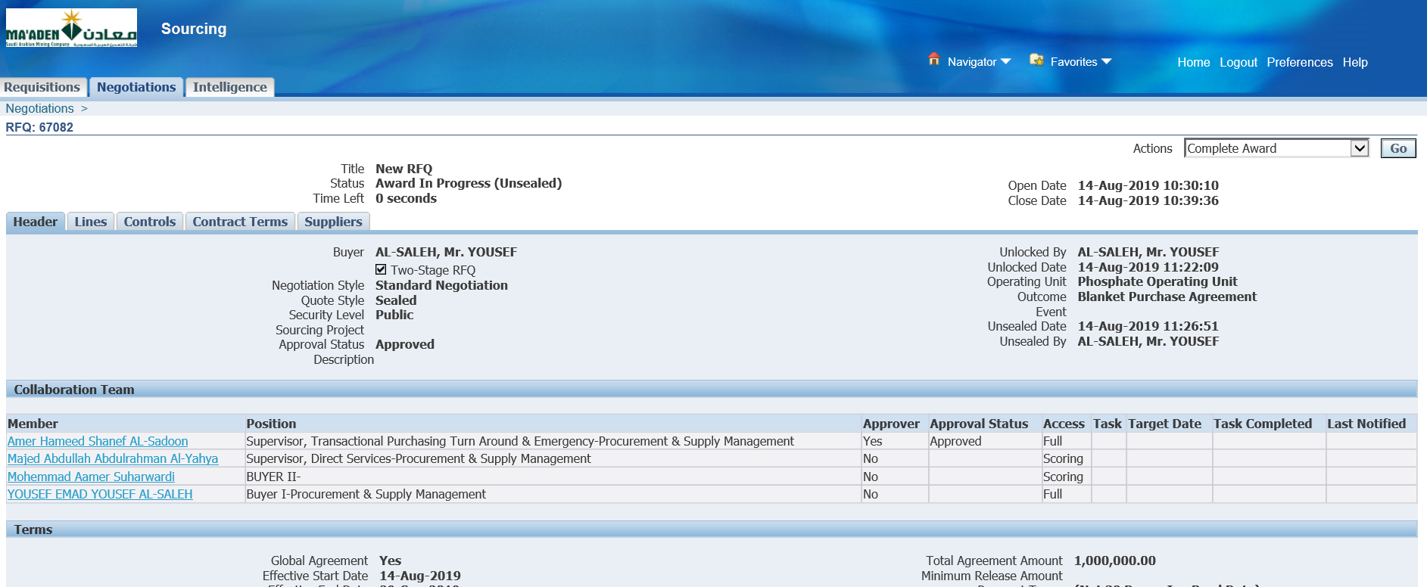

Complete Award

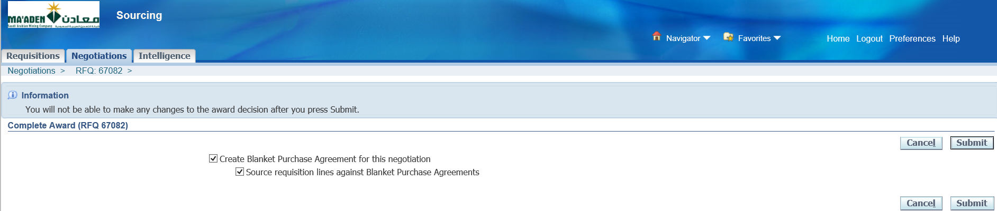

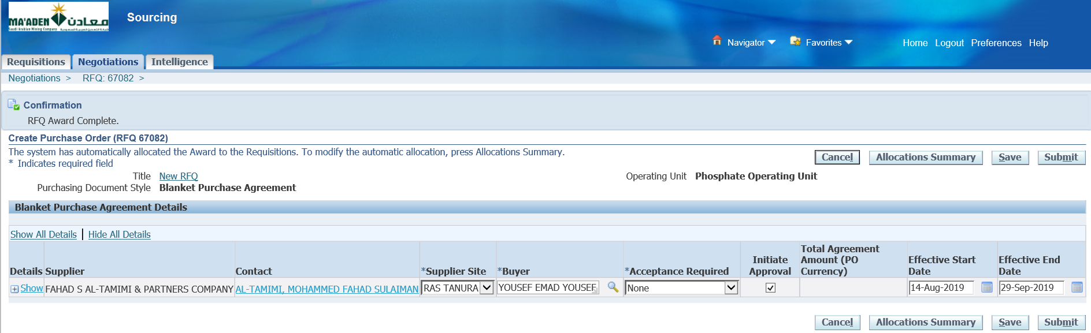

Submit

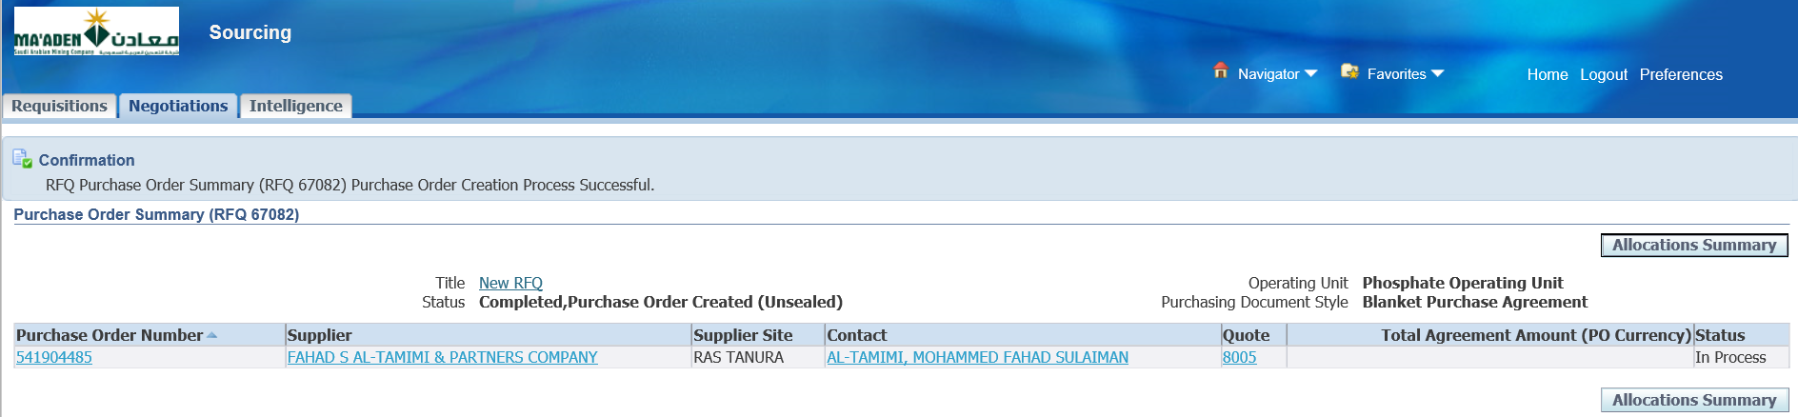

BPA has been generated

1. Express Receive – iProcurement

Login as ALHARBIK

MPC iProcurement

iProcurement Home Page

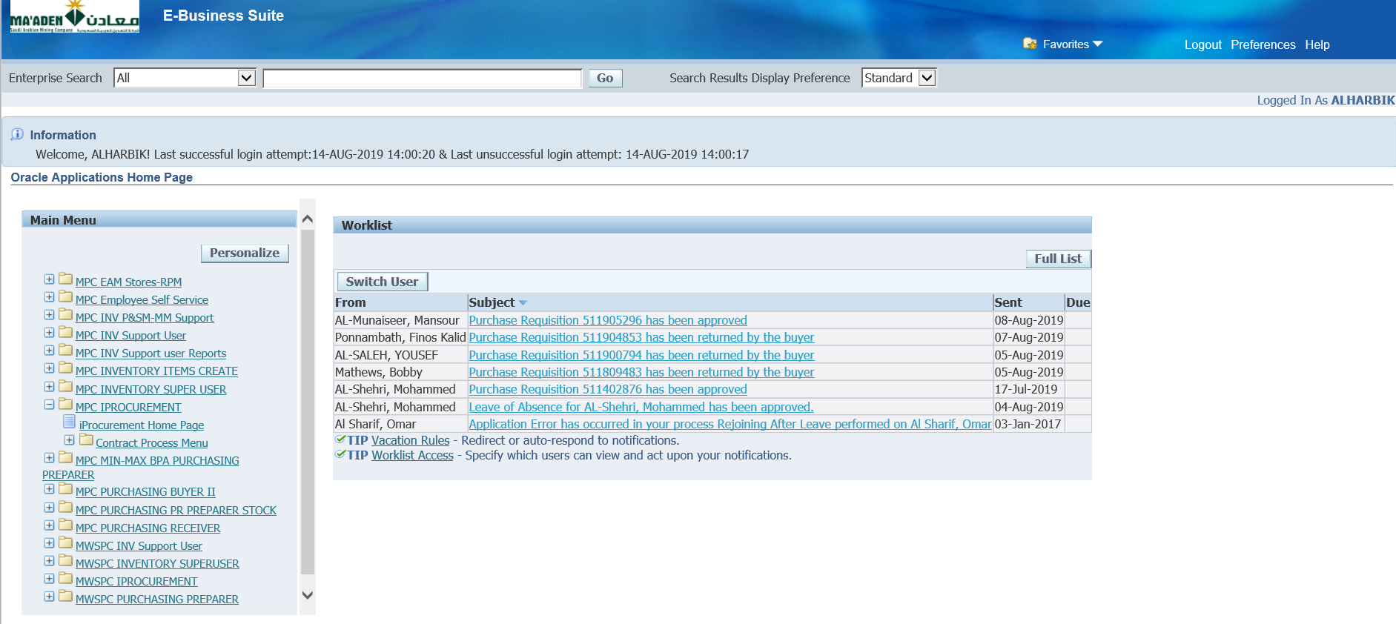

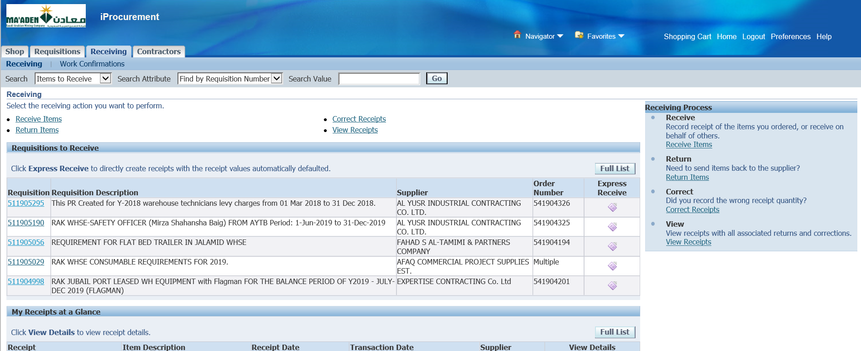

Receiving

Select one of the available Requisitions

PO should have been created against the Requisition then it would be available to Express Receive

PR- [511905295](http://riysoaclone.maaden.com:8010/OA_HTML/OA.jsp?page=/oracle/apps/icx/por/rcv/webui/IcxPorRcvHomePG&_ti=1306840222&oapc=15&OAMC=78349_144_0&menu=Y&oaMenuLevel=1&oas=IP_cNvrPPcQ_5IzQhyHkSQ..)

Express Receive

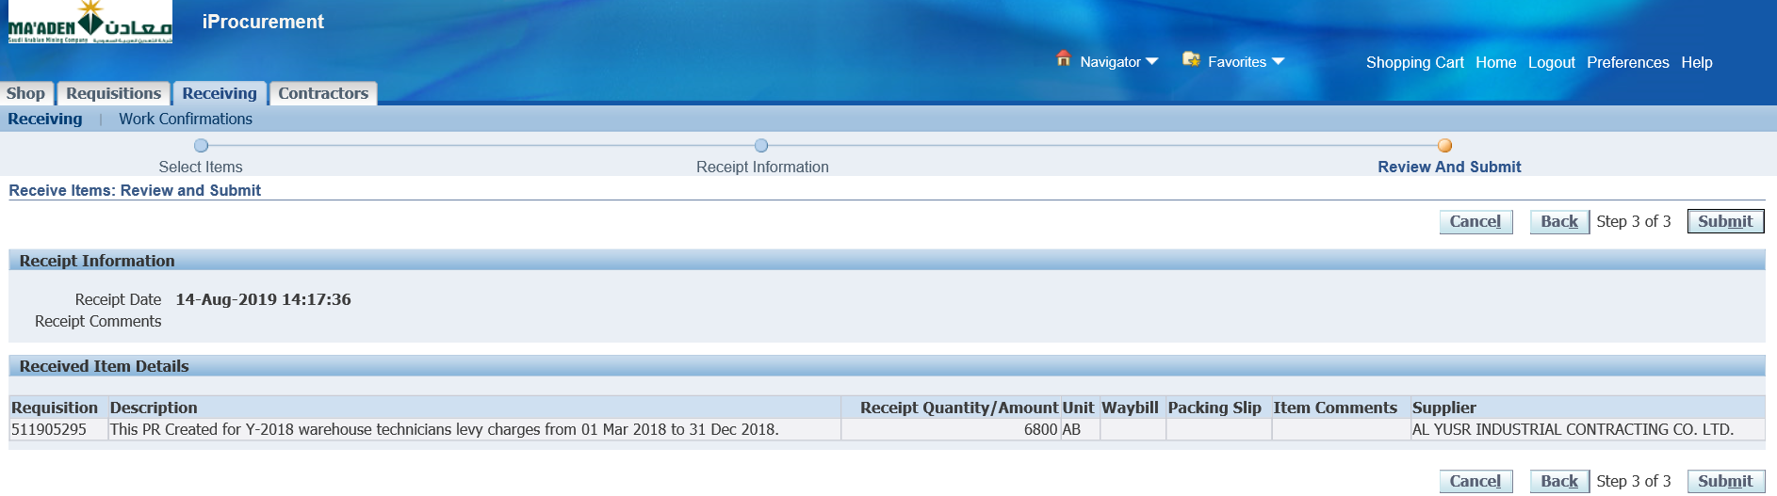

Submit

Receipt 52519007587 has been created

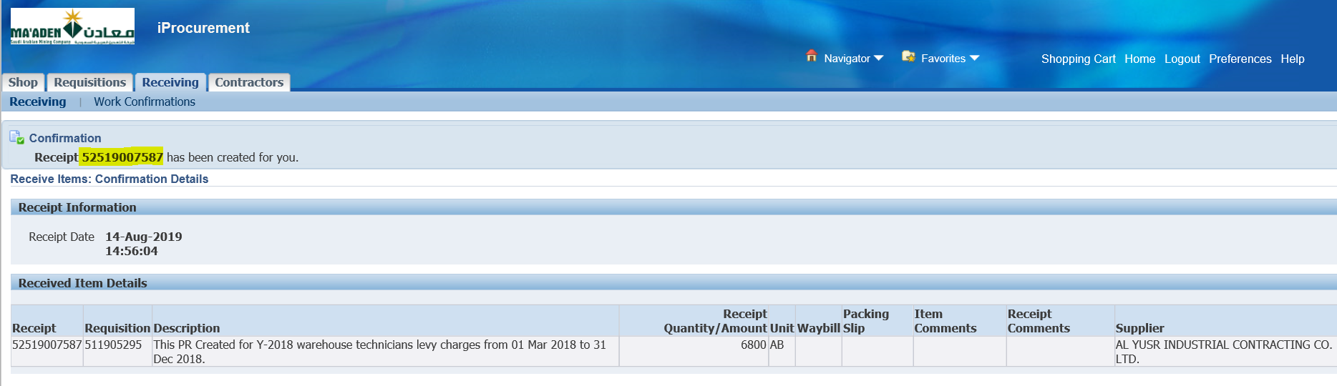

1. Reject a Purchase Order, Update and Submit for Approval

Login as ALHUSSAINIA

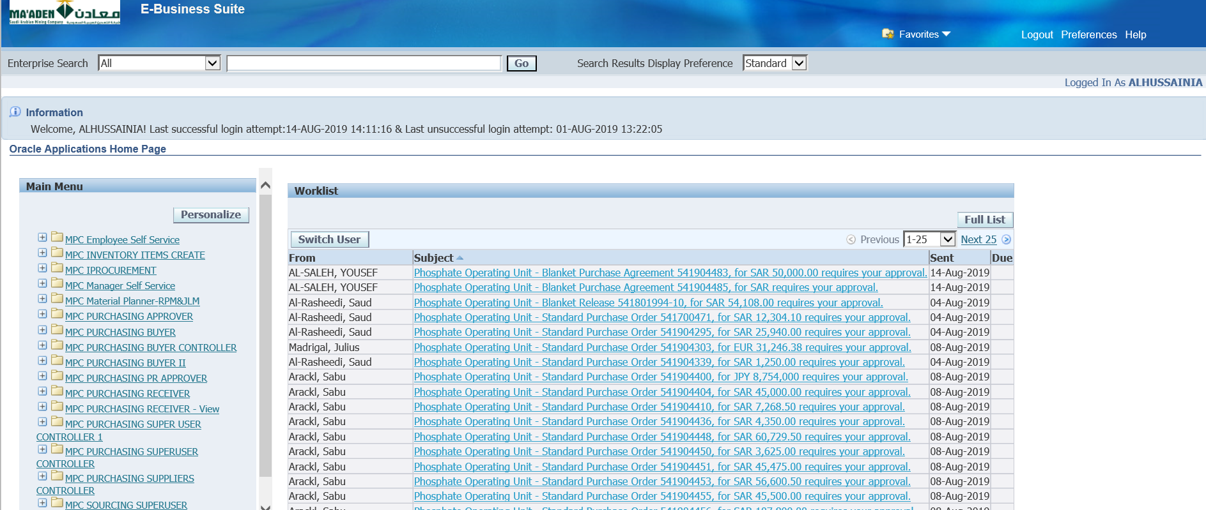

Select one of the POs from the worklist which requires Approval

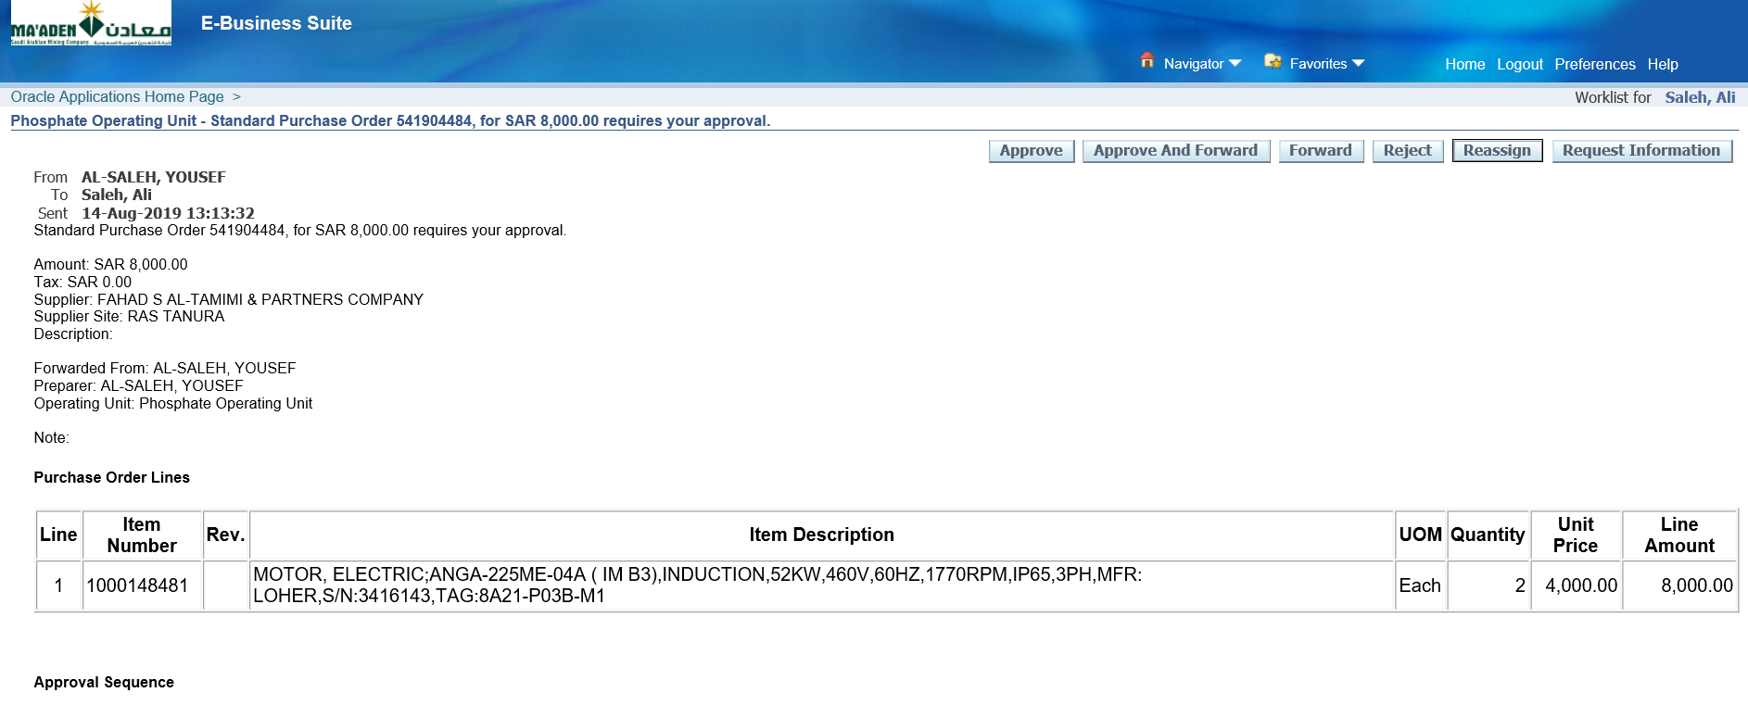

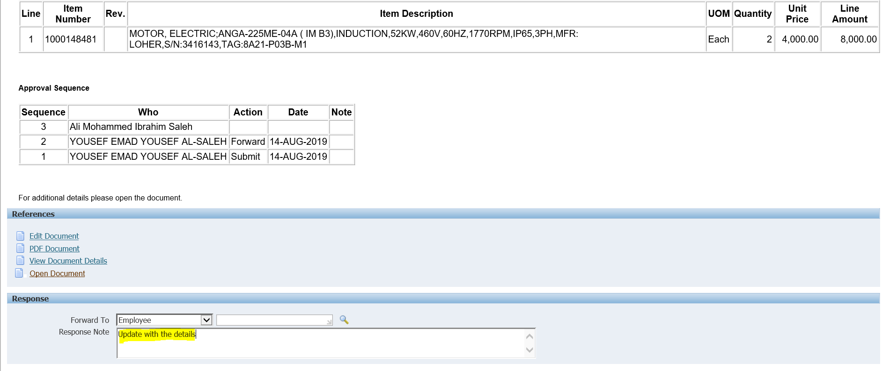

Update Response Note with the Reason for Rejection

Reject

Once Rejected, then it’ll be sent back to the Buyer

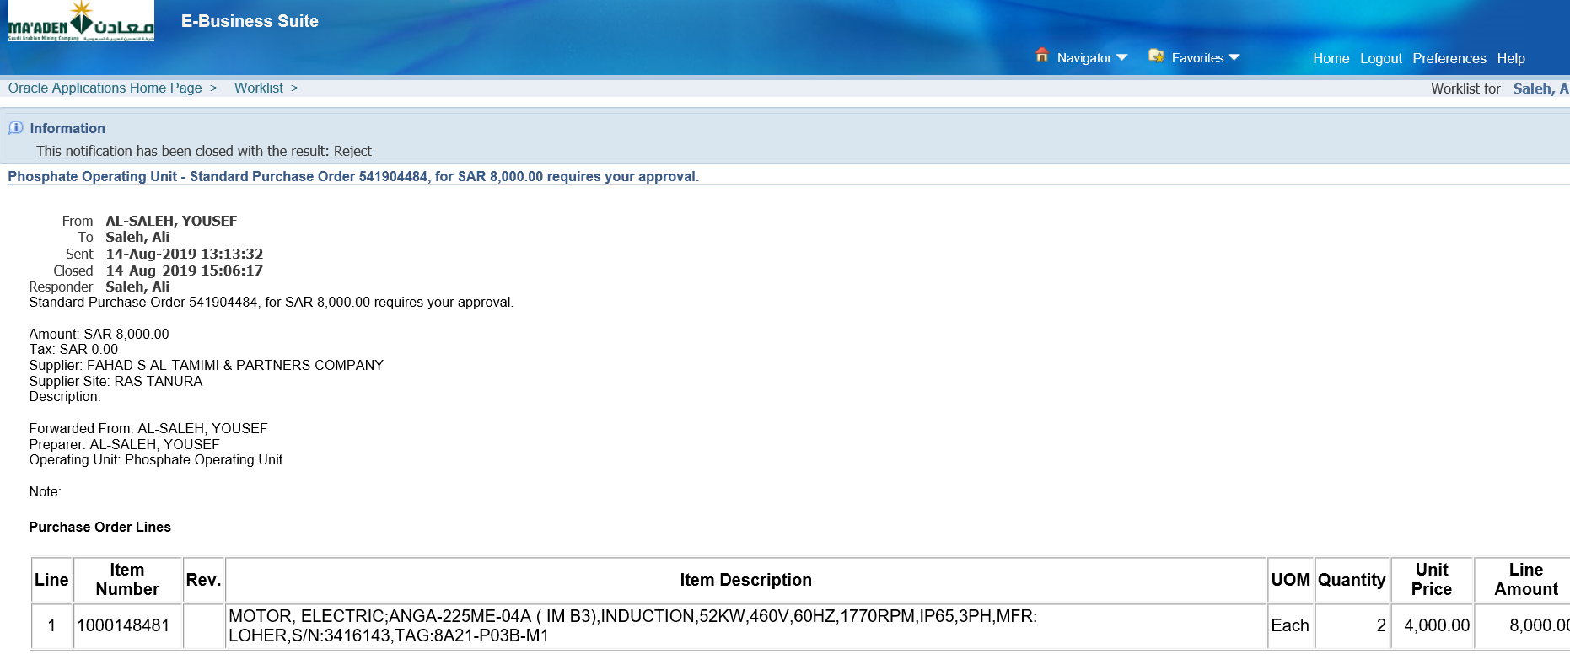

This PO has been Rejected

It’s been sent back to YOUSEF EMAD YOUSEF AL-SALEH

Then the Buyer has to update and submit for approval

Login as SALEHY

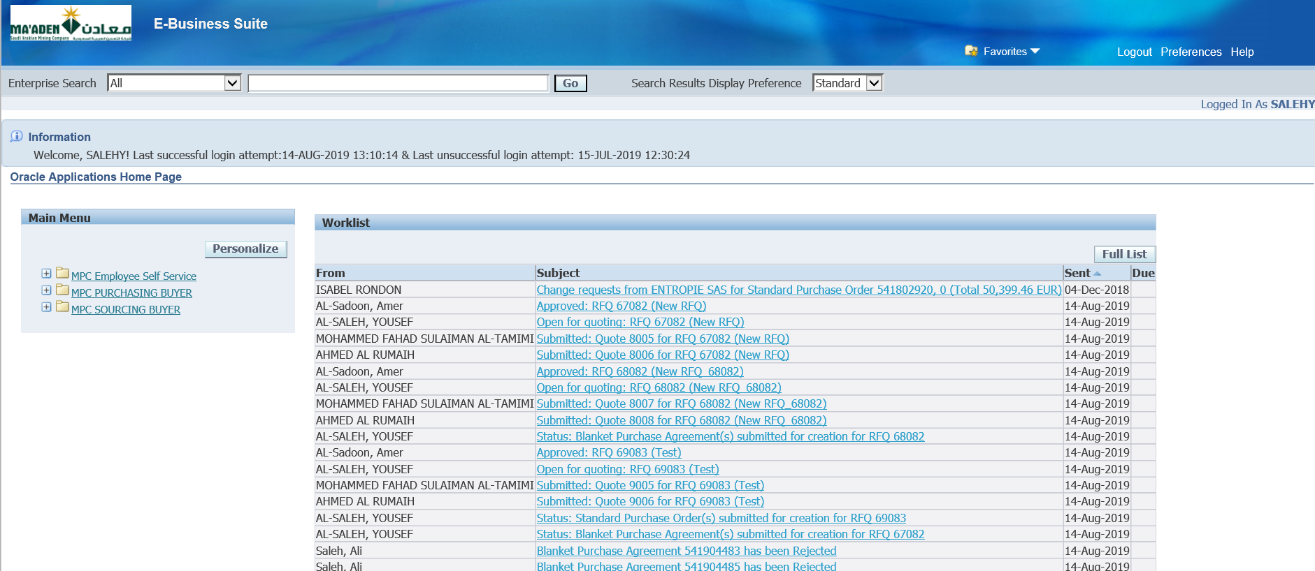

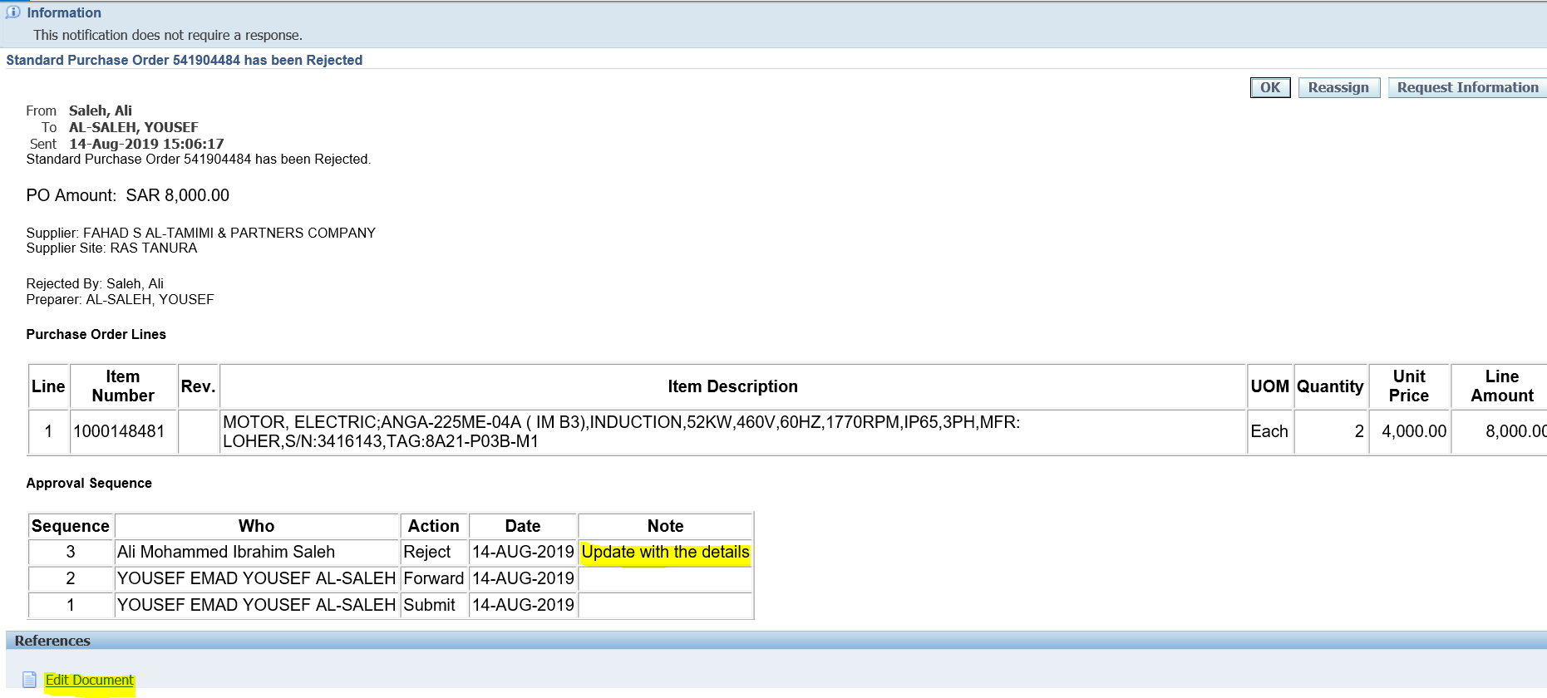

Select Edit Document

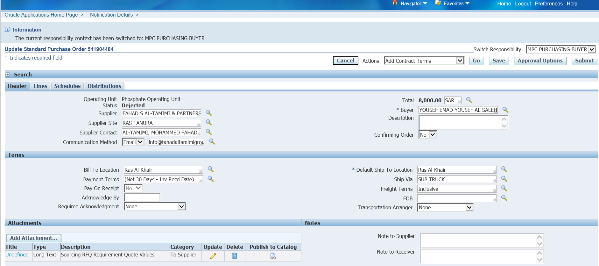

Update the PO with the necessary details

Submit

Once submitted the PO will be sent to the Approver again

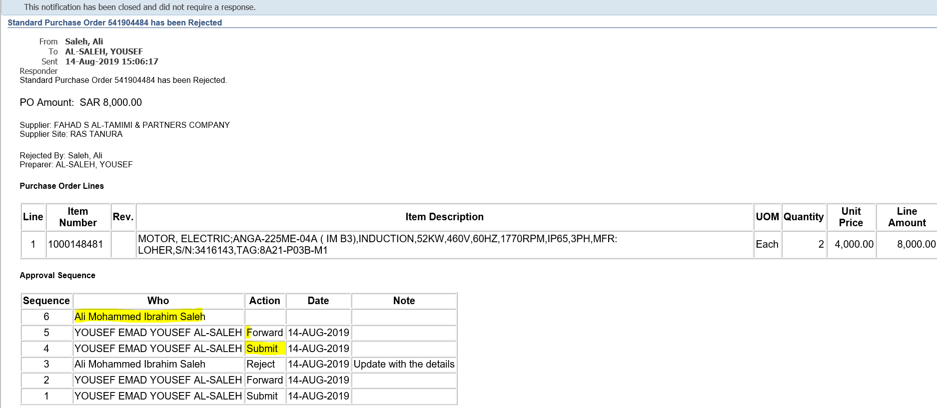

Login as the PO Approver – ALHUSSAINIA

Select the PO from the worklist

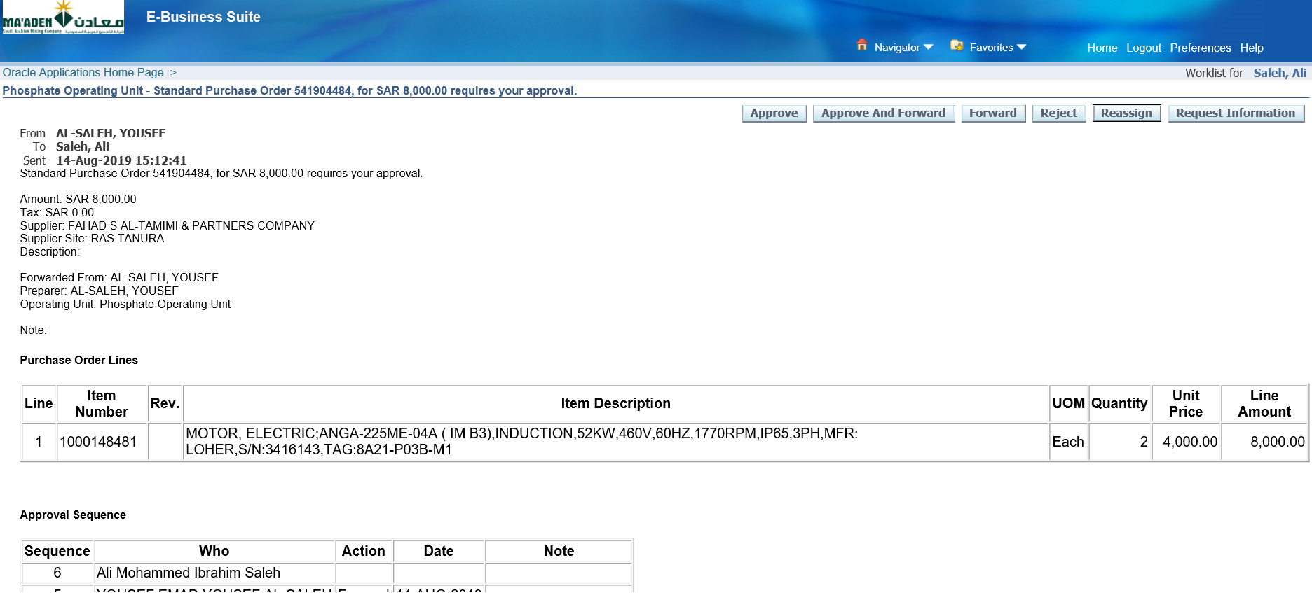

Approve

Login as the Buyer – SALEHY

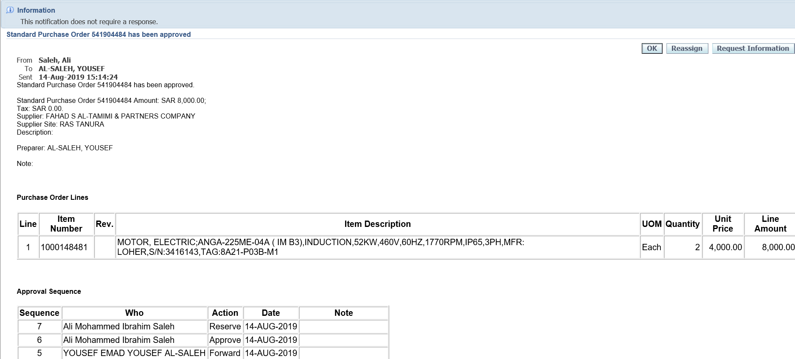

Select the PO from worklist

The PO has been Approved

1. Internal Requisition

Login as ENEZIK

MAC Rolling iProcurement

iProcurement Home Page

Copy to Cart

Checkout

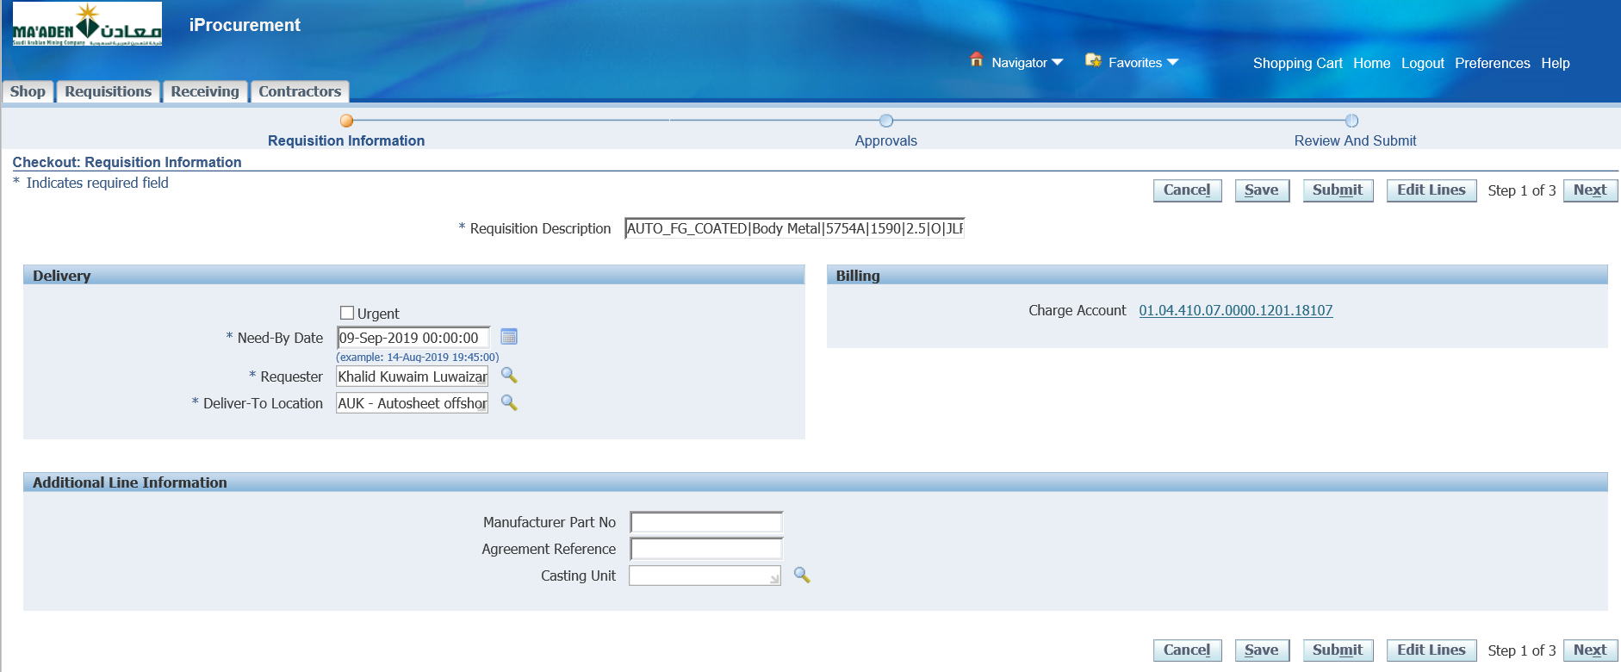

Next

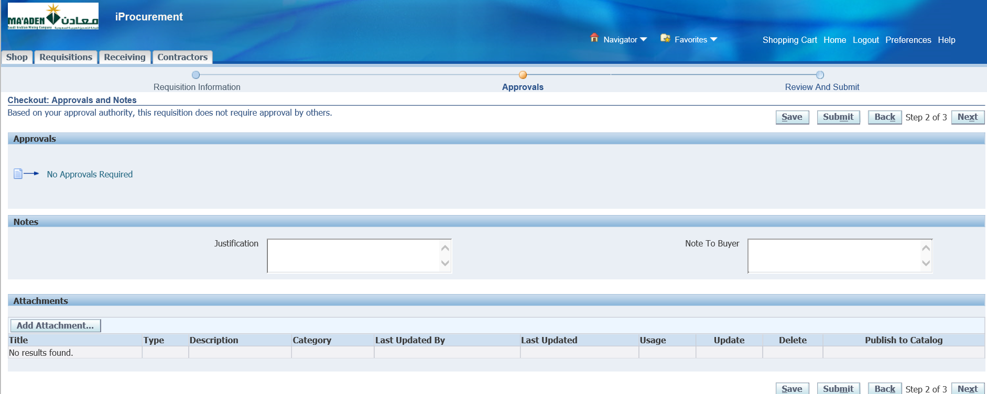

No Approval is required for this Requisition

Submit

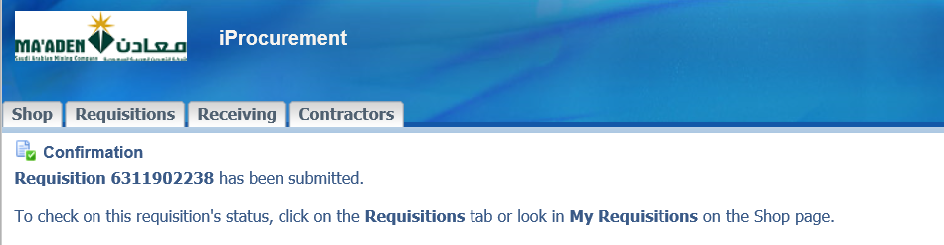

Go to My Requisitions

Check the approval status

Continue Shopping

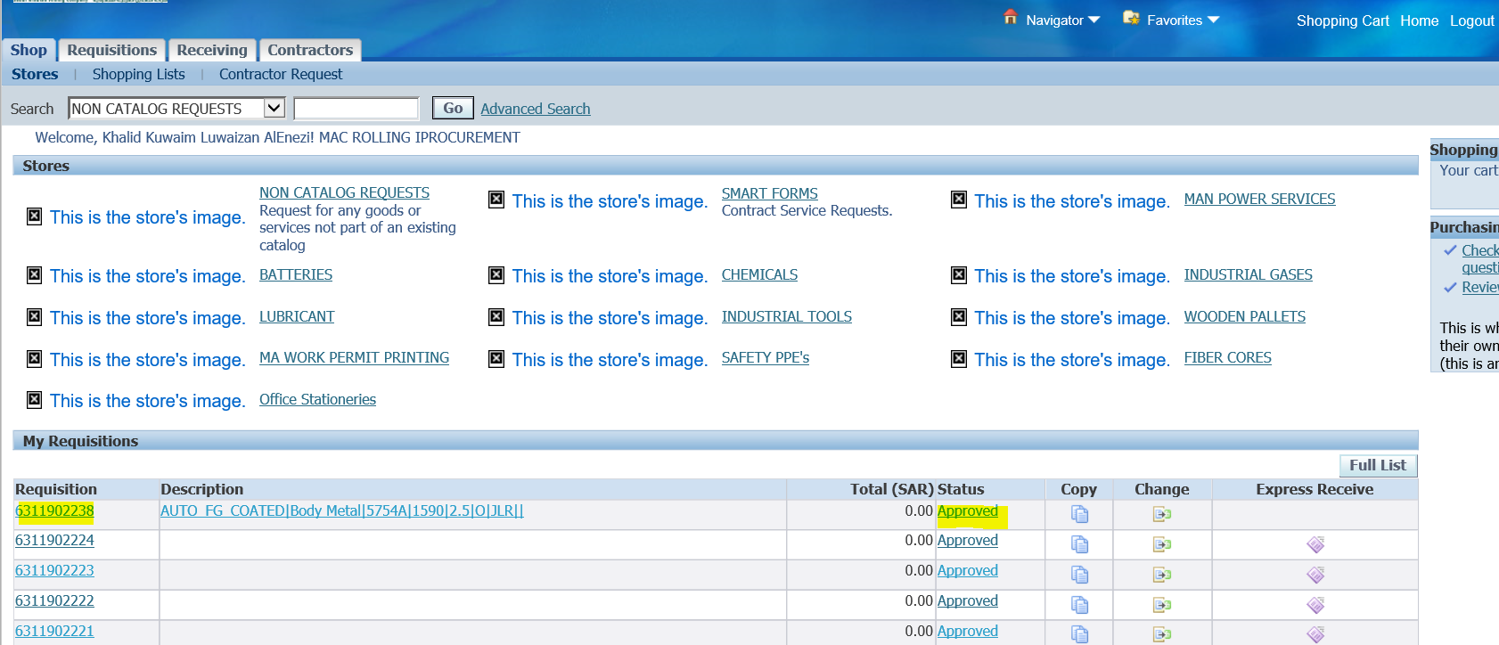

The Internal Requisition 6311902238 has been Approved

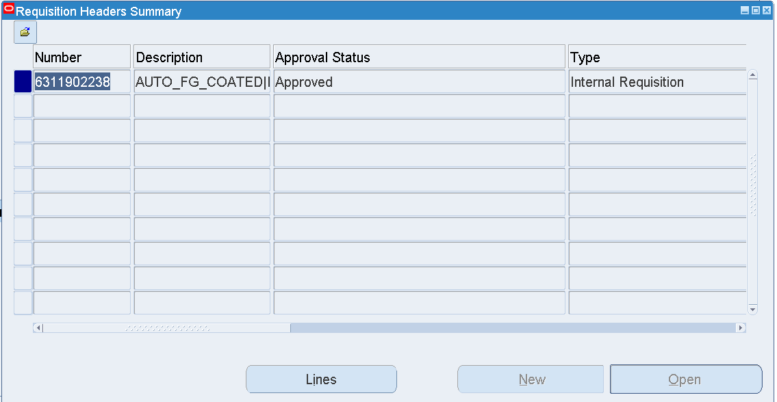

Concurrent Request **Create Internal Orders** will generate Sales order for the approved Internal Requisitions